Company X Data Department Report

# Executive Summary

We exported the sales data from our data base and we conducted some analysis on it to gain insight into some of our sales operations and study ways of enhancing our services based on a certain scope.

## Scope

* Customer Loyalty
* Strengths and weakness
* Performance

### Data Specs:

Here are the tables that we used to conduct our analysis:

* Orders table
* Return table
* People table

# The Analysis

## Customer Loyalty

* What the most ship mode used by customers?

Based on the above table we counted that the numbers of items each shipping mode occurred in the orders table

And we found that the Standard class Sipping Mode was the most one used by our customers by 72.97%.

Recommendations:-

* We should focus more promotions on the standard shipping Mode as it is the most used
* We should find ways to reduce the cost of the standard shipping mode and make sure it’s profitable as it is the most used shipping mode.
* Who are our top 10 customers in the terms of the sales ?

Based on the above table we found there are the Top 10 of customers in Terms of Sales

in the orders table

Recommendations:-

* We must offer them offers in order to encourage them and encourage other customers.

* And Also there is Top Customers By Order Frequency

## Strengths and weakness

* Which segment of clients generate the most sales by category?

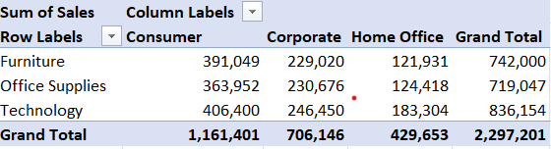

Based on the above table we found The Technology Category and the Consumer Segment generated the most Sales in the orders table

Recommendations:-

* We must offer more offers in technology category in order to attract more customers
* Which city has the most sale value?

Based on the above table we found that Chicago is the city which has the most sale value in the orders table

* Which state generates the most sales percentage by region?

Based on the above table we found that California in the west region has the most sales contribution By 19.92% in the orders table

## Performance

* what are the top performing product categories in terms of sales and profit?

Based on the above table we found there are the Top 10 of performing product categories in Terms of Sales and profit in the orders table