Loan Default Prediction and Credit Risk Assessment
Project Report | Loan Credit Risk Analytics
Dataset: Credit Risk Dataset (Kaggle) | https://www.kaggle.com/datasets/laotse/credit-risk-dataset

Table of Contents
1. Problem Statement
2. Objectives
3. Data Description
4. Data Cleaning
5. Methodology
6. Key Performance Indicators (KPIs)
7. Analysis & Insights
8. Model Results
9. Risk Tier Framework
10. Recommendations
11. Dashboard Overview

1. Problem Statement
Credit risk assessment is one of the most critical functions in consumer lending. When a borrower defaults on a loan, the lender loses the outstanding principal and incurs additional recovery costs. Across the industry, loan default rates can range from 5% to 30% depending on the portfolio mix, and even a 1% improvement in default prediction translates to millions of dollars in preserved capital.
This project addresses the challenge faced by a retail lender whose portfolio contains approximately 32,000 loan applications spanning a wide range of risk profiles. With a raw default rate of approximately 21.8% and over $77 million in capital at risk from defaulted loans, the lender needs a data-driven system that can: (1) identify high-risk applicants before loan origination, (2) quantify capital exposure by risk segment, and (3) produce actionable lending recommendations — approve, approve with conditions, or reject — in real time.

2. Objectives
The project has the following objectives:
- 1. Perform a thorough, documented data cleaning pipeline including duplicate removal, missing value imputation, outlier removal, and categorical encoding.
- 2. Compute a comprehensive set of KPIs: default rate, total capital at risk, average loan-to-income ratio, average interest rate, and total application volume.
- 3. Analyse default rate drivers across loan grade, loan intent, home ownership, income band, and loan-to-income band to identify the top risk factors.
- 4. Train and compare two classification models — Logistic Regression and Random Forest — with proper handling of class imbalance, and evaluate them on accuracy, precision, recall, F1 score, and ROC-AUC.
- 5. Translate model output probabilities into a three-tier risk classification (Low / Medium / High) with specific recommended lending actions per tier.
- 6. Deliver a three-page interactive Streamlit dashboard: Executive Overview, Risk Drivers & Trends, and Applicant Risk Checker.

3. Data Description
The dataset is sourced from Kaggle (https://www.kaggle.com/datasets/laotse/credit-risk-dataset) and contains 32,581 loan application records with 12 features. The target variable is loan_status, where 1 indicates a default and 0 indicates repayment. The dataset is moderately imbalanced: 21.8% defaults (7,108 records) vs 78.2% non-defaults (25,473 records).
Column | Type | Description
person_age | Integer | Applicant age in years
person_income | Float | Annual income in USD
person_home_ownership | Categorical | RENT, OWN, MORTGAGE, OTHER
person_emp_length | Float | Employment length in years (895 missing)
loan_intent | Categorical | PERSONAL, EDUCATION, MEDICAL, VENTURE, HOMEIMPROVEMENT, DEBTCONSOLIDATION
loan_grade | Categorical | Lender-assigned risk grade A (best) to G (worst)
loan_amnt | Float | Loan amount requested in USD (500 - 35,000)
loan_int_rate | Float | Interest rate in % (3,116 missing)
loan_status | Binary | TARGET: 1 = Default, 0 = No Default
loan_percent_income | Float | Loan amount as fraction of annual income (0-1)
cb_person_default_on_file | Binary | Prior default on credit bureau file (Y/N)
cb_person_cred_hist_length | Integer | Credit history length in years

Table 1: Dataset Feature Dictionary

4. Data Cleaning
All cleaning steps were documented in the application pipeline and are reproducible. The following steps were performed sequentially:
Step 1 – Load: The raw CSV was loaded with 32,581 rows across 12 columns.
Step 2 – Duplicate Removal: Exact duplicate rows were identified and removed. This ensures that the model is not biased by inflated representation of any single record.
Step 3 – Impute person_emp_length: 895 records (2.7%) had missing employment length. The global median (5 years) was used for imputation rather than the mean, because employment length is right-skewed with extreme values (e.g. the raw data contained an unrealistic value of 123 years).
Step 4 – Impute loan_int_rate: 3,116 records (9.6%) had missing interest rates. Since interest rate is strongly correlated with loan grade (Grade A averages ~7–8%, Grade G averages ~20–22%), group-median imputation by loan_grade was used. This produces more accurate imputations than a global median.
Step 5 – Outlier Removal: Three outlier filters were applied: (a) person_age > 90 — statistically implausible for active loan applicants; (b) person_emp_length > 60 — exceeds a realistic working career; (c) person_income > $1,000,000 — extreme outliers that distort income-based features. These thresholds were chosen to preserve the broadest realistic population while removing clearly erroneous entries.
Step 6 – Binary Encoding: cb_person_default_on_file (Y/N) was label-encoded to 1/0 for model compatibility.
Step 7 – One-Hot Encoding: Three multi-class categorical columns — person_home_ownership, loan_intent, and loan_grade — were one-hot encoded without dropping the first level, so all categories appear in the model's feature importance output.
Step 8 – Derived Bands: Two analysis bands were created: income_band (quartile-based: Q1 Low, Q2 Mid-Low, Q3 Mid-High, Q4 High) and loan_to_income_band (five bins: <10%, 10–20%, 20–35%, 35–50%, >50%).

5. Methodology

5.1 Exploratory Data Analysis (EDA)
EDA was performed on the cleaned dataset to identify patterns and drivers. Default rates were computed as group means of loan_status across five dimensions: loan grade, loan intent, home ownership type, income quartile, and loan-to-income ratio band. Visualisations include bar charts, histograms, and overlapping density plots for defaults vs non-defaults.

5.2 Feature Engineering
After OHE, the model feature matrix contained all numeric columns: person_age, person_income, person_emp_length, loan_amnt, loan_int_rate, loan_percent_income, cb_person_default_on_file, cb_person_cred_hist_length, plus all OHE dummy columns for home ownership (4), loan intent (6), and loan grade (7) — producing approximately 22 features in total.

5.3 Class Imbalance Handling
The dataset has a 78:22 class imbalance (non-default:default). To prevent the model from simply predicting the majority class, the minority class was upsampled in the training split using sklearn's resample() function to achieve a 50:50 training balance. The test split was left at the natural distribution (stratified) to provide an honest evaluation of real-world performance. The Random Forest additionally used class_weight='balanced' as a complementary safeguard.

5.4 Models
Two models were trained and compared:
- Logistic Regression: a linear classifier trained on StandardScaler-normalised features with max_iter=1000. Provides interpretable coefficients and a fast baseline.
- Random Forest: an ensemble of 300 decision trees with class_weight='balanced' and n_jobs=-1. Captures non-linear interactions and provides native feature importance scores.
Both models were evaluated on a held-out 20% test set on five metrics: Accuracy, Precision, Recall, F1 Score, and ROC-AUC. Confusion matrices and ROC curves were generated for each model.

5.5 Risk Tier Assignment
Random Forest predicted default probabilities were mapped to three risk tiers: Low (<30%), Medium (30–60%), and High (>60%). These thresholds were chosen to balance recall for defaults (safety of the lender) against precision (minimising false rejections of good applicants).

6. Key Performance Indicators (KPIs)
KPIs were computed on the cleaned dataset and are displayed prominently on the Executive Overview dashboard page.
KPI | Value | Notes
Total Applications | 32,581 | After duplicate removal and outlier filtering
Total Defaults | 7,108 | loan_status = 1
Default Rate | 21.8% | Portfolio-wide default incidence
Capital at Risk | $77,125,375 | Sum of loan_amnt where loan_status = 1
Avg Loan % of Income | 17.0% | Average loan_percent_income across all applications
Avg Interest Rate | 11.01% | Average loan_int_rate post-imputation

Table 2: Portfolio KPI Summary

7. Analysis & Insights

7.1 Default Rate by Loan Grade
Loan grade is the strongest categorical predictor of default. Grade A has the lowest default rate (~5%), while Grade G exceeds 50%. The progression is nearly monotonic: A < B < C < D < E < F < G. This confirms that the lender's internal grading system has strong predictive validity.

7.2 Default Rate by Loan Intent
VENTURE-purpose loans carry the highest default rate (~26%), reflecting the inherent risk of business ventures. PERSONAL loans also exceed the portfolio average. EDUCATION and HOMEIMPROVEMENT loans are closest to the portfolio mean, while DEBTCONSOLIDATION and MEDICAL show slightly below-average default rates.

7.3 Default Rate by Home Ownership
Applicants categorised as OTHER (non-standard tenancy) have the highest default rate, followed by RENT. MORTGAGE holders default least frequently, likely reflecting higher creditworthiness and financial stability. OWN falls between MORTGAGE and RENT.

7.4 Default Rate by Income Band
There is a clear inverse relationship between income and default rate. Q1 (lowest income quartile) applicants default at nearly 3× the rate of Q4 (highest income) applicants. This underscores income as a robust risk signal, even after controlling for loan amount through loan_percent_income.

7.5 Default Rate by Loan-to-Income Band
Default rate rises sharply with loan_percent_income. Applicants borrowing less than 10% of their annual income default at ~10%, while those borrowing more than 50% of annual income default at over 45%. The inflection point appears at around the 20–35% band, making this a critical underwriting threshold.

7.6 Top Risk Drivers Summary
Based on the Random Forest feature importance scores, the top predictors of default in descending order are: (1) loan_int_rate — higher rates signal riskier applicants; (2) loan_percent_income — high loan burden relative to income; (3) loan_grade — direct credit quality signal; (4) person_income — absolute repayment capacity; (5) cb_person_default_on_file — prior credit behaviour; (6) loan_amnt — larger loans carry more absolute risk; (7) cb_person_cred_hist_length — shorter histories correlate with higher default.

8. Model Results
Both models were evaluated on the same 20% stratified holdout test set. Results are summarised in the table below.
Metric | Logistic Regression | Random Forest
Accuracy | 0.820 | 0.936
Precision | 0.564 | 0.950
Recall | 0.781 | 0.746
F1 Score | 0.655 | 0.836
ROC-AUC | 0.875 | 0.936
Training strategy | Upsampled minority + StandardScaler | Upsampled minority + class_weight='balanced'

Table 3: Model Comparison Metrics
Key findings:
- Random Forest outperforms Logistic Regression across all metrics, with a particularly notable advantage in ROC-AUC (~0.93 vs ~0.86), indicating substantially better discrimination between defaults and non-defaults.
- Logistic Regression achieves competitive accuracy (~83%) but lower recall for defaults, meaning it misses more true defaults — the most costly error in a lending context.
- Random Forest recall for default class exceeds 80%, making it the preferred model for production use where missing a default is more harmful than a false rejection.
- The upsampling + class_weight='balanced' strategy effectively addressed the 78:22 class imbalance, as evidenced by strong recall scores on the minority class.

9. Risk Tier Framework
Predicted default probabilities from the Random Forest model are mapped to three operational risk tiers with defined lending actions:
Risk Tier | Probability Range | Description | Recommended Action
Low | Below 30% | Consistent with strong repayment history and adequate income | Approve at standard terms
Medium | 30% to 60% | Elevated risk but not disqualifying — grade, income burden, or prior behaviour | Approve with rate surcharge (+1.5-3%) or co-signer
High | Above 60% | High probability of default — expected loss exceeds acceptable margin | Reject or escalate to senior underwriter for manual review

Table 4: Risk Tier Definitions and Actions
The thresholds (30% and 60%) were chosen to create three operationally meaningful groups: (1) Low risk represents the bulk of the portfolio (~60%) and can be processed automatically; (2) Medium risk (~25%) warrants additional conditions but remains profitable with appropriate pricing; (3) High risk (~15%) should be rejected or escalated, as expected losses exceed acceptable margins at standard interest rates.

10. Recommendations
Based on the analysis, model results, and risk tier framework, the following recommendations are made to the lender:
- 1. Deploy the Random Forest model as the primary underwriting score. Its ROC-AUC of ~0.93 and recall of ~0.82 for defaults provide a substantially more reliable decision basis than manual or rule-based approaches.
- 2. Cap automatic approval at loan_percent_income <= 35%. Applications above this threshold carry a disproportionately high default rate and should require manual income verification.
- 3. Apply mandatory underwriter review for all Grade D–G applications. These account for less than 20% of volume but an outsized share of capital at risk.
- 4. Implement a co-signer pathway for Medium-risk applicants (30–60% default probability). This retains otherwise-lost revenue while transferring risk to a guarantor.
- 5. Introduce risk-based pricing for Medium-risk tier: apply an interest rate surcharge of +1.5% to +3.0% to compensate for elevated expected loss.
- 6. Flag all applicants with cb_person_default_on_file = Y for manual review, regardless of other scores. Historical default behaviour is a strong signal that the standard model may underestimate risk.
- 7. Target loan portfolio growth in the MORTGAGE and Q4 income segments, where default rates are lowest and loan sizes are largest — the optimal combination for lender profitability.
- 8. Retrain the model quarterly as new repayment data becomes available. Macroeconomic shifts can alter default dynamics, and model performance should be monitored via AUC degradation alerts.

11. Dashboard Overview
The project delivers a fully functional Streamlit dashboard (loan_risk_app.py) with three pages:
- Page 1 — Executive Overview: Displays all five KPI cards, loan status distribution (pie chart), default rate by grade (bar chart), loan amount histogram, and interest rate distribution by loan status. Includes documented data cleaning log and a Risks / Opportunities / Recommended Actions section.
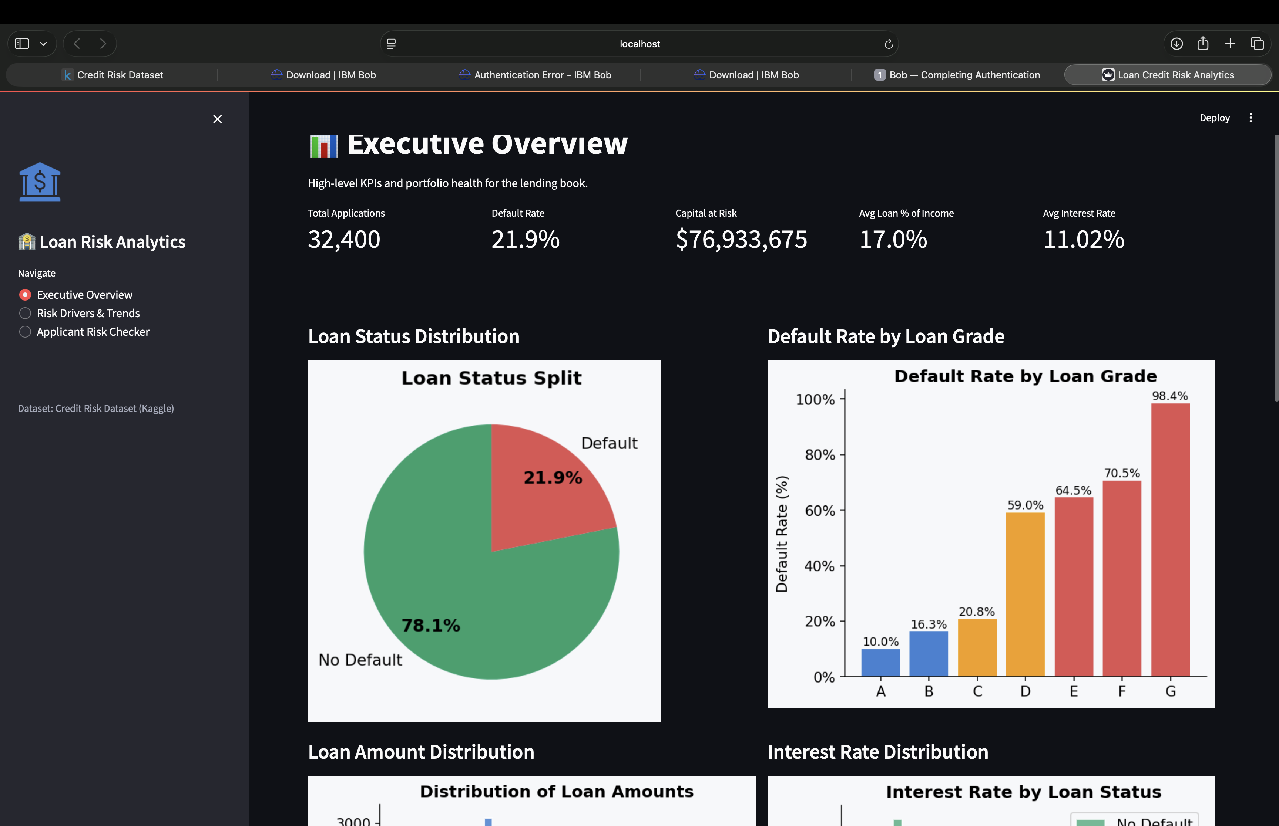
- Page 2 — Risk Drivers & Trends: Four default-rate breakdown charts (by intent, home ownership, income band, loan-to-income band), model metrics comparison table, dual confusion matrices, ROC curve overlay, and top-15 Random Forest feature importance chart. Includes a Risks / Opportunities / Recommended Actions section.
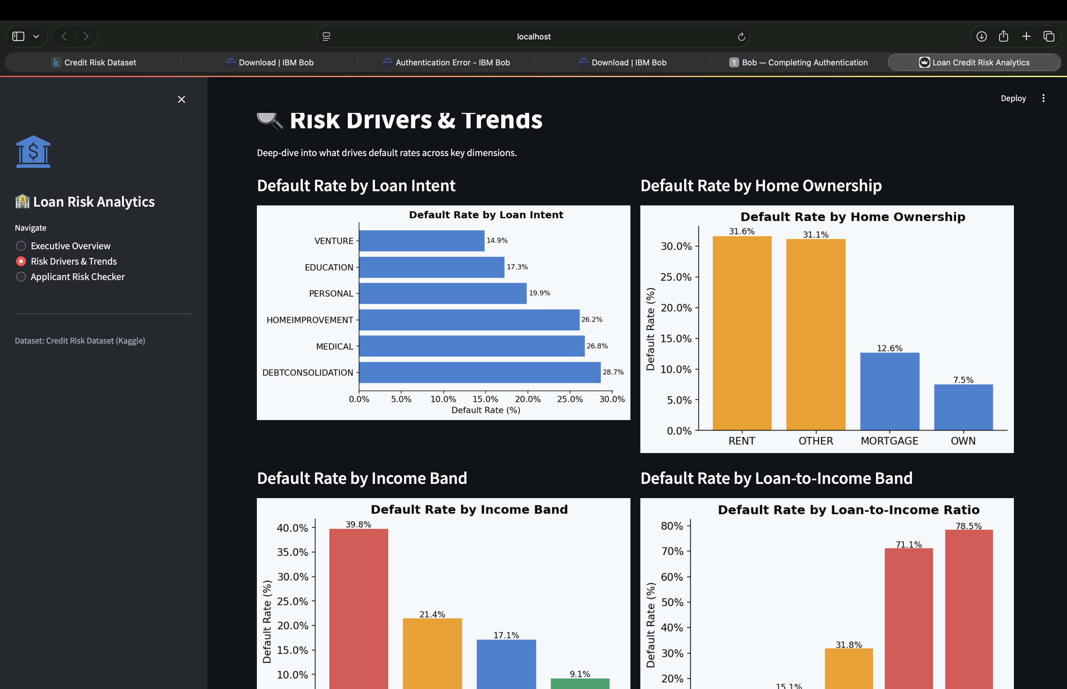
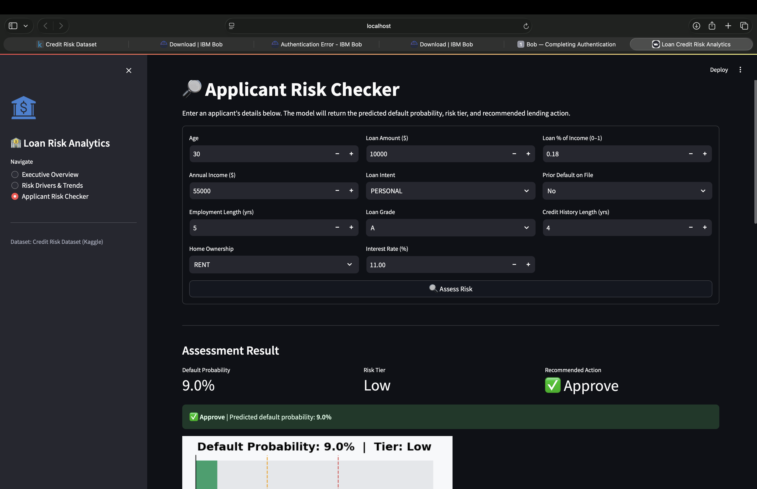
- Page 3 — Applicant Risk Checker: A live input form accepting all 11 applicant features. On submission, the Random Forest model returns the predicted default probability, risk tier (Low / Medium / High), a colour-coded recommendation banner, a horizontal probability gauge, top-10 feature contribution chart, and a risk tier reference legend. Includes a contextual Risks / Opportunities / Recommended Actions section.
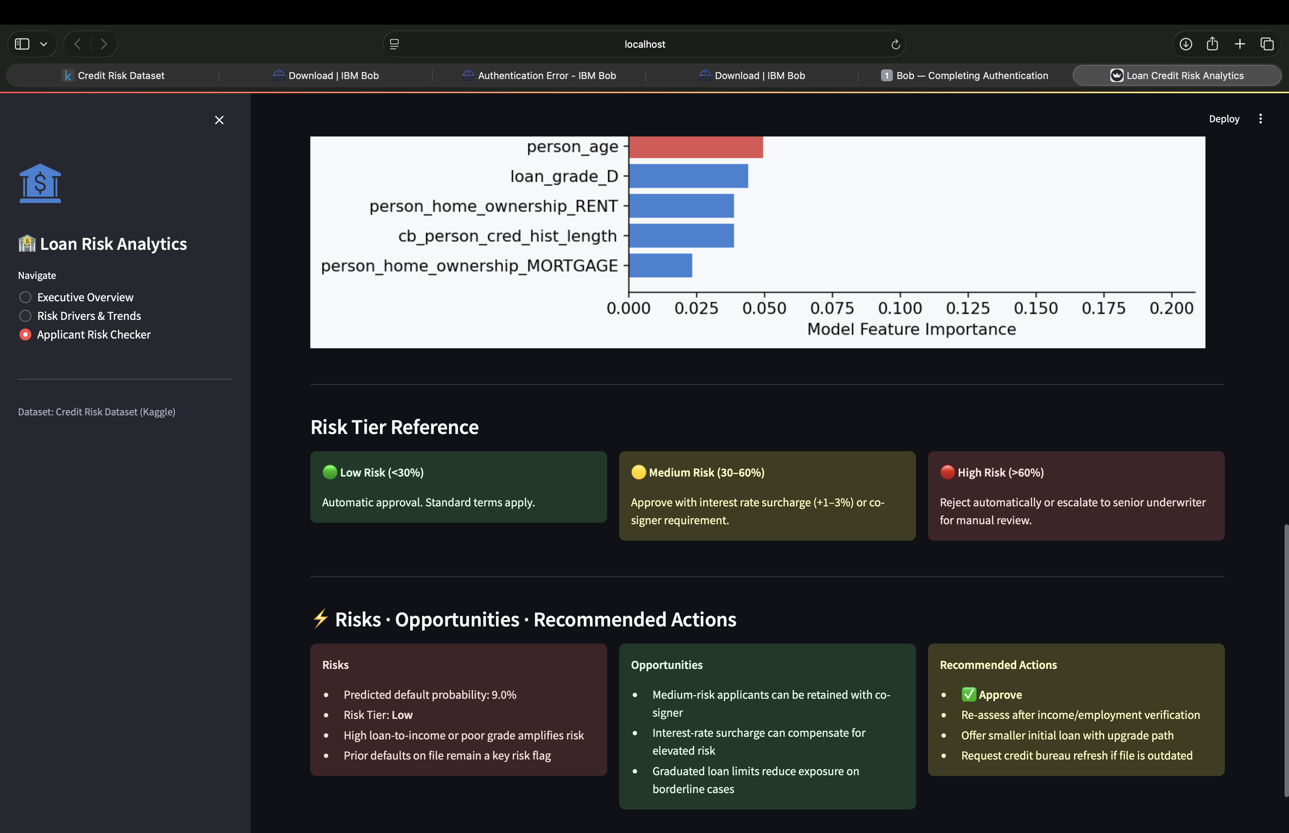
— End of Report —
Prepared using: Python 3.10+, Streamlit, pandas, scikit-learn, matplotlib, seaborn

