**ITT-307 Lab Assessment**

Professor: Juan Gonzalez

Course: ITT-307

Student: Matt Sievers

Date: 07/30/2019

Title: Setup a VM – Install Kali Linux

Directions:

# Overview: To provide detailed instructions on how to setup a virtual machine and then install kali linux on to that new VM.

# Details:

*Assumptions: User has requested access to VM toolset from GCU, if not, follow the how to setup documentation found under coarse material.*

Setting up a virtual machine.

1. Start by navigating to the following link to gain access to the VM software available to you.

<https://e5.onthehub.com/WebStore/ProductsByMajorVersionList.aspx?ws=9c07565e-a326-e711-9427-b8ca3a5db7a1&vsro=8>

1. Sign in using your GCU email and password (this is the same you use to login into the online student portal).
2. For mac users click on the VMWare Fusion.

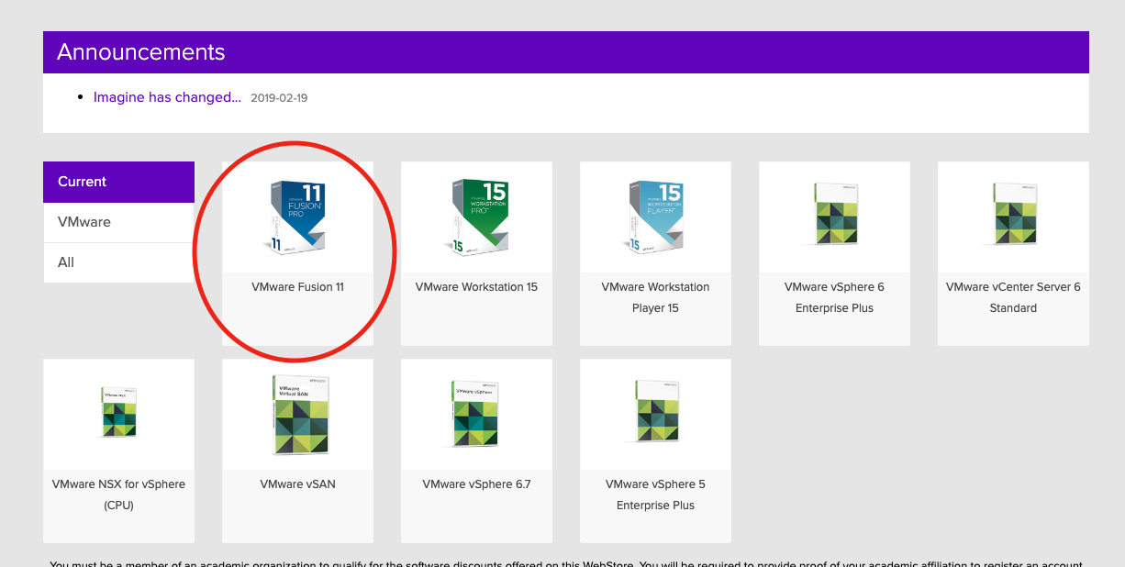

1. On the next screen choose the option that is listed for students. Click add to cart and follow the check-out process.

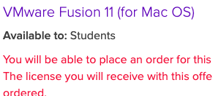

1. On the download screen make a note of the serial number that is issued to you for installation registration later. Click download button and download the installer.
2. Once download is complete double click or run the installer. You may receive the following message upon installation. Click open to proceed since you are aware of the source. You may also be prompted for admin password depending on how your system was configured. Enter password as needed to proceed.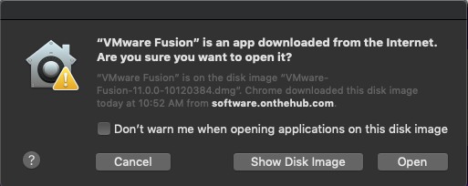
3. On the installation screen you will be required to provide that serial number you wrote down in step 5. Enter it in the “I have a license” box and click continue to proceed.

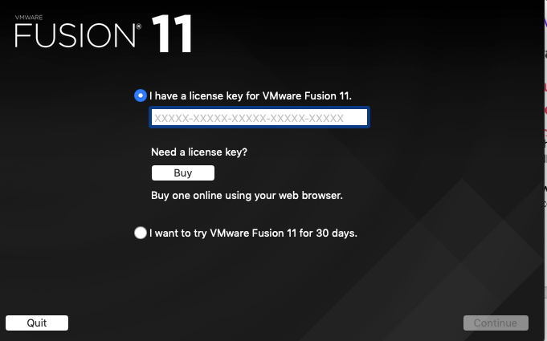

1. Click done on the next screen to proceed.
2. Depending on he version installed, you may receive a prompt to update. Click the download and install button to update your software.

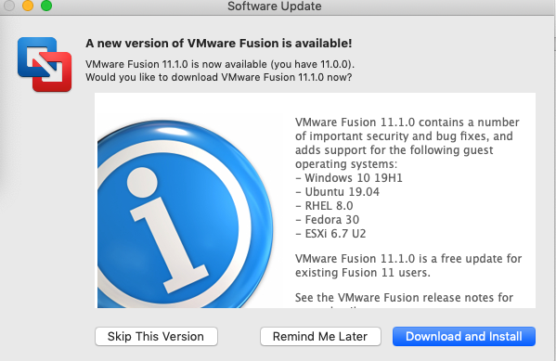

1. When download is complete, click the install and relaunch button to proceed.

Installation of Kali Linux.

1. Kali linux download link is available at: <https://www.gcumedia.com/digital-resources/kali-linux/2016/kali-linux_ebook_1e.php>
2. On the page you will find many links. Locate the one that is for Kali Linux and your system requirements (64 or 32 bit) and click on the http link to download your .iso file.



1. In VMWare you will have a home app screen that looks like the following, click on the install from disc or image” button at the top and click continue.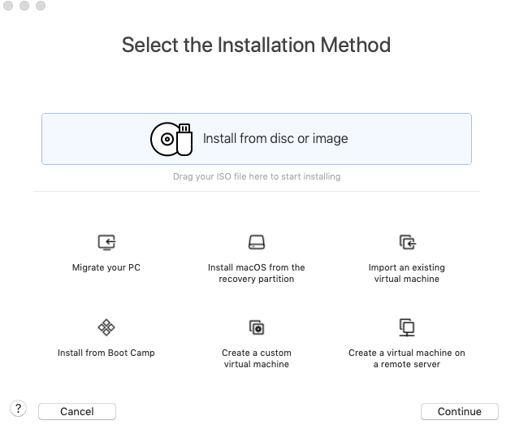
2. Locate the downloaded Kali Linux image (downloads folder or where ever you have specified for your downloads to go) and drag it into the box that says “Drag a disc image here”. If you are unable to drag and drop, you can click on the Use another disc or disc image button to open a finder box to locate your file. Once the file is either drug over or added manually click continue to proceed.
3. The next screen will ask what OS you wish your virtual machine to run. Select Linux and version Debian 9.x 64bit. Click continue to proceed.

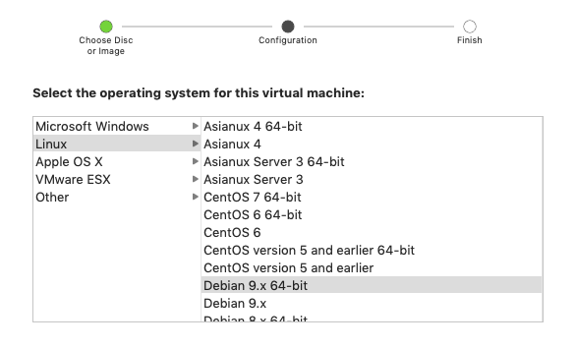

1. Click continue on the next screen and leave the firmware on default settings
2. Verify your request and click finish.
3. The next screen gives you an option to name your VM and add tags, leave these details as default. Click Save to proceed.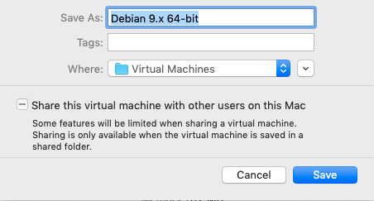
4. If you experience an error with unable to open /dev/vmmon, please watch this simple video on how to resolve said issue.

<https://www.youtube.com/watch?v=EMmRkr1uGVw>

1. Click the play button to start your VM. If installed correctly you will load the following screen.

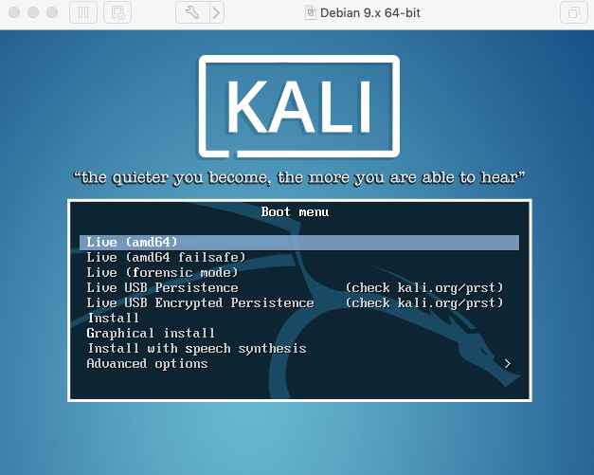

1. Select the install or graphic install to install Kali linux. Both will do the same thing.
2. Select your language, location and keyboard type, clicking continue between pages. The installation will start once these selections are made.
3. Next steps are to configure your network. Leave the default values for Hostname. The domain name can be created, for this class use itt307.com
4. Next setup your root password. Keep this simple and easy to remember. It will be how you log in later after installation.
5. Next you need to set up the disk image for your VM. Most times these are set to 20gb partition (can be changed in the settings). Ensure that you have enough free disk space to proceed. Keep in mind VMWare will set up the new partition and if using an existing partition, all data will be deleted and lost. This ***WILL NOT*** change anything on your current system and no data will be lost there. It will simply use a portion or the existing drive not in use. Click continue to use the guided – full disk partition open and select yes on the final screen to proceed.
6. Installation of system will take 5 – 10 minutes to complete.
7. Configure your package manager and keep settings default.
8. HTTP Proxy – leave this blank.
9. Install GRUB book loader – keep all default settings, click continue to proceed. Select /dev/sda for the boot loader to load on and click continue to complete.
10. Installation complete – click continue to complete installation.

Setup of Kali

1. Start by providing your username. If you kept all the settings as default, this will be root. Provide the password you gave to root during setup as well.
2. Once complete you will be logged into the desktop.

# Summary: Installation was successful. Encountered a few bugs along the way. These were not pertinent to the installation of the project.

1. I had run out of disk space or didn’t have enough for the first installation.
2. On a mac, required a little reading on what product to use.
3. Had a common error encountered on macs upon installation and some system privacy blockers that needed to be addressed. Included video on how to fix as part of the installation should it occur for other users.

