**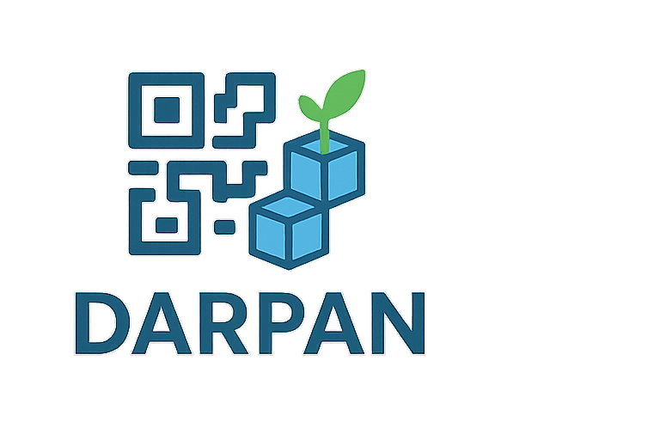**

**DARPAN** : **Blockchain Based Supply Chain Transparency for Agricultural Produce**

**Team Name :** **GAMOPS** (Global Alliance of Motivated Optimistic Problem Solvers)

**Team ID :** 80317

**Institute/College :** Hirachand Nemchand College of Commerce

**Problem Statement ID :** SIH25045

**Title :** Blockchain-Based Supply Chain Transparency for Agricultural Produce

# Abstract

The agricultural supply chain faces challenges like lack of transparency, unfair farmer compensation, and risks of fraud. Our solution combines Blockchain and AI-based crop quality analysis to ensure trust and fairness. Farmers upload crop details and images, which AI evaluates for quality and pricing. Updates from transporters, wholesalers, and retailers are stored immutably on the blockchain. A QR code allows consumers to trace the produce, while a complaint mechanism ensures accountability. This system empowers farmers, protects consumers, and modernizes the supply chain with transparency and efficiency.

# Problem Statement

The Indian agricultural supply chain lacks transparency, with farmers underpaid, consumers unable to verify quality, and intermediaries exploiting the system. Manual record-keeping is tamper-prone and fails to provide end-to-end visibility. A transparent, tamper-proof system is needed to ensure fairness, traceability, and trust for all stakeholders.

# Existing Solutions & Gaps

- Manual record-keeping is error-prone and vulnerable to fraud..  
- Partial digital platforms lack blockchain immutability.  
- Consumers have limited visibility of produce journey.  
- Complaint and accountability mechanisms are missing

# Proposed Solution

We propose a Blockchain-based supply chain system integrated with AI quality assessment:  
1. Farmer registers crop details and uploads crop images.  
2. API (Roboflow) checks quality and predicts price range.  
3. Data stored immutably in blockchain.  
4. Transporter collects produce, transport details added to blockchain.  
5. Wholesaler procures in bulk, adds wholesale data to blockchain.  
6. Retailer sources produce, records details, and makes it available to consumers.  
7. Consumer scans QR code to view complete journey from farmer to retailer.  
8. All stakeholders except farmers can flag complaints for accountability.

# System Architecture & Design

System Flow:  
Farmer (registers crop + image) → AI Model (quality & price prediction) → Blockchain Record → Transporter (adds transport details) → Blockchain Record → Wholesaler (bulk aggregation, adds details) → Blockchain Record → Retailer (consumer supply, adds details) → Blockchain Record → Consumer (QR scan → journey details, option to flag complaints).

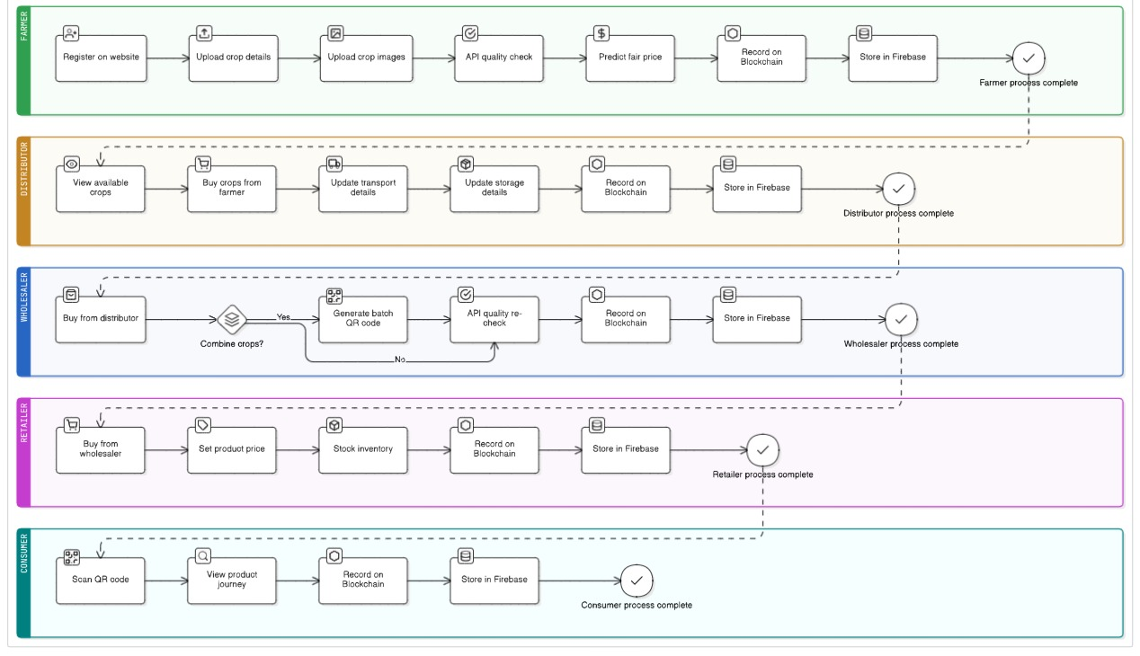

# Technology Stack

|  |  |
| --- | --- |
| **Component** | **Technology** |
| Frontend | Flutter |
| Backend | DART , Python (FastAPI / Django) |
| Blockchain | Ethereum |
| Database | Firebase |
| AI Model | Roboflow API |
| QR Integration | QR libraries |
|  |  |

# Use Cases / User Stories

- Farmer: Registers crop, uploads image, and sees predicted price.  
- Transporter: Updates transport details .  
- Wholesaler: Records bulk purchase and supply details.  
- Retailer: Updates availability for consumers.  
- Consumer: Scans QR code to verify authenticity, journey, and can flag complaints.

## Prototype Details

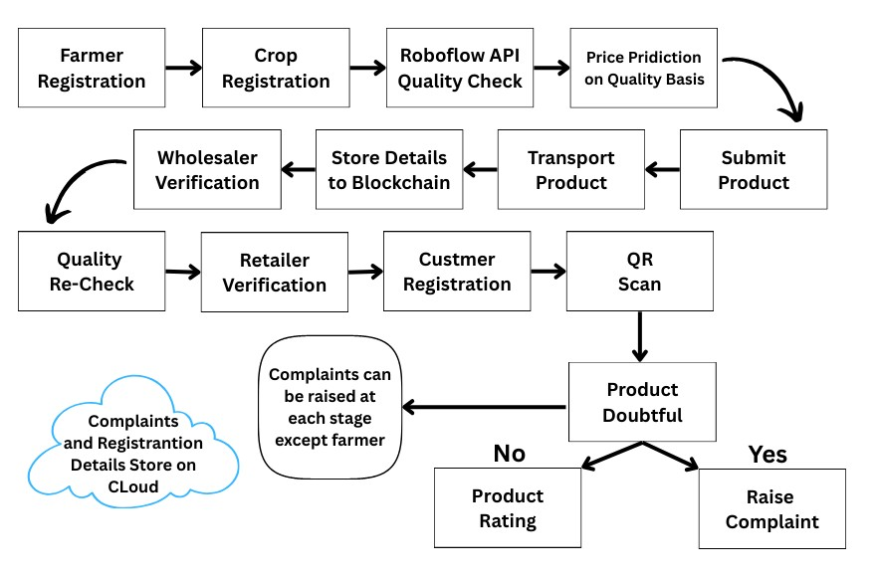

# 

# C:\Users\Shreya\AppData\Local\Packages\5319275A.WhatsAppDesktop_cv1g1gvanyjgm\TempState\CA851E9F71B25D2D588B7E0D4DE3D627\WhatsApp Image 2025-09-28 at 06.53.53_d6982d4f.jpg C:\Users\Shreya\AppData\Local\Packages\5319275A.WhatsAppDesktop_cv1g1gvanyjgm\TempState\73FED7FD472E502D8908794430511F4D\WhatsApp Image 2025-09-28 at 06.53.53_baab44f1.jpg

# C:\Users\Shreya\AppData\Local\Packages\5319275A.WhatsAppDesktop_cv1g1gvanyjgm\TempState\735143E9FF8C47DEF504F1BA0442DF98\WhatsApp Image 2025-09-28 at 06.53.54_252282be.jpg

# C:\Users\Shreya\AppData\Local\Packages\5319275A.WhatsAppDesktop_cv1g1gvanyjgm\TempState\2974788B53F73E7950E8AA49F3A306DB\WhatsApp Image 2025-09-28 at 06.53.54_8b14b6df.jpg

# C:\Users\Shreya\AppData\Local\Packages\5319275A.WhatsAppDesktop_cv1g1gvanyjgm\TempState\99BE9F83741D1275639DF2C1E4D0072F\WhatsApp Image 2025-09-28 at 06.53.55_8674f25c.jpg

# C:\Users\Shreya\AppData\Local\Packages\5319275A.WhatsAppDesktop_cv1g1gvanyjgm\TempState\E91068FFF3D7FA1594DFDF3B4308433A\WhatsApp Image 2025-09-28 at 06.53.55_cb72e504.jpg

# Impact & Benefits

- Enhances trust and transparency across the supply chain.  
- Prevents farmer exploitation with fair price prediction.  
- Provides verifiable product authenticity for consumers.  
- Reduces fraud, tampering, and inefficiencies.  
- Improves accountability through blockchain immutability.  
- Builds a sustainable, traceable supply ecosystem.

## Stakeholder Analysis

* **Farmers:** Fair pricing and quality assessment.
* **Transporters & Wholesalers:** Track produce and ensure accountability.
* **Retailers:** Manage inventory and provide quality feedback.
* **Consumers:** Verify produce origin and quality via QR code.
* **Regulatory Authorities / Government:** Monitor compliance and enforce fairness.

# Feasibility & Risk Analysis

Technical Feasibility: Achievable using blockchain frameworks and AI models.  
Operational Feasibility: Requires training farmers and stakeholders to use the system.  
Financial Feasibility: Initial costs may be high but offset by long-term efficiency gains.  
Risks: Limited internet access in rural areas, dataset availability for AI, adoption resistance.

# Future Enhancements / Scalability

- Integrate IoT sensors for real-time monitoring (temperature, humidity during transport).  
- Expand system to international export tracking.  
- Use predictive analytics for demand forecasting.  
- AI-powered fraud detection.  
- Mobile-friendly lightweight versions for rural farmers.

# Team & Roles

|  |  |
| --- | --- |
| **Member Name** | **Role** |
| Anaswara S. | Member |
| Pogul Geeta Ashok | Member |
| Bitodkar Shreya Sudhir | Member |
| Yadav Priya Santosh | Member |
| Kota Mallesham | Member |
| Changale Omkar Yogiraj | Leader |

# Conclusion

The Blockchain-Based Supply Chain Transparency system ensures trust, fairness, and traceability in agriculture. AI-driven quality checks and immutable blockchain records empower farmers, assure consumers, and hold intermediaries accountable, offering a scalable solution to modernize the agricultural supply chain.