ECONOMIC & HEALTH INSIGHTS ANALYSIS REPORT

Presented by: M.Durga Malleswari

Date:31/01/2025

Institution Name: TEKS ACADEMY, Ameerpet.

INTRODUCTION:

The economic & Health insights dashboard presents a detailed analysis of global economic indicators such as ”GDP per capita ,life expectancy ,inflation ,child mortality, fertility rates, exports and imports”. This report summarizes key findings from the data visualizations and provides insights into how economic factors influence health outcomes across countries.

OBJECTIVES:

This analysis aims to:

* Identify economic disparities by comparing GDP per capita across countries.
* Examine the impact of GDP on life expectancy and child mortality
* Understand inflation,trade,and their effects on economic stability
* Provide data –driven recommendations for improving economic and health conditions

REQUIRED CHARTS FOR DATA VISUALIZATION

1. World Map visualization
2. Bar chart-For country comparison
3. Scatter plot
4. Heat Map-For correlation Analysis
5. Key performance Indicators(KPIs)

Why this analysis is important?

* Helps government and policymakers to create better economic and healthcare policies.
* Supports economists and researchers in understanding global economic trends.
* Provides insights for investors and businesses about stable and growing markets.
* Aids health organizations and NGOs in targeting regions that need better healthcare investments

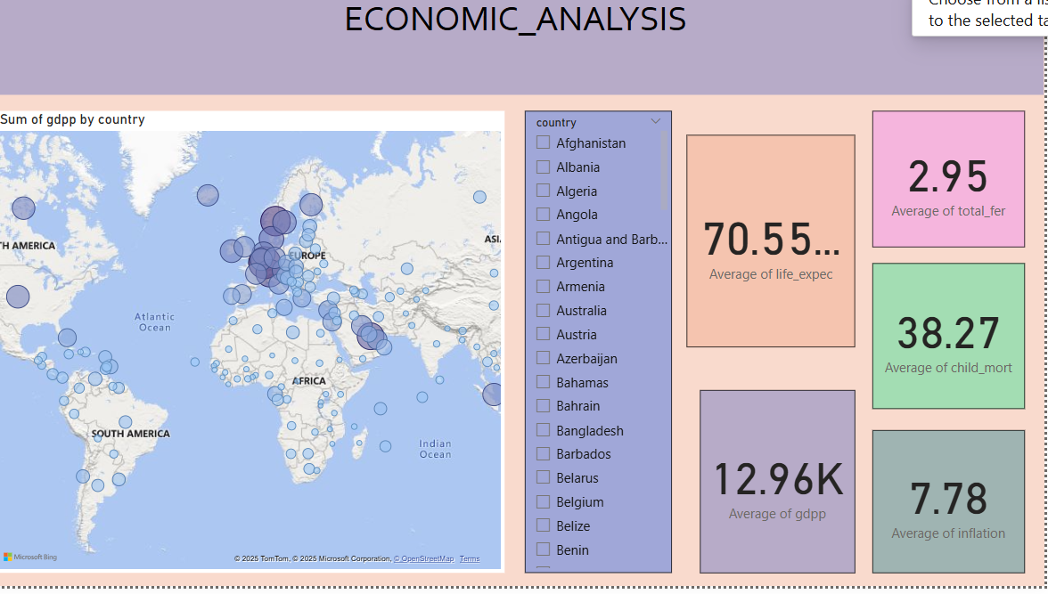

For showing the global economic distribution in a single glance use map visualization..In data mapping drag country to the location and GDP to bubble size..for better understanding use darker color for higher GDP.

Take slicer and add country that allows selecting a specific country.Take card visuals and add average GDP,average,life expectancy,average child mortality,average inflation rate, and average fertility rate….

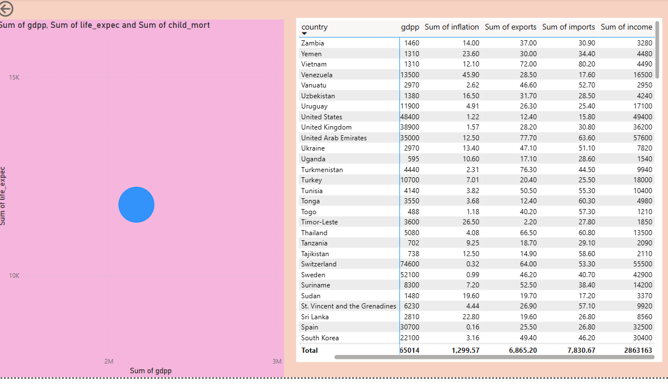

Creating a scatter chart for GDP vs life expectancy.Drag GDP per capita to x axis ,life expectancy to y axis and drag child mortality to bubble size..It shows higher GDP leads to longer life expectancy

For correlation analysis take matrix visual drag country to rows,drag GDP per capita,inflation,life expectancy,exports,imports to values….It helps to analyze the impact of economic factors.

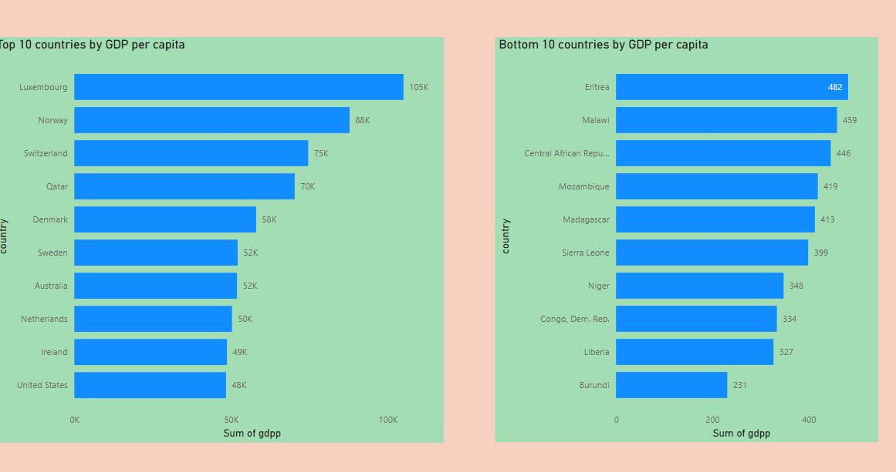

Creating a bar chart for country comparison .Drag country to axis and drag GDP per capita to values . sort in descending order to show the top 10 richest countries . duplicate the chart and sort in ascending order to show bottom 10 countries.

OBSERVATIONS:

1. Trade Insights (Exports & Imports):

* Highest Exports: Singapore with 200 billion USD.
* Highest Imports: Singapore with 174 billion USD.
* Lowest Exports: Myanmar with 0.11 billion USD.
* Lowest Imports: Myanmar with 0.07 billion USD.

2. Inflation Trends:

* + Highest Inflation Rate: Nigeria at 104% , indicating severe economic instability.
  + Lowest Inflation Rate: Ireland at -3.22% , suggesting deflationary trends.

3. Income Distribution:

* Highest Average Income: Qatar at 125,000 USD per capita.
* Lowest Average Income: Burundi at 764 USD per capita.

4. GDP Comparison:

Highest GDP Per Capita: Luxembourg at 105,000 USD, reflecting a strong and wealthy economy.

* Lowest GDP Per Capita: Burundi at 231 USD, highlighting economic challenges.

CONCLUSION:

This analysis highlights how economic strength and healthcare outcomes are interlinked .countries with strong economics tend to provide better healthcare, lower child mortality, and higher life expectancy .However economic growth alone is not enough government must invest in education, healthcare, and social infrastructure to ensure sustainable development.

By implementing strong trade policies, controlling inflation, and investing in public services , emerging economics can transition into sustainable ,high income nations