Matched Orders:

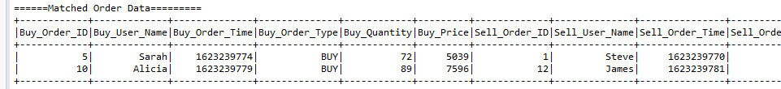

Un-Matched Orders:

