NAME : L.Naga Malli Karjun

Reg No : 192211444

Subject : software Engineering

Course code: CSA1024

Facutly : Arul Raj.A.M

|  |  |  |
| --- | --- | --- |
| S.NO | LIST OF EXPERIMENTS | PG.NO. |
| 1. | Draw a USE-CASE diagram for Online Voting System using CASE tool |  |
| 2. | Draw a USE-CASE diagram for Library Management System using CASE tools. |  |
| 3. | Draw and validate the flowchart to compute the quotient and remainder |  |
| 4. | Draw a USE-CASE diagram for Online Shopping system using CASE tools. |  |
| 5. | Draw a USE-CASE diagram for Online Railway Reservation System using CASE tools. |  |
| 6. | Draw a USE-CASE diagram for Hospital Management System using CASE tools. |  |
| 7. | Draw a USE-CASE diagram for ATM System using CASE tools. |  |
| 8. | Draw a USE-CASE diagram for Online college management System using CASE tools |  |
| 9. | Draw a USE-CASE diagram for Online Airline Reservation System using CASE tools. |  |
| 10. | Draw a Class diagram for Online Airline Reservation System using CASE tools. |  |
| 11. | Draw a Class diagram for Online Voting System using CASE tools |  |
| 12. | Draw a Class diagram for Library Management System using CASE tools. |  |
| 13. | Draw a Class diagram for Online Shopping system using CASE tools. |  |

|  |
| --- |
|  |

|  |  |  |
| --- | --- | --- |
| 14. | Draw a Class diagram for Online Railway Reservation System using CASE tools. |  |
| 15. | Draw a Activity diagram for Online Voting System using CASE tools. |  |
| 16. | Draw a Activity diagram for Library Management System using CASE tools. |  |
| 17. | Draw a Activity diagram for Online Shopping system using CASE tools. |  |
| 18. | Draw a Activity diagram for Online Railway Reservation System using CASE tools. |  |
| 19. | Draw a Activity diagram for Hospital Management System using CASE tools. |  |
| 20. | Using Raptor- Draw the flowchart to check whether the given number is a palindrome or not. |  |
| 21. | Using Raptor- Draw and validate the flowchart to calculate Fibonacci series. |  |
| 22. | Using Raptor – Draw and validate the flowchart to swap two characters. |  |
| 23. | Using Raptor – Draw the flowchart to display the length of the string. |  |
| 24. | Using Raptor – Draw the flowchart to find whether the given number is prime or not. |  |
| 25. | Find Complexity for a graph having number of edges as 12, number of nodes as 13 and number of predicate nodes in the flow graph as 5. |  |

**EXERCISE 1:ONLINE VOTING**

**AIM :**

The main aim of this project work is use-case diagram of online voting system.

**Objective:**

1. Each voter will be able to vote only once
2. Nobody will have access to the votes before the official opening of the electronic ballot box.
3. The votes cast cannot be intercepted, modified or diverted.
4. The on-line site will resist any attack
5. Only registered voters will have access to the application
6. Voters will be protected against any attempt of identified theft.
7. The secrecy of the vote will be guaranteed
8. The rigging of the election will be controlled
9. The system will not accept vote outside the voting period
10. It put to an end the indiscriminate alteration of the election result by any officer of the electoral commission of Enugu

**Procedure :**

The board of the KDE e.V. assigns one or more voting administrators which are responsible for technically performing the voting. This includes sending out the ballots, receiving the votes, calculating and publishing the results.

The voting administrators must not disclose any information about the identity of the voters or any other information which isn’t contained in the published voting results.

An online voting is initiated by a voting proposal followed by a discussion period. After the discussion period the voting period is started. The voting is finished by calculating and publishing the voting results.

Results of online votes are effective immediately following publication of the results unless otherwise stated in the voting proposal.

Output:

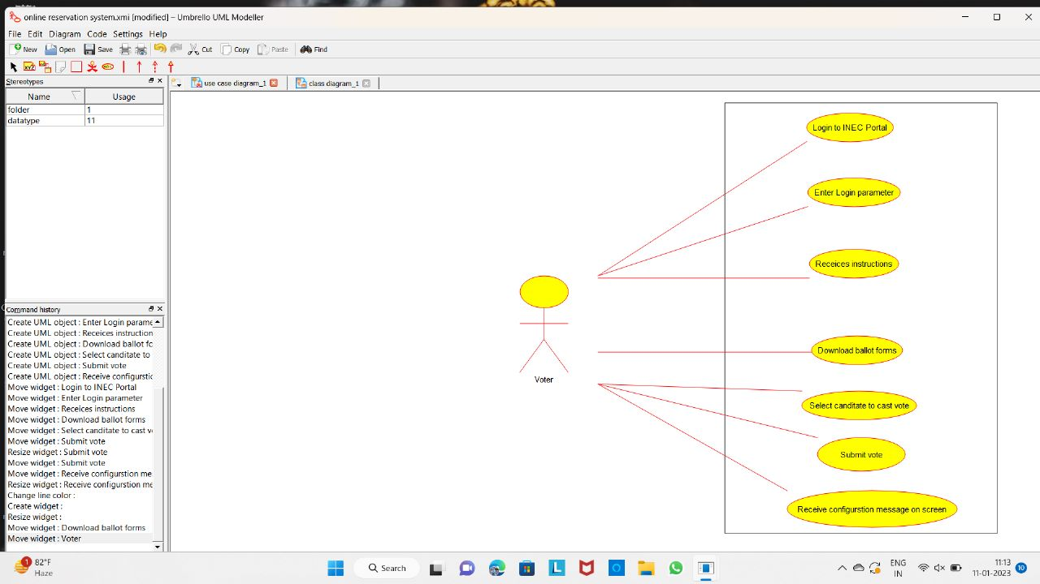

RESULT:

Thus, with this software (umbrella) the use case diagram for online voting system is implemented.

**EXERCISE 2: LIBRARY MANAGEMENT SYSTEM.**

**AIM:**

The main aim of the project is to identify the Library management system by using use case .

**Objective:**

library management system is software that is designed to manage all the functions of a library. It helps librarian to maintain the database of new books and the books that are borrowed by members along with their due dates.

This system completely automates all your library’s activities. The best way to maintain, organize, and handle countless books systematically is to implement a library management system software

.A library management system is used to maintain library records. It tracks the records of the number of books in the library, how many books are issued, or how many books have been returned or renewed or late fine charges, etc .You can find books in an instant, issue/reissue books quickly, and manage all the data efficiently and orderly using this system. The purpose of a library management system is to provide instant and accurate data regarding any type of book, thereby saving a lot of time and effort.

**Procedure :**

Library management systems are designed to manage the movement of books and maintain records of the members in a library. The software solution is designed based on the system requirements, the people involved, the content of the operation and the activity to be performed.

The system requirement in library management focuses on the possibility of search for books by title, author or subject by the member. They should be able to locate a book physically by the unique identification code and the rack number for each book.

The system should provide details on the books held by the members. The system should limit the number of books that can be taken and the number of days that a book can be kept for. The system should generate fines when due from the member.

The next step focuses on the functions of the librarian, the member and the system. Managing books by the librarian, searching for books by the members and notifications sent by the system are detailed in a case diagram. The third step in the design of the library management system software is based on the different aspects of a library.

The name of the library, the book details, member details, membership cards, book reservations, book lending, cataloging, fines, book racks and notifications are consolidated as a class diagram.

Output:

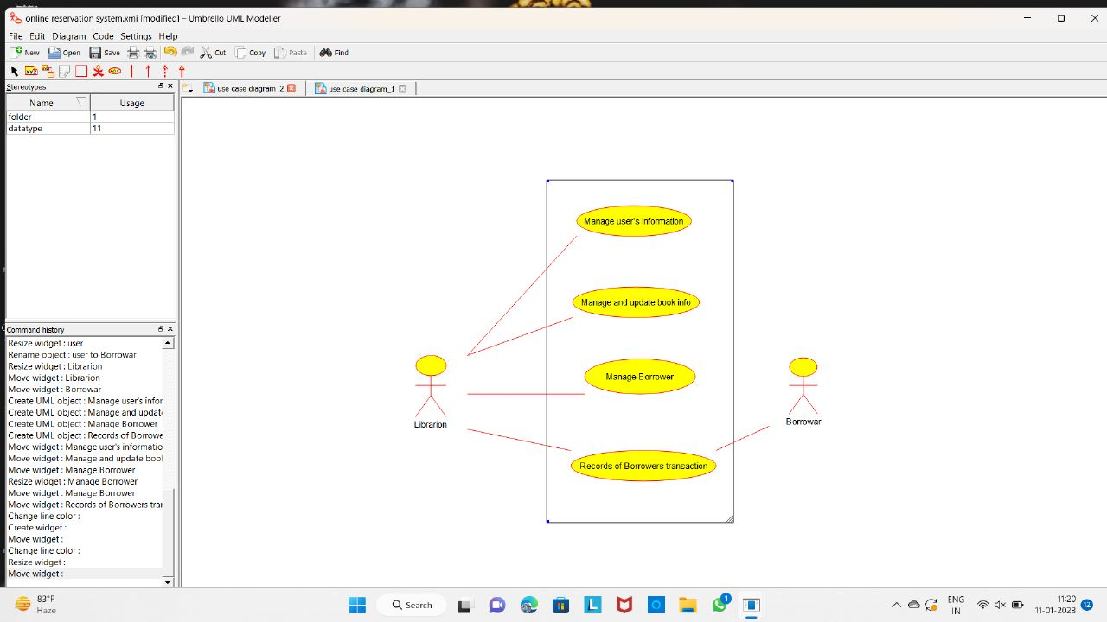

RESULT:

Thus ,with this umbrella soft the use case diagram for library management system is implemented.

**EXERCISE 4: ONLINE SHOPPING SYSTEM**

**AIM:**

The main aim of the project is use case diagram of the online shopping system.

**OBJECTIVE:**

If you plan to establish an online presence for your business or company and create the first web page, you have to consider the objectives and the main purpose of your new website. Every element and detail of your page should mirror the objectives. Not following this rule may result in a hard to manage web page that could finally turn to be useless. You have to establish a clear match between the objectives and construction elements and adopt a flexible structure for the new website in order to cope with further technical changes and corporate requirements.

1. Promoting a service or product online.

2. Selling a service or product.

3. Providing product support or customer service.

4. Providing corporate information.

5. Establishing brand awareness and corporate identity.

**Procedure:**

A high end solution can be bought or rented as a standalone program or as an addition to an enterprise resource planning program. It is usually installed on the company’s own webserver and may integrate into the existing supply chain so that ordering, payment, delivery, accounting and warehousing can be automated to a large extent.

Other solutions allow the user to register and create an online shop on a portal that hosts multiple shops at the same time.

Open source shopping cart packages include advanced platforms such as Interchange, and off the shelf solutions as Avactis, Satchmo, os Commerce.

Magento, Zen Cart, Virtue Mart, Batavi and Presta Shop Commercial systems can also be tailored to ones needs so that the shop does not have to be created from scratch. By using a framework already existing, software modules for different functionalities required by a web shop can be adapted and combined.

Output:

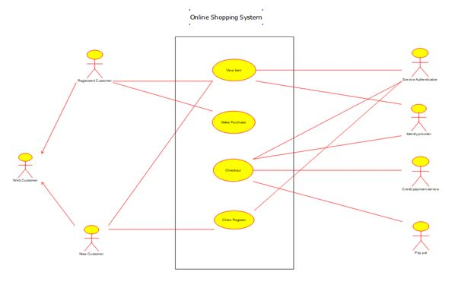

RESULT:

Thus, the use case diagram for online shopping system is implemented.

**EXERCISE 5: RAILWAY RESERVATION SYSTEM**

**AIM:**

The main aim of this project is use-case diagram of Railway reservation system.

**OBJECTIVE:**

The main objective of the Railway Reservation System is to manage the details of Train, Booking. Payment, Seat, Ticket. It manages all the information about Train, Customer, Ticket, Train. The project is totally built at administrative end and thus only the administrator is guaranteed the ac- cess. The purpose of the project is to build an application program to reduce the manual work for managing the Train, Booking, Customer, Payment. It tracks all the details about the Payment, Seat, Ticket.

**PROCEDURE:**

Provides the searching facilities based on various factors. Such as Train, Payment, Seat, Ticket. The transactions are executed in off-line mode, hence on-line data for Train, Booking capture and modification is not possible. It tracks all the information of Booking, Customer, Seat etc..,

Manage the information of Booking Shows the information and description of the Train, Payment. All the fields such as Train, Payment, Ticket are validated and does not take invalid values. It generates the report on Train, Booking . Customer Provide filter reports on Payment, Seat, Ticket.

You can easily export PDF for the Train, Customer, Seat Application also provides excel export for Booking. Payment, Ticket. You can also export the report into csv format for Train ,Booking, Ticket. To increase efficiency of managing the Train, Booking It deals with monitoring the information and transactions of Seat.

Manage the information of Train. Editing, adding and updating of Records is improved which results in proper resource management of Train data. Manage the information of Seat Integration of all records of Ticket.

**OUTPUT:**

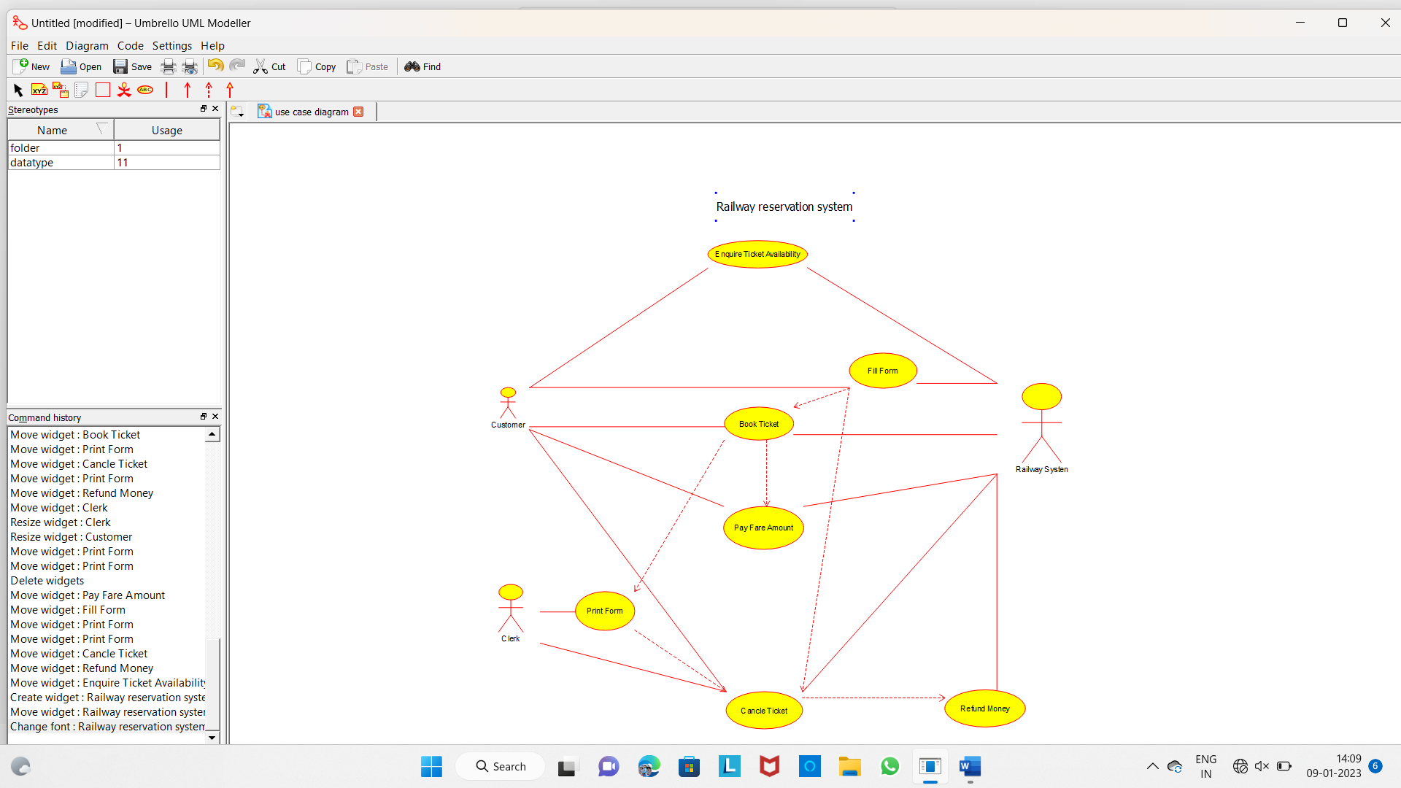

**RESULT:**

Thus, the use case diagram for online railway reservation system is implemented.

**EXERCISE 6: HOSPITAL MANAGEMENT SYSTEM.**

**AIM:**

The main aim of the project is use-case of the Hospital management system.

**OBJECTIVE:**

The effective distribution of resources is vital to good care and the overall well-being of the organization. A well-managed workload and efficient budgeting, in particular, allow for optimal planning of hospital performance.

Subject-based alternatives due software with extensive scheduling capabilities can also improve doctor-patient communication. In addition, it is possible to keep track of clinical, patient, and financial data if all records and transactions are preserved in the system.

**PROCEDURE:**

The project Hospital Management system includes registration of patients, storing their details into the system, and also computerized billing in the pharmacy, and labs. The software has the facility to give a unique id for every patient and stores the details of every patient and the staff automatically.

It includes a search facility to know the current status of each room. Users can search the availability of a doctor and the details of a patient using the id. The Hospital Management System can be entered using a username and password. It is accessible either by an administrator or receptionist. Only they can add data into the database. The data can be retrieved easily.

The interface is very user-friendly. The data are well protected for personal use and make the data processing very fast. Hospital Management System is powerful, flexible, and easy to use and is designed and developed to deliver real conceivable benefits to hospitals. Hospital Management System is designed for multispeciality hospitals, to cover a wide range of hospital administration and management processes.

It is an integrated end-to-end Hospital Management System that provides relevant information across the hospital to support effective decision-making for patient care, hospital administration, and critical financial accounting, in a seamless flow. Hospital Management System is a software

product suite designed to improve the quality and management of hospital management in the areas of clinical process analysis and activity-based costing. Hospital Management System enables you to develop your organization and improve its effectiveness and quality of work. Managing the key processes efficiently is critical to the success of the hospital helps you manage your processes.

**OUTPUT:**

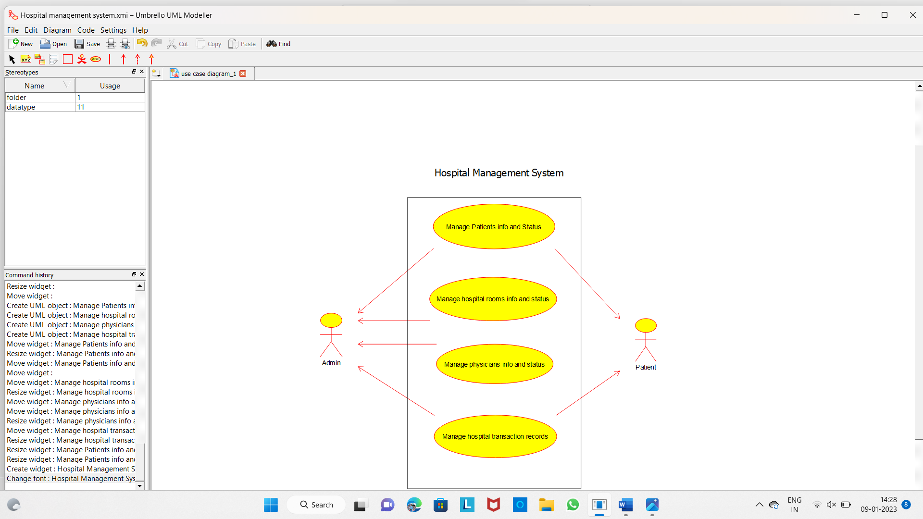

**RESULT:**

Thus , the use case diagram for hospital mangement system is implenmented.

**EXERCISE 7: ATM SYSTEM.**

**AIM:**

The main aim of the project is use-case of the ATM System.

**OBJECTIVE:**

ATMs have changed the face of banking, allowing customers of financial institutions to perform financial transactions 24/7, such as cash withdrawals, account information queries, deposits, fund transfers.

Since the first ATM was put in use in the 1960s, ATMs have gone a long way. Today they offer advanced functions, and go way beyond simple cash machines. We even see more and more Bitcoin ATMs and digital currency machines installed all over the United States and in countries around the globe. In addition to being available anytime, customers can access those ATM services almost everywhere, with around 3 million units currently in use for Financial Institutions, keeping their AT, network activity balanced is a challenge.

**PROCEDURE:**

Banks place ATMs inside and outside of their branches. Other ATMs are located in high-traffic areas such as shopping center , grocery stores, convenience stores, airports, bus and railway stations, gas stations, casinos, restaurants, and other locations. Most ATMs that are found in banks are multifunctional, while others that are off-site tend to be primarily or entirely designed for cash withdrawals.

ATMs require consumers to use a plastic card—either a bank debit card or a credit card—to complete a transaction. Consumers are authenticated by a PIN before any transaction can be made.

**OUTPUT:**

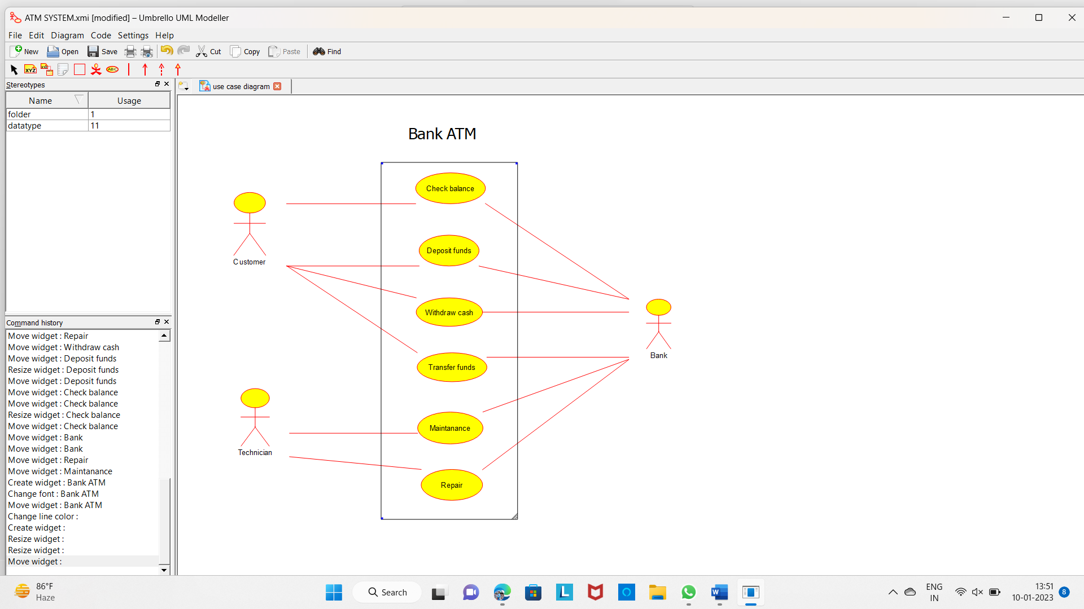

**RESULT:**

**Thus , the use – case diagram for ATM system is implemented.**

**EXERCISE 8 : ONLINE COLLEGE MANAGEMENT SYSTEM**

**AIM:**

The main aim of the project is use-case of college management system.

**Objective:**

The College Management System is the ultimate solution to digitize and streamline the day-to-day operations of colleges and universities. From student enrolment system to admission management and online classes management to finance management and human resource management, as well as every other process of college operations. It also digitizes routine work of the campus such as student attendance management system, student record management system, student profile management system, student record keeping system, student mark management system, student fee management, and other small and big operations.

**PROCEDURE:**

A college management system is a cloud based educational ERP software that enables HEIs to manage online admission & fees, students’ attendance, library books, etc. It can also generate students’ performance reports & simplify the hassles of faculty.

Master Soft College Management System is an end-to-end solution for colleges to improve operational efficiency & institutional outcomes by automating Student-Faculty lifecycle & campus administration. This college ERP software is designed keeping in mind the different operations of a college.

Master Soft's College ERP has 25+ pro modules and 30+ inbuilt modules. It helps educators to streamline all the core activities with biometrics, BI tools, and an analytics dashboard that generates precise reports on college admission, scholarship, compliance management, etc.

The College Management System is the ultimate solution to digitize and streamline the day-to-day operations of colleges and universities. From student enrolment system to admission management and online classes management to finance management and human resource management, as well as every other process of college operations. It also digitizes routine work of the campus such as student attendance management system, student

record management system, student profile management system, student record keeping system, student mark management system, student fee management, and other small and big operations.

**OUTPUT:**

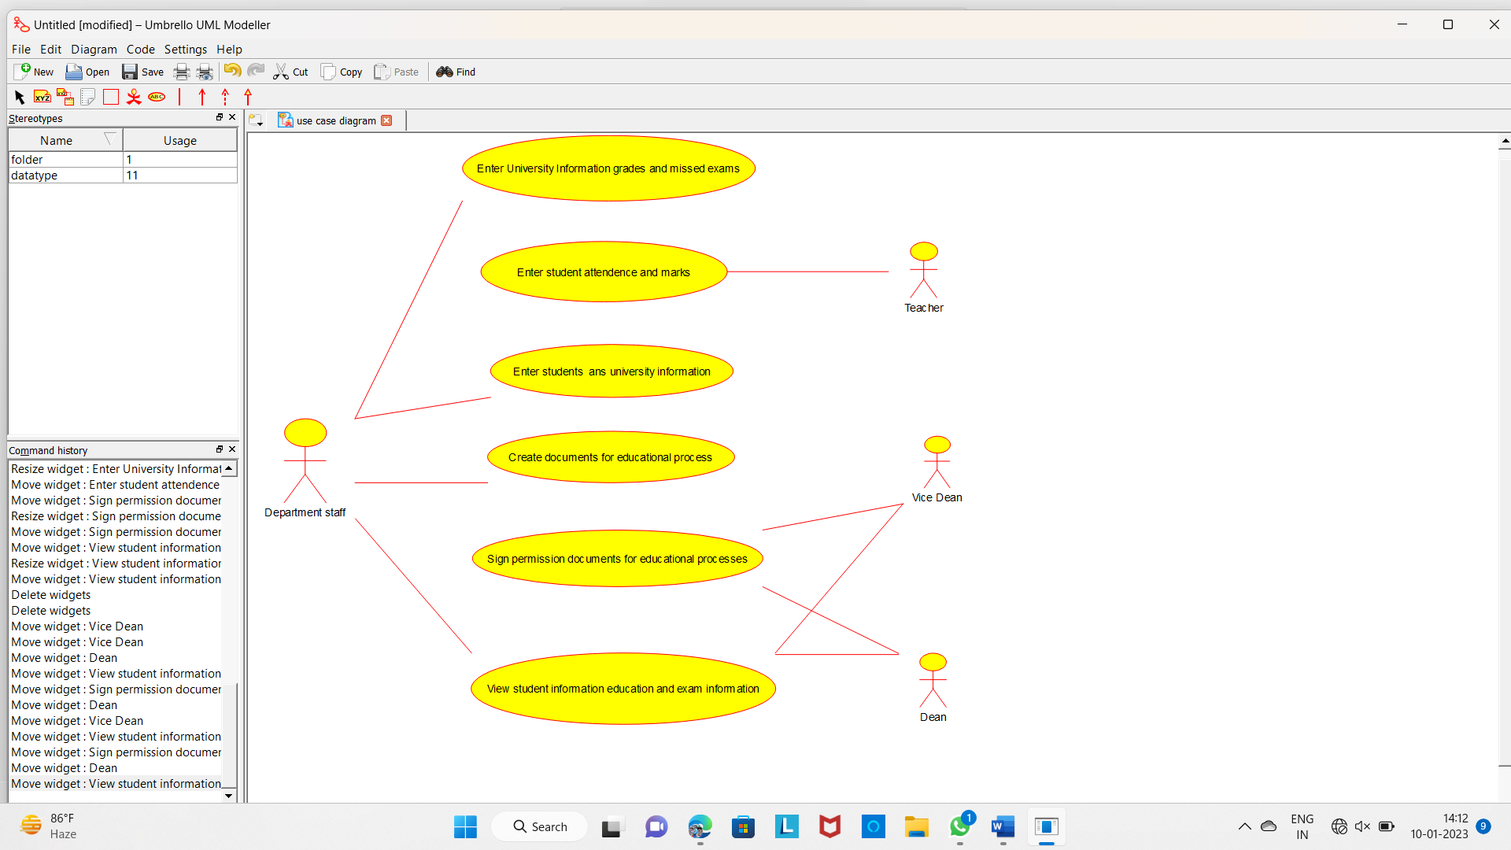

**RESULT:**

Thus, the use case diagram for online college management system is implemented.

**EXERCISE 9: ONLINE AIRLINE RESERVATION SYSTEM.**

**AIM:**

The main aim of the project is use-case diagram of online reservation system.

**OBJECTIVE:**

The College Management System is the ultimate solution to digitize and streamline the day-to-day operations of colleges and universities. From student enrolment system to admission management and online classes management to finance management and human resource management, as well as every other process of college operations. It also digitizes routine work of the campus such as student attendance management system, student record management system, student profile management system, student record keeping system, student mark management system.

**PROCEDURE:**

With some basics covered, let’s closely look at what happens between the moment of reservation via a travel platform and baggage reclaim at the destination airport. The whole process of this traveler/airline interaction can be divided into several major steps:

1.flight search,

2.flight booking,

3.ancillary booking,

4.using frequent flyer miles and points,

5.payment processing,

6.ticketing,

7.check-in and boarding, and

8.baggage handling and reclaim.

Booking flight tickets is a breeze, but only if you know how. Getting your hands on the best – read cheapest – tickets may be a task, given the huge number of options you have for ticketing. Everyone from travel agents to online websites and airlines want in on the game, leaving you completely muddled. It’s Skyscanner to the rescue! Skyscanner is a flight ticket aggregator – a website that gets multiple agents and websites on to one platform and sorts the tickets they offer according to your preference – all for your booking convenience. Try it out!

Pack right, and light. After you are done figuring out what all you may need at your destination – weather wise – it would do well to check how much weight your airline allows you to carry without charging extra. All airlines have different rules for domestic and international routes, so check your ticket for the maximum allowance and stay within it. Check the airline website for articles not allowed on a flight. There is a list of things that can be packed in your check-in baggage but not in your hand baggage – make sure to follow that list.

**OUTPUT:**

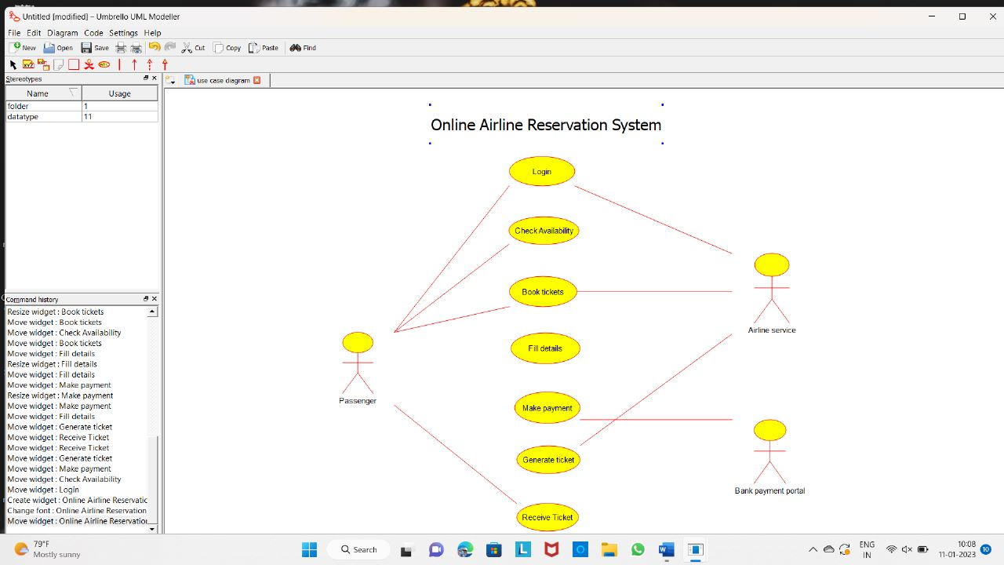

**RESULT:**

THUS , the use case diagram for online airline reservation system.

**EXERCISE 10 . ONLINE AIRLINE RESERVATION SYSTEM**

**AIM:**

The main aim of the project is class diagram of online reservation system.

**OBJECTIVE**:

Airline computerized reservation systems (CRS) are the primary form of travel agency computerization in the world. These systems manage the millions of reservation requests and cancellations, fare, and reservation pricing requests1 that are initiated by travel agencies using these systems—not to mention the thousands of database changes that occur daily. The CRS function as extremely powerful and valuable distribution and marketing tools for their airline owners.

**PROCEDURE:**

➢ For drawing a class diagram for Online college Airline reservation system, we have to download umbrella software for PC.

➢ After downloading the software install it in your PC and open it.

➢ Now just above the top of the work space an icon is there which contains several types of diagrams from that class.

➢ Your required tools displayed on top left of the screen (select, note, Anchor, Label, box, class, interface, datatype, Enum, package, association, Directional association, Dependency, implements, composition, aggregation and containment.)

➢ For drawing use case diagram for Online Airline reservation system search a suitable diagram from google for reference and draw the diagram in the work space as shown in google with the help of tools.

➢ After drawing the class diagram save it and take a screen shot of the diagram.

➢ Go to paint app in your PC and paste the image you captured and select only the image, copy it.

➢ Now open word document and paste it under related experiment.

**OUTPUT**:

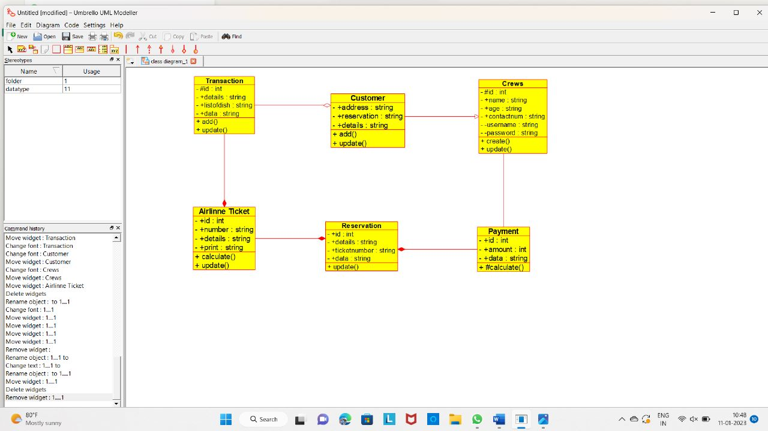

**RESULT:**

Thus, the class diagram for online reservation system is implemented.

**EXERCISE 11.ONLINE VOTING SYSTEM.**

**AIM:**

The main aim of the project is class diagram of Online voting system.

**OBJECTIVE:**

As an alternative for is easy voting system, where rigging of votes, insecurity etc. are usual which can be eliminated. At the same time, this new voting system is electoral voting System is easy to use, both for the official and people concerned. This type of voting system can completely eradicate all kinds of fraudulent activities especially casting votes from Same id more than once We are implementing the electronic voting system with the help of python. Python is commonly used for developing websites and software task automation, data analysis and data visualization The main advantage of system is that it can be easily adopted by many non-programs as Such as accountants and scientists

**PROCEDURE:**

* For drawing a class diagram for Online college voting system, we have to download umbrella software for PC.
* After downloading the software install it in your PC and open it.
* Now just above the top of the work space an icon is there which contains several types of diagrams from that class.
* Your required tools displayed on top left of the screen (select, note, Anchor, Label, box, class, interface, datatype, Enum, package, association, Directional association, Dependency, implements, composition, aggregation and containment.)
* For drawing use case diagram for Online voting system search a suitable diagram from google for reference and draw the diagram in the work space as shown in google with the help of tools.
* After drawing the class diagram save it and take a screen shot of the diagram.
* Go to paint app in your PC and paste the image you captured and select only the image, copy it.
* Now open word document and paste it under related experiment.

**OUTPUT:**

**CLASS DIAGRAM FOR ONLINE VOTING SYSTEM**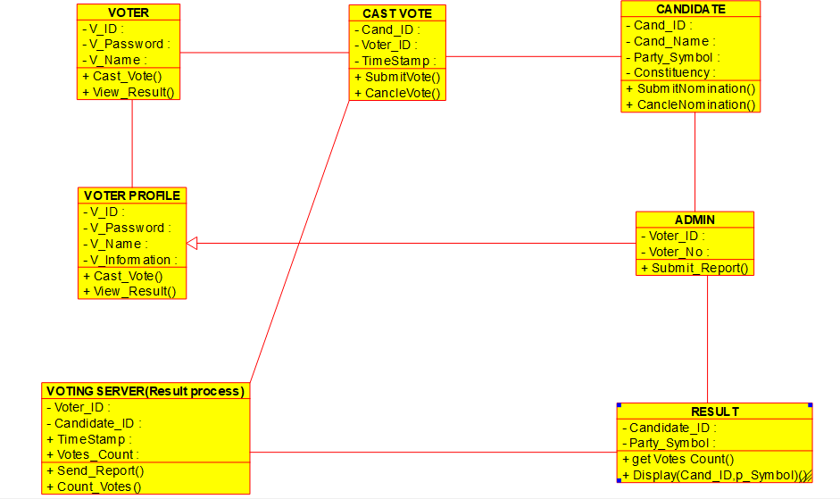

**RESULT:**

Thus, class diagram for Online voting system is implemented successfully.

**EXERCISE 12. LIBRARY MANAGEMENT SYSTEM**

**AIM:**

The main aim of the project is class diagram of Library system.

**OBJECTIVE:**

With the advancement of technology, it is imperative to exalt all the systems into a user-friendly manner. The Library Management system (LMS) acts as a tool to transform traditional libraries into digital libraries. In traditional libraries, the students/user has to search for books which are hassle process and there is no proper maintenance of database about issues/fines. The overall progress of work is slow and it is impossible to generate a fast report. The librarians have to work allotted for arranging, sorting books in the book sells. At the same time, they have to check and monitor the lend/borrow book details with its fine. It is a tedious process to work simultaneously in different sectors.

**PROCEDURE:**

* For drawing a class diagram for Library management system, we have to download umbrella software for PC.
* After downloading the software install it in your PC and open it.
* Now just above the top of the work space an icon is there which contains several types of diagrams from that class.
* Your required tools displayed on top left of the screen (select, note, Anchor, Label, box, class, interface, datatype, Enum, package, association, Directional association, Dependency, implements, composition, aggregation and containment.)
* For drawing use case diagram for Library management system search a suitable diagram from google for reference and draw the diagram in the work space as shown in google with the help of tools.
* After drawing the class diagram save it and take a screen shot of the diagram.
* Go to paint app in your PC and paste the image you captured and select only the image, copy it.
* Now open word document and paste it under related experiment.

**Output:**

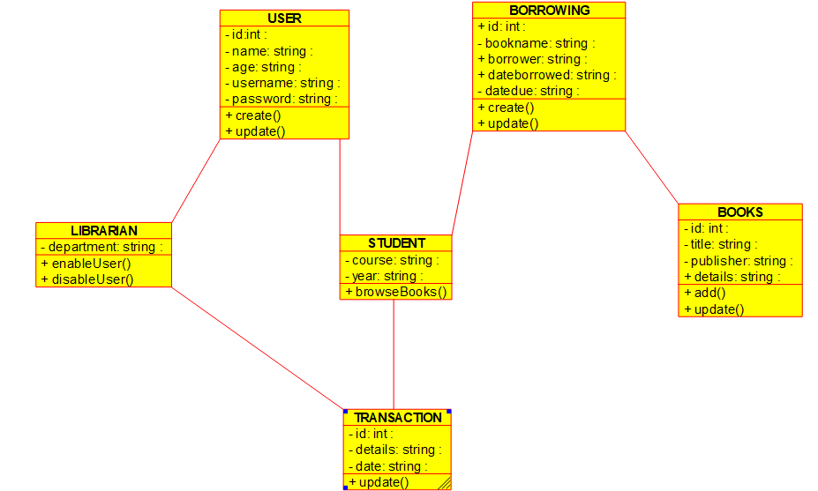

**RESULT:**

Thus, class diagram for Library management system is implemented successfully.

**EXERCISE:13 ONLINE SHOPPING SYSTEM.**

**AIM:**

The main aim of the project is class diagram of Online shopping system.

**OBJECTIVE:**

Now a days the life style of the people is different. People feel uncomfortable and time consuming for going crowded markets. So, E-Shopping is a boon as it saves lot of time. Online shopping is a process whereby consumers directly buy goods, services etc. from a seller without an intermediary service over the Internet. Shoppers can visit web stores from the comfort of their house and shop as by sitting in front of the computer. Online stores are usually available 24 hours a day and many consumers have internet access both at work and at home. So, it is very convenient for them to shop Online.

**PROCEDURE:**

* For drawing a class diagram for online shopping system, we have to download umbrella software for PC.
* After downloading the software install it in your PC and open it.
* Now just above the top of the work space an icon is there which contains several types of diagrams from that class.
* Your required tools displayed on top left of the screen (select, note, Anchor, Label, box, class, interface, datatype, Enum, package, association, Directional association, Dependency, implements, composition, aggregation and containment.)
* For drawing use case diagram for online shopping system search a suitable diagram from google for reference and draw the diagram in the work space as shown in google with the help of tools.
* After drawing the class diagram save it and take a screen shot of the diagram.
* Go to paint app in your PC and paste the image you captured and select only the image, copy it.
* Now open word document and paste it under related experiment.

**OUTPUT:**

CLASS DIAGRAM FOR ONLINE SHOPPING SYSTEM.

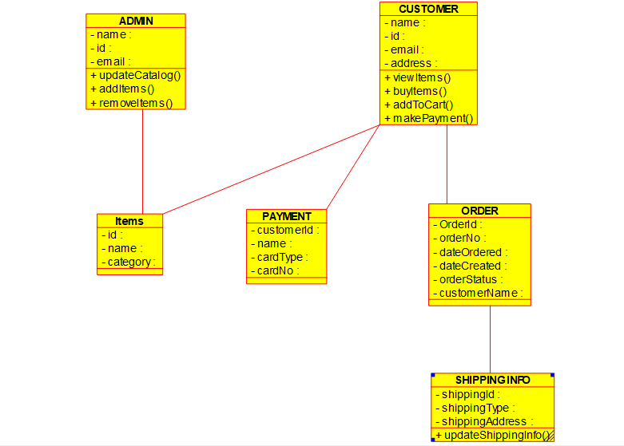

**RESULT:**

Thus, class diagram for Online shopping system is implemented successfully.

**EXERCISE 14. ONLINE RAILWAY RESERVATION**

**SYSTEM.**

**AIM:**

The main aim of the project is class diagram of Online Railway reservation system.

**OBJECTIVE:**

In Current Railway Ticket Booking System Project User faces various difficulties while booking their tickets by visiting to the reservation counter or by visiting to the agents. Railway Ticket Booking System Project will save customers time and money as well. User will get the facility of making their payments of their choice and get entire information after reservations and many more of the login screen. Finding trains between given routes through simple search query on particular date and displaying all details of that particular train such as arrival time, departure time, number of seats available, class type, charges details and many more. Users will also able to update their profiles and can get details related to their transactions.

**PROCEDURE:**

* For drawing a class diagram for online Railway reservation system, we have to download umbrella software for PC.
* After downloading the software install it in your PC and open it.
* Now just above the top of the work space an icon is there which contains several types of diagrams from that class.
* Your required tools displayed on top left of the screen (select, note, Anchor, Label, box, class, interface, datatype, Enum, package, association, Directional association, Dependency, implements, composition, aggregation and containment.)
* For drawing use case diagram for online Railway reservation system search a suitable diagram from google for reference and draw the diagram in the work space as shown in google with the help of tools.
* After drawing the class diagram save it and take a screen shot of the diagram.
* Go to paint app in your PC and paste the image you captured and select only the image, copy it.
* Now open word document and paste it under related experiment.
* **OUTPUT:**
* CLASS DIAGRAM FOR ONLINE RAILWAY RESERVATION SYSTEM.
* 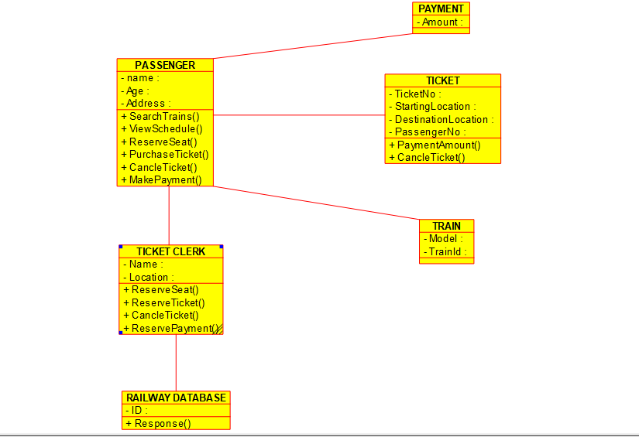
* **RESULT:**
* Thus, class diagram for Online Railway reservation system is implemented successfully.

**EXERCISE 15. ONLINE VOTING SYSTEM.**

**AIM:**

The main aim of the project is activity diagram of Online voting system.

**PROCEDURE:**

As an alternative for is easy voting system, where rigging of votes, insecurity etc. are usual which can be eliminated. At the same time, this new voting system is electoral voting System is easy to use, both for the official and people concerned. This type of voting system can completely eradicate all kinds of fraudulent activities especially casting votes from Same id more than once We are implementing the electronic voting system with the help of python.

**PROCEDURE:**

* For drawing a Activity diagram for online Voting system, we have to download umbrella software for PC.
* After downloading the software install it in your PC and open it.
* Now just above the top of the work space an icon is there which contains several types of diagrams from that class.
* Your required tools displayed on top left of the screen (select, note, anchor, label, box, initial activity, activity, end activity, final activity, branch/merge, fork/join, activity transition, exception, pre/post condition, send signal, accept signal, accept time event, region, pin and object node).
* For drawing activity diagram for online voting system search a suitable diagram from google for reference and draw the diagram in the work space as shown in google with the help of tools.
* After drawing the activity diagram save it and take a screen shot of the diagram.
* Go to paint app in your PC and paste the image you captured and select only the image, copy it.
* Now open word document and paste it under related experiment.

**OUTPUT:**

ACTIVITY DIAGRAM FOR ONLINE VOTING SYSTEM.

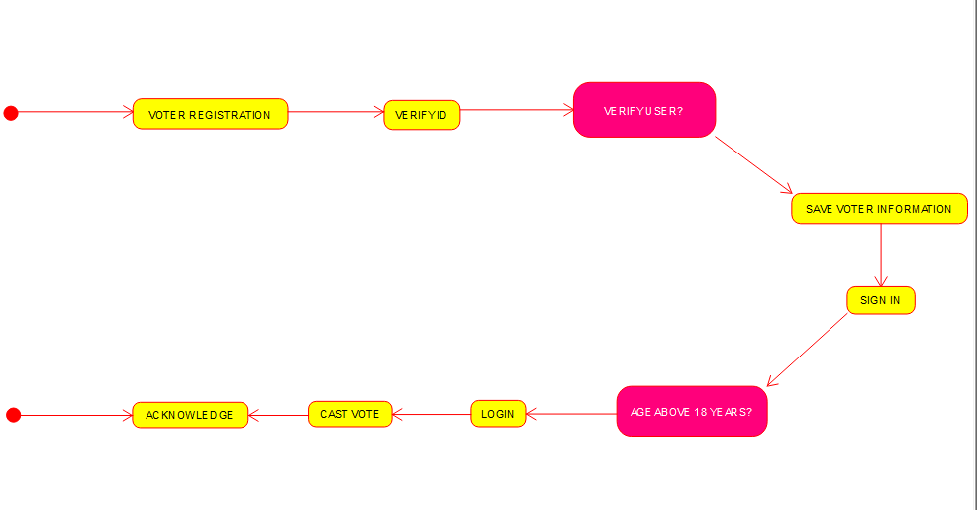

RESULT:

Thus, Activity diagram for Online voting system is implemented successfully.

**EXERCISE 16. LIBRARY MANAGE SYSTEM.**

**AIM:**

The main aim of the project is activity diagram of Library management system.

**OBJECTIVE:**

With the advancement of technology, it is imperative to exalt all the systems into a user-friendly manner. The Library Management system (LMS) acts as a tool to transform traditional libraries into digital libraries. In traditional libraries, the students/user has to search for books which are hassle process and there is no proper maintenance of database about issues/fines. The overall progress of work is slow and it is impossible to generate a fast report. The librarians have to work allotted for arranging, sorting books in the book sells. At the same time, they have to check and monitor the lend/borrow book details with its fine. It is a tedious process to work simultaneously in different sectors.

**PROCEDURE:**

* For drawing a Activity diagram for online library management system, we have to download umbrella software for PC.
* After downloading the software install it in your PC and open it.
* Now just above the top of the work space an icon is there which contains several types of diagrams from that class.
* Your required tools displayed on top left of the screen (select, note, anchor, label, box, initial activity, activity, end activity, final activity, branch/merge, fork/join, activity transition, exception, pre/post condition, send signal, accept signal, accept time event, region, pin and object node).
* For drawing activity diagram for library management system search a suitable diagram from google for reference and draw the diagram in the work space as shown in google with the help of tools.
* After drawing the activity diagram save it and take a screen shot of the diagram.
* Go to paint app in your PC and paste the image you captured and select only the image, copy it.
* **OUTPUT:**
* ACTIVITY DIAGRAM FOR LIBRARY MANAGEMENT SYSTEM.
* 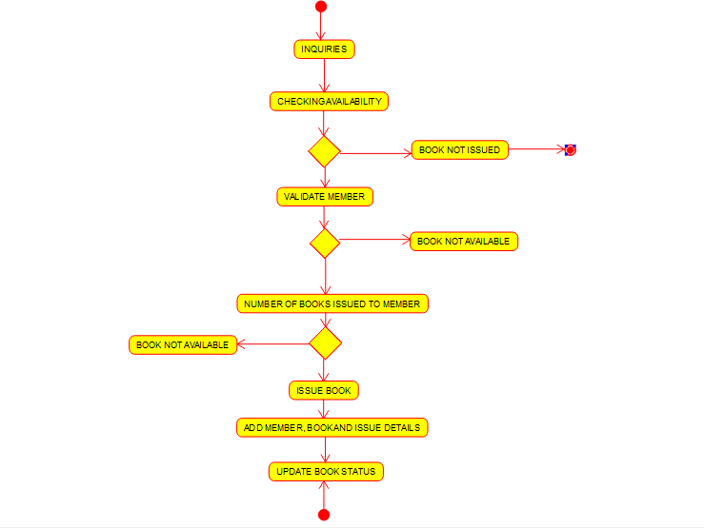
* RESULT:
* Thus, Activity diagram for Library management system is implemented successfully.

**EXERCISE 17. ONLINE SHOPPING SYSTEM.**

**AIM:**

The main aim of the project is activity diagram of Library management system.

**OBJECTIVE:**

Now a days the life style of the people is different. People feel uncomfortable and time consuming for going crowded markets. So, E-Shopping is a boon as it saves lot of time. Online shopping is a process whereby consumers directly buy goods, services etc. from a seller without an intermediary service over the Internet. Shoppers can visit web stores from the comfort of their house and shop as by sitting in front of the computer. Online stores are usually available 24 hours a day and many consumers have internet access both at work and at home. So, it is very convenient for them to shop Online. One of the most enticing factors about online shopping, particularly during holiday season is, it alleviates the need to wait in long lines or search from a store for a particular item. Variety of goods are available in online. So, the researcher wants to know the preference of the consumers.

**PROCEDURE:**

* For drawing a Activity diagram for online shopping system, we have to download umbrella software for PC.
* After downloading the software install it in your PC and open it.
* Now just above the top of the work space an icon is there which contains several types of diagrams from that class.
* Your required tools displayed on top left of the screen (select, note, anchor, label, box, initial activity, activity, end activity, final activity, branch/merge, fork/join, activity transition, exception, pre/post condition, send signal, accept signal, accept time event, region, pin and object node).
* For drawing activity diagram for online shopping system search a suitable diagram from google for reference and draw the diagram in the work space as shown in google with the help of tools.
* After drawing the activity diagram save it and take a screen shot of the diagram.
* Go to paint app in your PC and paste the image you captured and select only the image, copy it.
* Now open word document and paste it under related experiment.

**OUTPUT:**

ACTIVITY DIAGRAM FOR ONLINE SHOPPING SYSTEM.

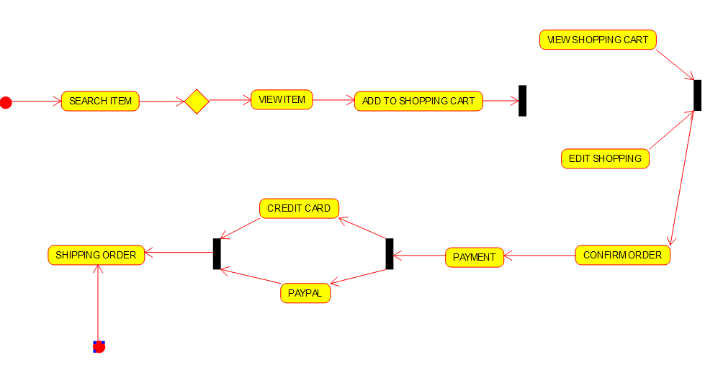

**RESULT:**

Thus, Activity diagram for Online shopping system is implemented successfully.

**EXERCISE 18. ONLINE RAILWAY REGISTRATION SYSTEM.**

**AIM:**

Activity diagram for Online Railway reservation system using case tools.

**OBJECTIVE:**

In Current Railway Ticket Booking System Project User faces various difficulties while booking their tickets by visiting to the reservation counter or by visiting to the agents. Railway Ticket Booking System Project will save customers time and money as well. User will get the facility of making their payments of their choice and get entire information after reservations and many more of the login screen. Finding trains between given routes through simple search query on particular date and displaying all details of that particular train such as arrival time, departure time, number of seats available, class type, charges details and many more. Users will also able to update their profiles and can get details related to their transactions.

**PROCEDURE:**

* For drawing a Activity diagram for online railway reservation system, we have to download umbrella software for PC.
* After downloading the software install it in your PC and open it.
* Now just above the top of the work space an icon is there which contains several types of diagrams from that class.
* Your required tools displayed on top left of the screen (select, note, anchor, label, box, initial activity, activity, end activity, final activity, branch/merge, fork/join, activity transition, exception, pre/post condition, send signal, accept signal, accept time event, region, pin and object node).
* For drawing activity diagram for online railway reservation system search a suitable diagram from google for reference and draw the diagram in the work space as shown in google with the help of tools.
* After drawing the activity diagram save it and take a screen shot of the diagram.
* Go to paint app in your PC and paste the image you captured and select only the image, copy it.
* Now open word document and paste it under related experiment.

**OUTPUT:**

ACTIVITY DIAGRAM FOR ONLINE RAILWAY RESERVATION SYSTEM.

**RESULT:**

Thus, the activity diagram for online railway reservation system is implemented successfully.

**EXPERIMENT-19 HOSPITAL MANAGEMENT SYSTEM.**

**AIM:**

Activity diagram for Hospital management system using CASE tools.

**OBJECTIVE**:

The objective of the “online hospital management system” is to simply track the knowledge of all the staff, patients, treatment provided, and prescription and also to produce periodic reports for analysis. The main goal of the software is to make a decent management tool. The main purpose of this software is to cut back the time taken through the manual system so as to take care of all the records. This project is helpful to cut back the time and quality of maintaining the records. It also helps the incorrect maintenance of patient and patient details.

**PROCEDURE:**

* For drawing a Activity diagram for Hospital management system, we have to download umbrella software for PC.
* After downloading the software install it in your PC and open it.
* Now just above the top of the work space an icon is there which contains several types of diagrams from that class.
* Your required tools displayed on top left of the screen (select, note, anchor, label, box, initial activity, activity, end activity, final activity, branch/merge, fork/join, activity transition, exception, pre/post condition, send signal, accept signal, accept time event, region, pin and object node).
* For drawing activity diagram for Hospital management system search a suitable diagram from google for reference and draw the diagram in the work space as shown in google with the help of tools.
* After drawing the activity diagram save it and take a screen shot of the diagram.
* Go to paint app in your PC and paste the image you captured and select only the image, copy it.
* Now open word document and paste it under related experiment.

**OUTPUT:**

ACTIVITY DIAGRAM FOR HOSPITAL MANAGEMENT SYSTEM.

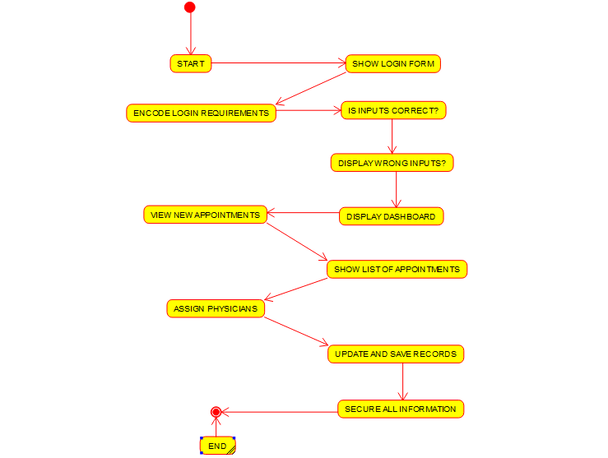

**RESULT:**

Thus, Activity diagram for Hospital management system is implemented successfully.

EXPERIMENT-20

**AIM:**

Using Raptor drawing the flowchart to check whether the given number is a palindrome or not.

**OBJECTIVE:**

The logic of a palindrome is simple, wherein **if we take a number and reverse it, it still stays the same as the original number**. For example, 10101 is a palindrome number as it is going to stay the same even if we reverse it. An integer is a palindrome if the reverse of that number is equal to the original number.

**PROCEDURE**:

* For drawing a flowchart to check whether the given number is a palindrome or not, we have to download Raptor software for PC.
* After downloading the software install it in your PC and open it.
* Your required tools displayed on top left of the screen (execute to completion, pause, stop/reset, step to next shape, test against server, toggle ink and symbols)
* Take reference from google and get flow charts of raptor diagram to check whether the given number is a palindrome or not.
* Now construct the flowchart accordingly with the help of Raptor tools.
* A RAPTOR program consists of connected symbols that represent actions to be executed.
* The arrows that connect the symbols determine the order in which the actions are performed.
* The execution of a RAPTOR program begins at the Start symbol and goes along the arrows to execute the program.
* The program stops executing when the End symbol is reached.
* After drawing the flowchart diagram save it and take a screen shot of the diagram.
* Go to paint app in your PC and paste the image you captured and select only the image, copy it.
* Now open word document and paste it under related experiment.

**OUTPUT:**

FLOWCHART TO CHECK WHEATHER A GIVEN NUMBER IS POLINDROME OR NOT USING RAPTOR.

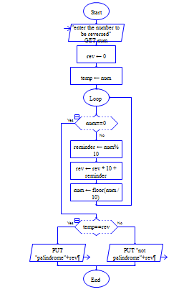

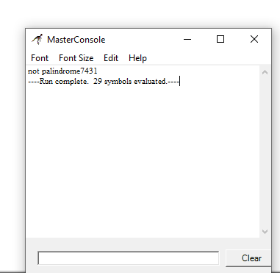

**RESULT:**

Thus, using Raptor above experiment is implemented successfully.

EXPERIMENT-21

**AIM:**

Using Raptor drawing the flowchart to calculate Fibonacci series.

**OBJECTIVE:**

A Fibonacci number is a series of numbers in which each Fibonacci number is obtained by adding the two preceding numbers. It means that the next number in the series is the addition of two previous numbers. Let the first two numbers in the series be taken as 0 and 1. By adding 0 and 1, we get the third number as 1. Then by adding the second and the third number (i.e.) 1 and 1, we get the fourth number as 2, and similarly, the process goes on. Thus, we get the Fibonacci series as 0, 1, 1, 2, 3, 5, 8, ……. Hence, the obtained series is called the Fibonacci number series.

**PROCEDURE**:

* For drawing a flowchart to calculate Fibonacci series, we have to download Raptor software for PC.
* After downloading the software install it in your PC and open it.
* Your required tools displayed on top left of the screen (execute to completion, pause, stop/reset, step to next shape, test against server, toggle ink and symbols)
* Take reference from google and get flow charts to calculate Fibonacci series.
* Now construct the flowchart accordingly with the help of Raptor tools.
* A RAPTOR program consists of connected symbols that represent actions to be executed.
* The arrows that connect the symbols determine the order in which the actions are performed.
* The execution of a RAPTOR program begins at the Start symbol and goes along the arrows to execute the program.
* The program stops executing when the End symbol is reached.
* After drawing the flowchart diagram save it and take a screen shot of the diagram.
* Go to paint app in your PC and paste the image you captured and select only the image, copy it.
* Now open word document and paste it under related experiment

**OUTPUT**:

FLOWCHART TO CALCULATE FIBONACCI SERIES USING RAPTOR.

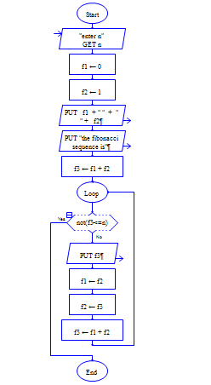

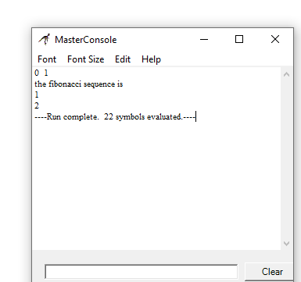

**RESULT:**

Thus, using Raptor above experiment is implemented successfully.

EXPERIMENT-22

**AIM:**

Using Raptor drawing the flowchart to swap two characters.

**OBJECTIVE:**

Swapping refers to **the exchange of two or more things**. For example, in programming data may be swapped between two variables, or things may be swapped between two people. Swapping may specifically refer to: In computer systems, an older form of memory management, similar to paging. Swapping (barter)

**PROCEDURE:**

* For drawing a flowchart to swap two numbers, we have to download Raptor software for PC.
* After downloading the software install it in your PC and open it.
* Your required tools displayed on top left of the screen (execute to completion, pause, stop/reset, step to next shape, test against server, toggle ink and symbols)
* Take reference from google and get flow charts to swap two number.
* Now construct the flowchart accordingly with the help of Raptor tools.
* A RAPTOR program consists of connected symbols that represent actions to be executed.
* The arrows that connect the symbols determine the order in which the actions are performed.
* The execution of a RAPTOR program begins at the Start symbol and goes along the arrows to execute the program.
* The program stops executing when the End symbol is reached.
* After drawing the flowchart diagram save it and take a screen shot of the diagram.
* Go to paint app in your PC and paste the image you captured and select only the image, copy it.
* Now open word document and paste it under related experiment.

**OUTPUT:**

FLOWCHART TO SWAP TWO CHARACTERS USING RAPTOR.

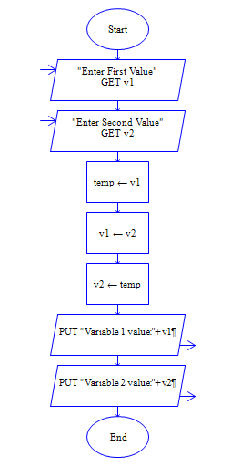

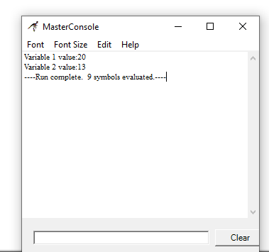

**RESULT:**

Thus, using Raptor above experiment is implemented successfully.

EXPERIMENT-23

**AIM:**

Using Raptor drawing the flowchart to display the length of the string.

**OBJECTIVE**:

The length or size of a string means **the total number of characters present in it**. For Example: The string “Geeks for Geeks” has 15 characters Declare a variable of type String. Initialize the String variable to a non-null value. Hold the value of the String length in a variable for future use.

**PROCEDURE:**

* For drawing a flowchart to display the length of the string, we have to download Raptor software for PC.
* After downloading the software install it in your PC and open it.
* Your required tools displayed on top left of the screen (execute to completion, pause, stop/reset, step to next shape, test against server, toggle ink and symbols)
* Take reference from google and get flow charts of raptor diagram to display the length of the string.
* Now construct the flowchart accordingly with the help of Raptor tools.
* A RAPTOR program consists of connected symbols that represent actions to be executed.
* The arrows that connect the symbols determine the order in which the actions are performed.
* The execution of a RAPTOR program begins at the Start symbol and goes along the arrows to execute the program.
* The program stops executing when the End symbol is reached.
* After drawing the flowchart diagram save it and take a screen shot of the diagram.
* Go to paint app in your PC and paste the image you captured and select only the image, copy it.
* Now open word document and paste it under related experiment.

.

**OUTPUT:**

FLOWCHART TO DISPLAY THE LENGTH OF THE STRING USING RAPTOR.

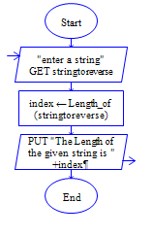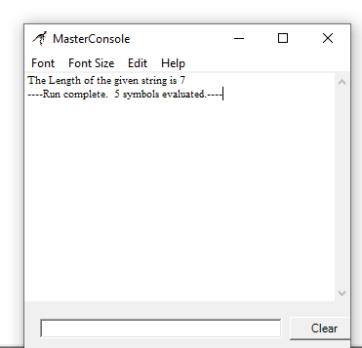

**RESULT:**

Thus, using Raptor above experiment is implemented successfully.

EXPERIMENT-24

**AIM:**

Using Raptor drawing the flowchart to find whether the given number is prime or not.

**OBJECTIVE**:

A prime number is a whole number greater than 1 whose only factors are 1 and itself. A factor is a whole number that can be divided evenly into another number. The first few prime numbers are 2, 3, 5, 7, 11, 13, 17, 19, 23 and 29. Every prime number can be written in the form of **6n + 1 or 6n – 1** (except the multiples of prime numbers, i.e., 2, 3, 5, 7, 11), where n is a natural number. **If a number has only two factors 1 and itself, then the number is prime**. Hence, by prime factorization of the given number, we can easily determine a prime number.

**PROCEDURE**:

* For drawing a flowchart to find whether the given number is prime or not, we have to download Raptor software for PC.
* After downloading the software install it in your PC and open it.
* Your required tools displayed on top left of the screen (execute to completion, pause, stop/reset, step to next shape, test against server, toggle ink and symbols)
* Take reference from google and get flow charts of raptor diagram to find whether the given number is prime or not.
* Now construct the flowchart accordingly with the help of Raptor tools.
* A RAPTOR program consists of connected symbols that represent actions to be executed.
* The arrows that connect the symbols determine the order in which the actions are performed.
* The execution of a RAPTOR program begins at the Start symbol and goes along the arrows to execute the program.
* The program stops executing when the End symbol is reached.
* After drawing the flowchart diagram save it and take a screen shot of the diagram.
* Go to paint app in your PC and paste the image you captured and select only the image, copy it.
* Now open word document and paste it under related experiment.

**OUTPUT:**

FLOWCHART TO FIND WHETHER THE GIVEN NUMBER IS PRIME OR NOT USING RAPTOR.

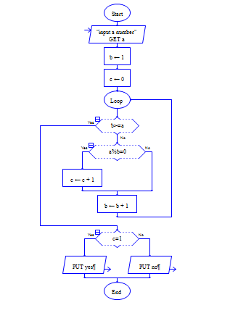

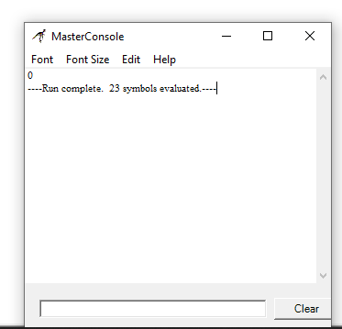

**RESULT:**

Thus, using Raptor above experiment is implemented successfully.

EXPERIMENT-25

**AIM:**

Finding Cyclomatic Complexity for a graph having number of edges as 12, number of nodes as 13 and number of predicate nodes in the flow graph as 5

**OBJECTIVE**:

The Cyclomatic complexity defines the number of independent paths in the basis set of the program that provides the upper bound for the number of tests that must be conducted to ensure that all the statements have been executed at least once.

**PROCEDURE**:

* For drawing a flowchart for the above experiment, we have to download Raptor software for PC.
* After downloading the software install it in your PC and open it.
* Your required tools displayed on top left of the screen (execute to completion, pause, stop/reset, step to next shape, test against server, toggle ink and symbols)
* Take reference from google and get flow charts of raptor diagram Find Cyclomatic Complexity for a graph having number of edges as 12, number of nodes as 13 and number of predicate nodes in the flow graph as 5.
* Now construct the flowchart accordingly with the help of Raptor tools.
* A RAPTOR program consists of connected symbols that represent actions to be executed.
* The arrows that connect the symbols determine the order in which the actions are performed.
* The execution of a RAPTOR program begins at the Start symbol and goes along the arrows to execute the program.
* The program stops executing when the End symbol is reached.
* After drawing the flowchart diagram save it and take a screen shot of the diagram.
* Go to paint app in your PC and paste the image you captured and select only the image, copy it.
* Now open word document and paste it under related experiment.

**OUTPUT:**

Finding Cyclomatic Complexity for a graph having number of edges as 12, number of nodes as 13 and number of predicate nodes in the flow graph as 5.

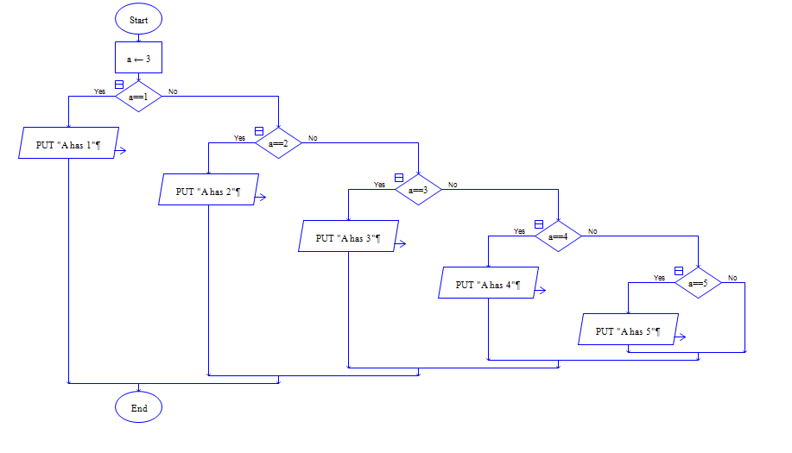

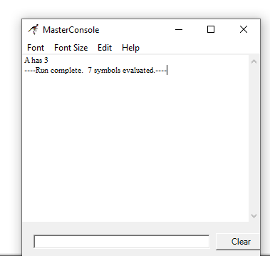

**RESULT:**

Thus, using Raptor above experiment is implemented successfully.