**ASSIGNMENT-1**

**Declare The Variables**

export RANDOM_ID=$(openssl rand -hex 3)

export RESOURCE_GROUP_NAME="myJavaVMResourceGroupS${RANDOM_ID}"

export REGION="westUS"

export VM_NAME="myJavaVMS${RANDOM_ID}"

export USERNAME="azureuser"

export VM_IMAGE="MicrosoftWindowsServer:WindowsServer:2019-Datacenter:latest"

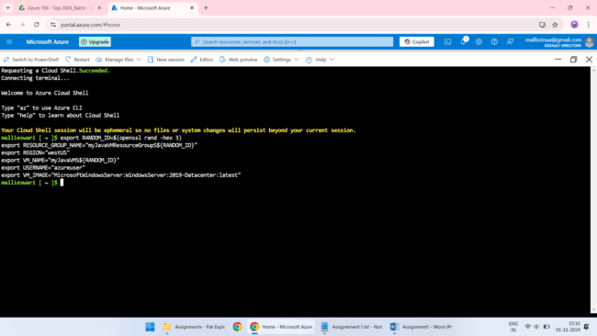

**To Create The Resource Group**

az group create --name ${RESOURCE_GROUP_NAME} --location ${REGION}

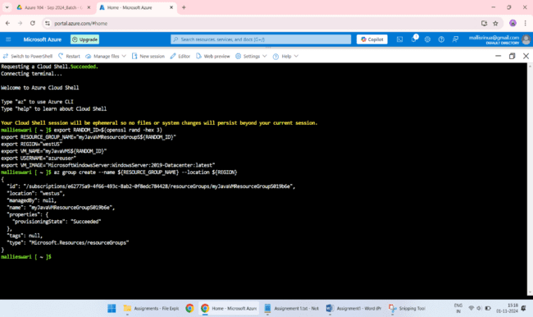

**To Create The VM**

az vm create \

--resource-group ${RESOURCE_GROUP_NAME} \

--name ${VM_NAME} \

--image ${VM_IMAGE} \

--admin-username ${USERNAME} \

--assign-identity \

--generate-ssh-keys \

--public-ip-sku Standard

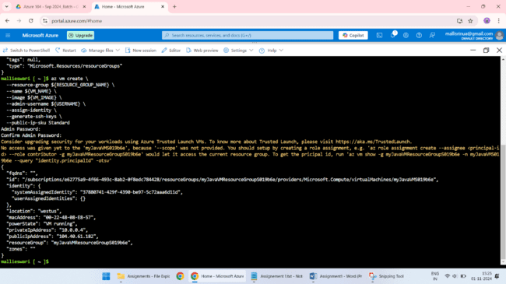

**Install Java using Azure CLI**

az vm run-command invoke \

--resource-group ${RESOURCE_GROUP_NAME} \

--name ${VM_NAME} \

--command-id RunPowerShellScript \

--scripts \

"Invoke-WebRequest -https://download.oracle.com/java/17/archive/jdk-17.0.12_windows-x64_bin.exe" \

"Invoke-WebRequest -https://download.oracle.com/java/17/archive/jdk-17.0.12_windows-x64_bin.exe.sha256" \

"$expectedHash = 'your_sha256_hash_here'; $actualHash = Get-FileHash -Path ./jdk-17.0.12_windows-x64_bin.exe | Select-Object -ExpandProperty Hash; if ($expectedHash -eq $actualHash) { .

/jdk-17.0.12_windows-x64_bin.exe /s }" \

"[Environment]::SetEnvironmentVariable('JAVA_HOME', 'C:\\Program Files\\Java\\jdk-17.0.12', 'Machine')" \

"[Environment]::SetEnvironmentVariable('PATH', \$env:PATH + ';C:\\Program Files\\Java\\jdk-17.0.12\\bin', 'Machine')" \

"java -version" \

--debug

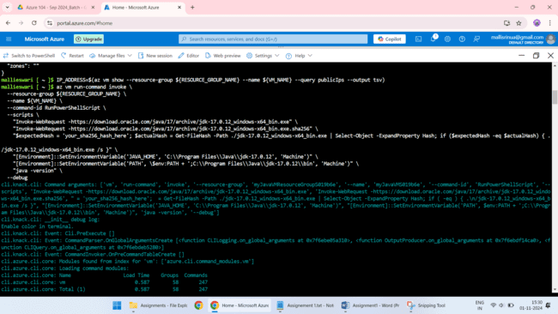

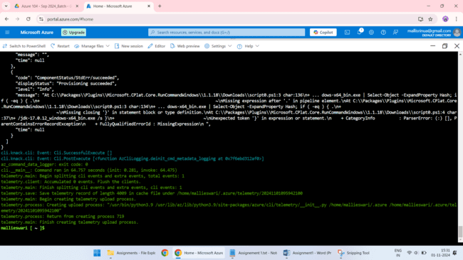

**Verify Java installation**

az vm run-command invoke \

--resource-group ${RESOURCE_GROUP_NAME} \

--name ${VM_NAME} \

--command-id RunPowerShellScript \

--scripts \

"Invoke-WebRequest -https://download.oracle.com/java/17/archive/jdk-17.0.12_windows-x64_bin.exe" \

"Invoke-WebRequest -https://download.oracle.com/java/17/archive/jdk-17.0.12_windows-x64_bin.exe.sha256" \

"$expectedHash = 'your_sha256_hash_here'; $actualHash = Get-FileHash -Path ./jdk-17.0.12_windows-x64_bin.exe | Select-Object -ExpandProperty Hash; if ($expectedHash -eq $actualHash) { .

/jdk-17.0.12_windows-x64_bin.exe /s }" \

"[Environment]::SetEnvironmentVariable('JAVA_HOME', 'C:\\Program Files\\Java\\jdk-17.0.12', 'Machine')" \

"[Environment]::SetEnvironmentVariable('PATH', \$env:PATH + ';C:\\Program Files\\Java\\jdk-17.0.12\\bin', 'Machine')" \

"java -version" \

--debug

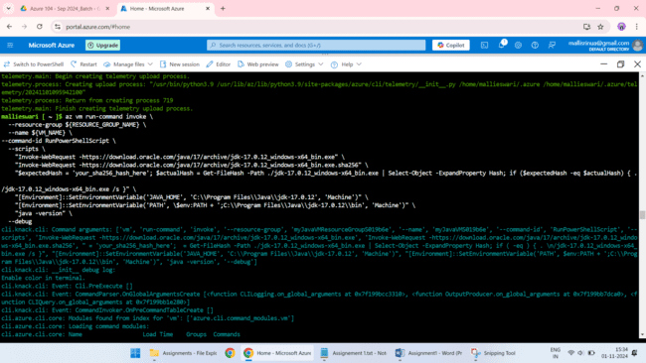

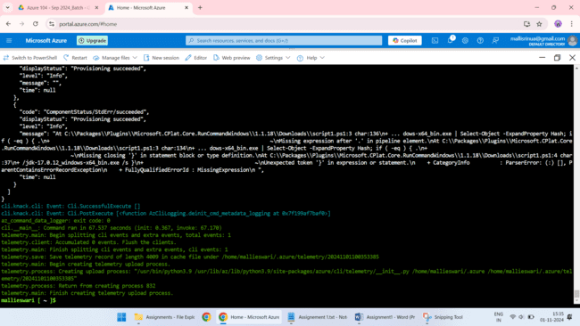

**Verified**

java -version

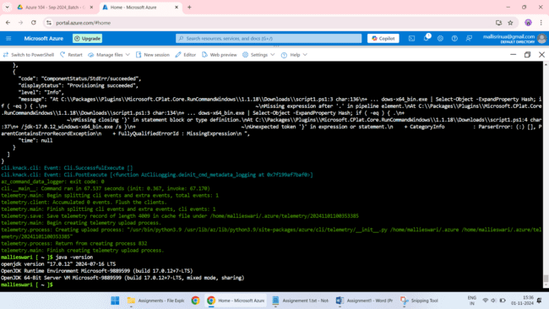

**SCRIPT**

-----------------Declare The Variables-------------

export RANDOM_ID=$(openssl rand -hex 3)

export RESOURCE_GROUP_NAME="myJavaVMResourceGroupS${RANDOM_ID}"

export REGION="westUS"

export VM_NAME="myJavaVMS${RANDOM_ID}"

export USERNAME="azureuser"

export VM_IMAGE="MicrosoftWindowsServer:WindowsServer:2019-Datacenter:latest"

--------------To Create The Resource Group---------------

az group create --name ${RESOURCE_GROUP_NAME} --location ${REGION}

------------------To Create The VM -------------------

az vm create \

--resource-group ${RESOURCE_GROUP_NAME} \

--name ${VM_NAME} \

--image ${VM_IMAGE} \

--admin-username ${USERNAME} \

--assign-identity \

--generate-ssh-keys \

--public-ip-sku Standard

IP_ADDRESS=$(az vm show --resource-group ${RESOURCE_GROUP_NAME} --name ${VM_NAME} --query publicIps --output tsv)

----------------Install Java using Azure CLI----------------

az vm run-command invoke \

--resource-group ${RESOURCE_GROUP_NAME} \

--name ${VM_NAME} \

--command-id RunPowerShellScript \

--scripts \

"Invoke-WebRequest -https://download.oracle.com/java/17/archive/jdk-17.0.12_windows-x64_bin.exe" \

"Invoke-WebRequest -https://download.oracle.com/java/17/archive/jdk-17.0.12_windows-x64_bin.exe.sha256" \

"$expectedHash = 'your_sha256_hash_here'; $actualHash = Get-FileHash -Path ./jdk-17.0.12_windows-x64_bin.exe | Select-Object -ExpandProperty Hash; if ($expectedHash -eq $actualHash) { .

/jdk-17.0.12_windows-x64_bin.exe /s }" \

"[Environment]::SetEnvironmentVariable('JAVA_HOME', 'C:\\Program Files\\Java\\jdk-17.0.12', 'Machine')" \

"[Environment]::SetEnvironmentVariable('PATH', \$env:PATH + ';C:\\Program Files\\Java\\jdk-17.0.12\\bin', 'Machine')" \

"java -version" \

--debug

---------------------Verify Java installation----------------

az vm run-command invoke \

--resource-group ${RESOURCE_GROUP_NAME} \

--name ${VM_NAME} \

--command-id RunPowerShellScript \

--scripts \

"Invoke-WebRequest -https://download.oracle.com/java/17/archive/jdk-17.0.12_windows-x64_bin.exe" \

"Invoke-WebRequest -https://download.oracle.com/java/17/archive/jdk-17.0.12_windows-x64_bin.exe.sha256" \

"$expectedHash = 'your_sha256_hash_here'; $actualHash = Get-FileHash -Path ./jdk-17.0.12_windows-x64_bin.exe | Select-Object -ExpandProperty Hash; if ($expectedHash -eq $actualHash) { .

/jdk-17.0.12_windows-x64_bin.exe /s }" \

"[Environment]::SetEnvironmentVariable('JAVA_HOME', 'C:\\Program Files\\Java\\jdk-17.0.12', 'Machine')" \

"[Environment]::SetEnvironmentVariable('PATH', \$env:PATH + ';C:\\Program Files\\Java\\jdk-17.0.12\\bin', 'Machine')" \

"java -version" \

--debug

----------------verified-------------

java -version

**Azure Portal**

1.login to azure portal.

2. Go to virtual machine and create the needed resources.

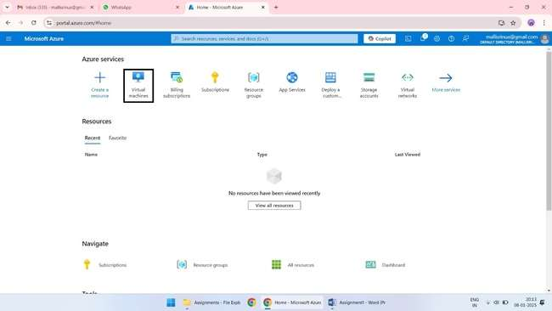

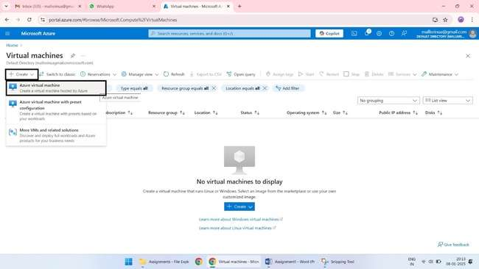

3.create a resource group and virtual machine with suitable location.

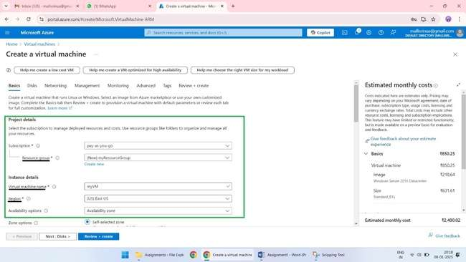

4.select suitable image & size, and provide crenditals to access.

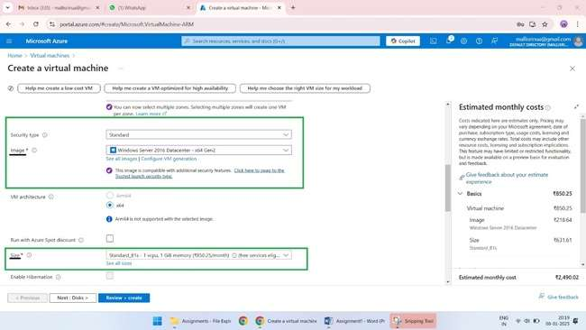

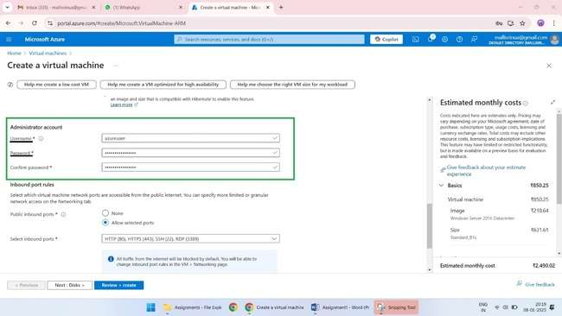

5. create virtual network, subnet and IP address.

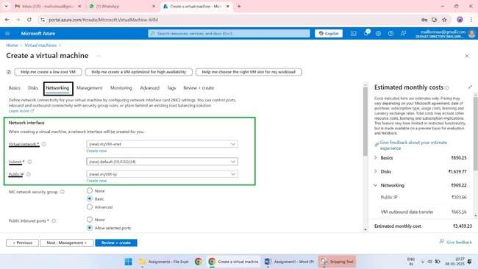

6. Review and create the VM.

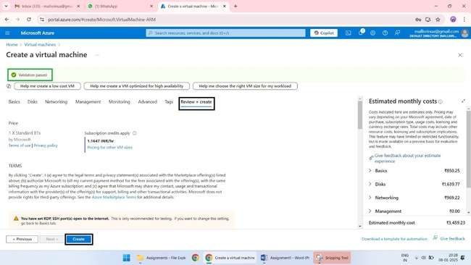

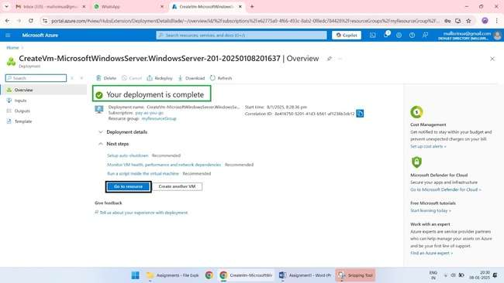

7. connect the VM to download the java SDK 11.

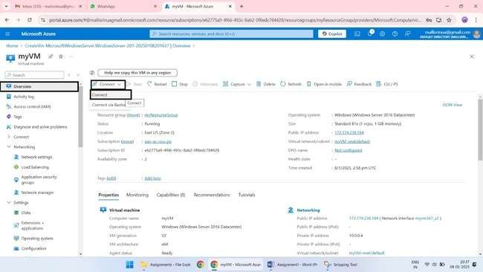

8. download the RDP file to connect.

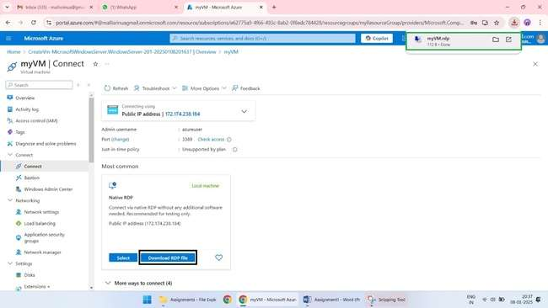

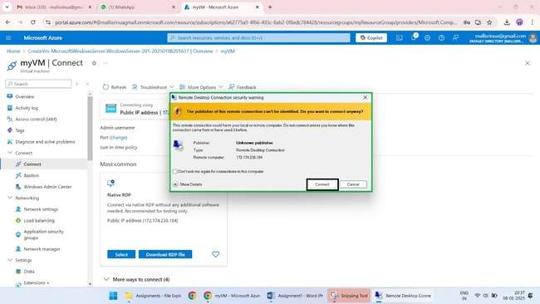

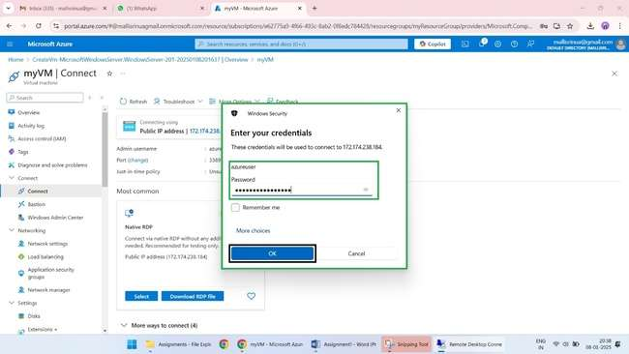

9. download and install java SDK 11

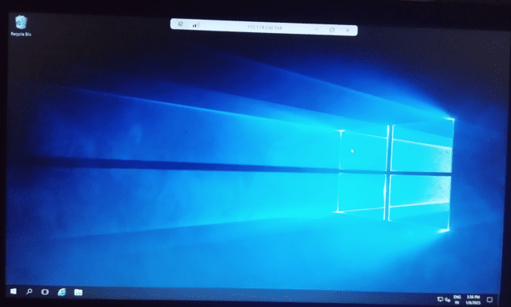

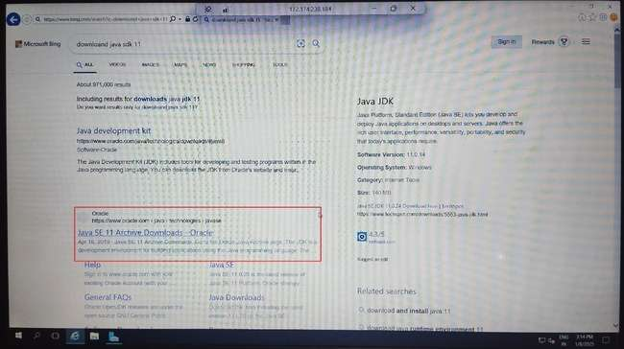

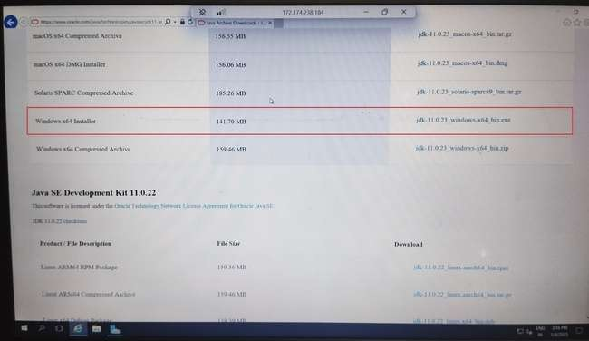

10. Go to downloads and install the java SDK11 in your windows.

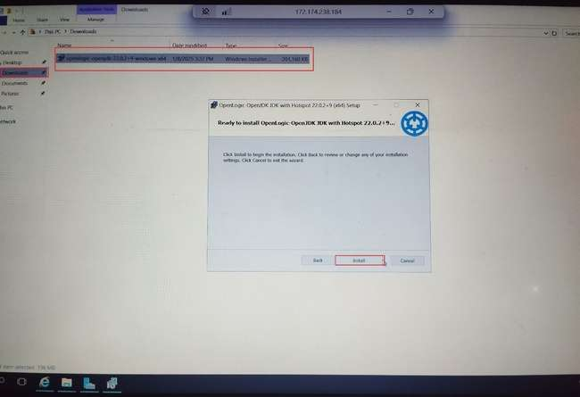

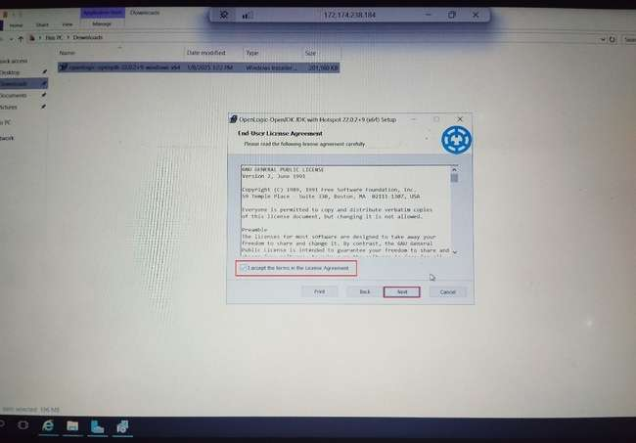

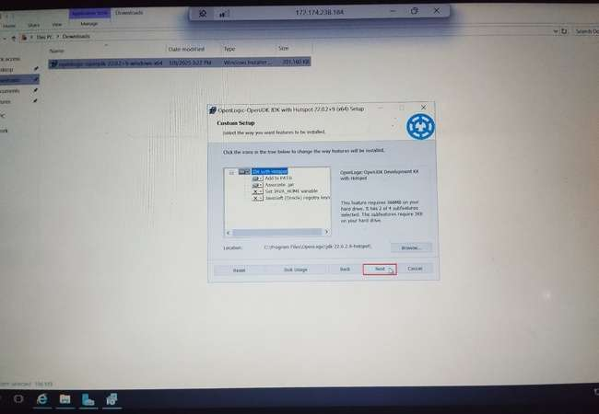

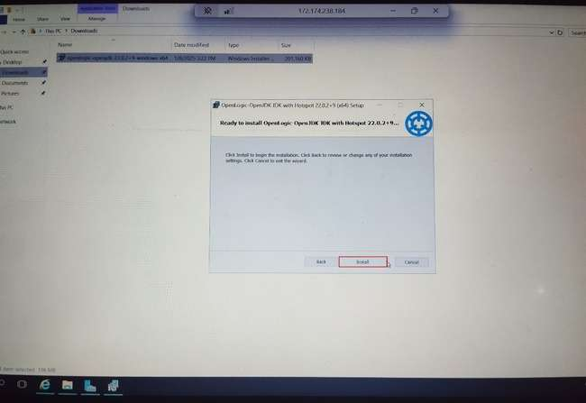

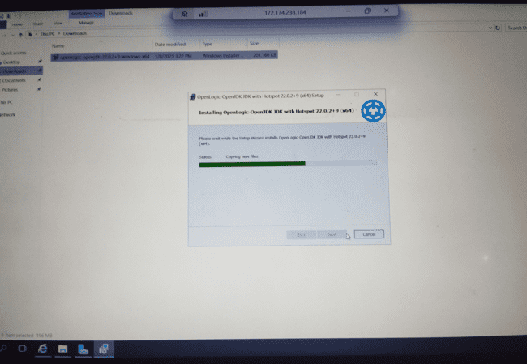

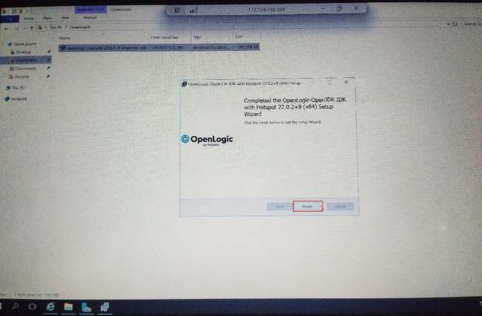

11. verify whether the java has been installed using command prompt.

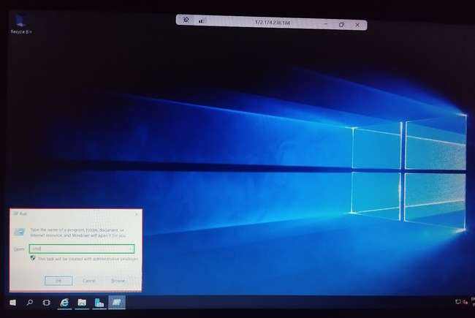

Java --version

