**ASSIGNMENT-10**

**Step1:** login to azure portal create an Ubuntu Vm.

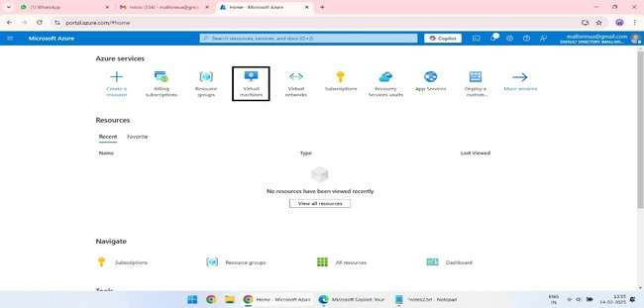

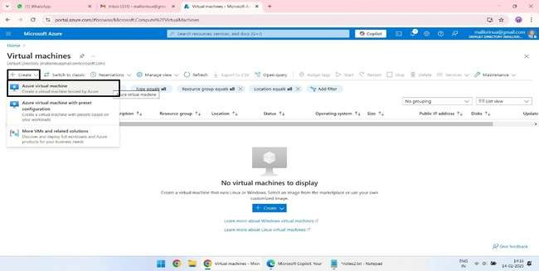

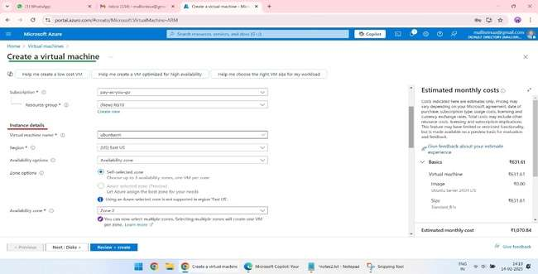

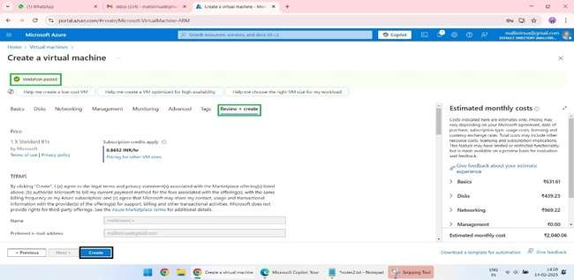

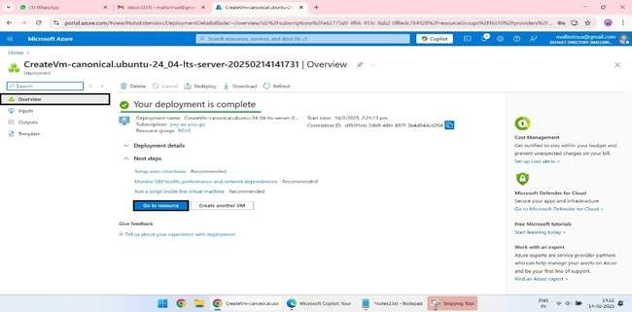  
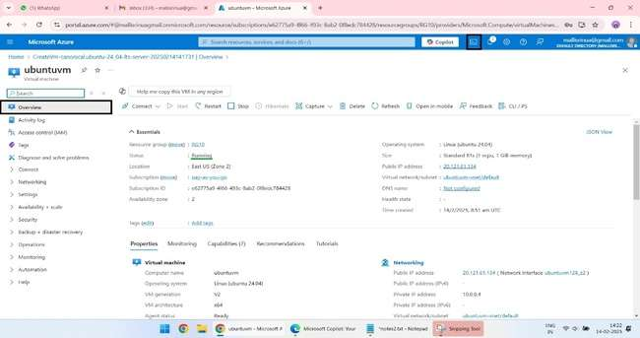

**Step2:** using azure cloud shell login to Ubuntu Vm. (ssh username@vm ip_address)

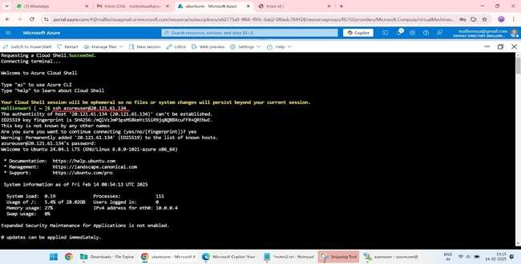

**Step3**: update sudo apt and install Apache2

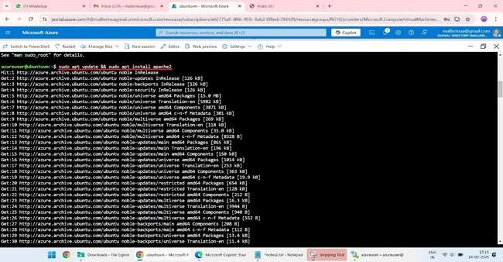

### Step4: 1. Download a Template from free-css.com:

1. **Visit free-css.com**: Go to free-css.com.
2. **Choose a Template**: Browse the website and select a template you like.
3. **Download the Template**: Click on the download button for the chosen template and save the ZIP file to your local machine.

**2. Deploy the Template:**

1. **Extract the Template Files**:
   * Right-click on the downloaded ZIP file and select "Extract All..." to extract the files.
2. **Copy the Files to Root Folder**:
   * Open File Explorer and navigate to the extracted template folder.
   * Copy all files in the folder.
   * Navigate to C:\inetpub\wwwroot.
   * Paste the copied files into wwwroot.

**Step5:** Go back to azure cloud shell unzip the extracted template file.

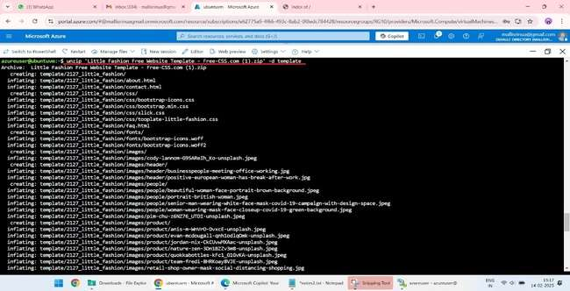

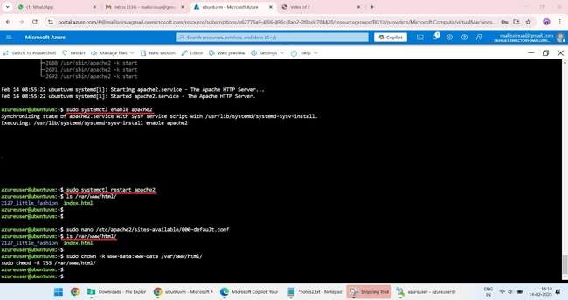

### Step6: ****Verify Your Website:****

1. **Open Your Web Browser**:
   * Enter the public IP address of your Ubuntu VM in the address bar: http://your_vm_ip_address.
2. **Check for Accessibility**:
   * If you can see your website, then the deployment is successful

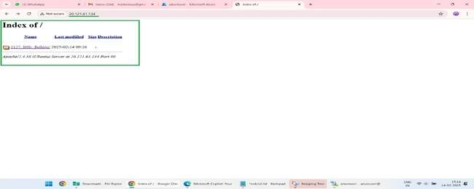

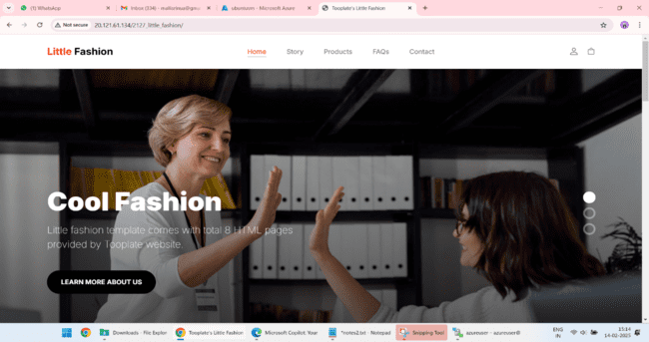

3. **Make Changes and Reconfirm:** using nano index.html

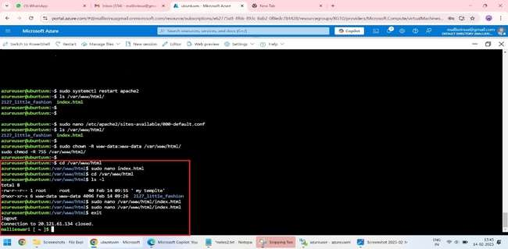

**4.**Again access through ip_address.

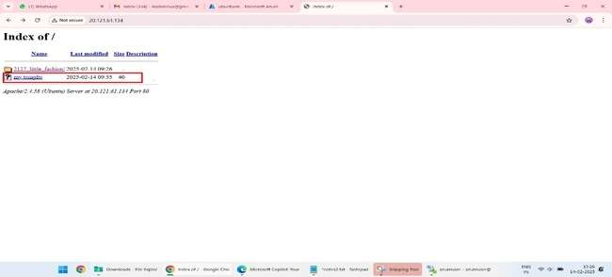

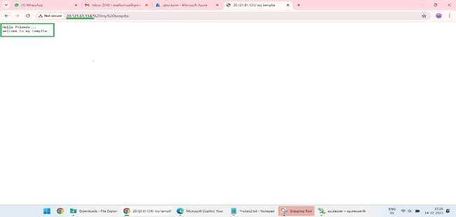

**Step7: Repeat the step 1 to create windows virtual machine**

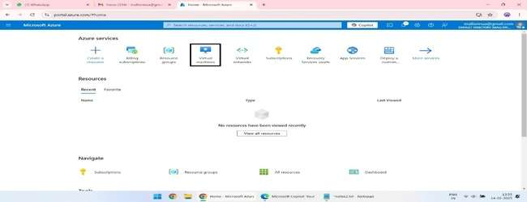

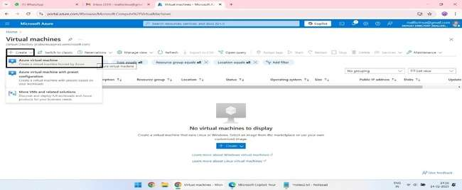

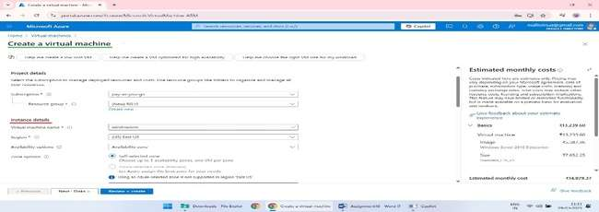

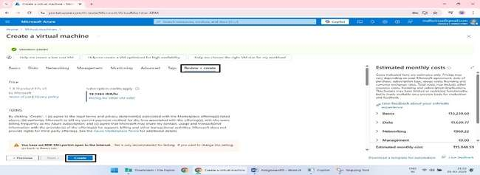

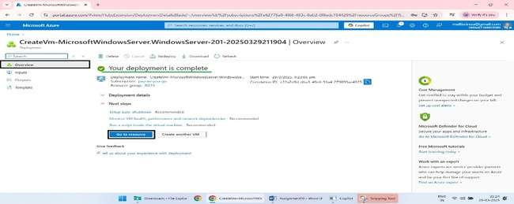

**Step8:** using RDP login to windowsvm.

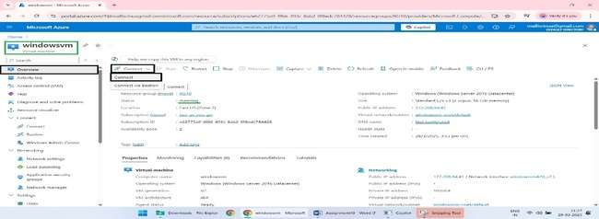

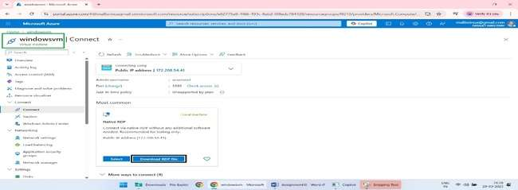

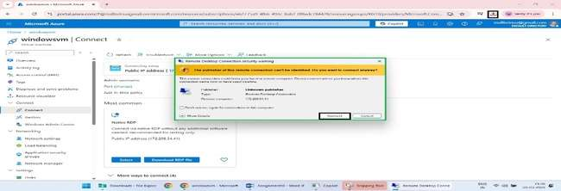

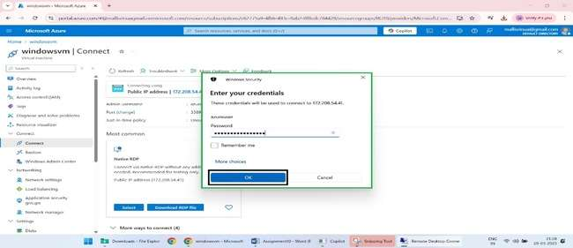

### Step9: Repeat the step 4.

### Before downloading the template install IIS in vm

### 1. Download a Template from free-css.com:

1. **Visit free-css.com**: Go to free-css.com.
2. **Choose a Template**: Browse the website and select a template you like.
3. **Download the Template**: Click on the download button for the chosen template and save the ZIP file to your local machine.

**2. Deploy the Template:**

1. **Extract the Template Files**:
   * Right-click on the downloaded ZIP file and select "Extract All..." to extract the files.
2. **Copy the Files to Root Folder**:
   * Open File Explorer and navigate to the extracted template folder.
   * Copy all files in the folder.
   * Navigate to C:\inetpub\wwwroot.
   * Paste the copied files into wwwroot.

### Step10: ****Verify Your Website:****

1. **Open Your Web Browser**:
   * Enter the public IP address of your windowsVM in the address bar: http://your_vm_ip_address.
2. **Check for Accessibility**:
   * If you can see your website, then the deployment is successful

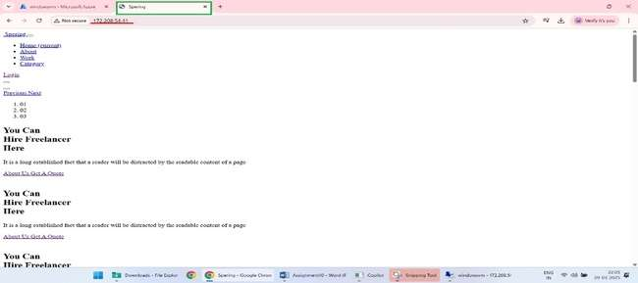

1. **Make Changes and Reconfirm: Using Notepad**

* Locate the file you want to edit (e.g., in c:\inetpub\wwwroot for web server files)
* Right-click the file and select Open with > Notepad
* Make the necessary changes and save the file by pressing Ctrl+S or clicking File > Save.
* I have changed the tittle of the page to **spering to my webpage spring.**

