**ASSIGNMENT-11**

**1. Initial Deployment**

1. Open notepad create an ARM template to define a Virtual Network (VNet), a Storage Account, and a Virtual Machine (VM). Deploy the template using Incremental Deployment Mode.

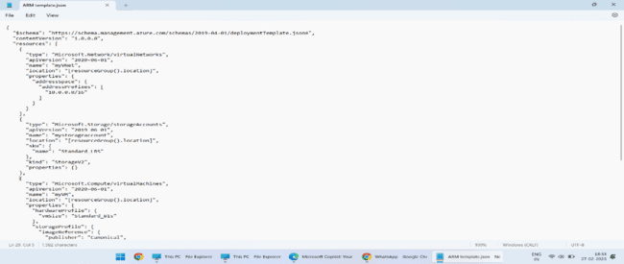

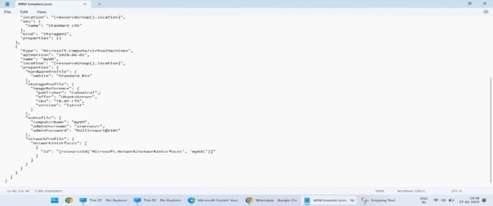

2. open could shell using azure portal and upload the json file to deploy.

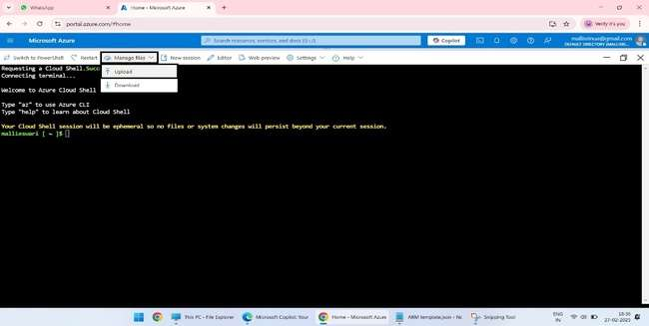

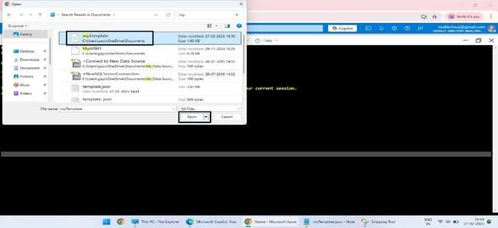

3. create the resource group to deploy the json file and run the myTemplate.json.

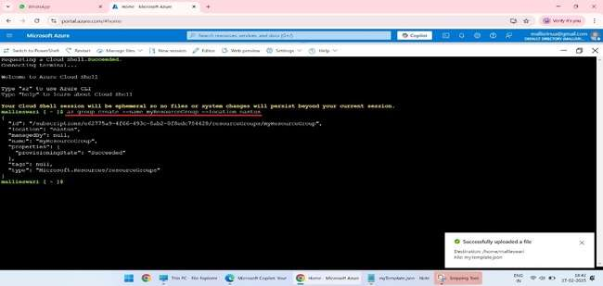

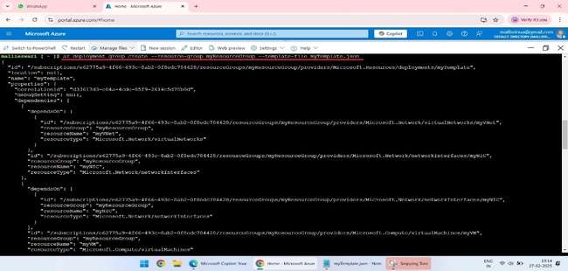

### 2. Modify the Template

1.After the initial deployment, again open the notepad modify the template to change the VM size and add a public IP address for the VM.

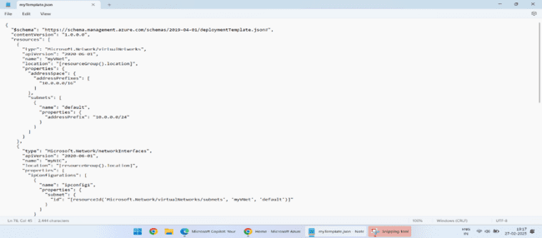

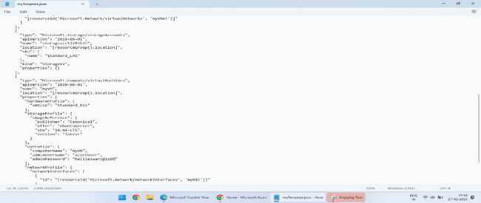

2. Again run the modified template file.

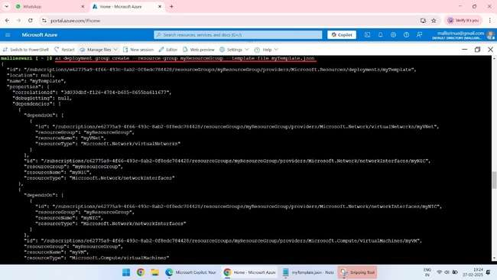

### 3. Re-deploy Using Incremental Mode

• Modify your ARM template to update the VM size and add a public IP address.

• Save the modified ARM template as myModifiedTemplate.json.

• Use the Azure CLI command to redeploy the template with Incremental Deployment Mode.

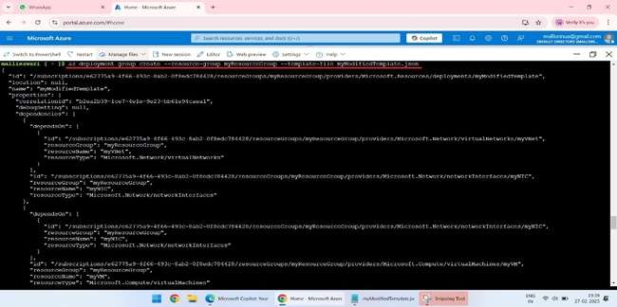

**4. Observe the Results**

1.After the deployment, you can check the differences using the Azure Portal or Azure CLI.

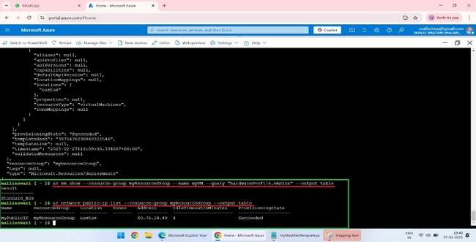

### 5. Answer the Following Questions

**1.Explain the behaviour of Incremental Deployment Mode in this scenario. Which resources were updated, and which ones were left unchanged?**

**Answer**: The VM size was updated, and the public IP address was added. The VNet and Storage Account remained unchanged.

**2.What happens to the existing VM during the deployment? Does it get replaced or updated?**

**Answer**: The existing VM gets updated with the new size. It doesn't get replaced.

**3.How does Incremental Mode handle adding a new resource (e.g., a public IP address)?**

**Answer**: Incremental Mode adds the new resource (public IP address) without affecting the existing resources.

**4.What are the advantages and limitations of using Incremental Mode in this case?**

**Answer:**

**Advantages:**

* + Only the resources defined in the template are deployed.
  + Existing resources not specified in the template remain unchanged.
  + Quicker deployments as it doesn't redeploy unchanged resources.

**Limitations:**

* + Requires careful management of resource definitions to avoid unintentional updates.
  + Doesn't remove resources that are not defined in the template but exist in the resource group.