**ASSIGNMENT-12**

**1. Initial Deployment**

1.Open notepad, create an ARM template to deploy a Web Server and a Network Security Group (NSG). Then, deploy the template to Azure using Complete Deployment Mode.

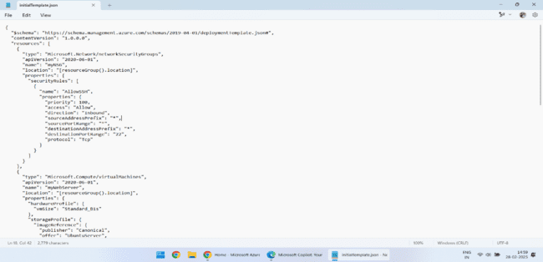

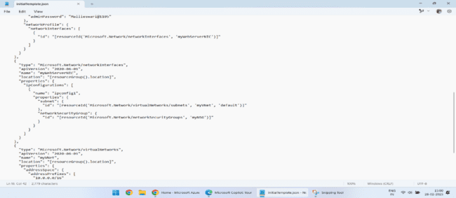

2. open could shell using azure portal and upload the json file to deploy.

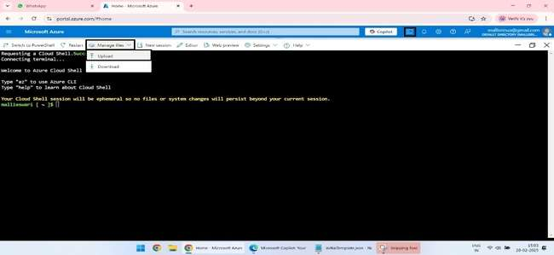

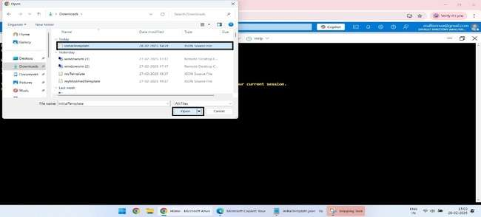

3. create the resource group to deploy the json file and run the initialTemplate.json.

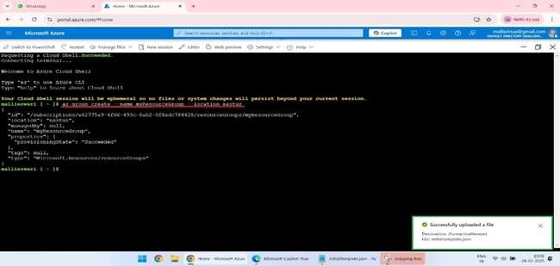

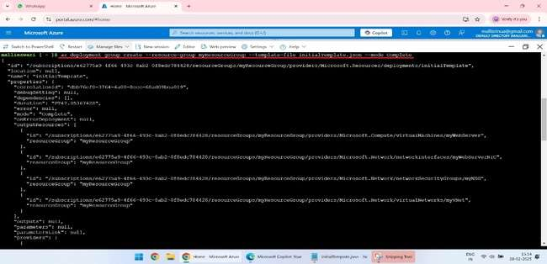

### 2. Modify the Template

1.Again open the notepad, modify the template to remove the Web Server resource, change the NSG rules, and add a Database Server resource.

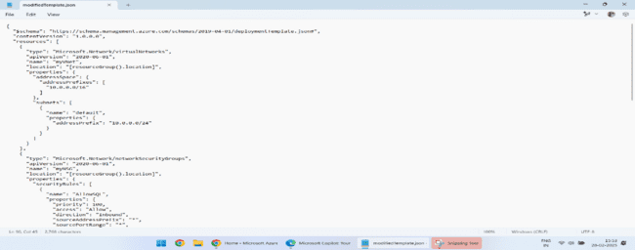

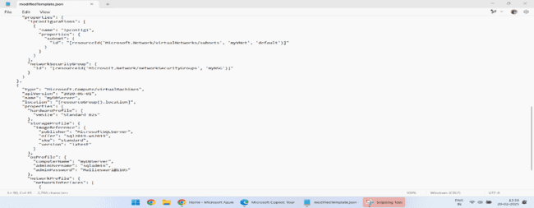

### 3. Re-deploy Using Complete Mode

1.Redeploy the modified ARM template using Complete Deployment Mode

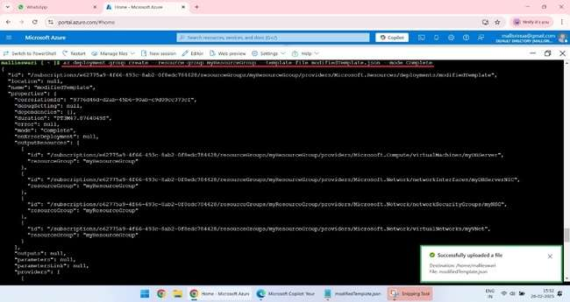

**4. Observe the Results**

1.After the deployment, you can check the differences using the Azure Portal or Azure CLI.

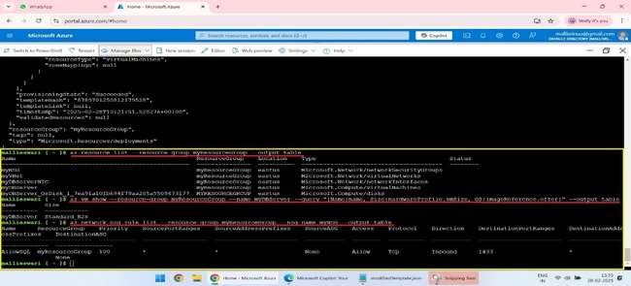

### 5. Answer the Following Questions

**1.Explain how Complete Deployment Mode handles the deletion of resources (e.g., Web Server) and deployment of new resources (e.g., Database Server).**

**Answer:** Complete Deployment Mode ensures that resources not defined in the template are deleted. The Web Server is removed, and the Database Server is deployed as defined in the modified template.

**2.How does Complete Mode differ from Incremental Mode in terms of resource deletion and replacement?**

**Answer:**

* **Incremental Mode** only updates or adds resources defined in the template and leaves existing resources unchanged if not specified.
* **Complete Mode** updates, adds, and removes resources to match exactly what is defined in the template, ensuring that resources not included in the template are deleted.

**3.What are the potential risks of using Complete Mode in this case, and how can you mitigate those risks before deployment?**

**Answer:**

* **Risks:**
  + Unintentional deletion of resources not defined in the template.
  + Potential service disruption if critical resources are deleted.
* **Mitigation:**
  + Carefully review the ARM template before deployment.
  + Take backups or snapshots of critical resources.
  + Use staging environments to test deployments before applying them to production.