**ASSIGNMENT-2**

**Create Resource Group**

az group create --name testResourceGroup --location westus

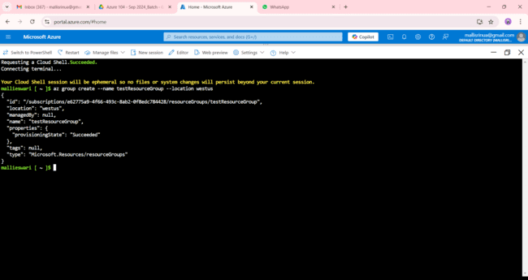

**Create Public IP**

az network public-ip create --resource-group testResourceGroup --name MyPublicIP --allocation-method Dynamic --sku Basic

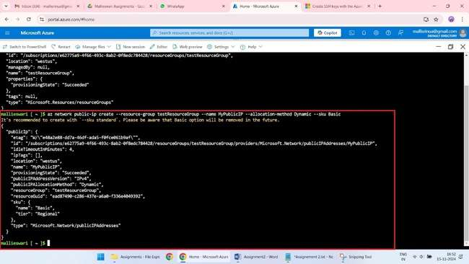

**Create Virtual Network and Subnet (required for VM)**

az network vnet create --resource-group testResourceGroup --name MyVNet --address-prefix 10.0.0.0/16 --subnet-name MySubnet --subnet-prefix 10.0.1.0/24

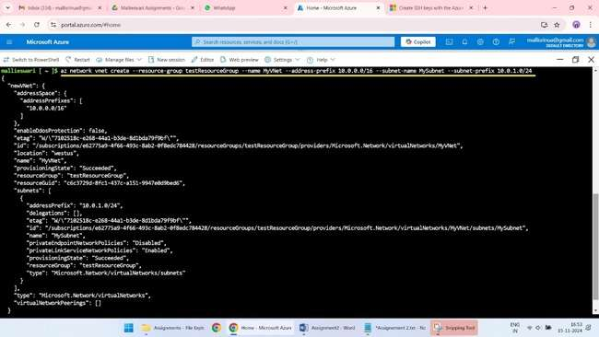

**Create Network Interface**

az network nic create --resource-group testResourceGroup --name MyNIC --vnet-name MyVNet --subnet MySubnet --public-ip-address MyPublicIP

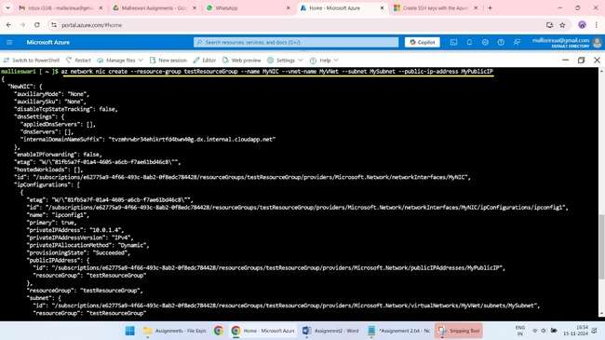

**Set the Boot Diagnostics option to be disabled (Monitoring tab)**

az configure --defaults vm.boot_diagnostics.enabled=false

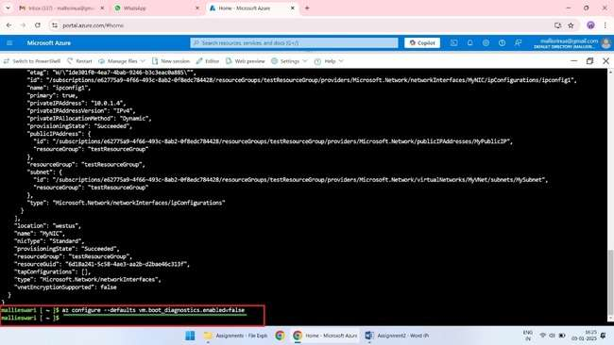

**Create Tag**

az resource tag --id /subscriptions/e62775a9-4f66-493c-8ab2-0f8edc784428/resourceGroups/testResourceGroup --tags Name=MyVM Value=AzureVM

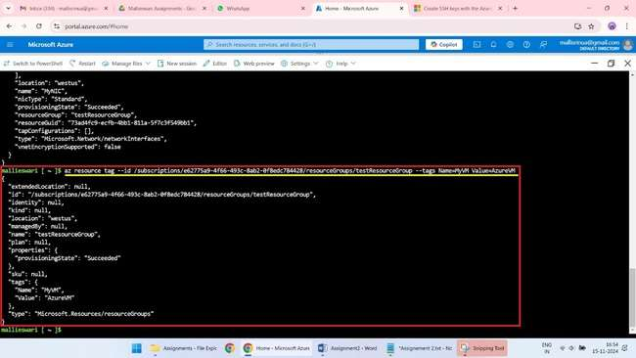

**Create a VM**

az vm create \

--resource-group testResourceGroup \

--name testVM \

--image Ubuntu2204 \

--nics MyNIC \

--tags Name=MyVM Value=AzureVM \

--admin-username azureuser \

--generate-ssh-keys

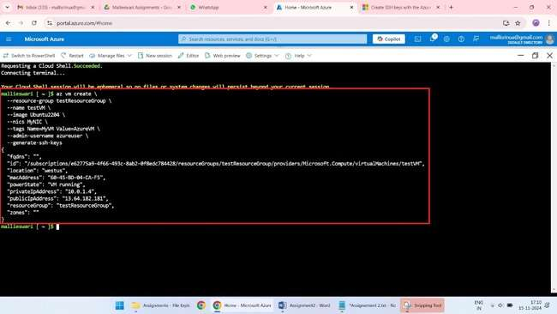

**Login to the vm**

ssh [azureuser@52.160.38.114](mailto:azureuser@52.160.38.114)

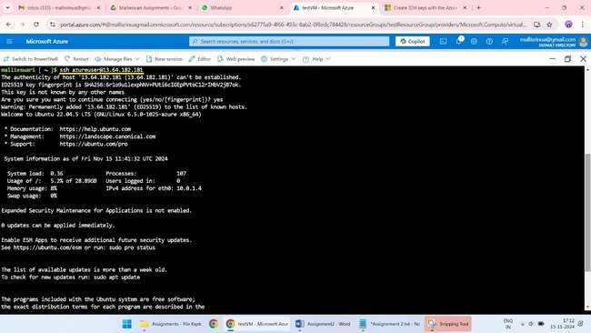

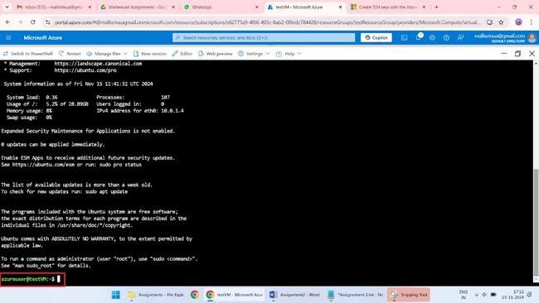

**To disconnect enter (exit)**

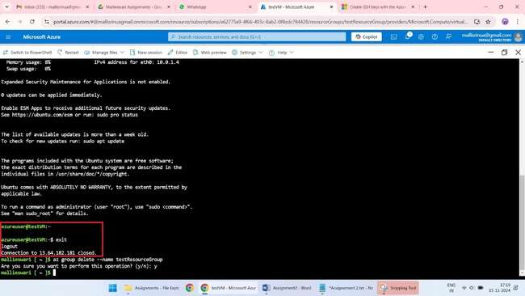

**Clean up resources**

az group delete --name testResourceGroup

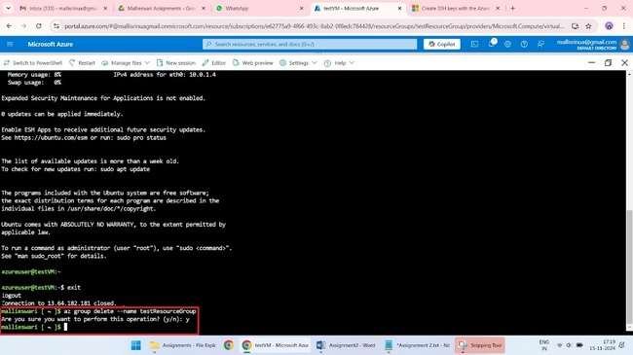

**Verify with portal**

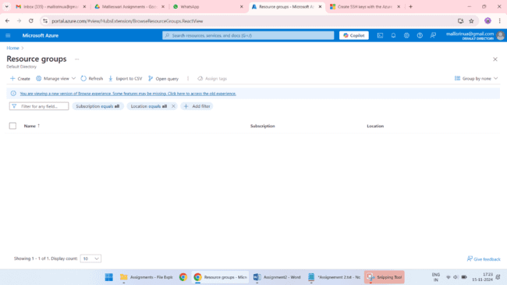

**SCRIPT**

**Create Resource Group**

az group create --name testResourceGroup --location westus

**Create Public IP**

az network public-ip create --resource-group testResourceGroup --name MyPublicIP --allocation-method Dynamic --sku Basic

**Create Virtual Network and Subnet (required for VM)**

az network vnet create --resource-group testResourceGroup --name MyVNet --address-prefix 10.0.0.0/16 --subnet-name MySubnet --subnet-prefix 10.0.1.0/24

**Create Network Interface**

az network nic create --resource-group testResourceGroup --name MyNIC --vnet-name MyVNet --subnet MySubnet --public-ip-address MyPublicIP

**Set the Boot Diagnostics option to be disabled (Monitoring tab)**

az configure --defaults vm.boot_diagnostics.enabled=false

**Create Tag**

az resource tag --id /subscriptions/e62775a9-4f66-493c-8ab2-0f8edc784428/resourceGroups/testResourceGroup --tags Name=MyVM Value=AzureVM

**Create a VM**

az vm create \

--resource-group testResourceGroup \

--name testVM \

--image Ubuntu2204 \

--nics MyNIC \

--tags Name=MyVM Value=AzureVM \

--admin-username azureuser \

--generate-ssh-keys

**Login to the vm**

ssh azureuser@52.160.38.114

**Clean up resources**

az group delete --name testResourceGroup