**ASSIGNMENT-3**

**Create a virtual machine using Azure CLI either Windows or Linux distribution**

az group create --name testResourceGroup --location westus

az vm create \

--resource-group testResourceGroup \

--name testVM \

--image win2019datacenter \

--admin-username azureuser

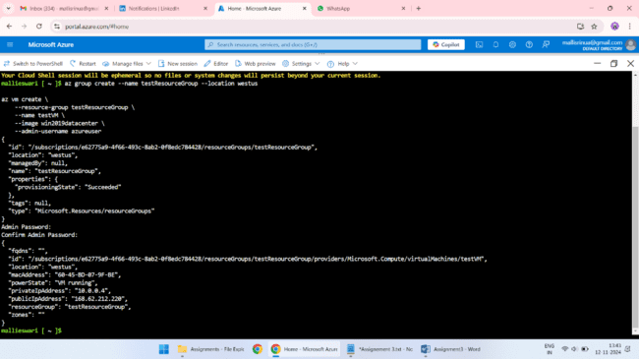

**Login to the VM machine using Portal**

1. Open the Azure portal and navigate to the "Virtual machines" blade.

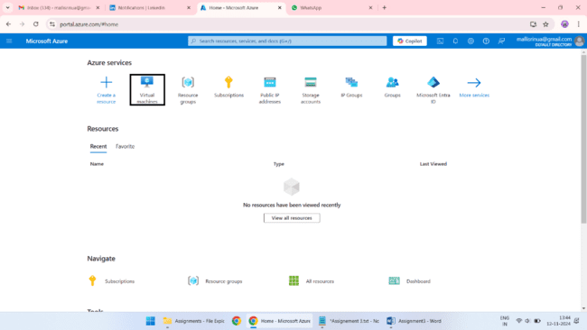

2. Select the "MyVM" virtual machine.

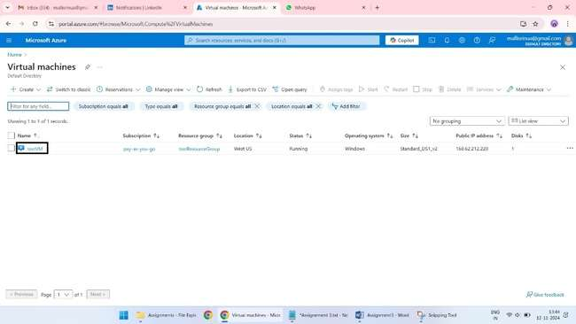

3. Click on the "Connect" button.

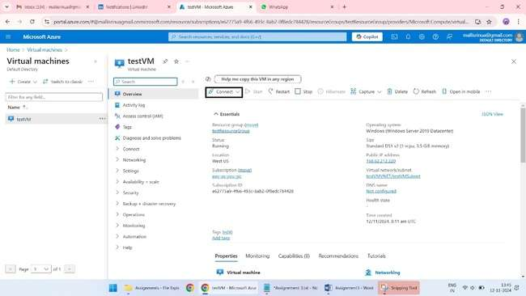

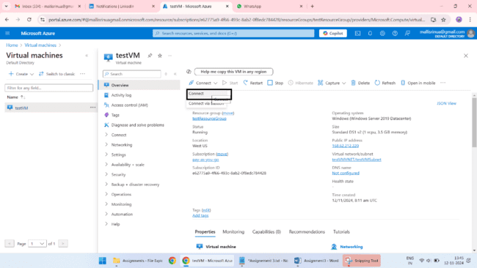

Select "RDP" as the protocol.

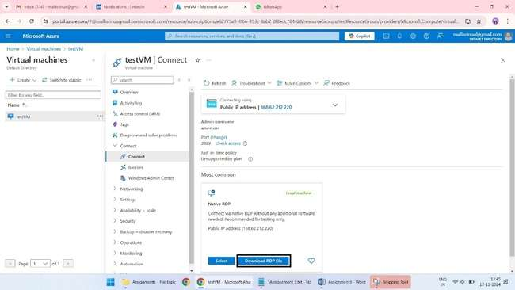

5. Download the RDP file.

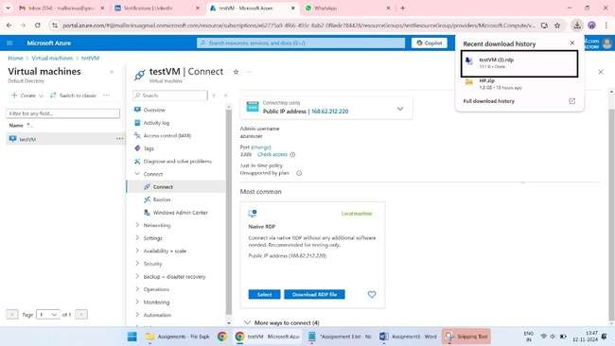

6. Open the RDP file and connect to the virtual machine.

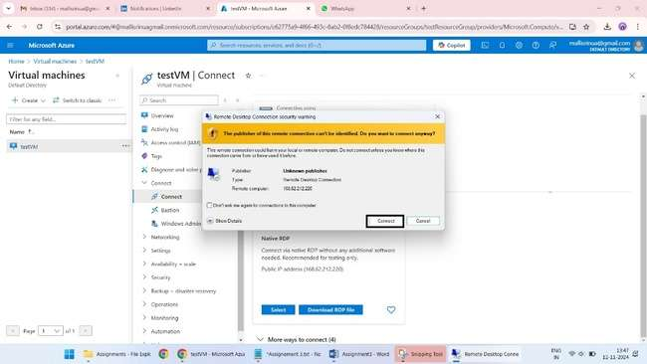

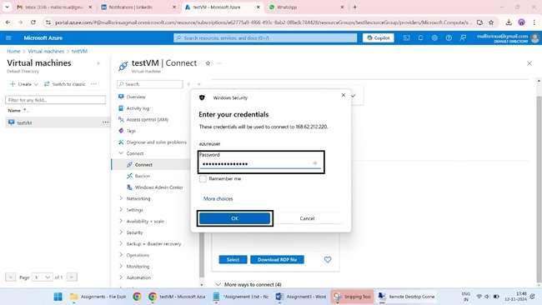

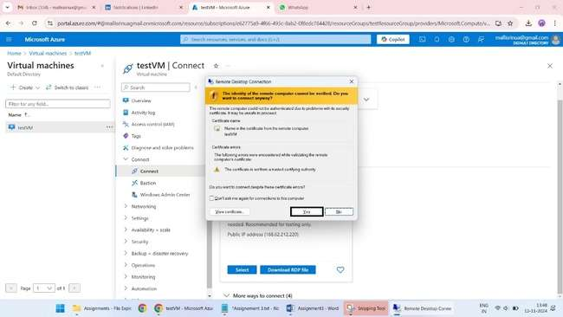

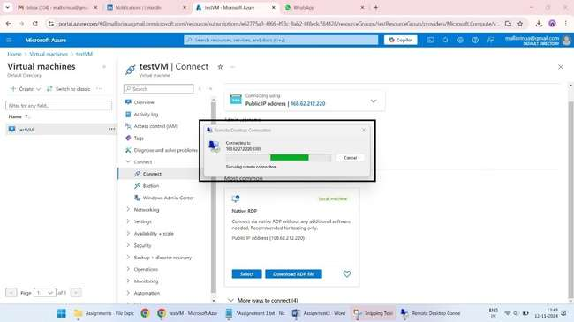

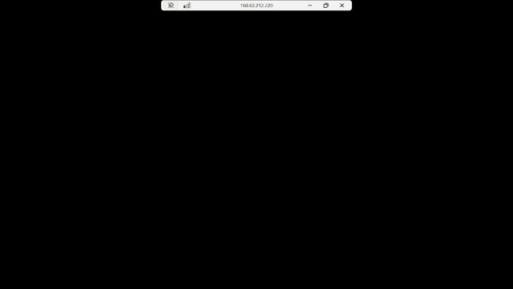

**Restart/Shutdown the VM Machine using Azure CLI**

az vm restart --resource-group testResourceGroup --name testVM

az vm stop --resource-group testResourceGroup --name testVM

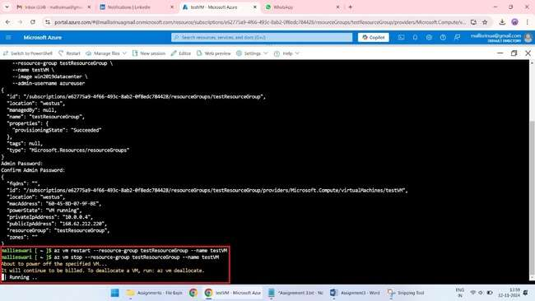

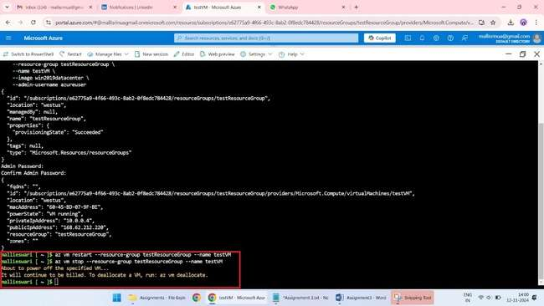

**Clean up Resources using Azure CLI**

az group delete --name testResourceGroup

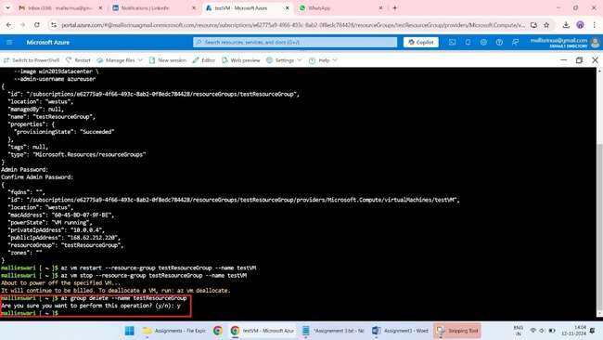

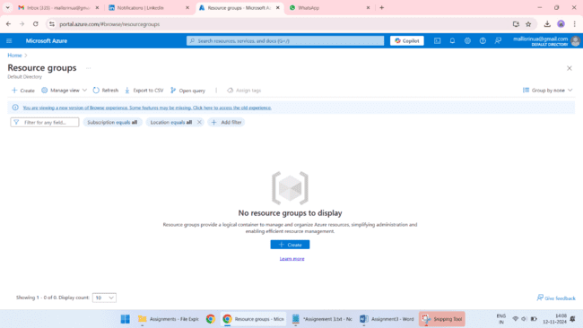

**SCRIPT**

**Create a virtual machine using Azure CLI either Windows or Linux distribution**

az group create --name testResourceGroup --location westus

az vm create \

--resource-group testResourceGroup \

--name testVM \

--image win2019datacenter \

--admin-username azureuser

**Restart/Shutdown the VM Machine using Azure CLI**

az vm restart --resource-group testResourceGroup --name testVM

az vm stop --resource-group testResourceGroup --name testVM

**Clean up Resources using Azure CLI**

az group delete --name testResourceGroup