**ASSIGNMENT-5**

**Azure Ubuntu VM Creation and Data Disk Management**

**Azure Portal Steps**

**Step 1: Create an Azure Ubuntu Virtual Machine (VM)**

1. Log in to the Azure Portal.

2. Click on "Virtual Machines" and then click on "Create"

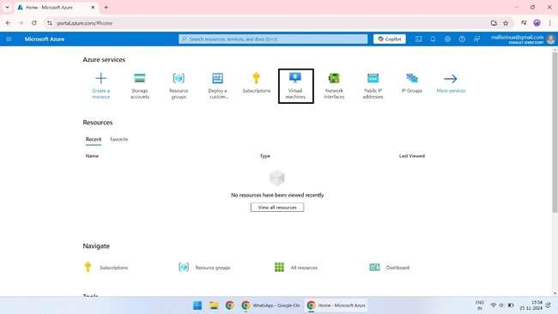

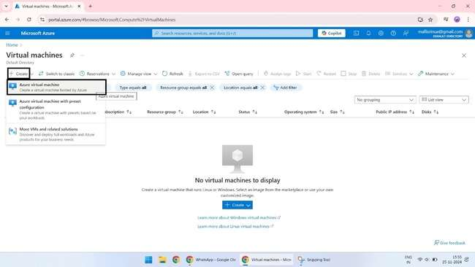

3.Select "Ubuntu Server" as the operating system.

4.Choose the desired VM size and configure the settings as needed.

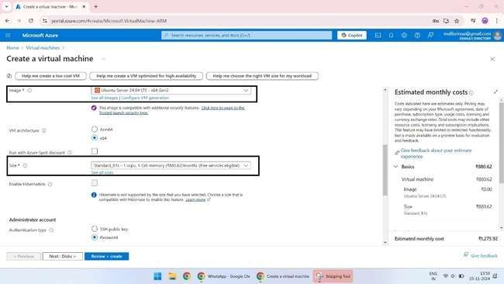

5. Click on "Create" to create the VM.

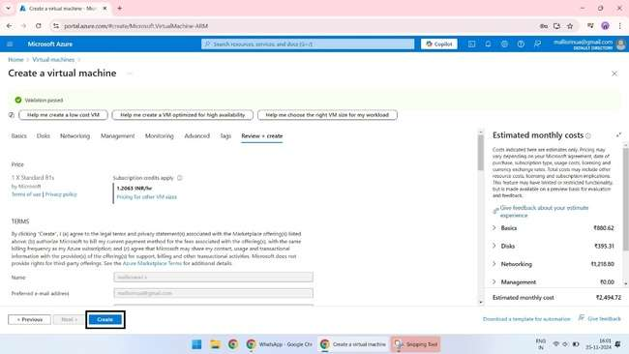

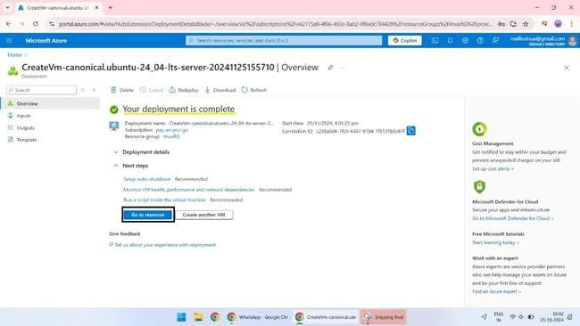

**Step 2: Add a New Data Disk**

1.Go to the Azure Portal and select the VM.

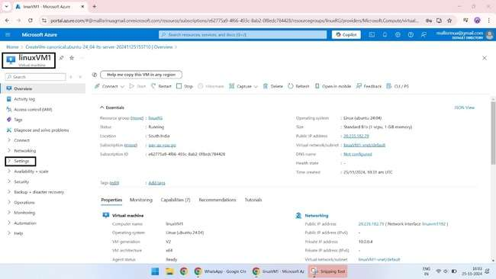

2.Click on "Disks" and then click on "Add data disk".

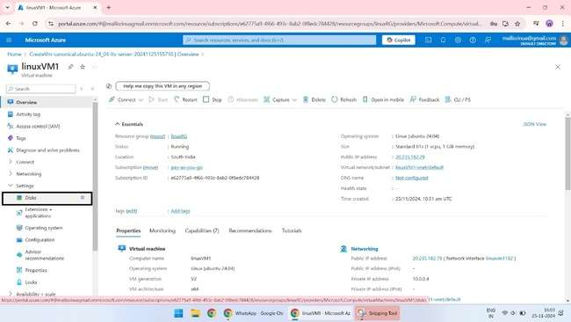

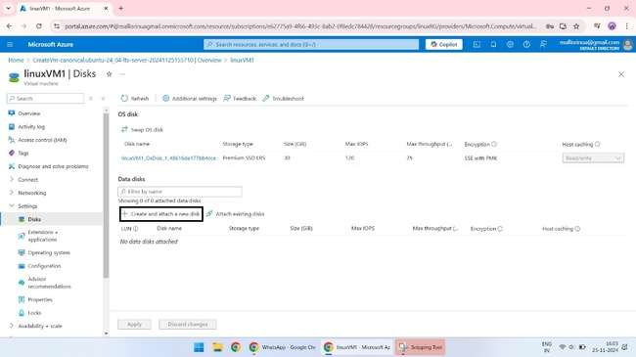

3.Configure the new disk and attach it to the VM.

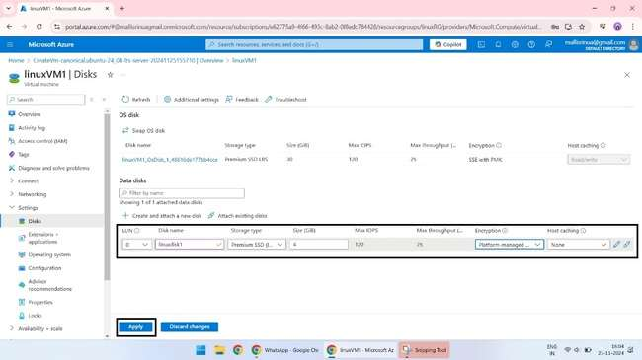

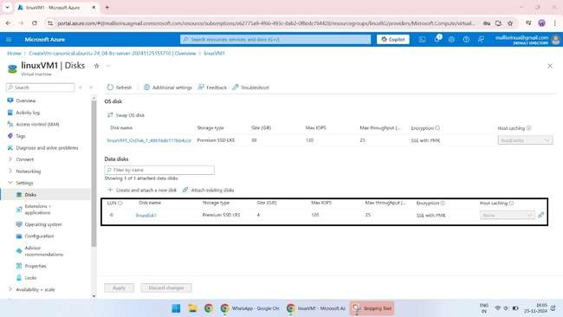

**Step 3: Make the Data Disk Usable**

1.SSH into the VM using your credentials.

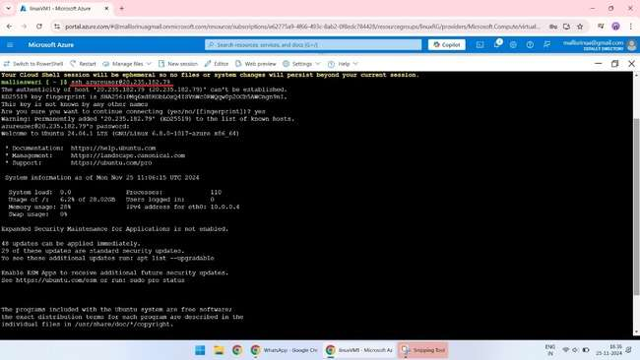

2.Initialize the New Disk

1. Check the disk name: sudo fdisk –l

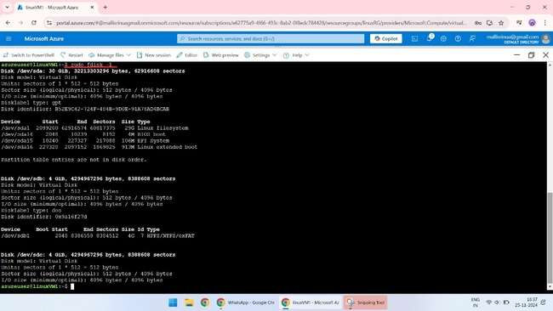

2. Create a partition on the new disk: sudo fdisk /dev/sdb

1.Press 'p' to print the partition table and verify that you're working with the correct disk.

2.Press 'd' to delete the existing partition.

3.Press 'n' to create a new partition.

4. Press 'p' to select the primary partition.

5.Press '1' to select the partition number.

6.Press 'Enter' to accept the default start sector.

7.Press 'Enter' to accept the default end sector.

8.Press 'w' to write the changes.

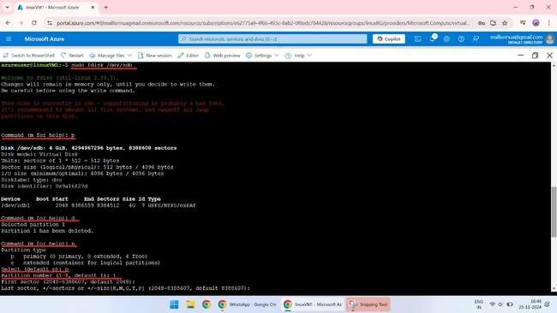

3. Format the new disk: sudo mkfs.ext4 /dev/sdb1

4. Create a mount point: sudo mkdir /mnt/data

5. Mount the disk: sudo mount /dev/sdb1 /mnt/data

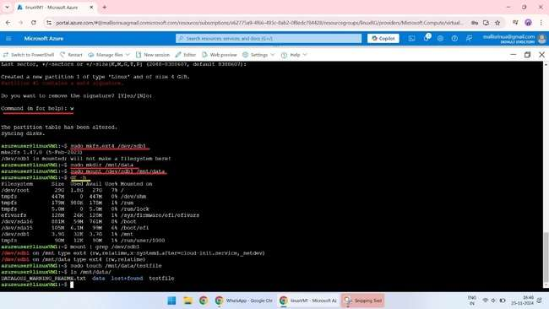

1. Check the disk usage: df -h

2. Verify the disk is mounted: mount | grep /dev/sdb1

3. Create a test file: sudo touch /mnt/data/testfile

4. Verify the file exists: ls /mnt/data/

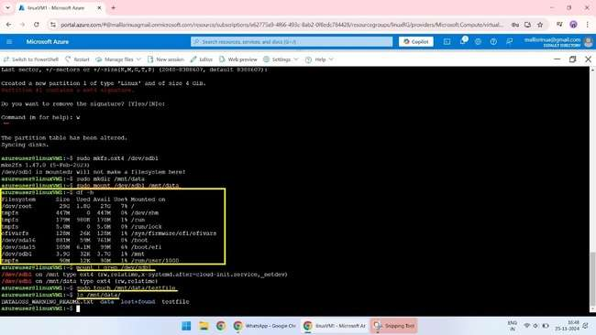

**4.Save Data to the Disk:**

Create a file or directory on the new disk. Verify that the data is saved and can be accessed.

1.sudo touch /mnt/data/newfile

ls /mnt/data/

2.sudo mkdir /mnt/data/newdirectory

ls /mnt/data

3.Write some data to the newfile file

"echo 'Hello, World!' | sudo tee /mnt/data/newfile"

4. View the updated contents of the newfile file

cat /mnt/data/newfile

5. Unmount the disk from the VM

Sudo umount -1/mnt

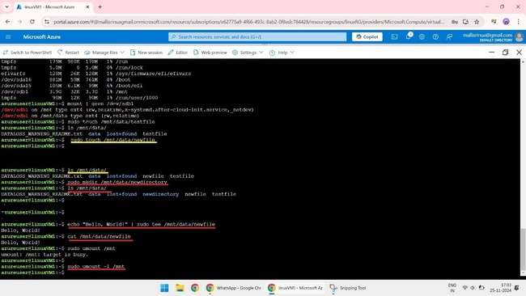

**5.Remove the Data Disk Safely:**

Go back to portal to Detach the disk from the VM and go overview for the delete process.

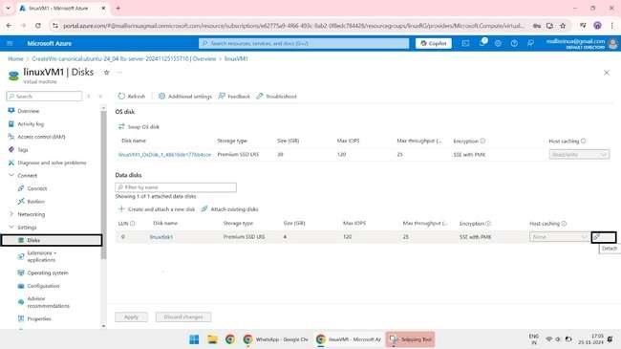

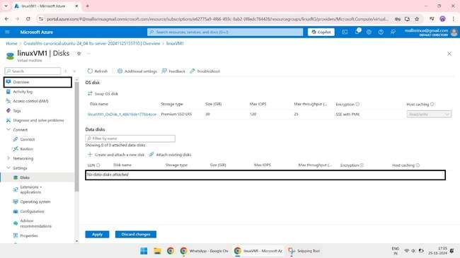

**6.Clean Up Resources:**

**Delete the disk and VM.**

While deleting the VM select the check box to delete the disk and other connection as shown and verify whether the disk and VM has been deleted.

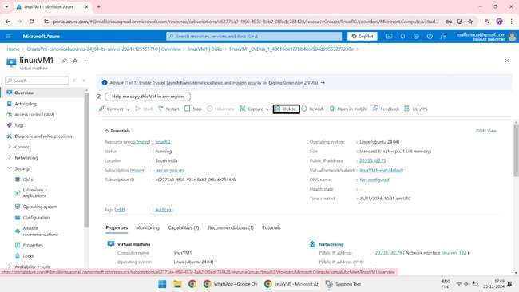

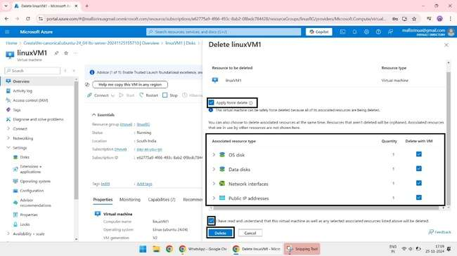

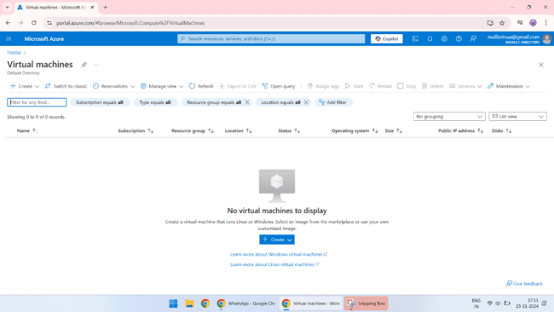

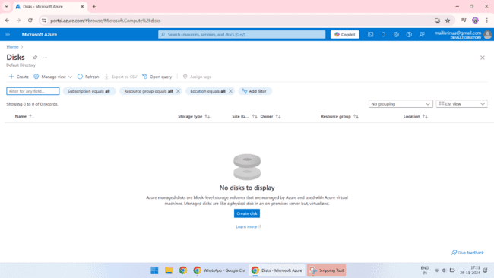

Delete the Resources Group

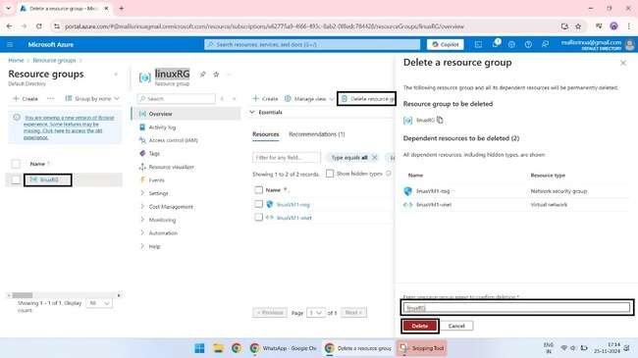

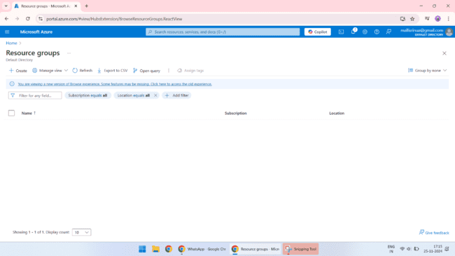

**Azure CLI Steps**

**Step 1: Create a Resource Group**

az group create --name testResourceGroup --location westus

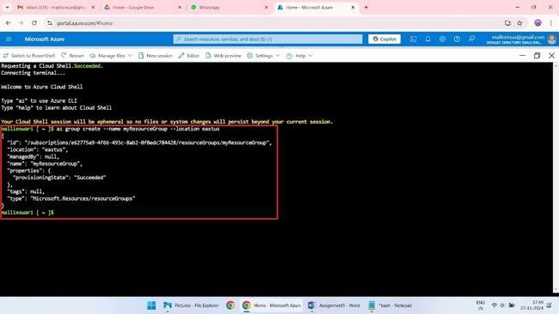

**Step 2: Create a Virtual Network**

az network vnet create --resource-group testResourceGroup --name MyVNet --address-prefix 10.0.0.0/16 --subnet-name MySubnet --subnet-prefix 10.0.1.0/24

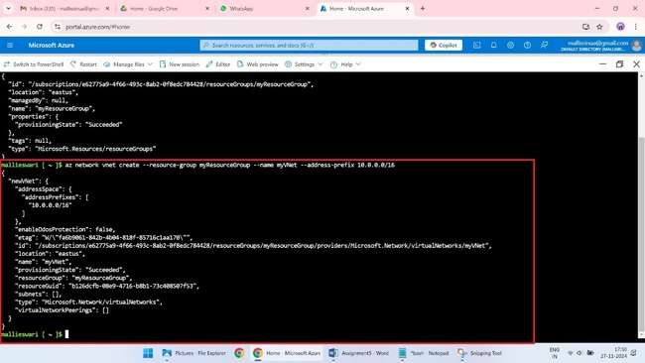

**Step 3: Create a Subnet**

az network vnet subnet create --resource-group myResourceGroup --vnet-name myVNet --name mySubnet --address-prefix 10.0.1.0/24

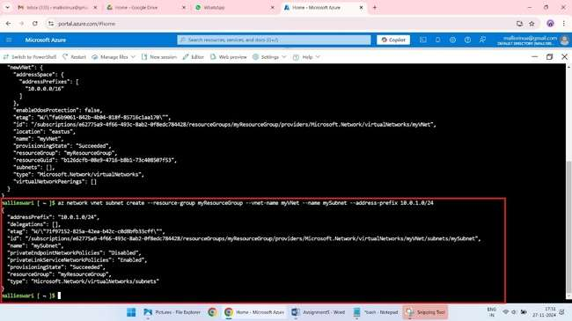

**Step 4: Create a Public IP Address**

az network public-ip create --resource-group testResourceGroup --name MyPublicIP --allocation-method Dynamic --sku Basic

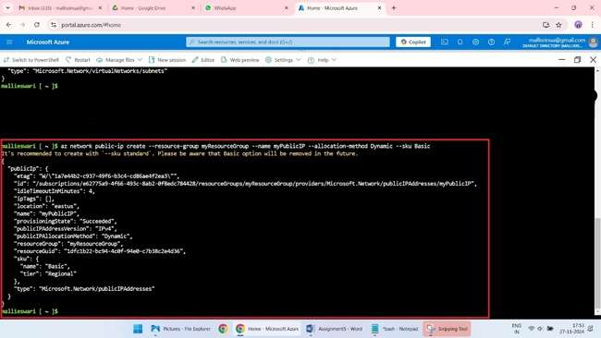

**Step 5: Create a Network Security Group**

az network nsg create --resource-group testResourceGroup --name myNSG

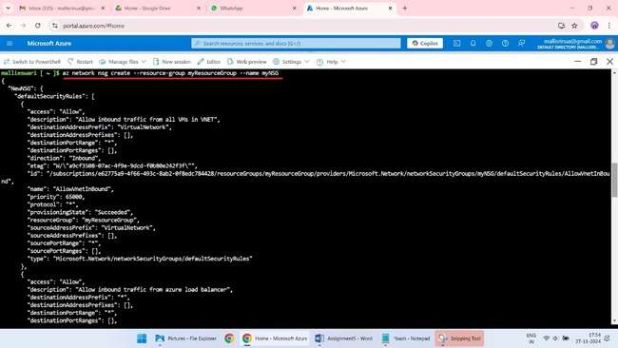

**Step 6: Create a Virtual Machine**

az vm create --resource-group testResourceGroup --name myVM --image Ubuntu2404 --size Standard_DS2_v2 --vnet-name MyVNet --subnet MySubnet --public-ip-address MyPublicIP --nsg myNSG --admin-username azureuser --generate-ssh-keys

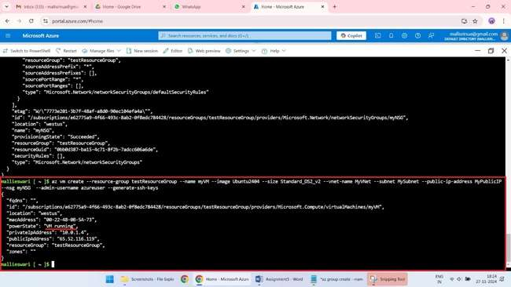

**Step 7: Add a Data Disk to the Virtual Machine**

az vm disk attach --resource-group testResourceGroup --vm-name myVM --name myDataDisk --size-gb 10 –new

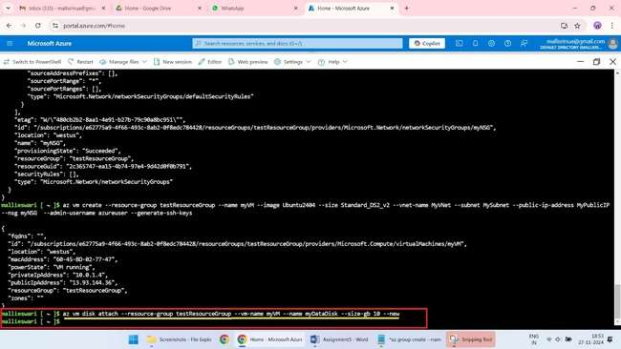

**Step 8: Initialize and Mount the Data Disk**

SSH into the virtual machine and initialize the data disk:

ssh azureuser@13.93.144.36

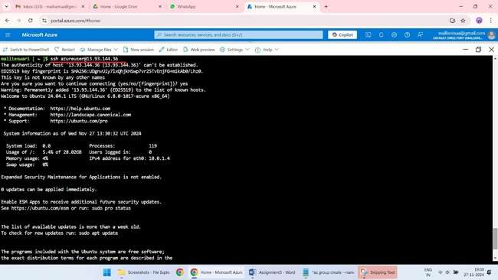

**sudo fdisk /dev/sdb**

1.Press 'p' to print the partition table and verify that you're working with the correct disk.

2.Press 'd' to delete the existing partition.

3.Press 'n' to create a new partition.

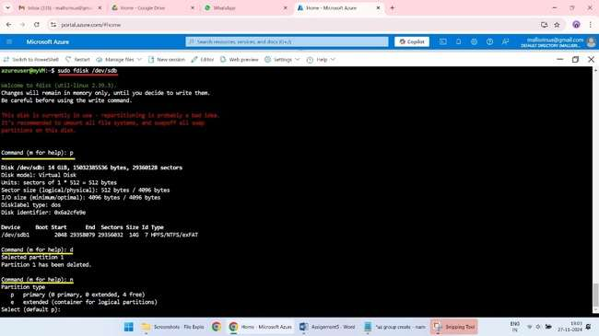

4. Press 'p' to select the primary partition.

5.Press '1' to select the partition number.

6.Press 'Enter' to accept the default start sector.

7.Press 'Enter' to accept the default end sector.

8.Press 'w' to write the changes.

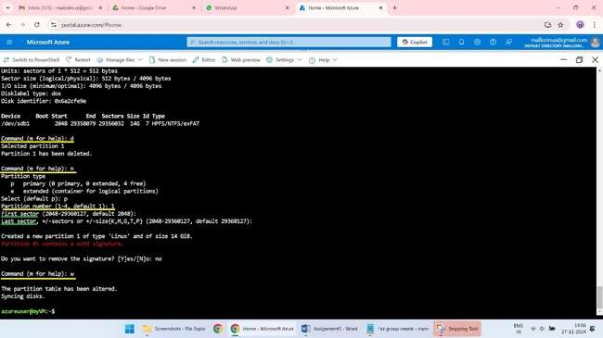

9.Format the new disk: sudo mkfs.ext4 /dev/sdb1

10. Create a mount point: sudo mkdir /mnt/data

11.Mount the disk: sudo mount /dev/sdb1 /mnt/data

12.Check the disk usage: df -h

13.Verify the disk is mounted: mount | grep /dev/sdb1

14.Create a test file: sudo touch /mnt/data/testfile

15.Verify the file exists: ls /mnt/data/

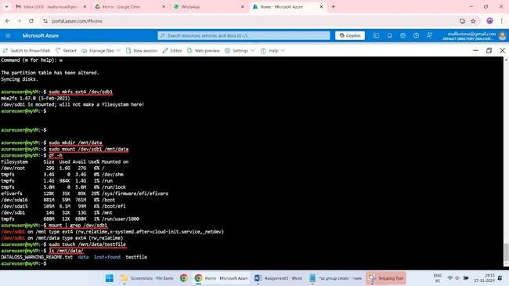

**9.Save Data to the Disk:**

Create a file or directory on the new disk. Verify that the data is saved and can be accessed.

1.sudo touch /mnt/data/newfile

ls /mnt/data/

2.sudo mkdir /mnt/data/newdirectory

ls /mnt/data

3.Write some data to the newfile file

"echo 'Hello, World!' | sudo tee /mnt/data/newfile"

4. View the updated contents of the newfile file

cat /mnt/data/newfile

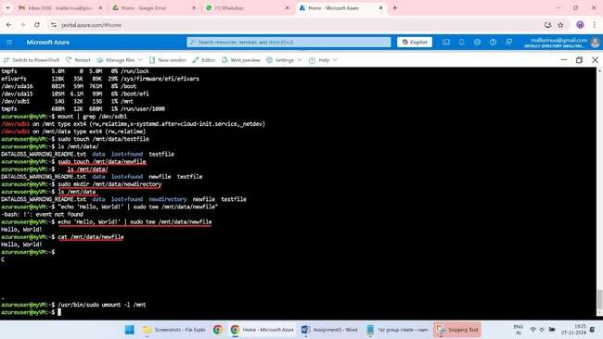

**Step 10: Remove the Data Disk Safely**

sudo umount /mnt/data

az vm disk detach --resource-group testResourceGroup --vm-name myVM --name myDataDisk

az disk delete --resource-group testResourceGroup --name myDataDisk

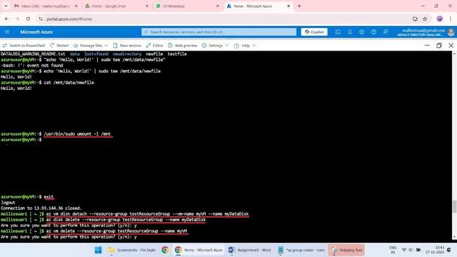

**Step 11: Clean Up Resources**

**Update the network interface to remove the NSG association**

az network nic update --resource-group testResourceGroup --name myVMVMNic --remove networkSecurityGroup

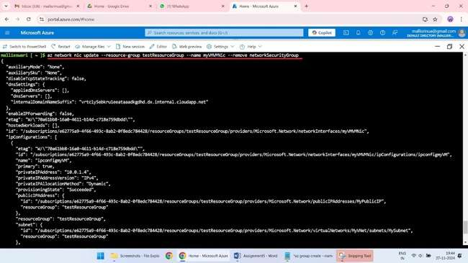

**Verify that the NSG association has been removed**

az network nic show --resource-group testResourceGroup --name myVMVMNic

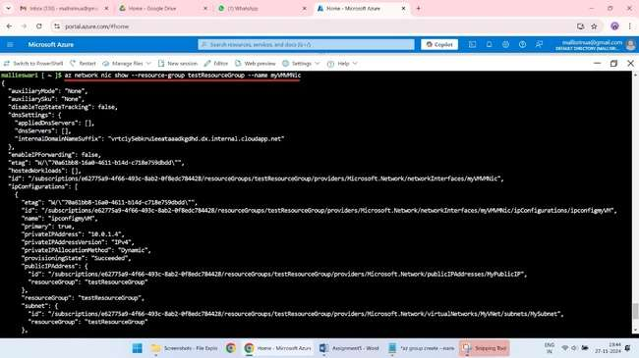

**Delete the NSG**

az network nsg delete --resource-group testResourceGroup --name myNSG

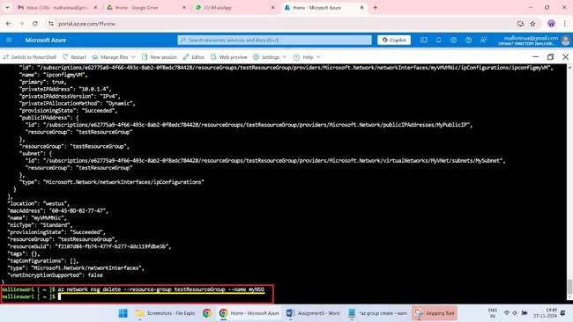

**Update the network interface to remove the Public IP Address association**

az network nic ip-config update --resource-group testResourceCenter --nic-name myVMVMNic --ip-config-name ipconfigmyVM --remove publicIPAddress

**Verify that the Public IP Address association has been removed**

az network nic show --resource-group testResourceGroup --name myVMVMNic

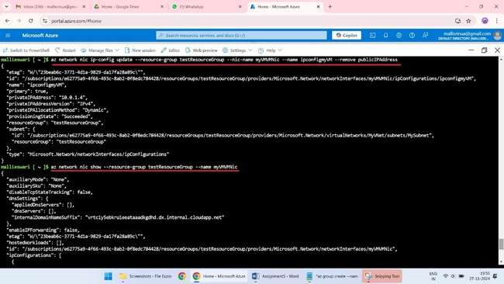

**Delete the Public IP Address**

az network public-ip delete --resource-group testResourceGroup --name myPublicIP

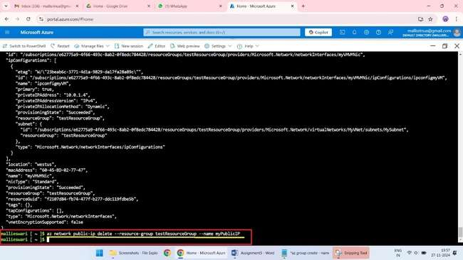

**Delete the network interface:**

az network nic delete --resource-group testResourceGroup --name MYVMVMNIC

**Delete the public IP address (if associated):**

az network public-ip delete --resource-group testResourceGroup --name myPublicIP

**Delete the virtual machine (if exists):**

az vm delete --resource-group testResourceGroup --name myVM

**Delete the subnet:**

az network vnet subnet delete --resource-group testResourceGroup --vnet-name myVNet --name mySubnet

**Delete the virtual network (if no other subnets exist):**

az network vnet delete --resource-group testResourceGroup --name myVNet

**Delete the ResourceGroup**

az group delete --name testResourceGroup

