**ASSIGNMENT-8**

**AzureProtal**

**Task 1: Create an Azure Resource Manager Template**

1. **Open a text editor** and create a new file named template. json.
2. Write an ARM template code, which defines a managed disk
3. **Save the file** as template. json.

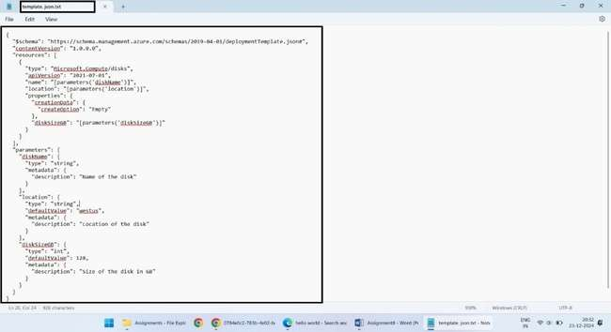

**Task 2: Edit Azure Resource Manager Template and Deploy the Template**

1. **Edit the** template. Json
2. Deploy the template using the Azure Portal
3. Go to the **Azure Portal**.
4. Navigate to **Resource Groups** and select or create a resource group.
5. Click **Create a resource** and search for **Template deployment**.

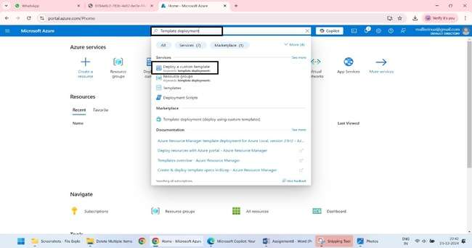

1. Select **Build your own template in the editor**.

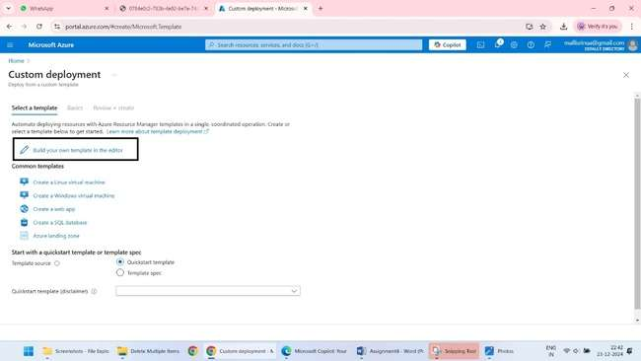

1. **Copy and paste** the corrected template. json code into the editor and click **Save**.

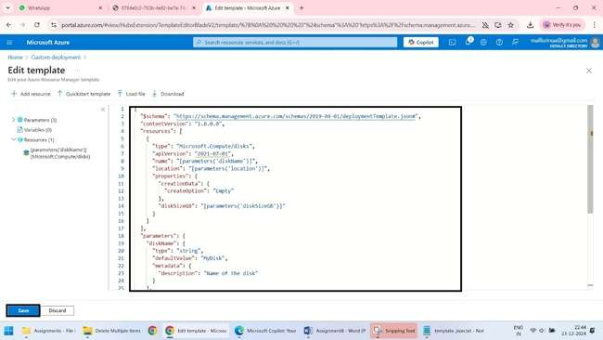

1. Provide the required parameters:

* **diskName**: MyDisk
* **location**: eastus
* **diskSizeGB**: 128

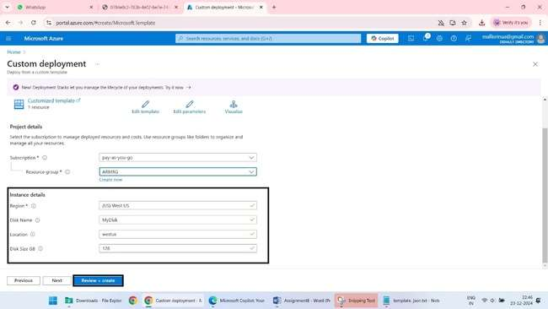

1. Click **Review + create**, and then click **Create** to start the deployment.

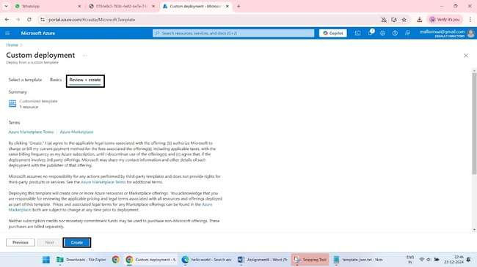

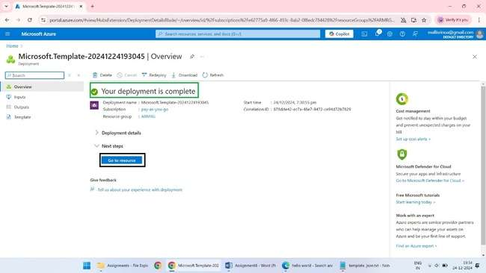

3 Verify the Disk has deployed successfully.

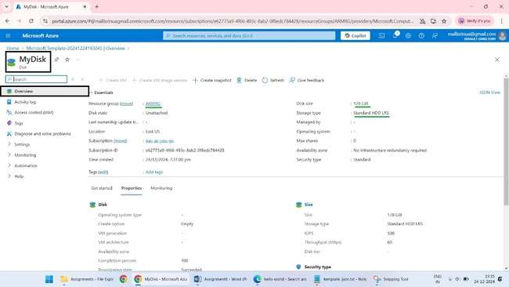

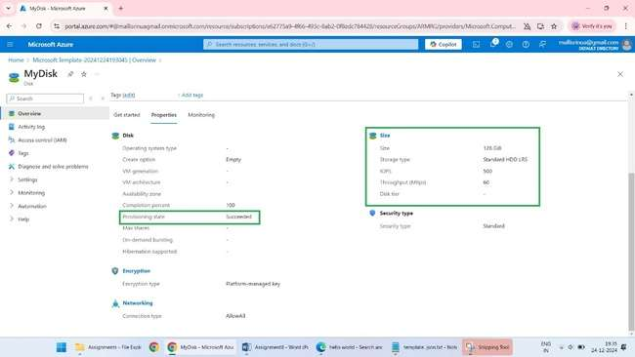

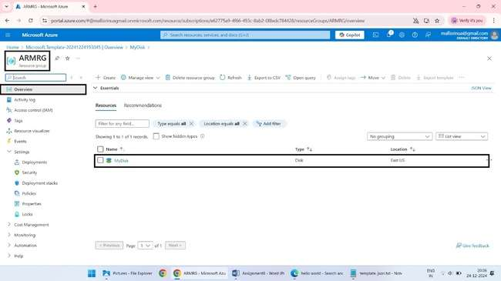

4 Clean up the resources.

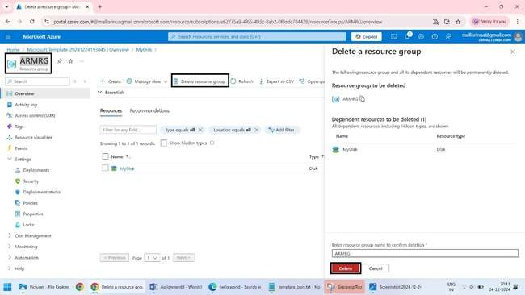

**Azure PowerShell**

**Task 3: Configure Cloud Shell and Deploy with Azure PowerShell**

1. **Open Azure Cloud Shell** in the Azure Portal.
2. **Choose PowerShell** if prompted.
3. **Upload the corrected** template. json **file** to Cloud Shell.

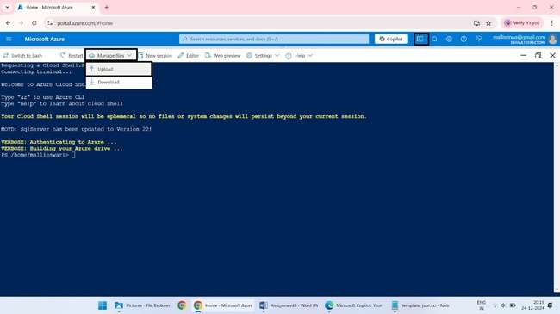

1. **Run the following PowerShell script** to deploy the template

**New-AzResourceGroup -Name myResourceGroup -Location eastus**

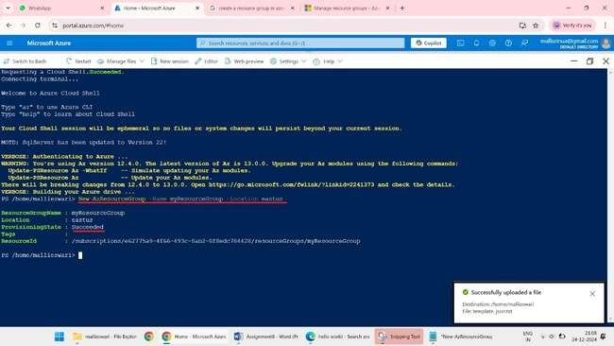

**# Define parameters**

**$resourceGroupName = "myResourceGroup"**

**$templateFile = "/home/mallieswari/template.json" # Ensure correct path**

**$parameters = @{**

**"diskName" = "MyDisk"**

**"location" = "eastus"**

**"diskSizeGB" = 128**

**}**

**# Deploy the template**

**New-AzResourceGroupDeployment -ResourceGroupName $resourceGroupName -TemplateFile $templateFile -TemplateParameterObject $parameters**

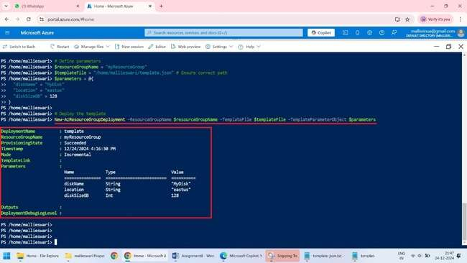

1. Verify in portal does the disk is deployed

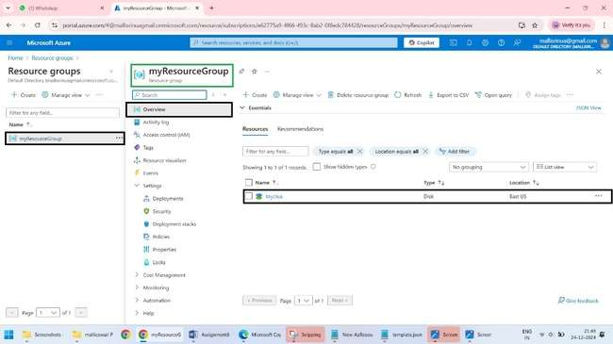

1. Cleanup the resource.

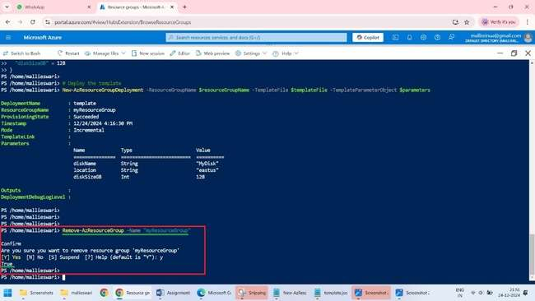

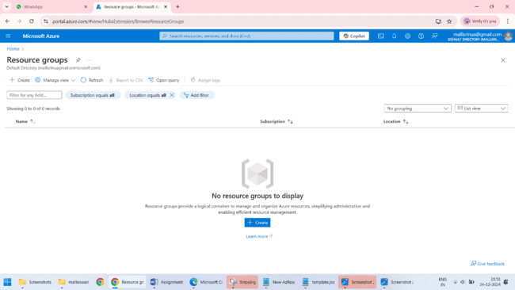

**Azure CLI**

### Task 4: Deploy a Template with the CLI

1. **Open Azure Cloud Shell** and select **Bash** if prompted.
2. **Upload the corrected** template. json **file** to Cloud Shell.

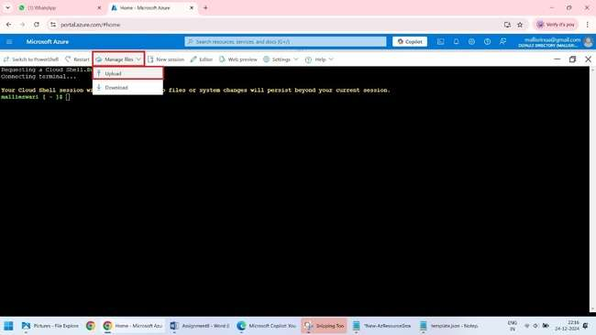

1. **Run the following CLI commands** to deploy the template

**az group create --name MyResourceGroup --location westus**

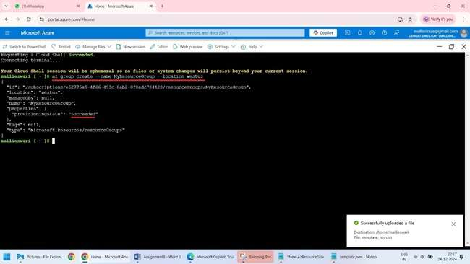

**# Define variables**

**resourceGroupName="myResourceGroup"**

**templateFile="/home/mallieswari/template.json" # Ensure correct path**

**parameters='{"diskName": {"value": "MyDisk"}, "location": {"value": "eastus"}, "diskSizeGB": {"value": 128}}'**

**# Deploy the template**

**az deployment group create --resource-group $resourceGroupName --template-file $templateFile --parameters "$parameters"**

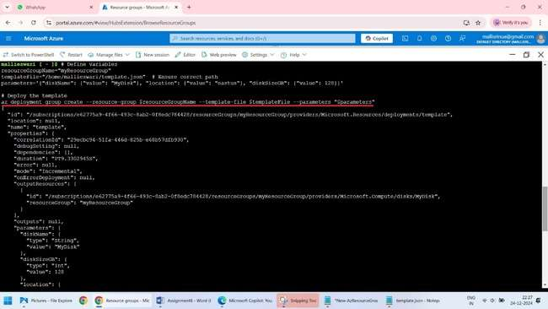

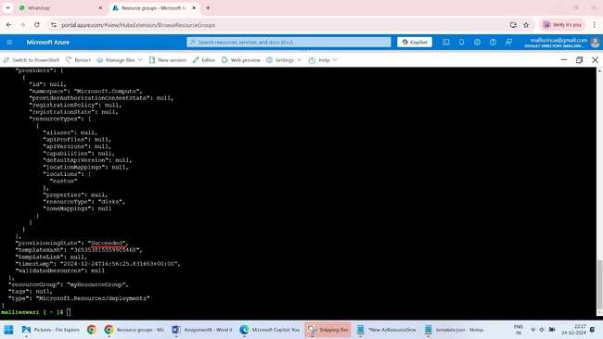

1. Verify in portal does the disk is deployed

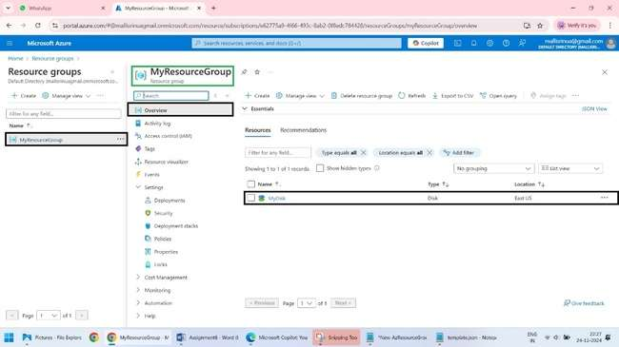

1. Cleanup the resource.

