**ASSIGNMENT-9**

**Step 1: Set the resource group**

az group create --name MyResourceGroup --location eastus

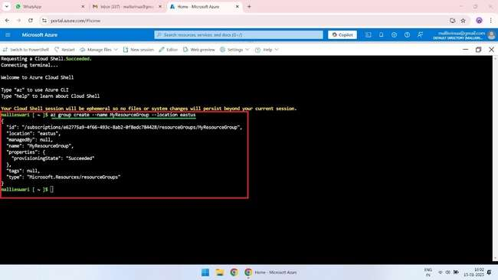

**Step 2: Create a VNET**

az network vnet create --resource-group MyResourceGroup --name MyVNET --address-prefix 10.0.0.0/16 --location eastus

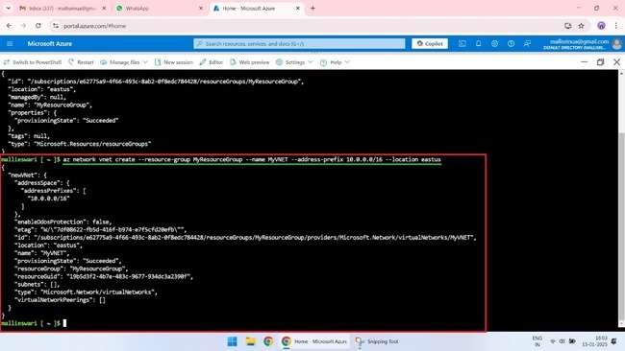

**Step 3: Create a Windows VM**

az vm create --resource-group MyResourceGroup --name MyWindowsVM --image win2019datacenter --vnet-name MyVNET --subnet default --size Standard_DS2_v2

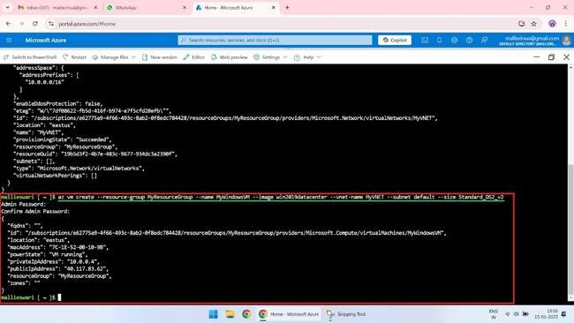

**Step 4: Find the VM public IP and disassociate it**

az vm show --resource-group MyResourceGroup --name MyWindowsVM --query publicIps

az network public-ip delete --resource-group MyResourceGroup --name MyWindowsVM-ip

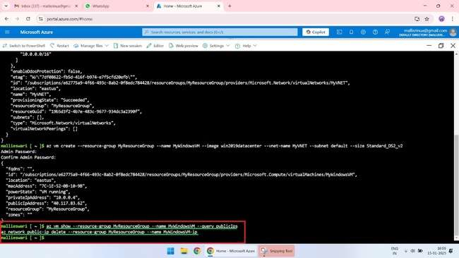

**Step 5: Restart the VM if it's stopped**

az vm restart --resource-group MyResourceGroup --name MyWindowsVM

**Step 6: List out the subnets of VM and Bastion Host**

az network vnet subnet list --resource-group MyResourceGroup --vnet-name MyVNET

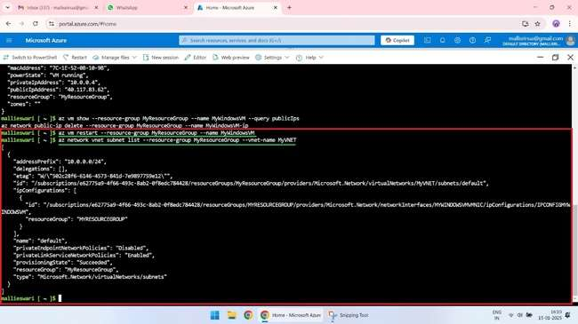

**Step 7: Try logging the VM with the available private IP from your machine**

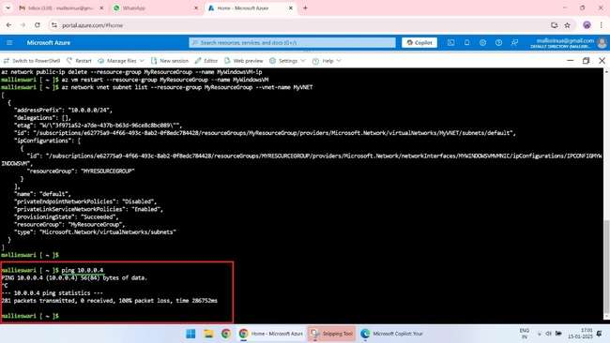

**Step 8: Reattach the public IP with the VM**

az network public-ip create --resource-group MyResourceGroup --name MyWindowsVM-ip --allocation-method Static

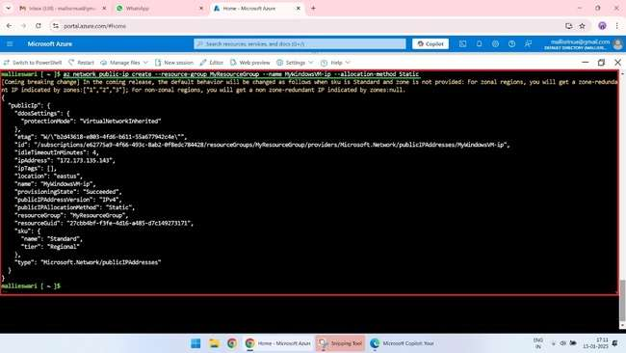

az network nic ip-config update --resource-group MyResourceGroup --nic-name MyWindowsVMVMNic --name ipconfigMyWindowsVM --public-ip-address MyWindowsVM-ip

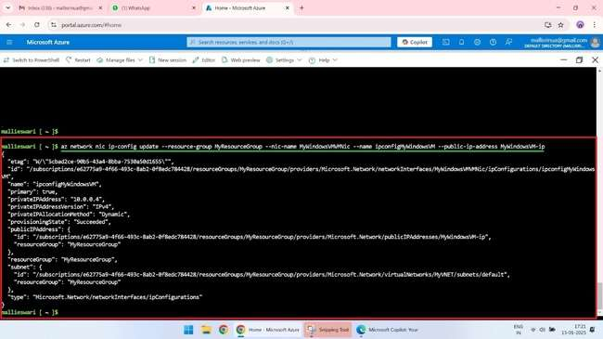

**Step 9: Restart the VM if it's stopped**

az vm restart --resource-group MyResourceGroup --name MyWindowsVM

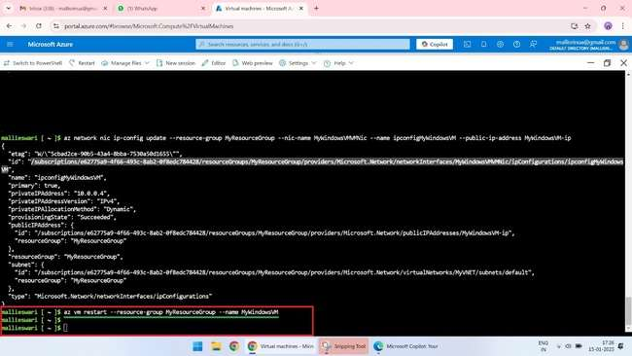

**Verify in portal**

