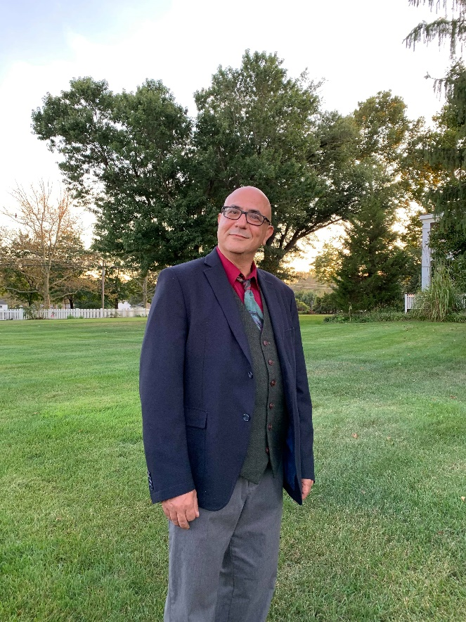Marc Jellinek

[marc.jellinek@gmail.com](mailto:marc.jellinek@gmail.com)

<https://www.linkedin.com/in/marcjellinek>

<https://github.com/marc-jellinek>

Parlin, NJ

Architecture 1

Architecture 2