# Governance for Speed and Scale

## Contents:

* Executive sponsorship
* General approach
* Membership
* Commitment and expectations
* Charter
* Training and Education

## Customizing this approach

This document describes the formation of various governance bodies. This guidance should be thought of as a generic proposal and not a one-size-fits-all design. The size of your organization and how it is structured should be taken into account when implementing these ideas. Feel free to customize this approach as needed if the approach you take produces the desired results. The details listed here is available for those organizations looking for a place to start.

## It’s Culture not Cloud

The

### Critical Success Factors

#### Leveraging your enablers

#### Realizing Benefits

#### Driving Self-reliance

## Executive sponsorship

Before you undertake the AGF or the formation of a CCoE is it imperative that you have an executive sponsor. This approach is forward-looking and disruptive to the way IT organizations have been run historically. You should expect to encounter resistance, either to cloud in general or this approach in particular (typically arguing instead for the “Extend the DC” model described in the [AGF Introduction](https://github.com/gosson/azure-governance-foundations/blob/master/AGF/100-AGF%20Introduction.md)). Ideally your sponsor should be a C-level executive (CIO, CTO, etc.) and one who shares the vision of modernizing IT and evolving it from a technology broker to a business partner. Again, depending on the size and complexity of your organization, this may not be feasible but secure a sponsor with as much power and authority as possible. Their endorsement will facilitate the creation of these groups and provide a mantel of authority under which they will operate.

Once your sponsor has been identified, they should nominate someone to head the CCoE (as they will probably not have the time to do this themselves). This person will be charged with the actual creation of the groups, nomination of membership and general day-today activities. They will also bring the sponsor in when organizational roadblocks occur at least until such a time as the charter, direction and endorsement of the CCoE is widely understood within the organization.

## General approach

At its core, the CCoE can be thought of as a parliamentary system with multiple assemblies (technically a multicameral governing body) in which each assembly (or committee) represents an aspect of the technology transformation: Platform, Security, Monitoring, etc. and is responsible for governing that aspect. The committees control their own destiny with respect to their areas but require consensus on matters that affect other committees for the CCoE as whole. A committee brings their proposal to the full CCoE to be discussed and ultimately ratified. If during this discussion, it becomes clear that the policy will affect other committees, the affected committees should come to an agreement. If they cannot, the full CCoE may vote on such matters.

Below are a few examples to help clarify this approach:

#### Example 1:

The Monitoring committee submits a policy where every new container that is deployed must have logging enabled and be configured to send those logs to a specified workspace so that it can be viewed by Azure Monitor. During discussion, a representative from the Architecture asks if the current architecture design for Azure Kubernetes Service needs to be modified to accommodate this change. The Monitoring committee explains that the policy will automatically be applied to new containers without any changes to the design and that existing containers can be updated with a simple script generated by the policy engine. The Architecture team having been satisfied that they are unaffected has no objection to the policy.

Because this policy does not affect other committees, the details of the policy (what amount of logging and where the log go) are solely the purview of the Monitoring Committee. Nonetheless it is important to submit the policy for ratification so that the CCoE understands what the policy does and has a chance to ask questions about it.

#### Example 2:

The Platform committee decides that having a large number of Azure subscriptions (one for each application) is desirable. When the Platform committee brings that policy to the full CCoE to be discussed, the Security committee raises a technical consideration – namely that the current Azure limitation for vnet peerings is 100. If the organization will have more than 100 subscriptions, connectivity between subscriptions will need to be addressed differently that they had planned. Since this policy does affect more than one committee the committees need to find an amicable resolution or have the entire CCoE vote on the policy.

In this case during discussion the CCoE determines that there are only 20 applications currently in the plan and that at the rate of growth is will be at least three years until the organization reaches 100 applications. Given the expected timeframe the Networking committee withdraws its objection with the expectation that the technical limit (which has grown over time) is likely to continue to grow and meet their needs.

If the Networking committee had not withdrawn its objection and was unable to reach a consensus with the Platform Committee, the CCoE would then vote of the matter with each member weighing the merits and risks of the policy.

## Membership

The CCoE, as a whole, is composed of the person nominated by the executive sponsor (Mgmt Authority in the diagram below) acting as chair, a SCRUM master or program manager and a representative from each committee.

Each committee must contain at least one member (but generally not more than six). Some committees can share memberships where appropriate. For example, a member of the Security committee would also be at home as a member of the product Catalog committee (since the certification of products in the catalog has a security element). This might also be a necessity if the number or resources that can be dedicated to CCoE work is minimal

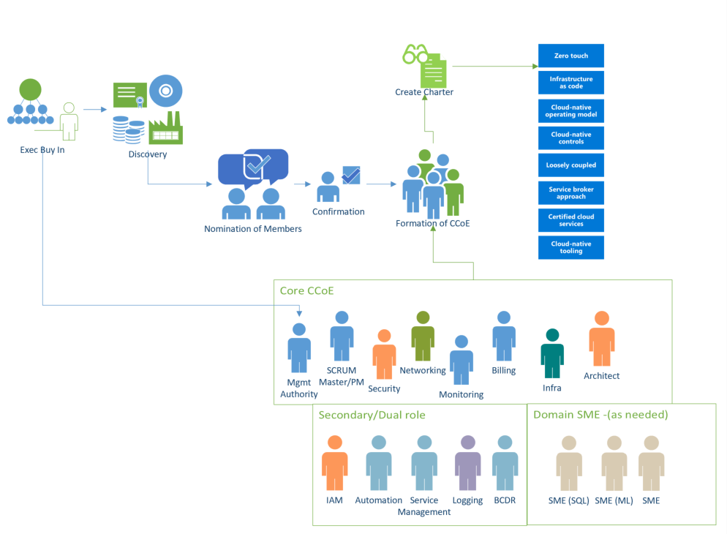

There should also be at least one project manager (or SCRUM manager) for each committee as well as the CCoE. The same PM can manage the responsibility across multiple committees if time/resourcing permits.

NOTE: In larger organizations the creation of a Project Management Committee would not be out of place.

In a smaller organization with resource constraints the CCoE might be as small as six people (four committees of one plus the PM and a chairperson. A CCoE smaller than this is discouraged as it is likely too daunting and demanding for those resources.

## Commitment and expectations

### Rhythm of the Business

The

### Program Management

The

### Agile, SaFE or Kanban?

The

### From Discovery to Delivery

The

### Escalations

The

### Creating a Culture of Accountability

The

### Empowered and self-organizing teams

The

## Governing bodies

### Steering Committee

The

## Bridging team

## Cloud Center of Excellence

One approach that successful customers have implemented is the creation of a Cloud Center of Excellence (CCoE). The CCoE is comprised of teams of very specialized personnel who focus on cloud governance and management. The idea of a CCoE is one of a modern IT operational model that that follows an agile approach to capturing business requirements to partner with the business. The goal of the AGF is to help customers create a functional CCoE that provided agility, governance and security to the business.

A Cloud Center of Excellence is a group dedicated to maintaining a secure, compliant and well-governed cloud. The CCoE is made up of representatives from the areas of the business that are affected by the cloud. Each of the members of the CCoE are experts in their respective areas both in the on-premise world and in the cloud. The CCoE is broken up into committees (or team of teams) which focus on specific areas of the cloud. Typically, these are:

* Platform governance
* Security
* Architecture
* Monitoring
* Automation
* Product Catalog
* DevOps
* Data
* Program Management

Each of these committees are focused on their area and they create the policies which will ultimately be enforced by the cloud. While the committees control their own destiny with respect to their area, they do not operate in a vacuum. As the committees create policies, they submit them back to the larger CCoE for comments and ratification. In this way, no one group operates without oversight and policies that are proposed are reviewed for any potential impact upon other groups or the cloud as a whole (this is imperative as policy decision may have unintended consequences for other committees).

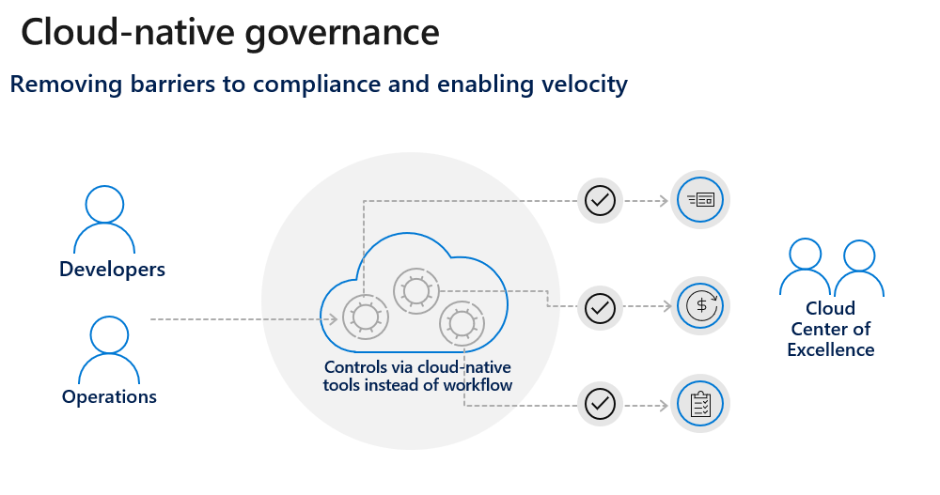

The CCoE achieves control over the cloud by using cloud-native tools to meet the organization’s needs. By building a secure framework they can step back and allow business units to consume the cloud without the same obstacles that the traditional approach creates.

### Hallmarks of a CCoE

A CCoE will create its own specific charter that will dictate how it operates in specific but in general terms there are a few common hallmarks of a CCoE model:

* Service Broker Approach
* Loosely Coupled Architectures
* Re-use of certified cloud services
* Use of Cloud-native tooling
* Cloud Native Controls
* Zero touch implementations
* Infrastructure as code
* A cloud native operating model

These hallmarks are detailed in the [Building a Cloud Center of Excellence](https://github.com/gosson/azure-governance-foundations/blob/master/AGF/101-Building-a-Cloud-Center-of-Excellence.md) guide.

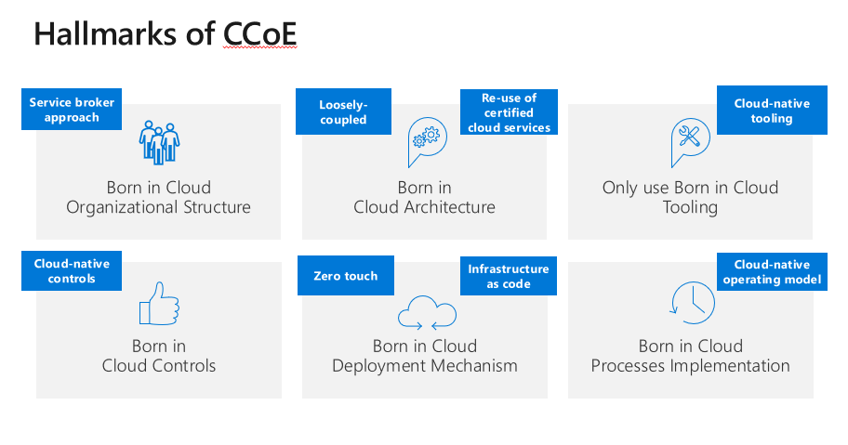

During the initial phases of this approach, expect members to have a full-time or near-full-time commitment. Between the training needed, research, experimentation and proposals a great deal of time needs to be invested by members.

If all members of the CCoE were already considered experts in their respective areas of cloud, the AGF might be completed in as little as one month. However, since at least some training and ramp up is typically required a more realistic timeframe is 90 days.

During this time, the CCoE should meet at least weekly with the intervening time dedicated to the work of individual committees which may be meeting daily.

After the foundations haven been completed and the platform is ready to accept workloads (at the completion of the work described in the AGF), the time commitment may be reduced. The amount of time the CCoE needs to invest will then be a function of the number of workloads expected and how close the platform gets to achieving a ‘steady state’.

In smaller organizations in a steady state, committee membership may drop to a single person with CCoE meeting happening as infrequently as monthly. In large organizations membership generally continues to be a full-time commitment, although the size of the committees may shrink.

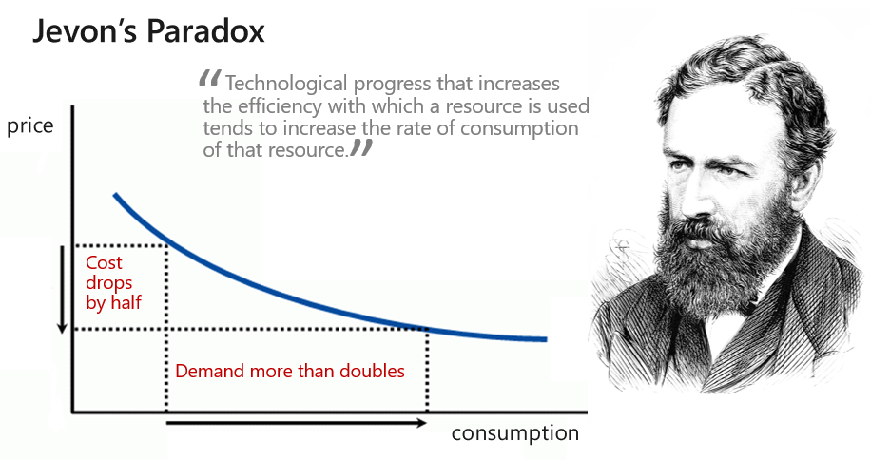

As the rate of consumption of new cloud services rises within an organization, the benefits that cloud offers becomes fully realized and IT department’s transformation from man-in-the-middle acquiring new hardware to a true business partner enabling their companies to achieve more.

## Organizational Change Management

s

## Training and Education

Please refer to the [Enterprise Learning Plan](https://github.com/gosson/azure-governance-foundations/blob/master/AGF/102-Enterprise-Learning-Plan.md) for a detailed sample of the courses, workshop and hacks that are available to upskill the members of the CCoE. This training document is broken down by committee for your convenience.