VISVESVARAYA TECHNOLOGICAL UNIVERSITY
“Jnana Sangama”, Belagavi-590018, Karnataka, India
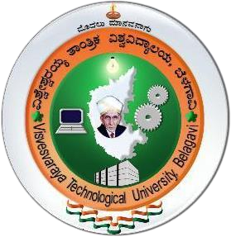
PROJECT PHASE-1 REPORT ON

“AI Virtual Voice Assistant”
Submitted in partial fulfilment of the requirements
For the Seventh Semester Bachelor of Engineering Degree
SUBMITTED BY
Kiran A (1IC22CD005)
Mallik Gowda M (1IC22CD006)
V Yoganjul Reddy (1IC22CD025)
Varun Kumar KS (1IC23CD403)

Under the guidance of Dr. Sheethal Aji Mani
Assistant Professor

Dept. of AIML

IMPACT COLLEGE OF ENGINEERING AND APPLIED SCIENCES
Sahakaranagar, Banglore-560092

2025-2026

IMPACT COLLEGE OF ENGINEERING AND APPLIED SCIENCES
Sahakaranagar, Banglore-560092



DEPARTMENT OF DATA SCIENCE
CERTIFICATE
This is to certify that the Project Work entitled " AI Virtual Voice Assistant” carried out by Kiran A (1IC22CD005), Mallik Gowda M (1IC22CD006), V Yoganjul Reddy (1IC22CD025),Varun Kumar (1IC23CD403) are bonafide students of Impact College of Engineering and Applied Sciences Bangalore has been submitted in partial fulfilment of requirements of VII semester Bachelor of Engineering degree in Computer Science & Engineering (Data Science) as prescribed by VISVESVARAYA TECHNOLOGICAL UNIVERSITY during the academic year of 2025-2026.

Signature of the Guide

Dr. Sheethal Aji Mani
Assistant Professor
Dept. of AIML
ICEAS, Bangalore.
Signature of the HoD

Dr. Kaipa Sandhya
Prof. & Head
Dept. of CSE (CD)
ICEAS, Bangalore.

Signature of the Principal

Dr. Jalumedi Babu
ICEAS, Bangalore

Name of Examiner Signature with date

- 1.

- 2.

