Day1

.Slack --> join
2.https://gitlab-ust.stackroute.in/
3.https://stackbooks-ust.stackroute.in/
4.https://hobbes-ust.stackroute.in/#/
5.Standup call
Software Setup :

JAVA JDK Version-> 8
https://www.oracle.com/in/java/technologies/javase-jdk11-downloads.html
IDE
Download IntelliJ IDEA
https://www.jetbrains.com/idea/download/#section=windows

STS Eclipse
https://spring.io/tools
GIT
https://git-scm.com/download/win
MYSQL / MONGODB
(server -> run in port)
https://dev.mysql.com/downloads/installer/
https://www.mongodb.com/try/download/community

GIT :
GIT BASIC COMMANDS:

Maven Project : Build Automation Tool
Makes Developer to bulid the project easy
Based on pom.xml (probect Object Model)
Central Repository : https://mvnrepository.com/
Remote Repository : UST Organization (Server)

Local Repository : it workspace

Version Control System
-> Central Repo
-> Updated Version
-> Work as Team
-> Track the changes you make to files (Track History)
GIT (Distributed VCS):
Git global setup
git config --global user.name "Sathish.G"
git config --global user.email "sathish.g@stackroute.in"
Initialize Git Local Repo:
git init
where we need to uplaod our code?
Remote Repo -> location -> gitlab -> url
git remote add origin https://gitlab-ust.stackroute.in/Sathish.G/demo-ust-wave45.git

git status
git add . (it will add all files in staging area(intermediate memory))

git status -> Changes to be committed:

git commit -m(message) "intial Commit"
git commit -m "first commit"

git status
Push the code from local to central
git push -u origin master

day2

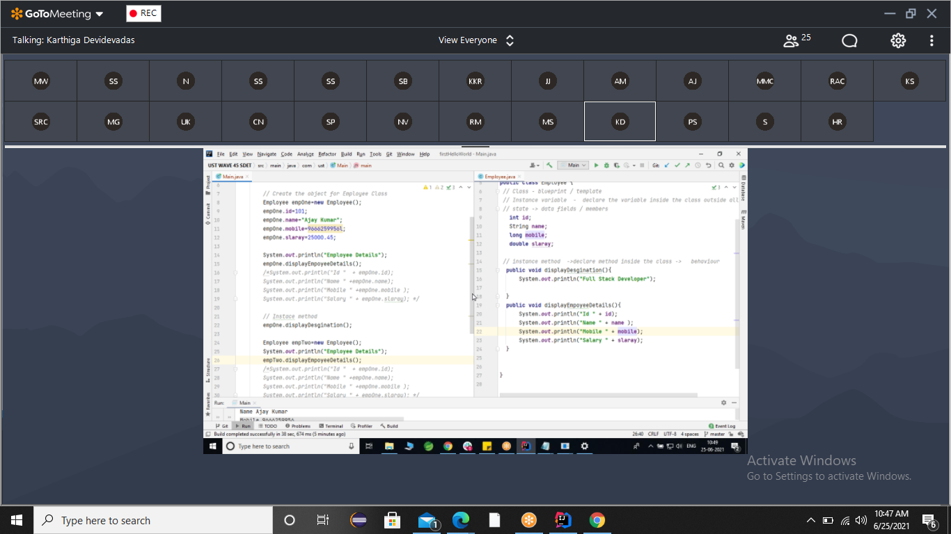

Private

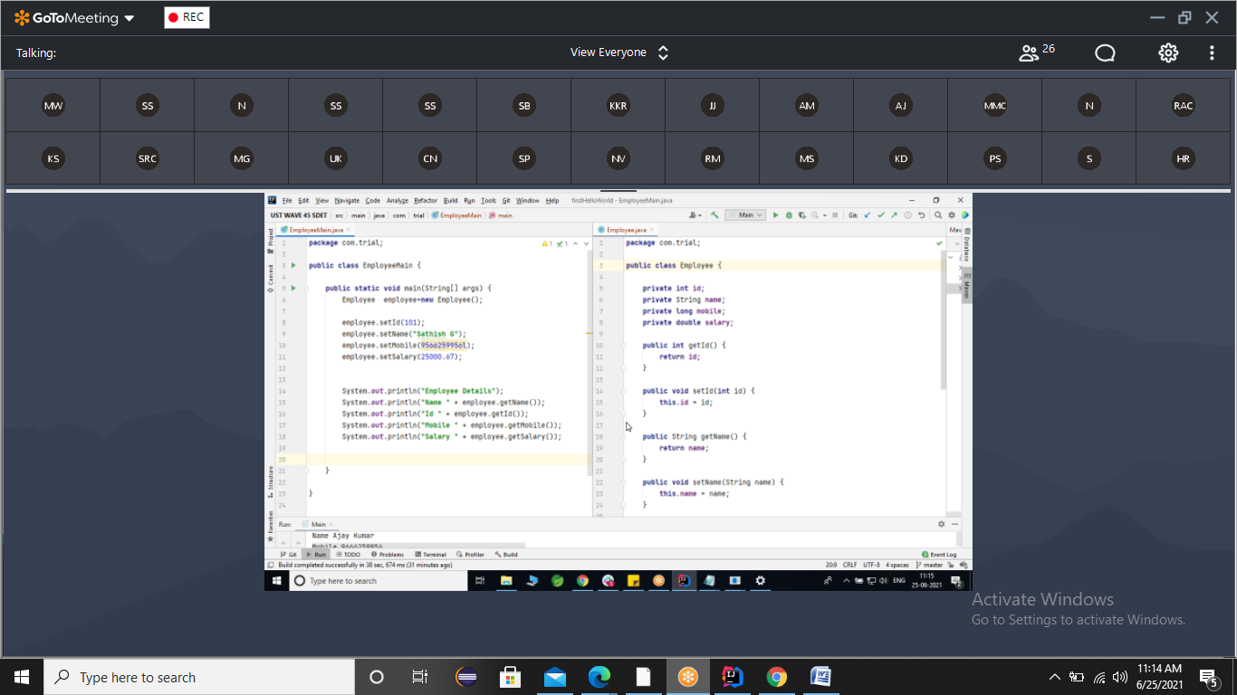

Input from keyboard

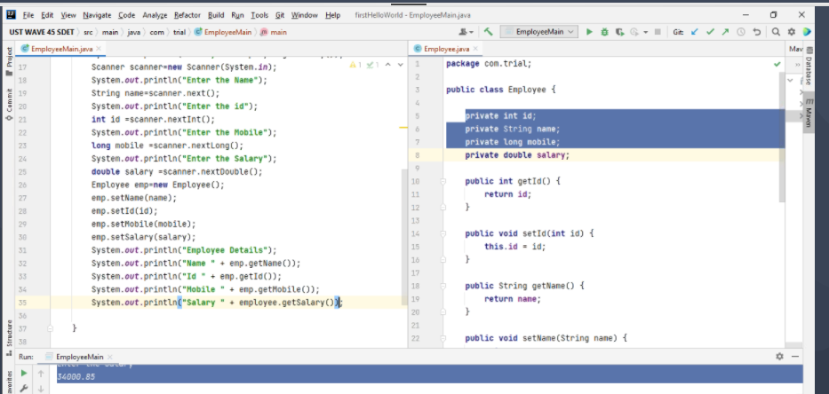

Constructor
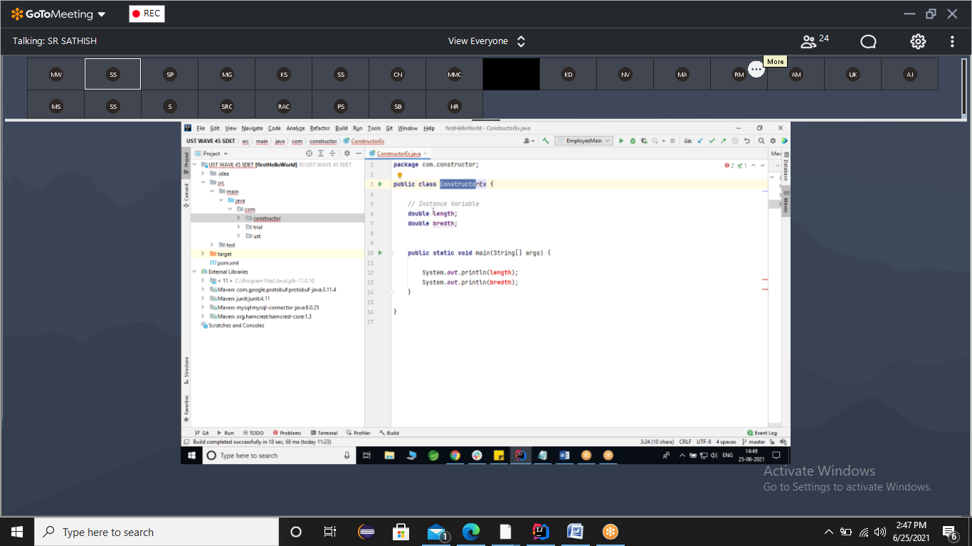

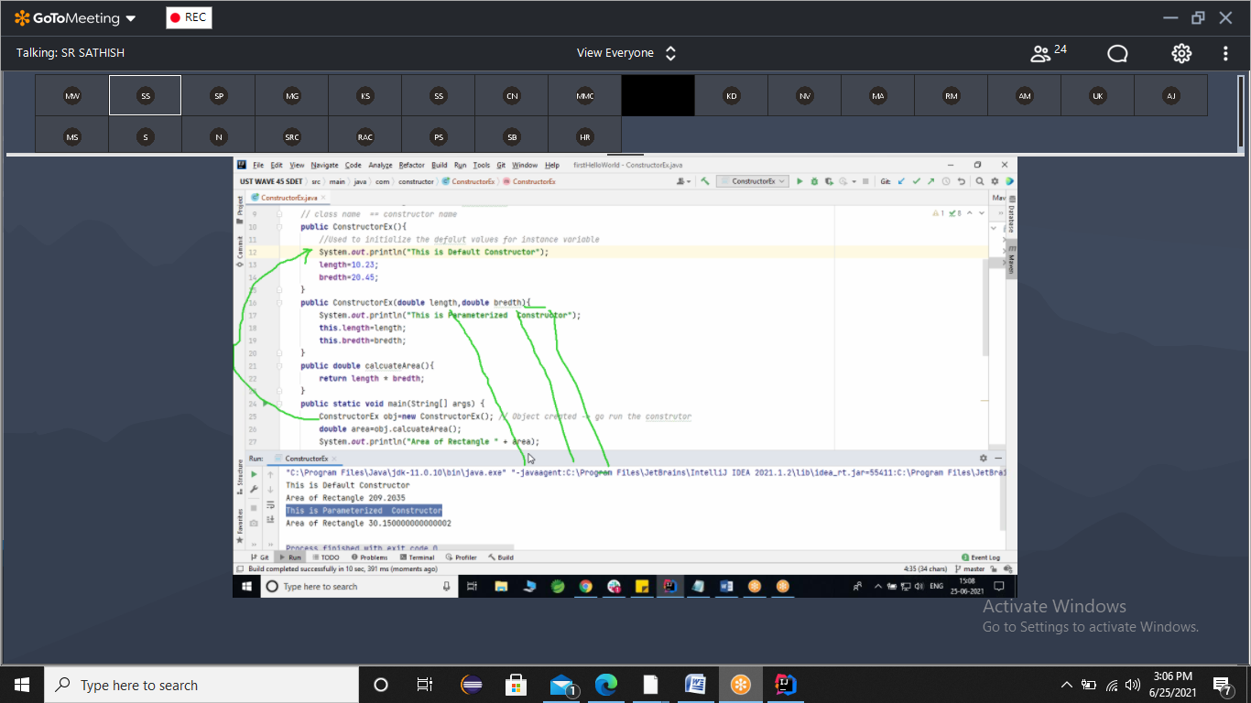

Constructor overloading

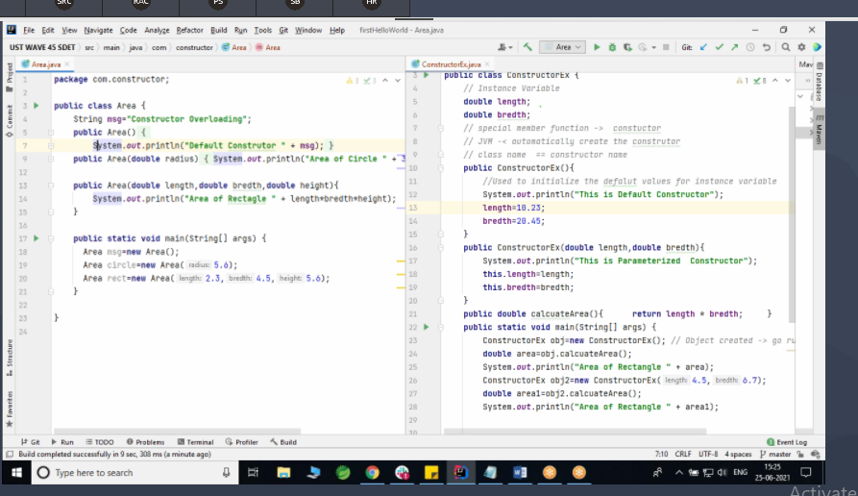

Array
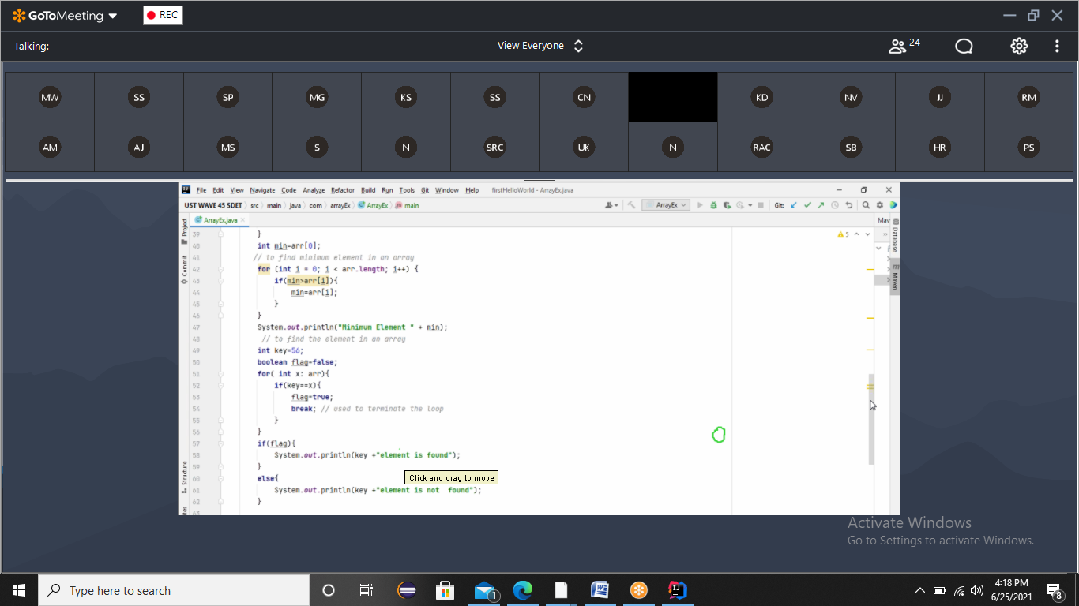
https://gitlab-ust.stackroute.in/stack_java_cycle1_exercises/exercise-bt-operator-arithmeticoperator
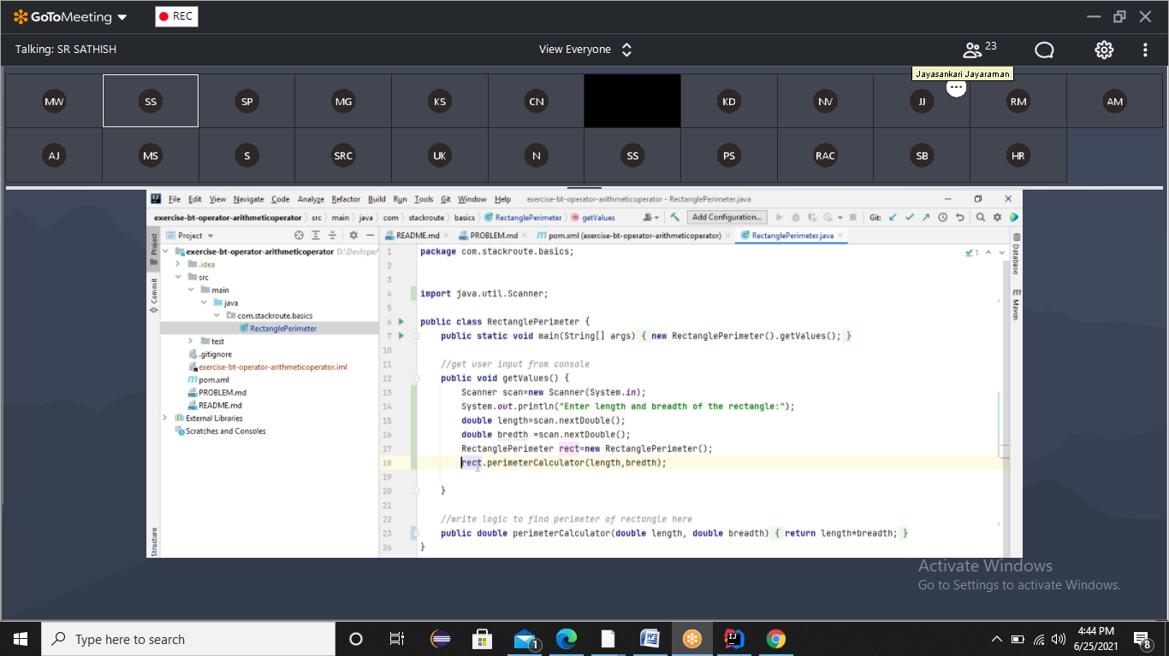
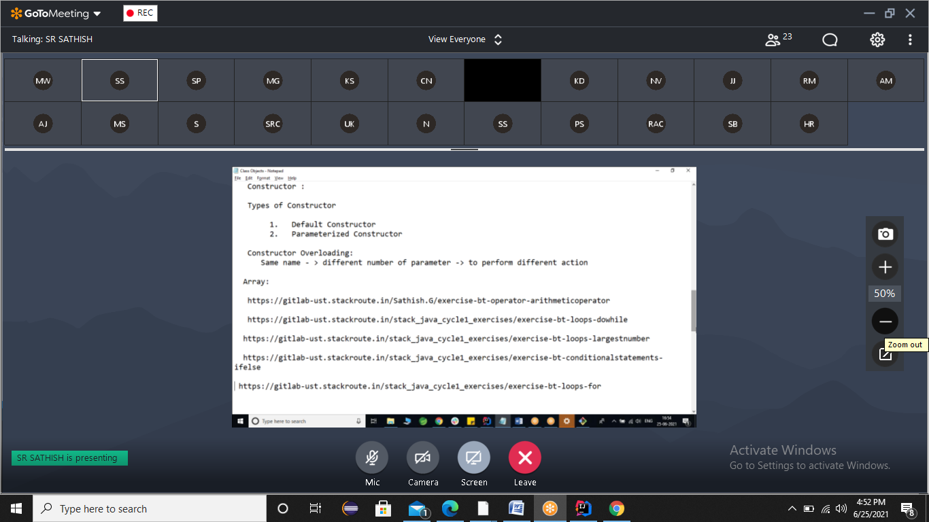
https://gitlab-ust.stackroute.in/stack_java_cycle1_exercises/exercise-bt-loops-dowhile
https://gitlab-ust.stackroute.in/stack_java_cycle1_exercises/exercise-bt-loops-largestnumber
https://gitlab-ust.stackroute.in/stack_java_cycle1_exercises/exercise-bt-conditionalstatements-ifelse
https://gitlab-ust.stackroute.in/stack_java_cycle1_exercises/exercise-bt-loops-for
