DSA0602 • DATA HANDLING AND VISUALIZATION
LAB EXPERIMENT
SET 28: VEHICLE PERFORMANCE ANALYSIS
Department | AIDS
Course Code / Course Name | DSA0602 / Data Handling and Visualization
Experiment | Data Visualization using R and Tableau
Name | B Mallika
Register Number | 192324234
Date | 22 October 2026
Day | Thursday

Aim
To analyze fuel efficiency, engine size, horsepower, top speed, and safety ratings using R visualizations and an interactive Tableau dashboard.

Dataset: Vehicle Performance
Vehicle ID | Engine Size (L) | Horsepower | Fuel Efficiency (km/l) | Top Speed (km/h) | Safety Rating
V1 | 1.5 | 110 | 18 | 180 | 4
V2 | 2.0 | 150 | 15 | 200 | 5
V3 | 3.0 | 250 | 12 | 250 | 5
V4 | 2.5 | 200 | 14 | 220 | 4
V5 | 1.8 | 130 | 17 | 190 | 3

PROGRAM 1: Violin Plot of Fuel Efficiency by Safety Rating
Compare the distribution of Fuel_Efficiency across Safety_Rating categories.
R Code:
vehicles <- data.frame(
Vehicle_ID=c("V1","V2","V3","V4","V5"),
Engine_Size=c(1.5,2.0,3.0,2.5,1.8),
Horsepower=c(110,150,250,200,130),
Fuel_Efficiency=c(18,15,12,14,17),
Top_Speed=c(180,200,250,220,190),
Safety_Rating=c(4,5,5,4,3))
groups <- split(vehicles$Fuel_Efficiency, vehicles$Safety_Rating)
vioplot::vioplot(groups, names=names(groups),
xlab="Safety Rating", ylab="Fuel Efficiency (km/l)",
main="Fuel Efficiency by Safety Rating")
OUTPUT:
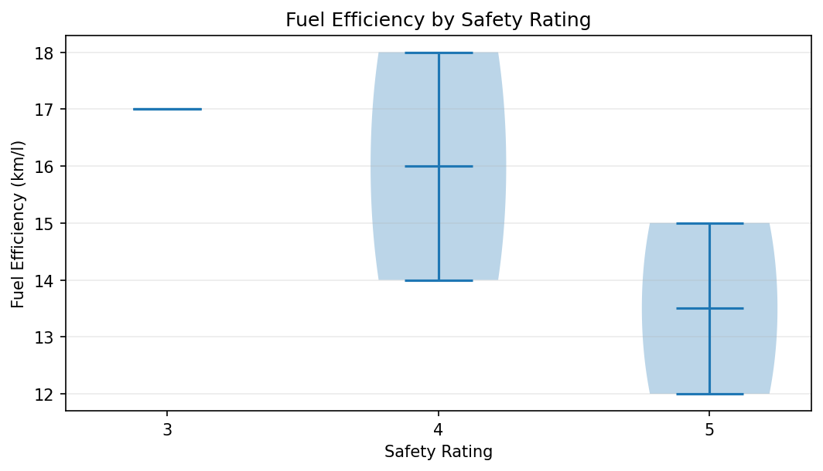
Output 1: Violin Plot of Fuel Efficiency by Safety Rating
Observation: Safety rating groups have very few observations, so violin shapes are unstable. Ratings 4 and 5 each have two vehicles; rating 3 has one.
Note: If the vioplot package is unavailable, install it with install.packages('vioplot').

PROGRAM 2: Horsepower vs Top Speed
Create a scatter plot colored by Engine_Size and analyze correlation.
R Code:
plot(vehicles$Horsepower, vehicles$Top_Speed, pch=19,
col=as.factor(vehicles$Engine_Size),
xlab="Horsepower", ylab="Top Speed (km/h)",
main="Horsepower vs Top Speed")
text(vehicles$Horsepower, vehicles$Top_Speed,
labels=vehicles$Vehicle_ID, pos=3)
legend("topleft", legend=levels(as.factor(vehicles$Engine_Size)),
col=seq_along(levels(as.factor(vehicles$Engine_Size))),
pch=19, title="Engine Size (L)", bty="n")
cor(vehicles$Horsepower, vehicles$Top_Speed)
OUTPUT:
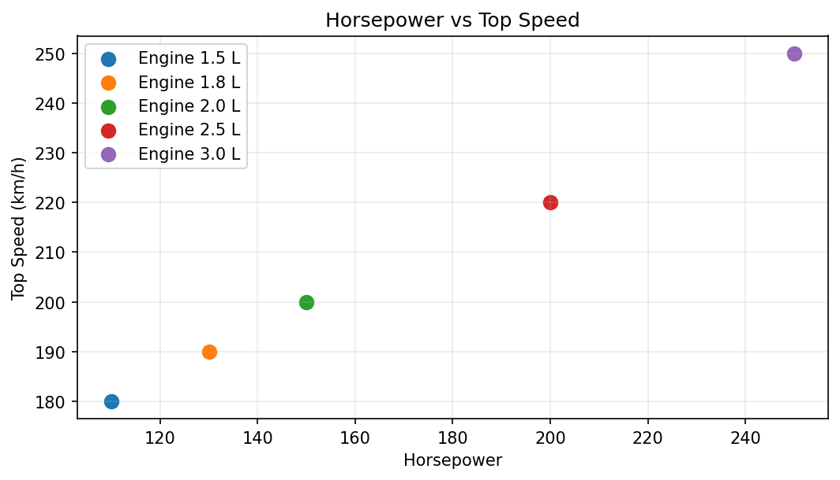
Output 2: Horsepower vs Top Speed
Observation: Horsepower and top speed have a strong positive association in this five-vehicle sample (correlation is approximately 0.99).

PROGRAM 3: Correlation Heatmap
Create a correlation heatmap for all numerical variables and identify variables most strongly associated with Top_Speed.
R Code:
numeric_data <- vehicles[, c("Engine_Size","Horsepower",
"Fuel_Efficiency","Top_Speed","Safety_Rating")]
cor_matrix <- cor(numeric_data)
heatmap(cor_matrix, Rowv=NA, Colv=NA, scale="none",
main="Correlation Heatmap of Vehicle Variables")
print(round(cor_matrix, 2))
OUTPUT:
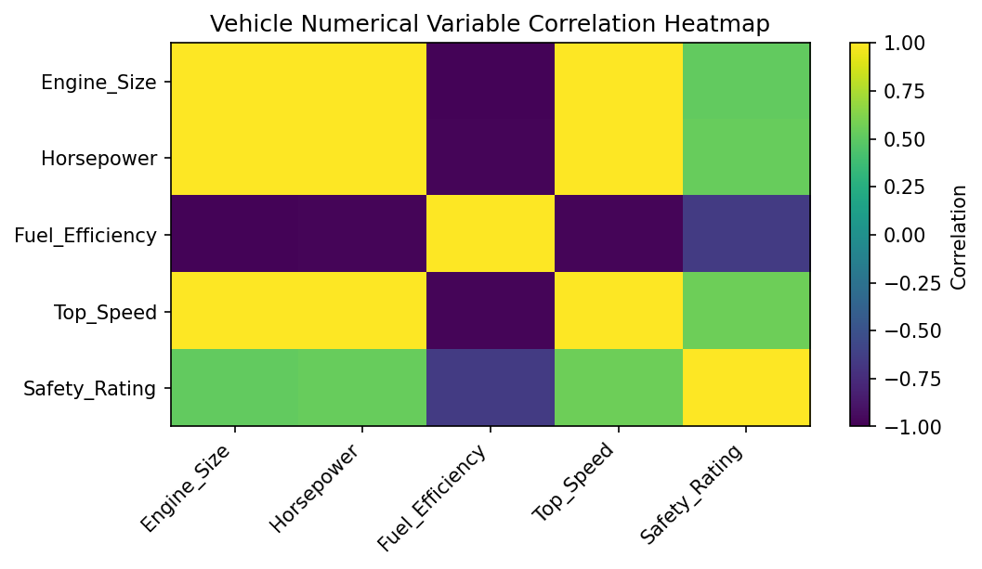
Output 3: Correlation Heatmap
Observation: Top_Speed is strongly positively associated with Horsepower and Engine_Size, and negatively associated with Fuel_Efficiency in this small dataset.

PROGRAM 4: Tableau Interactive Vehicle Dashboard
Create an interactive dashboard combining bar charts and scatter plots with Engine Size and Safety Rating filters.
- Import the vehicle dataset into Tableau and verify numeric data types.
- Create a bar chart with Vehicle_ID on Columns and Fuel_Efficiency on Rows; color by Safety_Rating.
- Create a scatter plot with Horsepower on Columns and Top_Speed on Rows; add Vehicle_ID to Detail and Engine_Size to Color.
- Create a dashboard and add both worksheets. Show filters for Engine_Size and Safety_Rating.
- Use tooltips for horsepower, top speed, fuel efficiency, and safety rating; test filters to compare efficiency and performance.
Interpretation: V3 has the highest horsepower and top speed but the lowest fuel efficiency. V1 has the highest fuel efficiency in the sample. Use filters to explore this trade-off.

Procedure
- Enter the supplied vehicle records into a data frame.
- Group fuel efficiency by safety rating and create a violin plot.
- Plot Horsepower against Top_Speed and calculate their correlation.
- Calculate a correlation matrix for all numeric variables and visualize it as a heatmap.
- Build a Tableau dashboard with Engine Size and Safety Rating filters.

RESULT
The five vehicle records were analyzed using a violin plot, horsepower-versus-speed scatter plot, and correlation heatmap. Horsepower and top speed rise together in this sample, while higher performance appears to accompany lower fuel efficiency. The sample is small, so findings are descriptive.

Key Functions and Tools Used
Function / Tool | Purpose
split() | Groups fuel efficiency by safety rating.
vioplot() | Compares distributions across rating categories.
plot() / cor() | Visualizes and measures horsepower-top speed association.
cor() / heatmap() | Displays correlations among numerical variables.
Tableau Dashboard | Combines charts with engine-size and safety-rating filters.

