DSA0602 • DATA HANDLING AND VISUALIZATION
LAB EXPERIMENT
SET 29: STUDENT ACADEMIC PERFORMANCE
Department | AIDS
Course Code / Course Name | DSA0602 / Data Handling and Visualization
Experiment | Data Visualization using R and Tableau
Name | B Mallika
Register Number | 192324234
Date | 22 October 2026
Day | Thursday

Aim
To analyze student test and participation scores, compare study hours across attendance quartiles, assess score distribution, and create an interactive Tableau scatterplot.

Dataset: Student Academic Performance
Student ID | Age | Study Hours | Attendance (%) | Test Score | Participation Score
S1 | 19 | 12 | 90 | 85 | 8
S2 | 21 | 8 | 70 | 70 | 7
S3 | 20 | 15 | 95 | 92 | 9
S4 | 22 | 10 | 85 | 80 | 8
S5 | 23 | 7 | 60 | 65 | 6

PROGRAM 1: Stacked Area Chart of Scores
Create a stacked area chart showing Test_Score and Participation_Score across students.
R Code:
students <- data.frame(
Student_ID=c("S1","S2","S3","S4","S5"),
Age=c(19,21,20,22,23), Study_Hours=c(12,8,15,10,7),
Attendance=c(90,70,95,85,60), Test_Score=c(85,70,92,80,65),
Participation_Score=c(8,7,9,8,6))
mat <- t(as.matrix(students[,c("Test_Score","Participation_Score")]))
matplot(1:nrow(students), t(mat), type="n",
xaxt="n", xlab="Student", ylab="Score",
main="Test and Participation Scores")
axis(1, at=1:nrow(students), labels=students$Student_ID)
polygon(c(1:5,5:1), c(students$Test_Score,rep(0,5)),
col="lightblue", border=NA)
polygon(c(1:5,5:1), c(students$Test_Score+students$Participation_Score,
rev(students$Test_Score)), col="orange", border=NA)
legend("topleft",c("Test Score","Participation Score"),
fill=c("lightblue","orange"),bty="n")
OUTPUT:
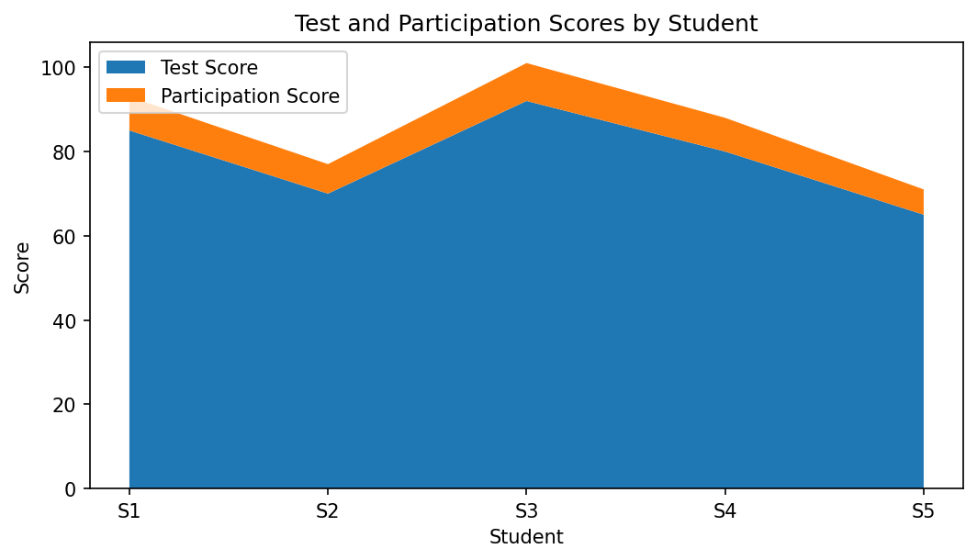
Output 1: Stacked Area Chart of Scores
Observation: S3 has the highest test score (92) and participation score (9); S5 has the lowest values (65 and 6).

PROGRAM 2: Boxplot of Study Hours by Attendance Quartile
Group Study_Hours by attendance quartiles and interpret median, IQR, and possible outliers.
R Code:
students$Attendance_Quartile <- cut(
students$Attendance,
breaks=quantile(students$Attendance, probs=seq(0,1,0.25)),
include.lowest=TRUE, labels=c("Q1","Q2","Q3","Q4"))
boxplot(Study_Hours ~ Attendance_Quartile, data=students,
col=c("lightblue","orange","lightgreen","plum"),
main="Study Hours by Attendance Quartile",
xlab="Attendance Quartile", ylab="Study Hours")
OUTPUT:
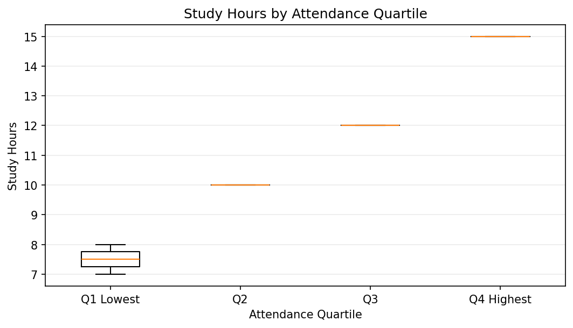
Output 2: Boxplot of Study Hours by Attendance Quartile
Observation: Attendance quartiles contain very few observations, so boxplots may collapse to lines and cannot reliably establish outliers. The raw study hours range from 7 to 15.

PROGRAM 3: Density Plot of Test Scores
Create a density plot of Test_Score and discuss distribution and possible outliers.
R Code:
plot(density(students$Test_Score), col="steelblue", lwd=2,
main="Density of Test Scores",
xlab="Test Score", ylab="Density")
rug(students$Test_Score, col="darkorange")
abline(v=students$Test_Score, lty=3, col="gray70")
OUTPUT:
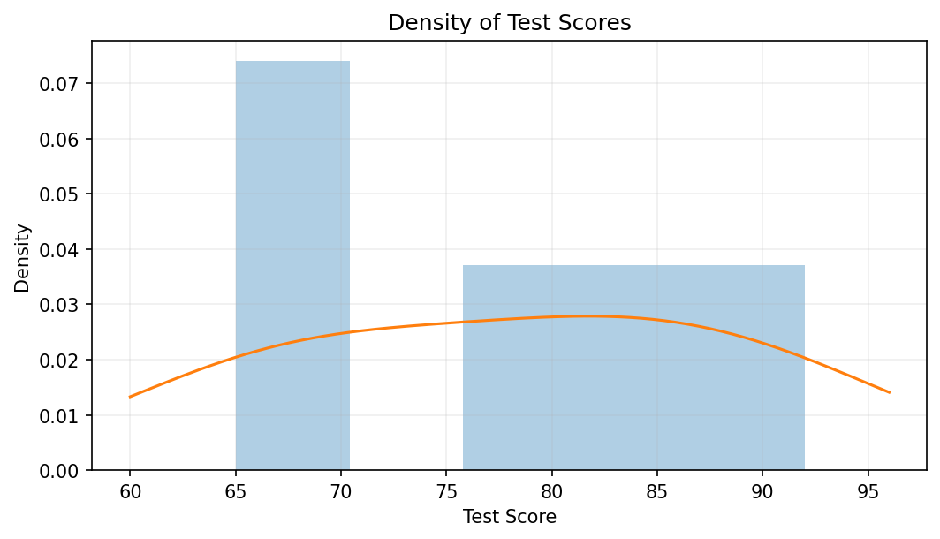
Output 3: Density Plot of Test Scores
Observation: Scores range from 65 to 92. With five observations, a density curve is only a smoothed summary; outlier identification is limited.

PROGRAM 4: Tableau Interactive Student Scatterplot
Create an interactive scatterplot with Study_Hours on the X-axis, Test_Score on the Y-axis, color by Participation_Score, and add an Age filter.
- Import the student dataset into Tableau and confirm all fields are numeric where appropriate.
- Drag Study_Hours to Columns and Test_Score to Rows; choose Circle marks.
- Drag Participation_Score to Color and Student_ID to Detail; add Age to Filters and select Show Filter.
- Add labels and tooltips for student ID, age, attendance, study hours, test score, and participation score.
- Format the chart title and test the Age filter.

Procedure
- Enter the student academic dataset into R.
- Use a stacked area chart to compare test and participation scores.
- Calculate attendance quartiles and compare study hours with a boxplot.
- Use density() and rug() to inspect the test-score distribution.
- Build a Tableau scatterplot with participation color encoding and an Age filter.

RESULT
Student academic data were visualized with a stacked area chart, attendance-quartile boxplot, and test-score density plot. S3 has the highest test score, while S5 has the lowest. Because there are only five students, distribution and outlier conclusions are tentative.

Key Functions and Tools Used
Function / Tool | Purpose
matplot() / polygon() | Displays score values as an area chart.
quantile() / cut() | Creates attendance quartile groups.
boxplot() | Compares study hours across quartile groups.
density() / rug() | Visualizes the smoothed score distribution and individual values.
Tableau Scatterplot | Shows study hours versus test score with participation color and age filter.

