DSA0602 • DATA HANDLING AND VISUALIZATION
LAB EXPERIMENT
SET 30: MOBILE APP USAGE ANALYSIS
Department | AIDS
Course Code / Course Name | DSA0602 / Data Handling and Visualization
Experiment | Data Visualization using R and Tableau
Name | B Mallika
Register Number | 192324234
Date | 22 October 2026
Day | Thursday

Aim
To explore screen-time distribution, analyze the relationship between data usage and screen time, compare satisfaction by gender, and design a Tableau mini dashboard.

Dataset: Mobile App Usage
User ID | Gender | Age | Screen Time (hrs) | App Usage Count | Data Used (GB) | Satisfaction | Usage Date
U01 | Male | 20 | 4.5 | 18 | 2.4 | 3 | 2025-01-08
U02 | Female | 22 | 6.0 | 25 | 3.8 | 5 | 2025-01-08
U03 | Male | 19 | 3.2 | 12 | 1.6 | 3 | 2025-02-11
U04 | Female | 21 | 7.1 | 30 | 4.5 | 5 | 2025-02-11
U05 | Male | 23 | 2.8 | 10 | 1.2 | 2 | 2025-03-14
U06 | Female | 20 | 5.4 | 22 | 3.1 | 4 | 2025-03-14

PROGRAM 1: Histogram and Density Plot of Screen Time
Plot a histogram and density plot for Screen_Time with suitable colors and labels.
R Code:
mobile <- data.frame(
User_ID=c("U01","U02","U03","U04","U05","U06"),
Gender=c("Male","Female","Male","Female","Male","Female"),
Age=c(20,22,19,21,23,20),
Screen_Time=c(4.5,6.0,3.2,7.1,2.8,5.4),
App_Usage_Count=c(18,25,12,30,10,22),
Data_Used=c(2.4,3.8,1.6,4.5,1.2,3.1),
Satisfaction=c(3,5,3,5,2,4),
Usage_Date=as.Date(c("2025-01-08","2025-01-08","2025-02-11",
"2025-02-11","2025-03-14","2025-03-14")))
hist(mobile$Screen_Time, probability=TRUE, col="lightblue",
main="Screen Time Distribution",
xlab="Screen Time (hours)", ylab="Density")
lines(density(mobile$Screen_Time), col="darkblue", lwd=2)
OUTPUT:
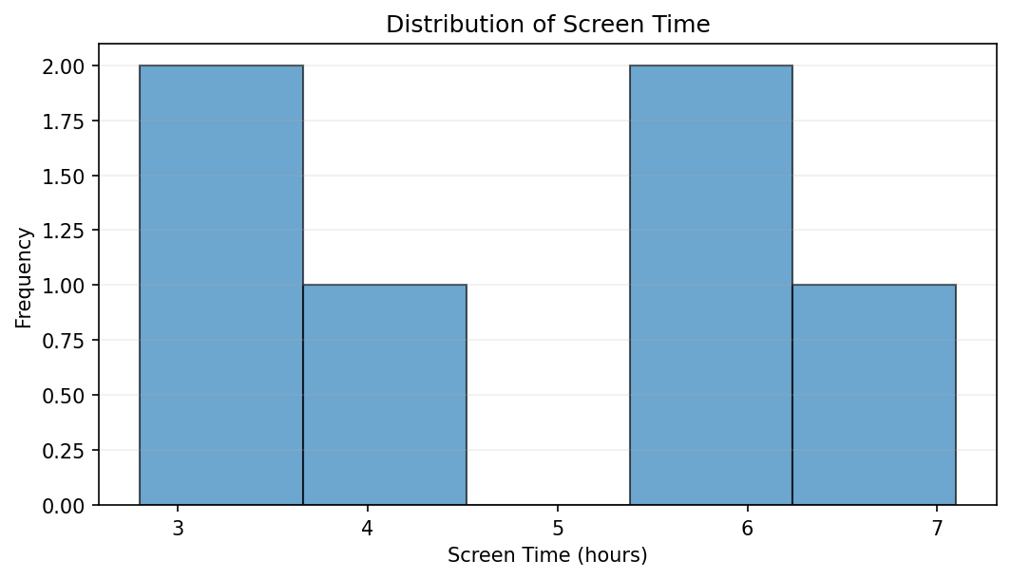
Output 1: Histogram and Density Plot of Screen Time
Observation: Screen time ranges from 2.8 to 7.1 hours. The six observations are spread across this interval, so distribution shape should be interpreted cautiously.

Output 1b: Density Plot of Screen Time
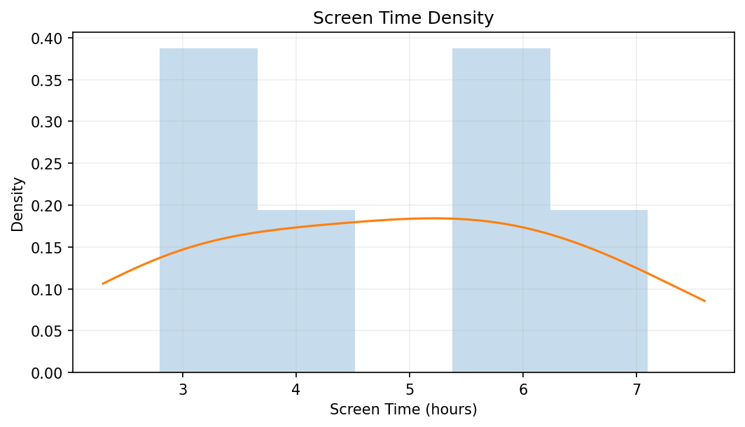

PROGRAM 2: Data Used vs Screen Time
Create a scatter plot between Data_Used and Screen_Time, calculate correlation, add a trend line, and explain the relationship.
R Code:
plot(mobile$Data_Used, mobile$Screen_Time, pch=19,
col="steelblue", xlab="Data Used (GB)",
ylab="Screen Time (hours)",
main="Data Used vs Screen Time")
abline(lm(Screen_Time ~ Data_Used, data=mobile),
col="darkorange", lwd=2)
cor(mobile$Data_Used, mobile$Screen_Time)
OUTPUT:
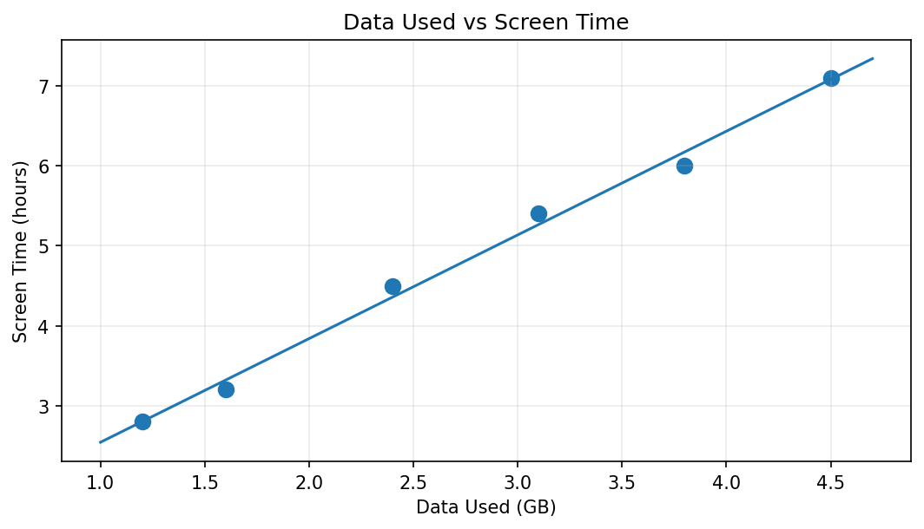
Output 2: Data Used vs Screen Time
Observation: Data usage and screen time have a strong positive correlation in the six supplied records; users with higher data usage generally have longer screen time.

PROGRAM 3: Average Satisfaction by Gender
Calculate average Satisfaction for each Gender and create a labeled bar chart.
R Code:
avg_sat <- aggregate(Satisfaction ~ Gender, data=mobile, FUN=mean)
bar <- barplot(avg_sat$Satisfaction, names.arg=avg_sat$Gender,
col=c("steelblue","darkorange"),
ylim=c(0,5), xlab="Gender",
ylab="Average Satisfaction",
main="Average Satisfaction by Gender")
text(bar, avg_sat$Satisfaction,
labels=round(avg_sat$Satisfaction,2), pos=3)
OUTPUT:
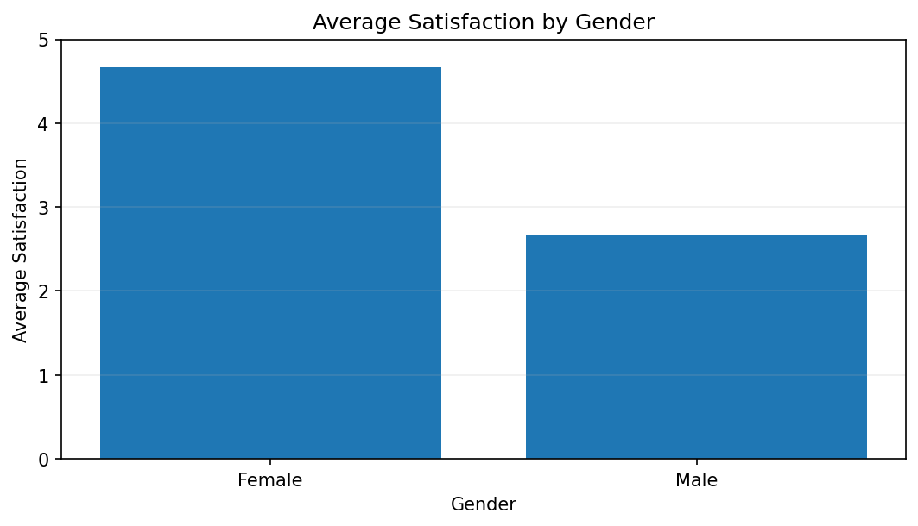
Output 3: Average Satisfaction by Gender
Observation: Average satisfaction is 2.67 for male users and 4.67 for female users in this sample. These figures describe only the six supplied records.

PROGRAM 4: Tableau Mobile App Usage Dashboard
Create a bubble chart of Screen Time vs Data Used, use Gender for color and App_Usage_Count for size, then add a usage-trend line chart and filters.
- Import Mobile_App_Usage.csv into Tableau and set Usage_Date to Date.
- Create a bubble chart: Data_Used on Columns, Screen_Time on Rows, Gender on Color, App_Usage_Count on Size, and User_ID on Detail.
- Create a line chart with Usage_Date on Columns and average Screen_Time or Data_Used on Rows.
- Create a dashboard and add both charts. Show filters for Gender and Usage_Date and apply them to relevant worksheets.
- Add tooltips for Age, Satisfaction, App Usage Count, Screen Time, and Data Used. Test the filters.

Procedure
- Import Mobile_App_Usage.csv into R and define the numeric columns.
- Plot the screen-time histogram and density curve.
- Plot Data_Used against Screen_Time, fit a linear trend, and calculate correlation.
- Calculate average satisfaction by gender and label the bars.
- Build the Tableau bubble chart and line chart with Gender and Usage_Date filters.

RESULT
Mobile app usage was analyzed using screen-time distribution plots, a data-versus-screen-time scatter plot, and average satisfaction by gender. In the supplied sample, data usage rises with screen time and female users have a higher average satisfaction score. The sample contains only six users, so results are descriptive.

Key Functions and Tools Used
Function / Tool | Purpose
hist() / density() | Shows screen-time distribution.
plot() / lm() / cor() | Visualizes, models, and measures the data-use relationship.
aggregate() | Calculates average satisfaction by gender.
barplot() / text() | Displays gender averages with value labels.
Tableau Dashboard | Combines bubble and trend charts with Gender and Usage_Date filters.

