LAB EXPERIMENT RECORD
Set 6: Product Sales Analysis
Field | Details
Department | AIDS
Course Code / Course Name | DSA0601 / Data Handling and Visualization
Experiment | Data Visualization using R
Aim
To visualize first-quarter product sales using grouped bar and stacked area charts, display the monthly sales table, and prepare an interactive Tableau dashboard.
Dataset: Monthly Product Sales
Product ID | Product Name | January Sales | February Sales | March Sales
1 | Product A | 2000 | 2200 | 2400
2 | Product B | 1500 | 1800 | 1600
3 | Product C | 1200 | 1400 | 1100
PROGRAM 1: Grouped Bar Chart of Product Sales
Create a grouped bar chart to visualize the sales of each product for the first quarter. Label the chart elements.
# Dataset
product <- c("Product A", "Product B", "Product C")
jan <- c(2000, 1500, 1200)
feb <- c(2200, 1800, 1400)
mar <- c(2400, 1600, 1100)
sales <- rbind(January = jan,
February = feb,
March = mar)
# Grouped Bar Chart
barplot(sales,
beside = TRUE,
names.arg = product,
xlab = "Product",
ylab = "Sales ($)",
main = "First Quarter Product Sales",
col = c("skyblue", "lightgreen", "orange"),
legend.text = TRUE)
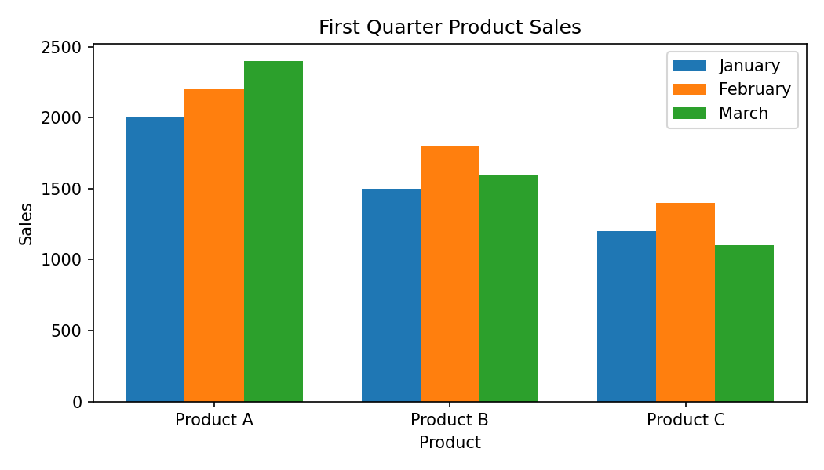
Output 1: Grouped Bar Chart of Product Sales
Observation: Product A has the highest sales in all three months. Product C has the lowest sales in each month.
PROGRAM 2: Stacked Area Chart of Overall Sales
Generate a stacked area chart to represent the overall sales trend for all products over the three months.
# Dataset
month <- c("January", "February", "March")
product_a <- c(2000, 2200, 2400)
product_b <- c(1500, 1800, 1600)
product_c <- c(1200, 1400, 1100)
sales <- rbind(product_a, product_b, product_c)
# Stacked Area Chart
matplot(1:3, t(sales),
type = "l",
lty = 1,
lwd = 2,
xlab = "Month",
ylab = "Sales ($)",
main = "Overall Sales Trend by Product",
xaxt = "n")
axis(1, at = 1:3, labels = month)
legend("topleft",
legend = c("Product A", "Product B", "Product C"),
lty = 1,
lwd = 2)
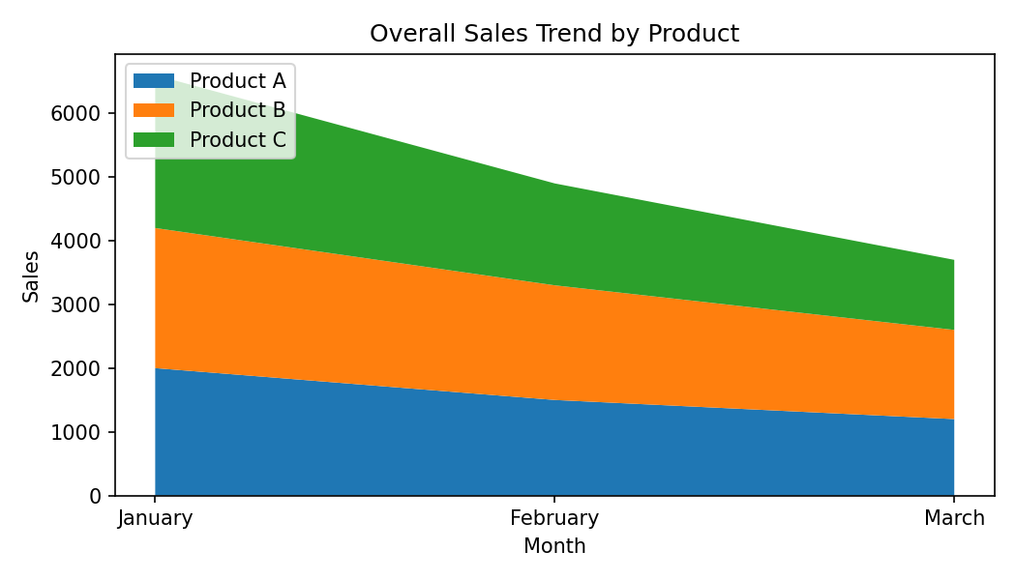
Output 2: Stacked Area Chart of Overall Sales
Observation: Product A remains the largest contributor across all three months. Product B increases from January to February and then decreases in March, while Product C also increases to February and decreases in March.
PROGRAM 3: Monthly Product Sales Table
Build a table to show the monthly sales data for each product. Label the table elements.
# Dataset
sales_data <- data.frame(
Product_ID = c(1, 2, 3),
Product_Name = c("Product A", "Product B", "Product C"),
January_Sales = c(2000, 1500, 1200),
February_Sales = c(2200, 1800, 1400),
March_Sales = c(2400, 1600, 1100)
)
# Display Monthly Sales Table
print(sales_data)
Output 3: Monthly Product Sales Table
Observation: The table displays the January, February, and March sales values for each product. Product A has the highest total first-quarter sales.
PROGRAM 4: Interactive Product Sales Dashboard
Develop a Tableau dashboard combining the grouped bar chart, stacked area chart, and the table for interactive exploration of sales data.
# Tableau Dashboard – Required Views
# 1. Create a grouped bar chart for Product Name and monthly sales.
# 2. Create a stacked area chart for Month and sales by Product Name.
# 3. Add the monthly sales table to the dashboard.
# 4. Combine all three views into one Tableau dashboard.
# 5. Add filters/actions to support interactive exploration.
# R data preparation:
sales_data <- data.frame(
Product = c("Product A","Product B","Product C"),
January = c(2000,1500,1200),
February = c(2200,1800,1400),
March = c(2400,1600,1100)
)
print(sales_data)
Output 4: Interactive Product Sales Dashboard
Observation: The dashboard combines the grouped bar chart, stacked area chart, and monthly sales table so that the first-quarter product sales can be explored together.
Set 6 Procedure
1. Create the product and monthly sales vectors from the given dataset.
2. Use barplot() with beside = TRUE to create the grouped first-quarter sales chart.
3. Use the monthly sales matrix to visualize the overall product sales trend.
4. Create a data frame and print it as the monthly sales table.
5. Import the dataset into Tableau and combine the three views into an interactive dashboard.
Set 6 Result
The monthly product sales data was successfully visualized using a grouped bar chart and a sales trend chart, and the monthly values were organized in a table. The three views can be combined in Tableau for interactive exploration.
Key R Functions Used
Function | Purpose
barplot() | Creates grouped and stacked bar charts.
plot() | Creates line and scatter plots.
matplot() | Plots multiple related data series.
rbind() | Combines vectors into a matrix by rows.
data.frame() | Creates a tabular data structure.
order() | Sorts values and helps identify top-N observations.

