LAB EXPERIMENT RECORD
Set 5: Website Analytics
Field | Details
Department | AIDS
Course Code / Course Name | DSA0601 / Data Handling and Visualization
Experiment | Data Visualization using R
Aim
To analyze website traffic using line and bar charts, represent user interactions using a stacked area chart, and prepare an interactive Tableau dashboard.
Dataset: Website Traffic
Date | Page Views | Click-through Rate
2023-01-01 | 1500 | 2.3%
2023-01-02 | 1600 | 2.7%
2023-01-03 | 1400 | 2.0%
2023-01-04 | 1650 | 2.4%
2023-01-05 | 1800 | 2.6%
PROGRAM 1: Line Chart of Daily Page Views
Create a line chart to visualize the trend in daily page views over time. Label the axes and title the chart.
# Dataset
date <- as.Date(c("2023-01-01", "2023-01-02", "2023-01-03",
"2023-01-04", "2023-01-05"))
page_views <- c(1500, 1600, 1400, 1650, 1800)
# Line Chart
plot(date, page_views,
type = "o",
xlab = "Date",
ylab = "Page Views",
main = "Daily Page Views Trend")
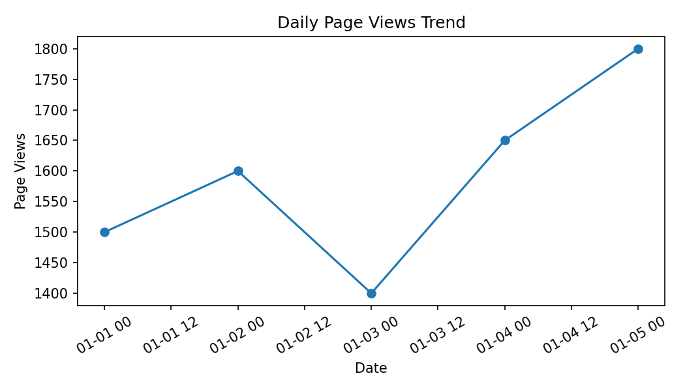
Output 1: Line Chart of Daily Page Views
Observation: Page views fluctuate during the five days, reach a low of 1400 on January 3, and reach the highest value of 1800 on January 5.
PROGRAM 2: Bar Chart of Top N Click-through Rates
Generate a bar chart showing the top N days with the highest click-through rates. Label the chart elements.
# Dataset
date <- as.Date(c("2023-01-01", "2023-01-02", "2023-01-03",
"2023-01-04", "2023-01-05"))
ctr <- c(2.3, 2.7, 2.0, 2.4, 2.6)
# Top N days
n <- 3
idx <- order(ctr, decreasing = TRUE)[1:n]
barplot(ctr[idx],
names.arg = format(date[idx], "%Y-%m-%d"),
xlab = "Date",
ylab = "Click-through Rate (%)",
main = "Top Days by Click-through Rate",
col = "skyblue")
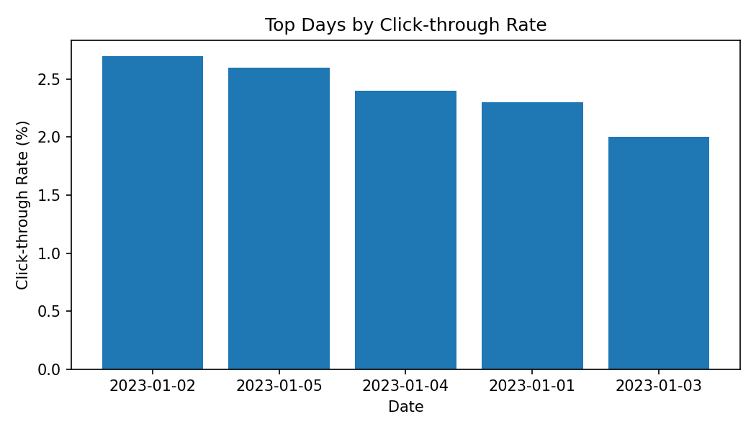
Output 2: Bar Chart of Top N Click-through Rates
Observation: For N = 3, January 2 has the highest click-through rate (2.7%), followed by January 5 (2.6%) and January 4 (2.4%).
PROGRAM 3: Stacked Area Chart of User Interactions
Develop a stacked area chart to display the distribution of user interactions (likes, shares, comments) on a website.
# The supplied Set 5 dataset contains only:
# Date, Page Views and Click-through Rate.
# Likes, Shares and Comments are not provided.
# Template after adding the interaction data:
date <- as.Date(c("2023-01-01", "2023-01-02", "2023-01-03",
"2023-01-04", "2023-01-05"))
# Replace NA values with the actual source data.
likes <- c(NA, NA, NA, NA, NA)
shares <- c(NA, NA, NA, NA, NA)
comments <- c(NA, NA, NA, NA, NA)
interactions <- rbind(Likes = likes,
Shares = shares,
Comments = comments)
# Stacked Area Chart
matplot(date, t(interactions),
type = "l",
lty = 1,
lwd = 2,
xlab = "Date",
ylab = "Number of Interactions",
main = "Website User Interactions")
legend("topleft",
legend = rownames(interactions),
lty = 1,
lwd = 2)
Output 3: Stacked Area Chart of User Interactions
Observation: The supplied Set 5 dataset does not contain Likes, Shares, or Comments values. Therefore, the requested interaction distribution cannot be calculated from the supplied data.
Note: The template code becomes runnable after the three interaction series are supplied.
PROGRAM 4: Interactive Website Traffic Dashboard
Build a Tableau dashboard with the line chart and bar chart for interactive exploration of website traffic data.
# Tableau Dashboard – Required Views
# 1. Import the Website Traffic dataset into Tableau.
# 2. Create a line chart using Date and Page Views.
# 3. Create a bar chart using Date and Click-through Rate.
# 4. Add both views to a dashboard.
# 5. For the requested traffic-source map and source-wise page views,
# a Traffic Source field must be added to the dataset.
# R view for the supplied data:
plot(date, page_views, type = "o",
xlab = "Date", ylab = "Page Views",
main = "Website Traffic")
Output 4: Interactive Website Traffic Dashboard
Observation: The supplied dataset supports the page-view line chart and click-through-rate bar chart. The additional traffic-source map and source-wise page-view analysis requires a Traffic Source field, which is not present in the supplied Set 5 dataset.
Note: Dashboard requirements involving traffic sources cannot be completed faithfully without traffic-source data.
Set 5 Procedure
1. Create Date, Page Views, and Click-through Rate vectors from the supplied website traffic data.
2. Use plot() to visualize the daily page-view trend.
3. Sort the click-through rates and use barplot() to display the top N days.
4. Add Likes, Shares, and Comments data before creating the stacked area chart.
5. Build the Tableau dashboard using the available charts and add traffic-source fields when they are supplied.
Set 5 Result
The supplied website traffic data was successfully used for the daily page-view line chart and top-N click-through-rate bar chart. The interaction and traffic-source analyses require fields that are not included in the provided dataset.

