LAB EXPERIMENT RECORD

SET 20: STOCK ANALYSIS

Department | AIDS
Course Code / Course Name | DSA0602 / Data Handling and Visualization
Experiment | Data Visualization using R and Tableau
Name | B Mallika
Register Number | 192324234
Date | 13 October 2026
Day | Tuesday

Aim
To analyze the daily stock prices of three companies using a line chart, a percentage change bar chart and a stock price table in R, and to build an interactive dashboard using Tableau. Dataset: Stock Prices

Date | Stock A | Stock B | Stock C
2023-01-01 | 100 | 150 | 120
2023-01-02 | 105 | 152 | 118
2023-01-03 | 110 | 148 | 122

PROGRAM 1: Line Chart of Stock Prices
Create a line chart to visualize the stock prices of three companies (Stock A, Stock B and Stock C) over a specific time period. Label the axes and title the chart.
library(ggplot2)

# Dataset in long format stocks <- data.frame(
Date = as.Date(rep(c("2023-01-01", "2023-01-02", "2023-01-03"), times = 3)),
Stock = rep(c("Stock A", "Stock B", "Stock C"), each = 3),
# Line Chart
ggplot(stocks, aes(x = Date, y = Price, color = Stock)) + geom_line(linewidth = 1) +
geom_point(size = 3) +
scale_x_date(breaks = stocks$Date, date_labels = "%Y-%m-%d") + labs(title = "Stock Prices of Companies A, B and C",
x = "Date",
y = "Stock Price", color = "Stock")

Price | = | c(100, | 105, | 110,
 |  | 150, | 152, | 148,
 |  | 120, | 118, | 122)
)

OUTPUT:
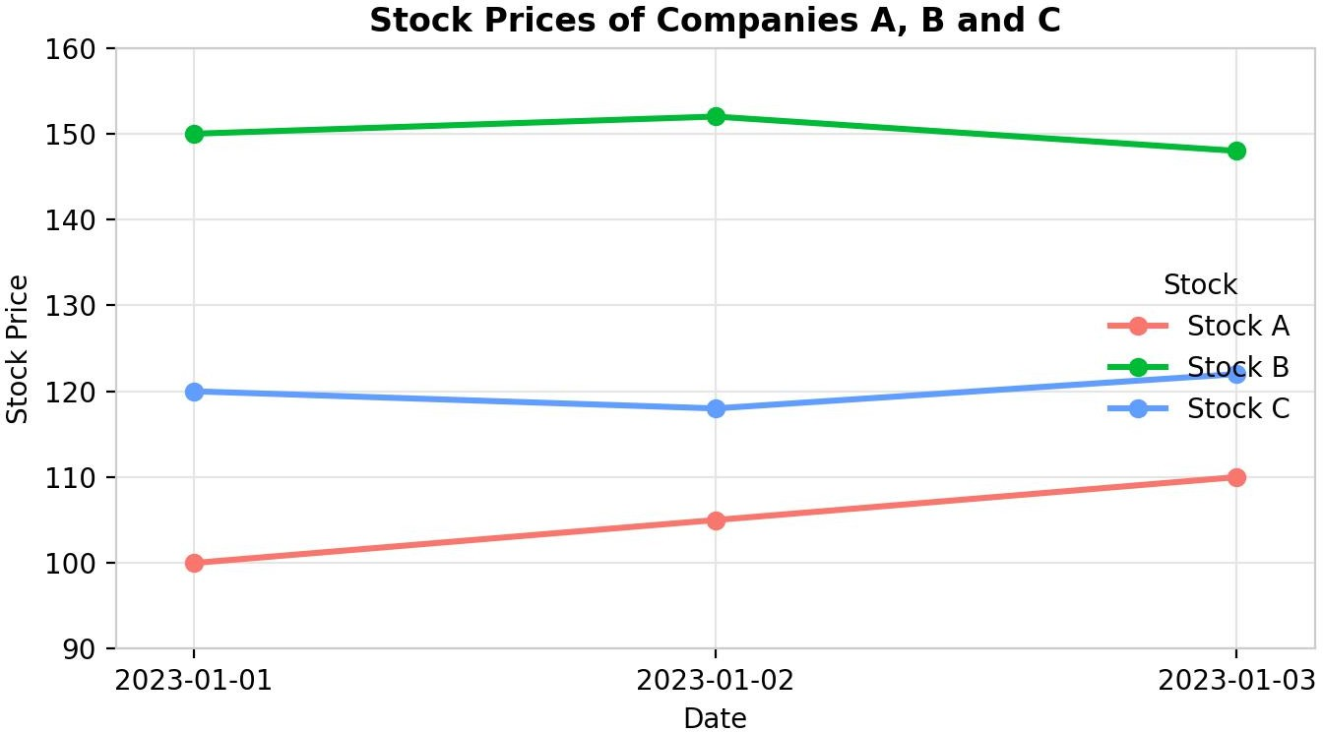
Output 1: Stock Prices of Companies A, B and C (Line Chart)

Observation:
Stock B has the highest price on all three days (148 to 152), while Stock A has the lowest and rises steadily from 100 to 110. Stock C dips from 120 to 118 on 2 January and then recovers to 122. Stock B rises to 152 and then falls to 148 on 3 January.

PROGRAM 2: Bar Chart of Daily Percentage Change for Stock A
Generate a bar chart showing the daily percentage change in stock prices for Stock A. Label the chart elements.
# Stock A prices
date
<- c("2023-01-01", "2023-01-02", "2023-01-03")
stock_a <- c(100, 105, 110)

# Daily percentage change = (today - yesterday) / yesterday * 100 pct_change <- diff(stock_a) / head(stock_a, -1) * 100
pct_change

# Bar Chart (the first date has no previous day, so it is left out) bp <- barplot(pct_change,
names.arg = date[-1], col = "steelblue", xlab = "Date",
ylab = "Percentage Change (%)",
main = "Daily Percentage Change in Stock A", ylim = c(0, 6))
text(bp, pct_change + 0.2, labels = paste0(round(pct_change, 2), "%"))

OUTPUT:
[1] 5.000000 4.761905

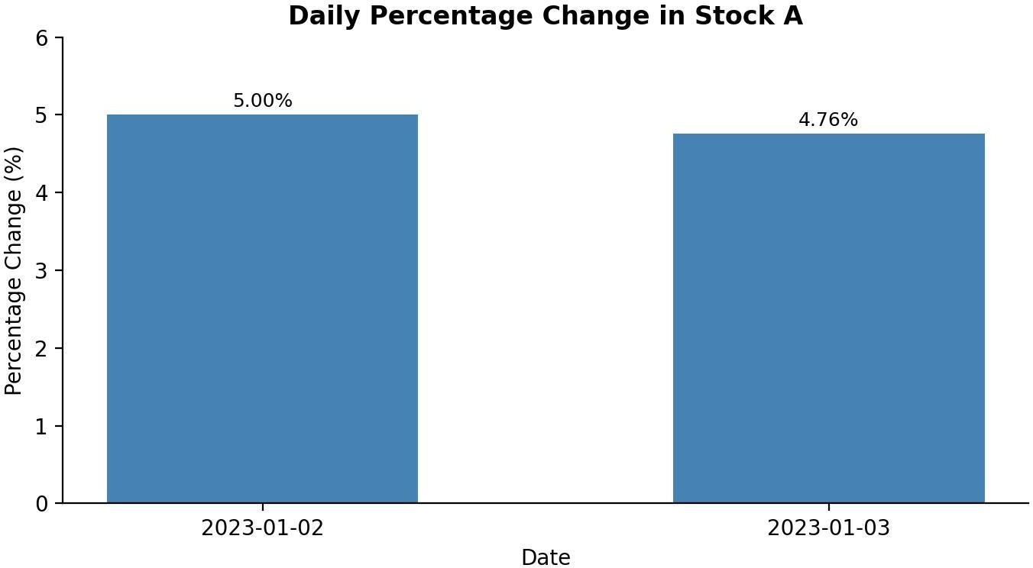

Output 2: Daily Percentage Change in Stock A (Bar Chart)

Observation:
Stock A rose by 5.00% on 2 January (100 to 105) and by 4.76% on 3 January (105 to 110). The percentage gain is slightly smaller on the second day even though the price rise is the same 5 points, because the base price is higher. Over the period, Stock A gained 10% in total.

PROGRAM 3: Table of Stock Prices for Each Company
Build a table to display the stock price data for each company over the given period. Label the table elements.
# Dataset
stock_table <- data.frame(
Date
= c("2023-01-01", "2023-01-02", "2023-01-03"),
# Display the table
print(stock_table)

# Average price of each stock over the period colMeans(stock_table[, c("Stock_A", "Stock_B", "Stock_C")])

Stock_A | = | c(100, | 105, | 110),
Stock_B | = | c(150, | 152, | 148),
Stock_C | = | c(120, | 118, | 122)
)

OUTPUT:

Date | Stock_A | Stock_B | Stock_C
1 2023-01-01 | 100 | 150 | 120
2 2023-01-02 | 105 | 152 | 118
3 2023-01-03 | 110 | 148 | 122
Stock_A Stock_B Stock_C
105 150 120
Output 3a: Stock Price Table (R Console)

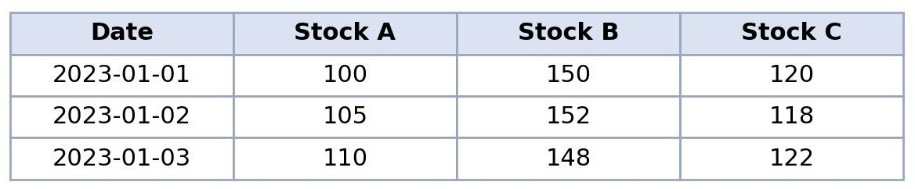

Output 3b: Stock Price Table

Observation:
The table gives the exact closing price of each stock on each date. Stock B has the highest average price (150), followed by Stock C (120) and Stock A (105). Stock A is the only stock that rises on both days.

PROGRAM 4: Interactive Stock Prices Dashboard in Tableau
Develop a Tableau dashboard combining the line chart, bar chart and the table for interactive exploration of stock prices.

Steps in Tableau
- Save the data as an Excel or CSV file and connect to it in Tableau (Connect > Microsoft Excel / Text file). Select the Stock A, Stock B and Stock C columns, right-click and choose Pivot, then rename the new fields to "Stock" and "Price".
- Sheet 1 (Line Chart): Drag Date to Columns (continuous or exact date) and Price to Rows (SUM). Drag Stock to Color, and add Price to Label. Rename the sheet "Stock Prices".
- Sheet 2 (Bar Chart): Drag Date to Columns and Price to Rows. Filter Stock to Stock A only. Right-click SUM(Price), choose Quick Table Calculation > Percent Difference (computed along Date), and change the Marks type to Bar. Add the calculation to Label and rename the sheet "Stock A % Change".
- Sheet 3 (Table): Drag Stock to Rows, Date to Columns and Price to Text. Rename the sheet "Stock Table".
- Create a new Dashboard (Dashboard > New Dashboard), set the size to Automatic, and drag the three sheets onto the dashboard area.
- Add interactivity: select the line chart and the table and click Use as Filter, so clicking a stock or date in one view filters the others. Add Stock and Date filters (Show Filter > Apply to Worksheets > All Using This Data Source).
- Add the title "Stock Prices Dashboard" and test the filters in Presentation Mode.

OUTPUT:
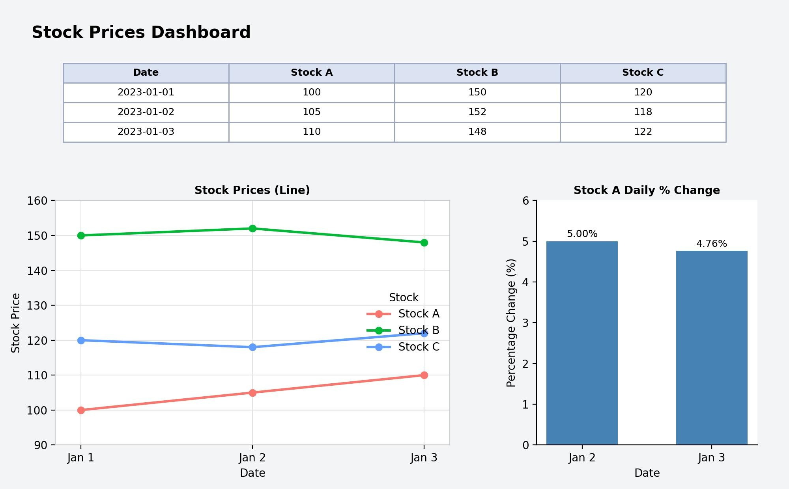
Output 4: Interactive Stock Prices Dashboard (Tableau)

Observation:
The dashboard shows the stock price table, the price trend of all three stocks and the daily percentage change of Stock A together. Clicking a stock or date in one view filters the other views.

Procedure
- Define the stock prices for each company and date in R as a data frame (long format for plotting).
- Use ggplot2 with geom_line() and geom_point() to create the line chart of the three stocks.
- Calculate the daily percentage change of Stock A with diff() and display it with barplot().
- Create a data frame of the stock prices and display it with print() and colMeans().
- Load the stock file into Tableau, pivot the Stock columns, and build the line chart, bar chart and table worksheets.
- Combine the worksheets in a Tableau dashboard and add filters and actions for interactivity.

RESULT:
The daily stock price data was successfully analyzed using a line chart, a percentage change bar chart and a stock price table in R. An interactive Tableau dashboard was also created, combining all three views so that users can explore the stock prices by company and by date.

Key Functions and Tools Used

Function / Tool | Purpose
data.frame() | Creates the stock price data and table.
ggplot() / geom_line() | Creates the line chart of the three stocks.
diff() | Finds the day-to-day change used for the percentage change.

barplot() | Creates the bar chart of Stock A percentage change.
print() / colMeans() | Displays the stock table and calculates the average prices.
Tableau Pivot | Converts the Stock columns into Stock and Price fields.
Tableau Dashboard | Combines worksheets with filters and actions.

