LAB EXPERIMENT

SET 21: ENERGY CONSUMPTION ANALYSIS

Department | AIDS
Course Code / Course Name | DSA0602 / Data Handling and Visualization
Experiment | Data Visualization using R and Tableau
Name | B Mallika
Register Number | 192324234
Date | 13 October 2026
Day | Tuesday

Aim
To analyze energy consumption data using a histogram with a density plot, a bubble scatter plot and a bar chart of renewable usage in R, and to build an interactive dashboard with a line chart and a heatmap using Tableau. Dataset: Energy_Consumption_Data.csv

Sector | Region | Month | Temperature (°C) | Units_Consumed (kWh) | Cost (₹) | Renewable_Usage (%) | Peak_Hours
Residential | North | Jan | 15 | 320 | 2100 | 22 | 4
Commercial | South | Jan | 24 | 540 | 3600 | 18 | 6
Industrial | West | Feb | 20 | 880 | 5900 | 12 | 8
Residential | East | Feb | 18 | 350 | 2300 | 25 | 5
Commercial | North | Mar | 28 | 610 | 4100 | 20 | 7
Industrial | South | Mar | 30 | 920 | 6200 | 15 | 9

PROGRAM 1: Histogram and Density Plot of Units Consumed
Import the dataset in R. Plot a histogram and density plot for Units_Consumed. Compare consumption patterns.
library(ggplot2)

# Import the dataset
energy <- read.csv("Energy_Consumption_Data.csv") summary(energy$Units_Consumed)

# Histogram with density curve ggplot(energy, aes(x = Units_Consumed)) +
geom_histogram(aes(y = after_stat(density)),
binwidth = 100, boundary = 300,
fill = "steelblue", alpha = 0.6, color = "white") + geom_density(color = "darkred", linewidth = 1) +
labs(title = "Histogram and Density Plot of Units Consumed",

x = "Units Consumed (kWh)", y = "Density")

OUTPUT:
Min. | 1st Qu. | Median | Mean 3rd Qu. | Max.
320.0 | 397.5 | 575.0 | 603.3 812.5 | 920.0
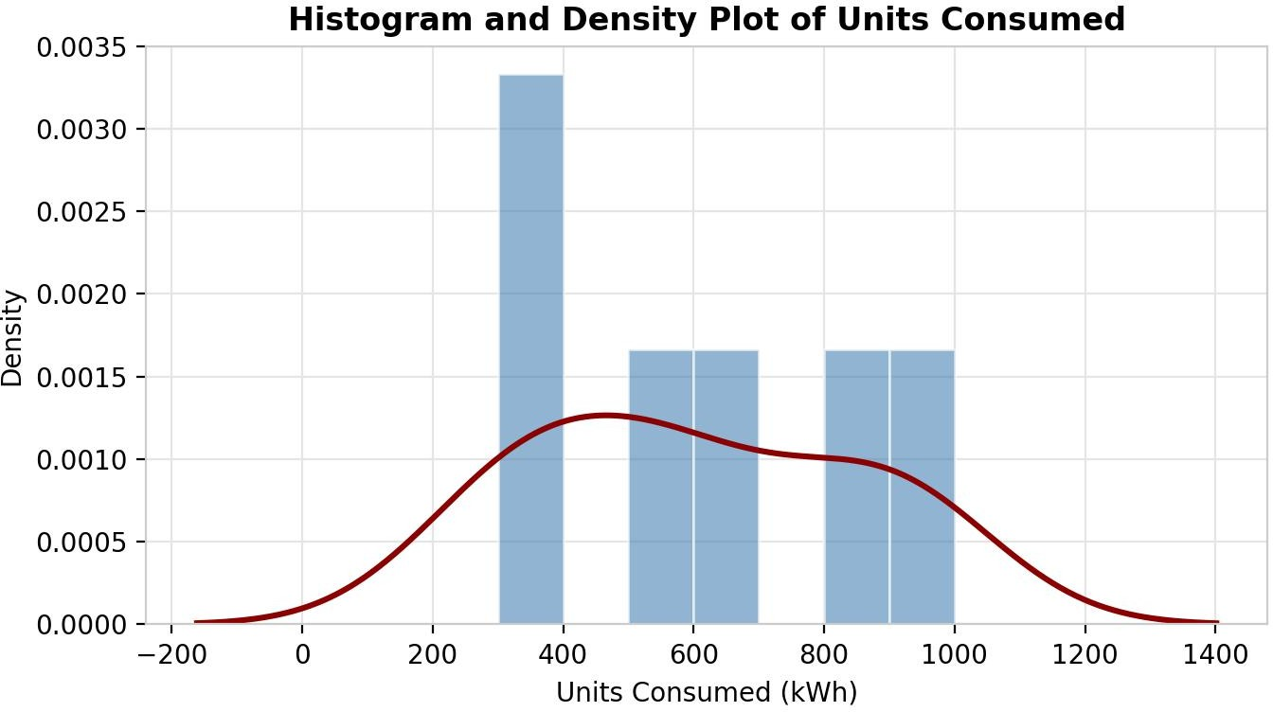
Output 1: Histogram and Density Plot of Units Consumed

Observation:
Units consumed range from 320 to 920 kWh, with a mean of about 603 kWh and a median of 575 kWh. The data does not form a single peak: it falls into three groups, a low group (320 and 350 kWh, residential), a middle group (540 and 610 kWh, commercial) and a high group (880 and 920 kWh, industrial). The density curve is therefore spread out and flat, showing that consumption depends strongly on the sector.

PROGRAM 2: Bubble Scatter Plot of Temperature and Units Consumed
Using R programming, create a scatter plot between Temperature and Units_Consumed. Represent Peak_Hours using bubble size. Apply transparency.
library(ggplot2)

# Scatter plot with bubble size = Peak_Hours and transparency ggplot(energy, aes(x = Temperature, y = Units_Consumed,
size = Peak_Hours, color = Sector)) + geom_point(alpha = 0.5) +
scale_size(range = c(4, 14)) +
labs(title = "Temperature vs Units Consumed", x = "Temperature (°C)",
y = "Units Consumed (kWh)", size = "Peak Hours")

# Correlation
cor(energy$Temperature, energy$Units_Consumed)

cor(energy$Peak_Hours, energy$Units_Consumed)

OUTPUT:
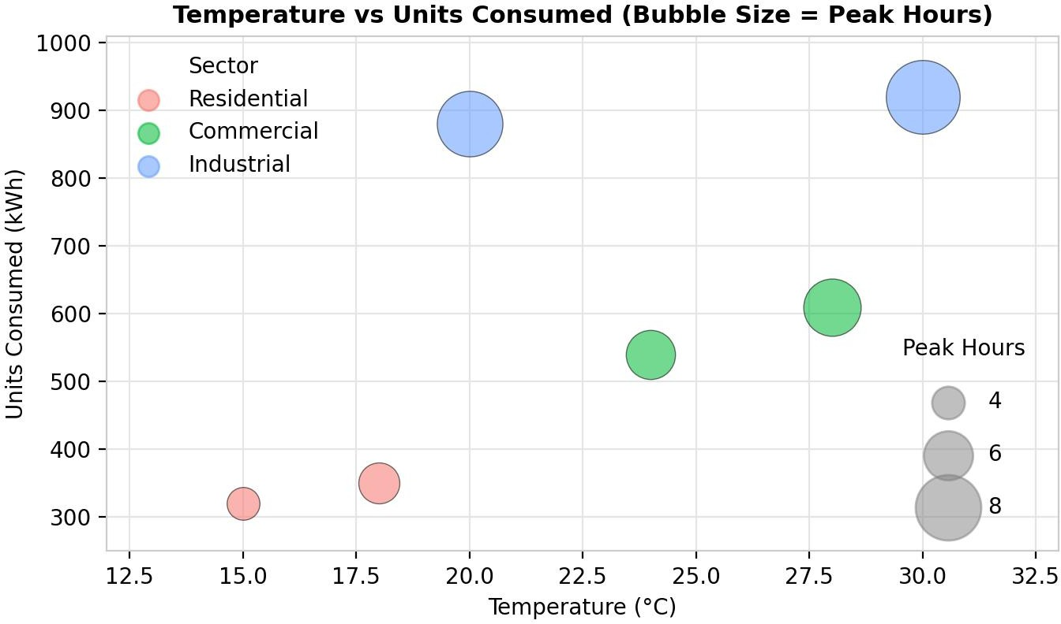
[1] 0.6546550
[1] 0.9765008

Output 2: Temperature vs Units Consumed (Bubble Scatter Plot)

Observation:
Units consumed generally increase with temperature (correlation about 0.65), so the two hottest records (28 °C and 30 °C) are among the highest consumers. The bubbles also get larger as consumption rises, and Peak_Hours has a very strong relationship with Units_Consumed (correlation about 0.98). Industrial records have the largest bubbles (8 and 9 hours), while residential records have the smallest (4 and 5 hours). With only six records, these patterns are indicative rather than conclusive.

PROGRAM 3: Average Renewable Usage by Sector
Using R, calculate average Renewable_Usage for each Sector. Create a bar chart. Interpret renewable energy adoption.
# Average renewable usage for each sector
avg_renew <- aggregate(Renewable_Usage ~ Sector, data = energy, FUN = mean) print(avg_renew)

# Bar chart
ggplot(avg_renew, aes(x = Sector, y = Renewable_Usage, fill = Sector)) + geom_col(width = 0.55) +
geom_text(aes(label = paste0(Renewable_Usage, "%")), vjust = -0.5) + labs(title = "Average Renewable Usage by Sector",
x = "Sector",
y = "Average Renewable Usage (%)") + theme(legend.position = "none")

OUTPUT:
Sector Renewable_Usage
- Commercial 19.0
- Industrial 13.5
- Residential 23.5
Output 3a: Average Renewable Usage by Sector (R Console)
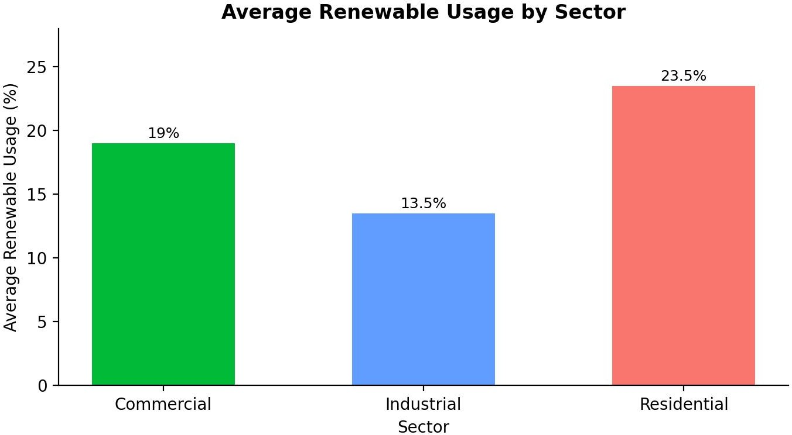

Output 3b: Average Renewable Usage by Sector (Bar Chart)

Observation:
Residential has the highest average renewable usage (23.5%), followed by Commercial (19%) and Industrial (13.5%). Renewable adoption is therefore highest where consumption is lowest and lowest where consumption is highest. Industrial users consume the most energy but get the smallest share from renewable sources, so they offer the greatest room to increase renewable adoption.

PROGRAM 4: Interactive Energy Consumption Dashboard in Tableau
Import Energy_Consumption_Data.csv into Tableau. Create a line chart for monthly energy usage trends. Create a heatmap (Sector vs Region vs Units). Add filters for Month and Sector. Design an interactive dashboard.

Steps in Tableau
- Open Tableau and connect to the file (Connect > Text file > Energy_Consumption_Data.csv). Check that Units_Consumed is a measure and Sector, Region and Month are dimensions.
- Sheet 1 (Line Chart): Drag Month to Columns and Units_Consumed to Rows (SUM). Change the Marks type to Line, add Units_Consumed to Label, and sort the months as Jan, Feb, Mar. Rename the sheet "Monthly Usage Trend".
- Sheet 2 (Heatmap): Drag Region to Columns and Sector to Rows. Drag Units_Consumed (SUM) to Color and to Text. Change the Marks type to Square and edit the color to a sequential palette. Rename the sheet "Sector Region Heatmap".
- Add filters: drag Month and Sector to the Filters shelf, right-click each filter and choose Show Filter, then Apply to Worksheets > All Using This Data Source.
- Create a new Dashboard (Dashboard > New Dashboard), set the size to Automatic, and drag the line chart and the heatmap onto the dashboard area.

- Add interactivity: select each sheet and click Use as Filter, so that clicking a month or a sector in one view filters the other. Keep the Month and Sector filters on the dashboard.
- Add the title "Energy Consumption Dashboard" and test the filters in Presentation Mode.

OUTPUT:
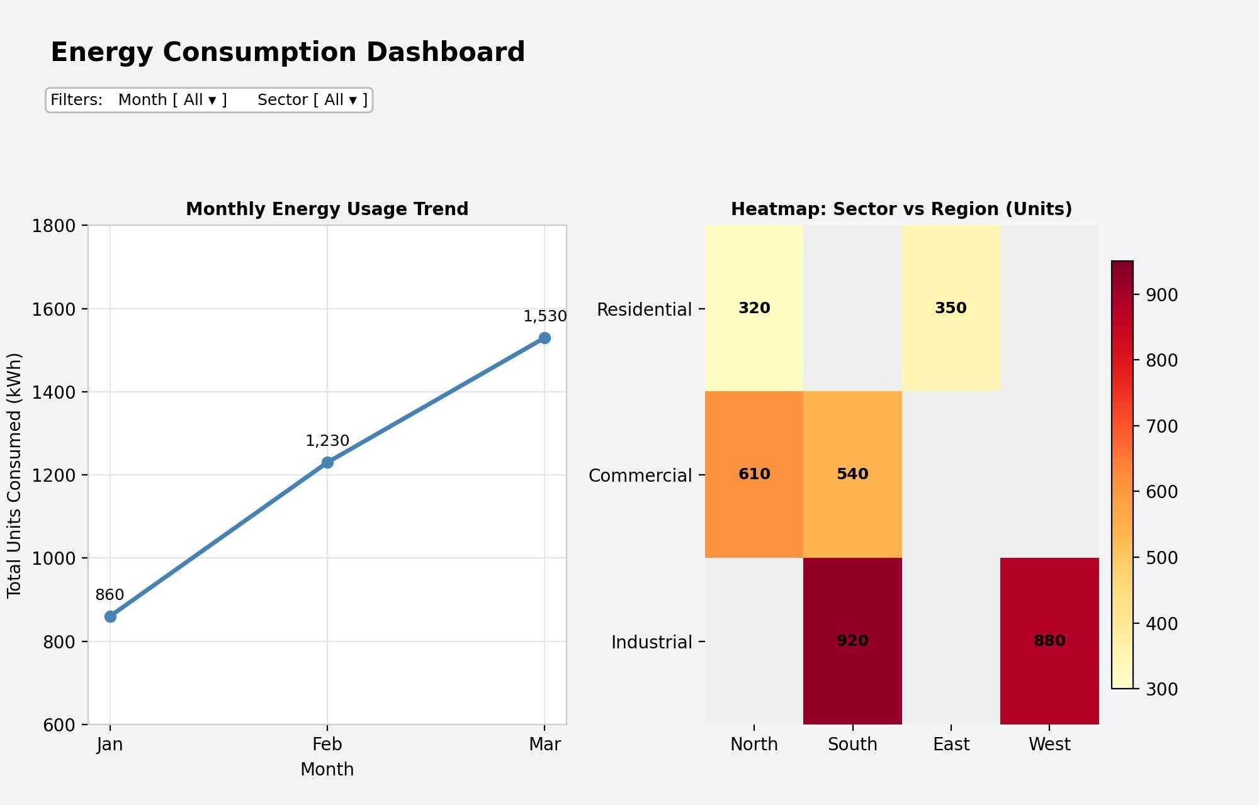
Output 4: Interactive Energy Consumption Dashboard (Tableau)

Observation:
Total energy usage rises every month, from 860 kWh in January to 1,230 kWh in February and 1,530 kWh in March. In the heatmap, the darkest cells are Industrial in South (920) and West (880), while Residential in North (320) and East (350) are the lightest. Empty cells show sector and region combinations that are not in the data. The Month and Sector filters update both views together.

Procedure
- Import the energy consumption file in R using read.csv() and check Units_Consumed with summary().
- Use ggplot2 with geom_histogram() and geom_density() to plot the distribution of Units_Consumed.
- Use geom_point() with the size aesthetic set to Peak_Hours and alpha for transparency to build the bubble scatter plot.
- Calculate the average Renewable_Usage for each Sector with aggregate() and draw the bar chart with geom_col().
- Load the file into Tableau and build the monthly line chart and the Sector vs Region heatmap worksheets.
- Add Month and Sector filters, combine the worksheets in a Tableau dashboard and add actions for interactivity.

RESULT:
The energy consumption data was successfully analyzed in R using a histogram with a density plot, a bubble scatter plot and a bar chart of average renewable usage. An interactive Tableau dashboard with a monthly line chart, a Sector vs Region heatmap and Month and Sector filters was also created, so that users can explore energy usage by month, sector and region.

Key Functions and Tools Used

Function / Tool | Purpose
read.csv() | Imports the energy consumption dataset.
geom_histogram() / geom_density() | Draws the histogram and the density curve of Units_Consumed.
geom_point(alpha, size) | Creates the bubble scatter plot with transparency.
aggregate() | Calculates the average Renewable_Usage for each Sector.
geom_col() | Creates the bar chart of average renewable usage.
Tableau Line Chart / Heatmap | Shows the monthly trend and the Sector vs Region usage.
Tableau Dashboard | Combines worksheets with filters and actions.

