DSA0602 • DATA HANDLING AND VISUALIZATION
LAB EXPERIMENT
SET 25: WEBSITE TRAFFIC ANALYSIS

Experiment Details
Field | Details
Department | AIDS
Course Code / Course Name | DSA0602 / Data Handling and Visualization
Experiment | Data Visualization using R and Tableau
Name | B Mallika
Register Number | 192324234
Date | 20 October 2026
Day | Thursday

Aim
To analyze website page views and click-through rates, visualize traffic trends, and plan an interactive Tableau dashboard.

Dataset: Website Traffic
Date | Page Views | Click-through Rate
2023-01-01 | 1500 | 2.3%
2023-01-02 | 1600 | 2.7%
2023-01-03 | 1400 | 2.0%
2023-01-04 | 1650 | 2.4%
2023-01-05 | 1800 | 2.6%

PROGRAM 1: Line Chart of Page Views
Create a line chart to visualize page views over time.
R Code:
traffic <- data.frame(Date=as.Date(c("2023-01-01","2023-01-02","2023-01-03","2023-01-04","2023-01-05")), Page_Views=c(1500,1600,1400,1650,1800), CTR=c(2.3,2.7,2.0,2.4,2.6))
plot(traffic$Date, traffic$Page_Views, type="o", col="steelblue", pch=16, xlab="Date", ylab="Page Views", main="Daily Website Page Views")
OUTPUT:
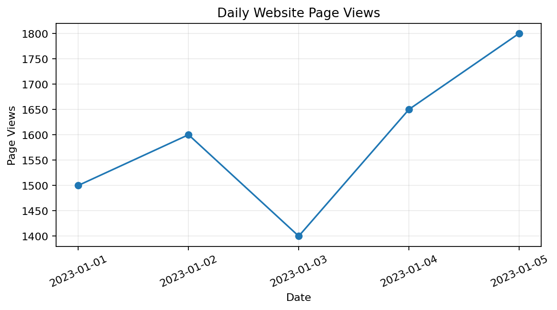
Output 1: Line Chart of Page Views
Observation: Page views dip to 1,400 on January 3 and then rise to 1,800 on January 5.

PROGRAM 2: Top Click-through Rates
Generate a bar chart for the top three dates with the highest CTR.
R Code:
traffic$CTR <- c(2.3,2.7,2.0,2.4,2.6)
N <- 3
top_days <- traffic[order(traffic$CTR, decreasing=TRUE),][1:N,]
barplot(top_days$CTR, names.arg=format(top_days$Date,"%b %d"), col="darkorange", xlab="Date", ylab="Click-through Rate (%)", main=paste("Top",N,"Days by CTR"), ylim=c(0,3.2))
OUTPUT:
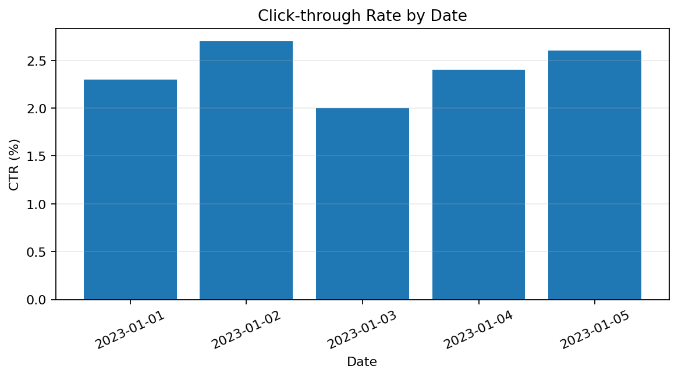
Output 2: Top Click-through Rates
Observation: January 2 has the highest CTR (2.7%), followed by January 5 (2.6%) and January 4 (2.4%).

PROGRAM 3: Stacked Area of User Interactions
Build a stacked area chart for likes, shares, and comments.
R Code:
# Interaction counts are absent from the supplied dataset.
days <- 1:5
likes <- c(2,3,2,4,5); shares <- c(1,2,1,2,3); comments <- c(1,1,2,2,2)
matplot(days, t(rbind(likes,shares,comments)), type="l", lty=1, lwd=2, col=c("steelblue","darkorange","seagreen"), xlab="Day Index", ylab="Interactions", main="Illustrative User Interactions")
legend("topleft",c("Likes","Shares","Comments"),col=c("steelblue","darkorange","seagreen"),lty=1)
Data note: Interaction counts are not in the supplied dataset; example values are illustrative only.
OUTPUT:
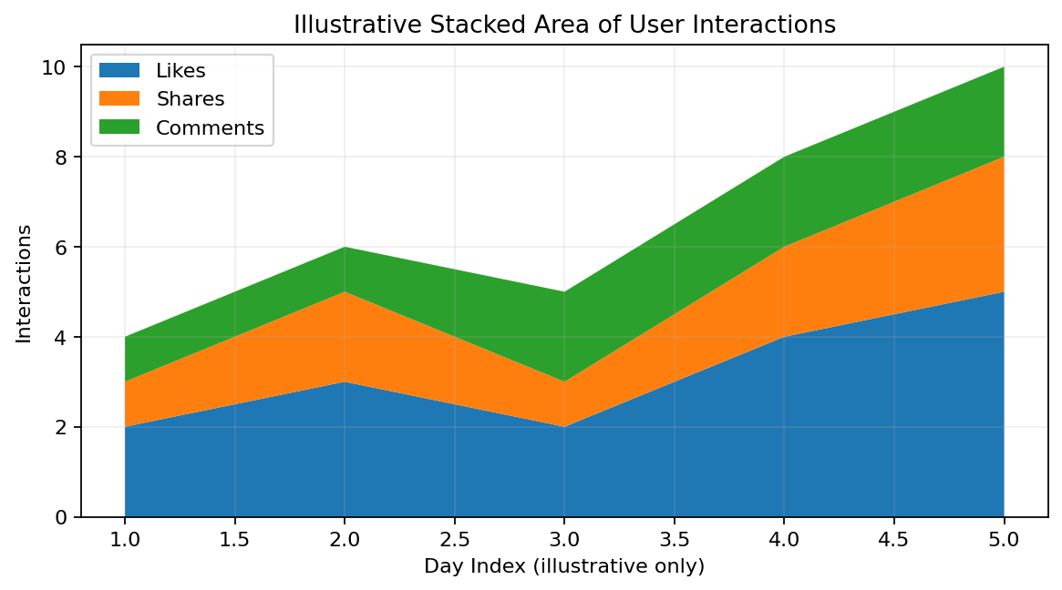
Output 3: Stacked Area of User Interactions
Observation: A stacked area chart can compare interaction types once actual interaction counts are collected.

PROGRAM 3: Tableau Dashboard
Create a Tableau dashboard with page-view trends and traffic-source views.
- Connect Tableau to the traffic CSV and confirm Date is a date field.
- Create a line chart with Date on Columns and Page Views on Rows.
- Create a bar chart by Traffic_Source only if that field is available.
- Create a map only if geographic fields are supplied.
- Combine views in a dashboard and add a date filter.
The supplied data only include Date, Page Views, and CTR. Traffic source and geographic fields are missing, so the map and source-based chart need additional data.

Procedure
- Create the data frame with date, page views, and CTR.
- Plot page views over time.
- Sort CTR values and chart the top three dates.
- Use actual likes, shares, and comments for a stacked area chart.
- Build a Tableau dashboard and add date filters.

RESULT
Page views increased overall from 1,500 to 1,800. The highest CTR was 2.7% on January 2. Interaction and traffic-source analysis require additional source fields.

Key Functions and Tools Used
Function / Tool | Purpose
as.Date() | Converts date strings into dates.
plot(type="o") | Displays the page-view trend.
order() | Ranks CTR values.
barplot() | Compares top CTR values.
Tableau Dashboard | Combines traffic charts and filters.

