DSA0602 • DATA HANDLING AND VISUALIZATION
LAB EXPERIMENT
SET 26: STUDENT PERFORMANCE ANALYSIS

Experiment Details
Field | Details
Department | AIDS
Course Code / Course Name | DSA0602 / Data Handling and Visualization
Experiment | Data Visualization using R and Tableau
Name | B Mallika
Register Number | 192324234
Date | 20 October 2026
Day | Thursday

Aim
To explore student score distributions, relationship between study hours and Math scores, monthly score trends, and an interactive Tableau dashboard.

Dataset: Student Mini Data
Student ID | Gender | Study Hours | Attendance | Math Score | Science Score | Exam Date
S01 | Male | 2.0 | 78 | 62 | 65 | 2025-01-10
S02 | Female | 3.5 | 90 | 80 | 85 | 2025-01-10
S03 | Male | 1.5 | 70 | 55 | 58 | 2025-02-12
S04 | Female | 4.0 | 95 | 90 | 92 | 2025-02-12
S05 | Male | 2.8 | 85 | 72 | 74 | 2025-03-15
S06 | Female | 3.0 | 92 | 82 | 86 | 2025-03-15

PROGRAM 1: Math Score Histogram
Plot a histogram for Math_Score and a boxplot for Science_Score by Gender.
R Code:
students <- data.frame(Student_ID=c("S01","S02","S03","S04","S05","S06"), Gender=c("Male","Female","Male","Female","Male","Female"), Study_Hours=c(2,3.5,1.5,4,2.8,3), Attendance=c(78,90,70,95,85,92), Math_Score=c(62,80,55,90,72,82), Science_Score=c(65,85,58,92,74,86), Exam_Date=as.Date(c("2025-01-10","2025-01-10","2025-02-12","2025-02-12","2025-03-15","2025-03-15")))
hist(students$Math_Score, col="steelblue", breaks=5, main="Distribution of Math Scores", xlab="Math Score", ylab="Number of Students")
boxplot(Science_Score ~ Gender, data=students, col=c("lightblue","orange"), main="Science Score by Gender", xlab="Gender", ylab="Science Score")
OUTPUT:
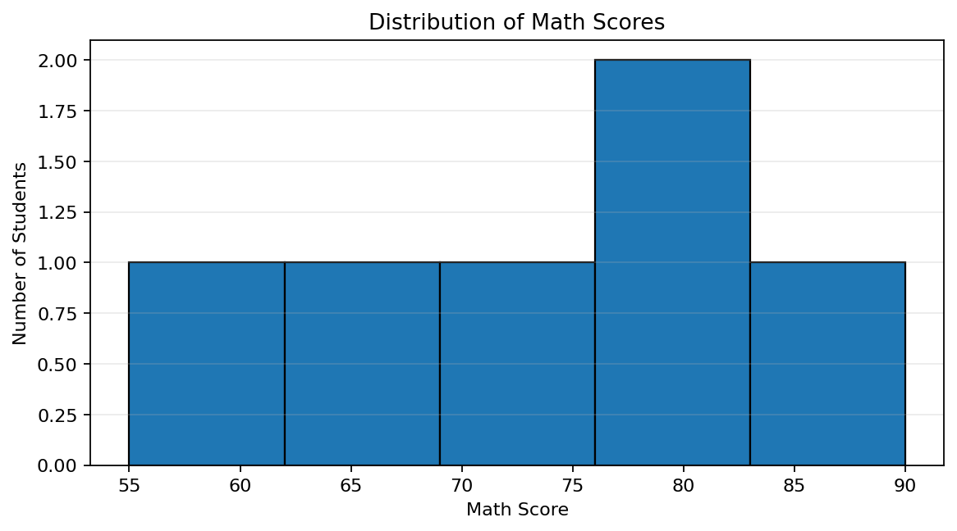
Output 1: Math Score Histogram
Observation: Math scores range from 55 to 90. Female Science scores are 85, 92, and 86; male scores are 65, 58, and 74.

PROGRAM 2: Study Hours vs Math Score
Create a gender-colored scatter plot, add a regression line, and explain the relationship.
R Code:
plot(students$Study_Hours, students$Math_Score, col=ifelse(students$Gender=="Female","darkorange","steelblue"), pch=19, xlab="Study Hours", ylab="Math Score", main="Study Hours vs Math Score")
abline(lm(Math_Score ~ Study_Hours, data=students), col="darkgreen", lwd=2)
legend("topleft",c("Male","Female"),col=c("steelblue","darkorange"),pch=19,bty="n")
OUTPUT:
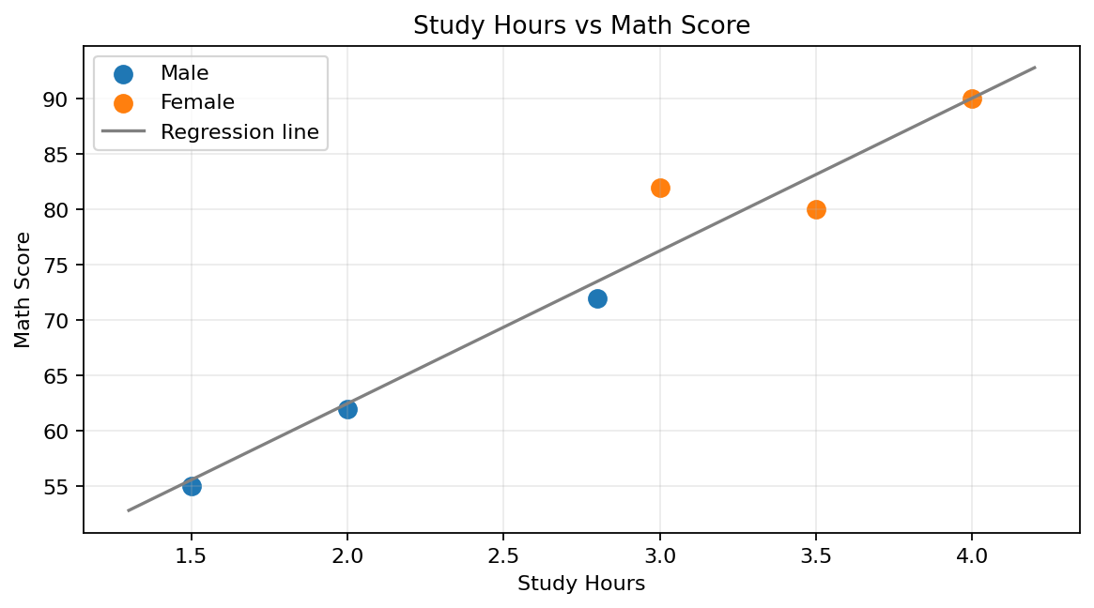
Output 2: Study Hours vs Math Score
Observation: The six observations show a positive association: more study hours generally correspond to higher Math scores. This is a small-sample pattern.

PROGRAM 3: Monthly Average Math Score Trend
Convert Exam_Date to Date, calculate monthly averages, and plot the trend with a moving average.
R Code:
students$Exam_Date <- as.Date(students$Exam_Date)
students$Month <- format(students$Exam_Date,"%Y-%m")
monthly_avg <- aggregate(Math_Score ~ Month, data=students, FUN=mean)
plot(seq_len(nrow(monthly_avg)),monthly_avg$Math_Score,type="o",pch=16,xaxt="n",xlab="Month",ylab="Average Math Score",main="Monthly Average Math Score")
axis(1,at=seq_len(nrow(monthly_avg)),labels=monthly_avg$Month)
if(nrow(monthly_avg)>=2) lines(seq_len(nrow(monthly_avg)),stats::filter(monthly_avg$Math_Score,rep(1/2,2),sides=1),col="darkorange",lwd=2)
OUTPUT:
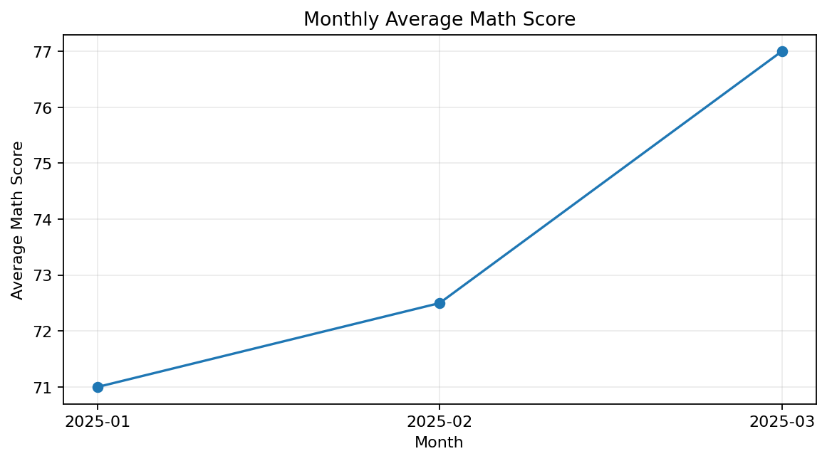
Output 3: Monthly Average Math Score Trend
Observation: Monthly mean Math scores are 71.0 in January, 72.5 in February, and 77.0 in March, showing a gradual increase.

PROGRAM 3: Tableau Dashboard
Create a Tableau dashboard of average Math scores by gender and score trends over time.
- Connect to Student_Mini_Data.csv and confirm Exam_Date is recognized as a date.
- Sheet 1: Gender on Columns and Math_Score on Rows; change aggregation to Average and show labels.
- Sheet 2: Exam_Date on Columns and Math_Score on Rows; choose Line and Average.
- Combine both sheets in a dashboard and show the Exam_Date filter.
- Apply the filter to relevant worksheets and test it.
Expected output: gender comparison of average Math scores and a score-trend line chart with a working exam-date filter.

Procedure
- Import the student data into R.
- Use hist() and boxplot() to inspect score distributions.
- Use plot() and lm() to analyze study hours against Math scores.
- Convert Exam_Date and aggregate Math scores by month.
- Build a Tableau dashboard with score charts and a date filter.

RESULT
Math scores range from 55 to 90. The study-hours scatter plot suggests a positive association, and monthly average Math scores rise from January to March.

Key Functions and Tools Used
Function / Tool | Purpose
hist() | Shows Math-score distribution.
boxplot() | Compares Science scores by gender.
lm() / abline() | Fits and draws a regression line.
aggregate() | Calculates monthly average scores.
Tableau Dashboard | Combines gender comparison, trend, and date filter.

Additional Output: Science Score Boxplot by Gender
R code: boxplot(Science_Score ~ Gender, data=students, col=c("lightblue","orange"), main="Science Score by Gender")
