DSA0602 • DATA HANDLING AND VISUALIZATION
LAB EXPERIMENT
SET 27: PATIENT HEALTH RISK ANALYSIS

Experiment Details
Field | Details
Department | AIDS
Course Code / Course Name | DSA0602 / Data Handling and Visualization
Experiment | Data Visualization using R and Tableau
Name | B Mallika
Register Number | 192324234
Date | 20 October 2026
Day | Thursday

Aim
To examine relationships among Age, BMI, blood pressure, and cholesterol; assess cholesterol distribution; summarize averages; and design a Tableau heatmap dashboard.

Dataset: Patient Health Risk
Patient ID | Age | BMI | BP | Cholesterol
P1 | 25 | 22 | 120 | 180
P2 | 40 | 28 | 135 | 210
P3 | 55 | 30 | 145 | 240
P4 | 35 | 26 | 130 | 200
P5 | 60 | 32 | 150 | 260

PROGRAM 1: Scatterplot Matrix of Health Indicators
Create a scatterplot matrix for Age, BMI, BP, and Cholesterol.
R Code:
health <- data.frame(Patient_ID=c("P1","P2","P3","P4","P5"), Age=c(25,40,55,35,60), BMI=c(22,28,30,26,32), BP=c(120,135,145,130,150), Cholesterol=c(180,210,240,200,260))
pairs(health[,c("Age","BMI","BP","Cholesterol")], main="Scatterplot Matrix of Patient Health Indicators", pch=19, col="steelblue")
OUTPUT:
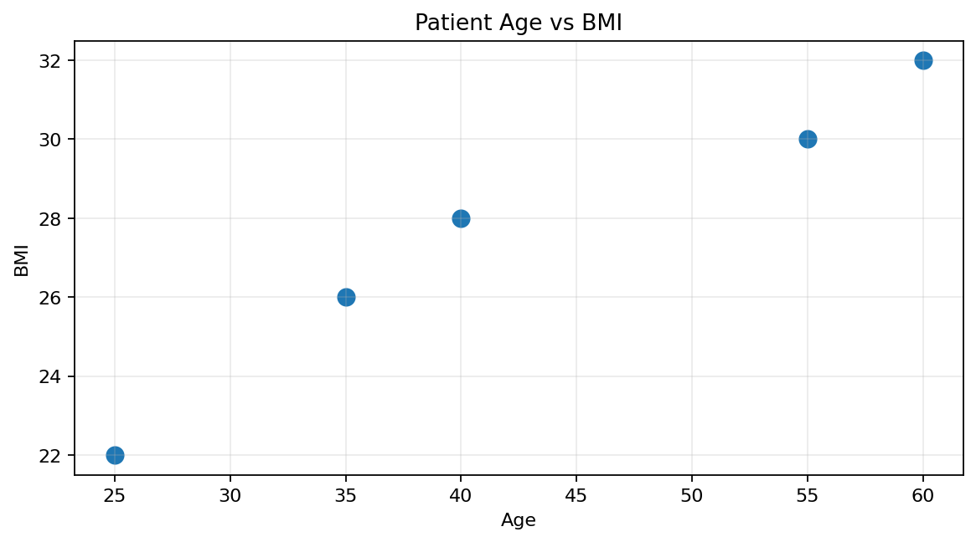
Output 1: Scatterplot Matrix of Health Indicators
Observation: Age, BMI, BP, and cholesterol tend to be higher together in these records, but five observations are too few for robust conclusions.

PROGRAM 2: Q-Q Plot of Cholesterol
Construct a Q-Q plot and ECDF for cholesterol and comment on distribution behaviour.
R Code:
qqnorm(health$Cholesterol, main="Q-Q Plot of Cholesterol")
qqline(health$Cholesterol, col="red", lwd=2)
plot(ecdf(health$Cholesterol), verticals=TRUE, do.points=TRUE, main="ECDF of Cholesterol", xlab="Cholesterol", ylab="Cumulative Proportion")
OUTPUT:
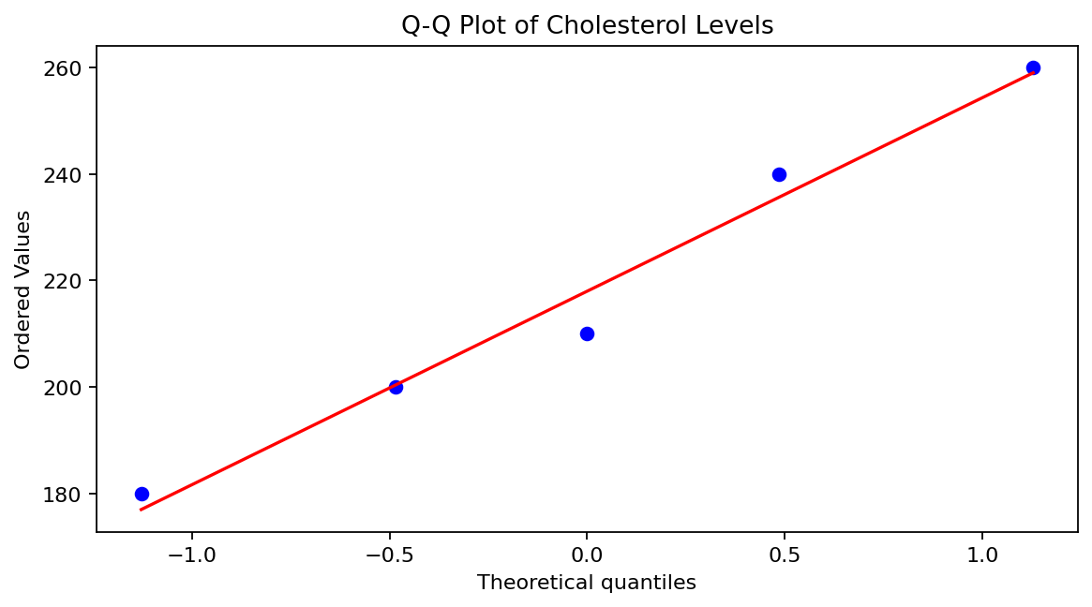
Output 2: Q-Q Plot of Cholesterol
Observation: The Q-Q plot compares sample quantiles with a normal reference; the ECDF rises at the five observed values. Normality and skewness cannot be assessed reliably from only five observations.

PROGRAM 3: Average Health Indicator Bar Chart
Create a bar chart of average Age, BMI, BP, and Cholesterol with labels and distinct colors.
R Code:
avg <- colMeans(health[,c("Age","BMI","BP","Cholesterol")])
barplot(avg, col=c("steelblue","darkorange","seagreen","mediumpurple"), names.arg=c("Age","BMI","BP","Cholesterol"), xlab="Health Indicator", ylab="Average Value", main="Average Patient Health Indicators", las=2)
OUTPUT:
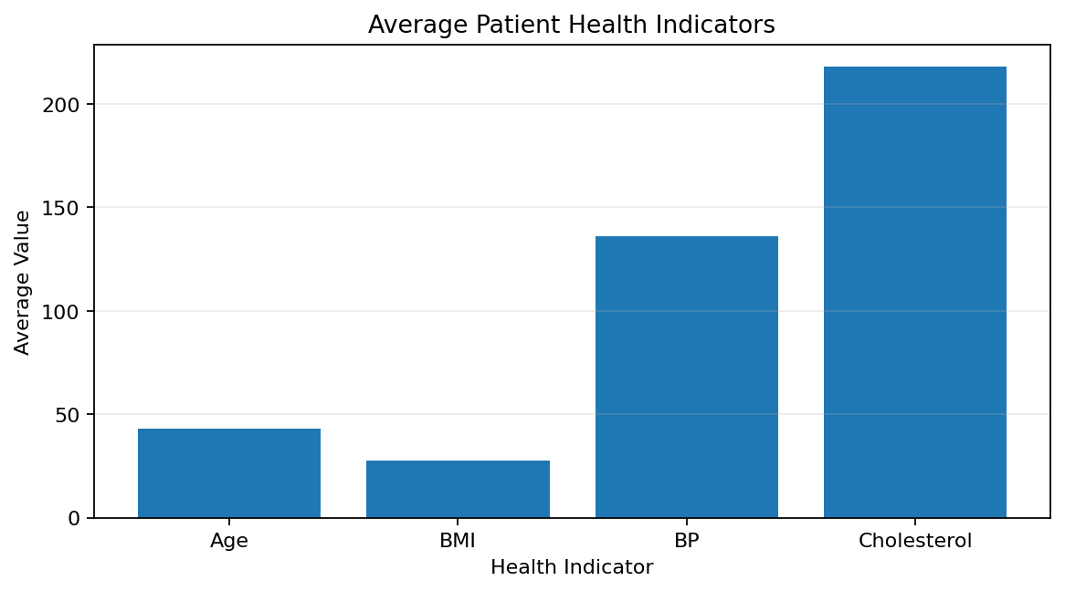
Output 3: Average Health Indicator Bar Chart
Observation: Sample averages are Age 43, BMI 27.6, BP 136, and Cholesterol 218. These describe this sample and should not be used alone to diagnose or assign clinical risk.

PROGRAM 3: Tableau Dashboard
Create an interactive Tableau heatmap dashboard with an Age filter and hover tooltips.
- Connect Tableau to a CSV with Patient_ID, Age, BMI, BP, and Cholesterol.
- Pivot BMI, BP, and Cholesterol into Indicator and Value fields if needed.
- Create a heatmap with Patient_ID on Rows, Indicator on Columns, and Value on Color.
- Add Age as a filter and apply it to all worksheets using the same data source.
- Add Age, BMI, BP, and Cholesterol to tooltips, then combine views in a dashboard.
P5 has the highest age (60), BMI (32), BP (150), and cholesterol (260); P1 has the lowest values in this sample. These are relative comparisons, not medical diagnoses.

Procedure
- Create the patient health data frame.
- Use pairs() to inspect pairwise relationships.
- Use qqnorm(), qqline(), and ecdf() to examine cholesterol distribution visually.
- Calculate means and display them using barplot().
- Build a Tableau heatmap, add an Age filter, and configure tooltips.

RESULT
The five-patient dataset was explored using pairwise plots, a cholesterol Q-Q plot and ECDF, and a bar chart of average indicators. P5 has the highest values in the sample. This small dataset is descriptive only and cannot diagnose clinical risk.

Key Functions and Tools Used
Function / Tool | Purpose
pairs() | Displays pairwise relationships among numeric variables.
qqnorm() / qqline() | Compares cholesterol quantiles with a normal reference.
ecdf() | Displays the empirical cumulative distribution.
colMeans() / barplot() | Calculates and visualizes average indicators.
Tableau Heatmap | Uses color and filters to explore indicator patterns.

