LAB EXPERIMENT RECORD
SET 22: TIME SERIES ANALYSIS

Department | AIDS
Course Code / Course Name | DSA0602 / Data Handling and Visualization
Experiment | Time Series Analysis using R and Tableau
Name | B Mallika
Register Number | 192324234
Date | 15 October 2026
Day | Thursday

Aim
To analyze monthly sales data as a time series using a line chart, a scatter plot and an autocorrelation plot in R, and to build a dashboard combining a sales trend line chart and a product-wise pie chart using Tableau. Dataset: Monthly Sales Data

Month | Sales (in $)
January | 15000
February | 18000
March | 22000
April | 20000
May | 23000

Note: the question gives no advertising budget and no product-wise sales. For Program 2 and Program 3, sample values are assumed and are shown in the tables of those programs. Replace them with your own figures if your faculty has provided them.

PROGRAM 1: Time Series Line Chart of Monthly Sales
In R, create a time series line chart to visualize the trend in monthly sales. Label the axes and title the chart.
# Dataset
months <- c("January","February","March","April","May") sales <- c(15000, 18000, 22000, 20000, 23000)

# Time Series Line Chart plot(1:5, sales,
type = "o",
col = "steelblue", lwd = 2,
pch = 16, xaxt = "n",
xlab = "Month",
ylab = "Sales (in $)",
main = "Monthly Sales Trend (January - May)", ylim = c(14000, 24000))
axis(1, at = 1:5, labels = months) grid()

OUTPUT:
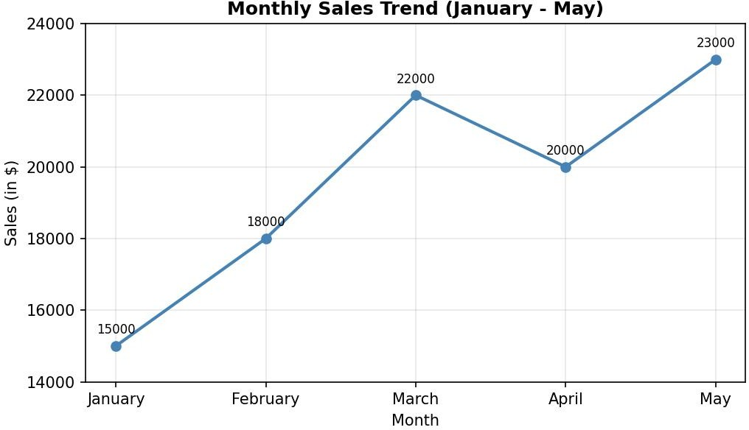
Output 1: Monthly Sales Trend (Time Series Line Chart)

Observation:
Sales show an upward trend overall, rising from 15,000 in January to 23,000 in May (about 53% growth). The sharpest rise is from February to March (+4,000, about 22%). April is the only month with a fall (22,000 to 20,000, about 9%), after which sales recover to their highest value of 23,000 in May.

PROGRAM 2: Scatter Plot of Advertising Budget vs Monthly Sales
In R, generate a scatter plot to analyze the relationship between advertising budget and monthly sales. Explain any insights.

Dataset (advertising budget is assumed):

Month | Advertising Budget (in $) | Sales (in $)
January | 2000 | 15000
February | 2500 | 18000
March | 3200 | 22000
April | 2800 | 20000
May | 3400 | 23000

# Dataset (advertising budget is an assumed value) ad_budget <- c(2000, 2500, 3200, 2800, 3400)
sales <- c(15000, 18000, 22000, 20000, 23000)

# Scatter Plot with regression line plot(ad_budget, sales,
pch = 16,
col = "firebrick", cex = 1.5,
xlab = "Advertising Budget (in $)", ylab = "Monthly Sales (in $)",
main = "Advertising Budget vs Monthly Sales") abline(lm(sales ~ ad_budget), col = "steelblue", lwd = 2)

# Strength of the relationship cor(ad_budget, sales) coef(lm(sales ~ ad_budget))

OUTPUT:
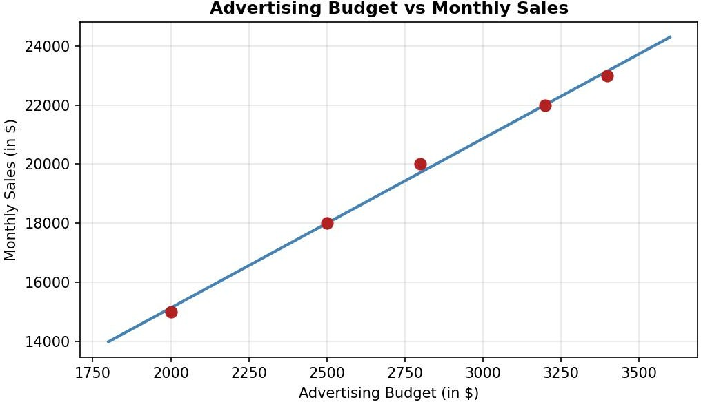

Output 2: Advertising Budget vs Monthly Sales (Scatter Plot)

Observation:
The points lie almost on a straight line rising to the right, so there is a very strong positive relationship between advertising budget and sales (correlation coefficient r = 0.999). The fitted line suggests that each extra $1 of advertising is associated with about $5.74 of extra monthly sales. The months with the highest budgets (March and May) also have the highest sales, and the dip in April matches the lower budget of that month. With only five points, and with the advertising values assumed, this shows association rather than proof that advertising causes the sales.

PROGRAM 3: Tableau Dashboard of Sales Trend and Product Distribution
In Tableau, build a dashboard combining a line chart showing the sales trend and a pie chart displaying the distribution of sales across products.

Dataset (product-wise split is assumed; each month adds up to the monthly total):

Month | Product A | Product B | Product C | Total
January | 6800 | 4700 | 3500 | 15000
February | 8000 | 5600 | 4400 | 18000
March | 10000 | 6600 | 5400 | 22000
April | 9000 | 6000 | 5000 | 20000
May | 10300 | 6900 | 5800 | 23000
Total | 44100 | 29800 | 24100 | 98000

Steps in Tableau
- Save the data as a CSV file with the columns Month, Product and Sales (15 rows: 5 months x 3 products) and connect to it in Tableau (Connect > Text file).
- Sheet 1 (Line Chart): Convert Month to a continuous or discrete date field, drag Month to Columns and Sales to Rows (SUM). Set the Marks type to Line, add Sales to Label, and rename the sheet "Sales Trend".
- Sheet 2 (Pie Chart): Change the Marks type to Pie. Drag Product to Color and Sales to Angle, then drag Sales to Label and use Quick Table Calculation > Percent of Total. Rename the sheet "Sales by Product".
- Create a new Dashboard (Dashboard > New Dashboard), set the size to Automatic, and drag the "Sales Trend" and "Sales by Product" sheets onto the dashboard area.
- Add interactivity: select each chart and click Use as Filter, so clicking a pie slice or a month in one view filters the other. Add a Month filter (Show Filter > Apply to Worksheets > All Using This Data Source).
- Add the title "Sales Time Series Dashboard" and test the filters in Presentation Mode.

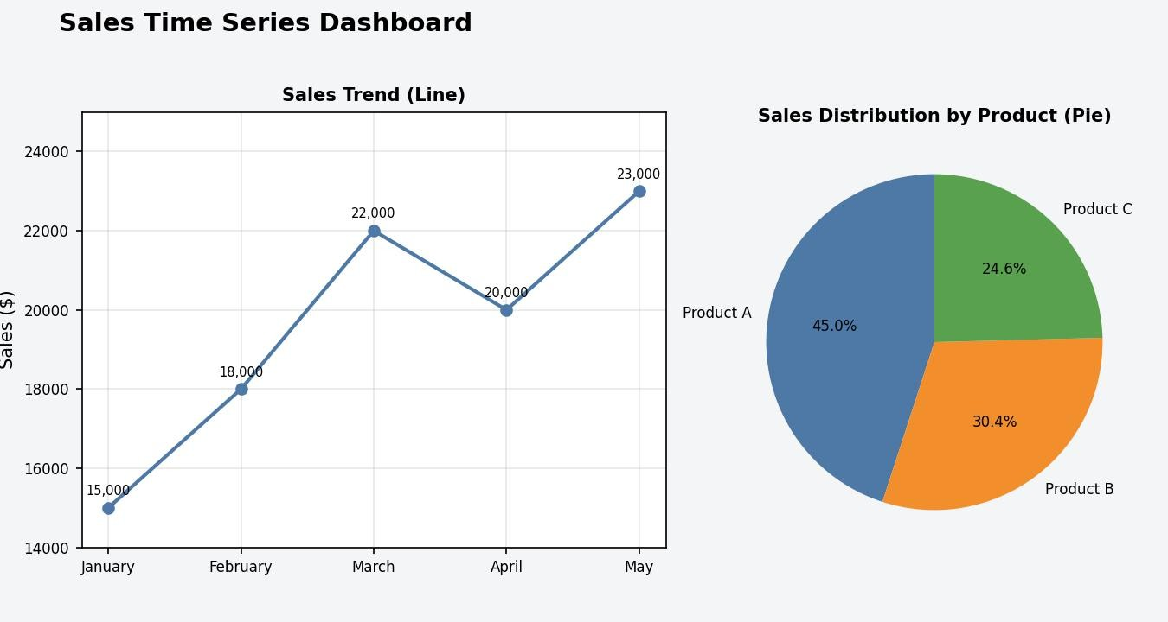
Output 3: Sales Time Series Dashboard (Tableau)

Observation:
The dashboard shows the monthly sales trend and the product-wise share together. Product A contributes the largest share of the total sales of 98,000 (44,100, about 45.0%), followed by Product B (29,800, about 30.4%) and Product C (24,100, about 24.6%). Clicking a slice or a month in one view filters the other view.

PROGRAM 4: Autocorrelation Plot to Identify Seasonality
In R, create an autocorrelation plot to identify seasonality in the time series data.
# Dataset
sales <- c(15000, 18000, 22000, 20000, 23000)

# Autocorrelation Plot acf(sales,
lag.max = 4,
main = "Autocorrelation of Monthly Sales", xlab = "Lag",
ylab = "ACF")

# ACF values
acf(sales, lag.max = 4, plot = FALSE)

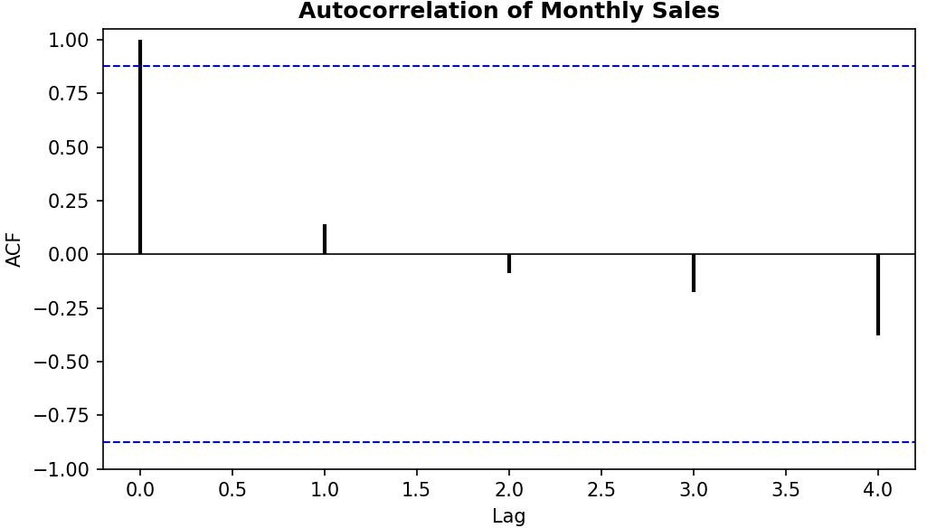

Output 4: Autocorrelation Plot of Monthly Sales
ACF values (mean of sales = 19,600):

Lag | ACF | Inside 95% limits (±0.88)?
0 | 1.000 | -
1 | 0.142 | Yes
2 | -0.085 | Yes
3 | -0.177 | Yes
4 | -0.380 | Yes

Observation:
The ACF is 1 at lag 0 by definition. At lags 1 to 4 the values (0.14, -0.09, -0.18 and -0.38) all stay inside the dashed 95% confidence limits, so no lag shows a significant autocorrelation and there is no clear sign of seasonality. The slow drift of the ACF towards negative values reflects the upward trend. Only five months of data are available, so seasonality cannot be judged reliably; at least two full years (24 months) of monthly data are needed to detect a yearly pattern at lag 12.

Procedure
- Define the monthly sales (and the assumed advertising budget) as vectors in R.
- Use plot() with type = "o" and axis() to draw the time series line chart with labelled axes and a title.
- Use plot() for the scatter plot, add a regression line with abline(lm()), and find the relationship with cor().
- Prepare the data with Month, Product and Sales columns, load it into Tableau, and build the line chart and pie chart worksheets.
- Combine the two worksheets in a Tableau dashboard and add filters and actions for interactivity.
- Use acf() on the sales series to draw the autocorrelation plot and check for seasonality.

RESULT:
The monthly sales data was successfully analyzed as a time series in R using a line chart, a scatter plot and an autocorrelation plot. A Tableau dashboard combining the sales trend line chart and the product-wise pie chart was also created. Sales grow steadily from January to May, advertising budget and sales are strongly positively related, and the autocorrelation plot shows no clear seasonality in the five months of data.

Key Functions and Tools Used

Function / Tool | Purpose
c() | Creates the sales and advertising budget vectors.
plot(type = "o") / axis() | Creates the time series line chart with month labels.
plot() / abline(lm()) | Creates the scatter plot and adds the regression line.
cor() / coef() | Measures the strength of the relationship and the slope.
acf() | Draws the autocorrelation plot and gives ACF values.
Tableau Pie / Line marks | Builds the product pie chart and the sales trend line chart.
Tableau Dashboard | Combines worksheets with filters and actions.

