LAB EXPERIMENT RECORD

Set 8: Employee Performance Analysis
Department: AIDS
Course Code / Course Name: DSA0602/ Data Handling and Visualization
Experiment: Data Visualization using R
Aim
To visualize employee performance scores, compare employee counts across departments, display employee performance details in a table, and design an interactive dashboard.
Dataset: Employee Performance
Employee ID | Department | Years of Service | Performance Score
1 | Sales | 5 | 85
2 | HR | 3 | 92
3 | Marketing | 7 | 78

PROGRAM 1: Line Chart of Employee Performance
Create a line chart to visualize the performance trend of employees over time. Label the axes and title the chart.
# Dataset
employee_id <- c(1, 2, 3)
years_service <- c(5, 3, 7)
performance <- c(85, 92, 78)
# Order employees by years of service
ord <- order(years_service)
# Line Chart
plot(years_service[ord], performance[ord],
type = "o",
xaxt = "n",
xlab = "Years of Service",
ylab = "Performance Score",
main = "Employee Performance by Years of Service",
col = "blue",
pch = 19)
axis(1, at = years_service[ord],
labels = employee_id[ord])
Output 1: Line Chart of Employee Performance
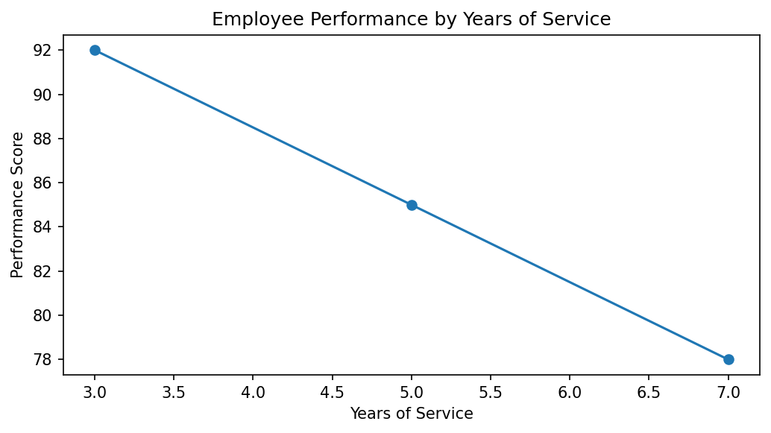
Observation: Employee 2 has the highest performance score (92) with 3 years of service. Employee 3 has the lowest score (78) with 7 years of service. The dataset is cross-sectional and does not contain repeated observations over time; therefore, the chart compares employees by years of service rather than showing a true time-series trend.

PROGRAM 2: Bar Chart of Employees by Department
Generate a bar chart showing the distribution of employees across different departments. Label the chart elements.
# Dataset
department <- c("Sales", "HR", "Marketing")
# Department frequency
dept_count <- table(department)
# Bar Chart
barplot(dept_count,
xlab = "Department",
ylab = "Number of Employees",
main = "Employee Distribution by Department",
col = "lightgreen")
Output 2: Bar Chart of Employees by Department
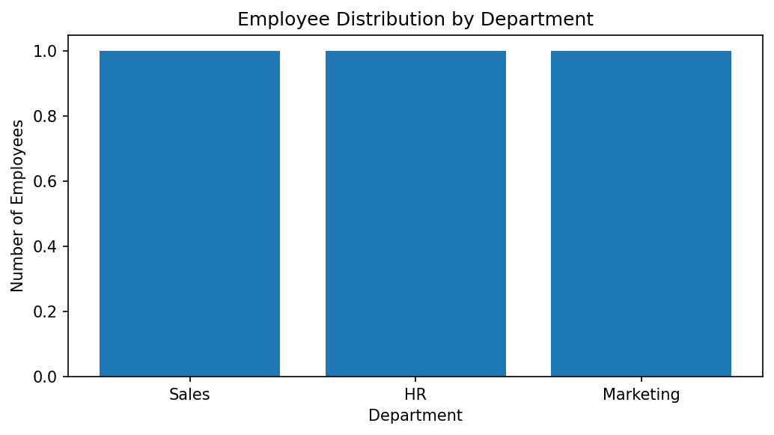
Observation: Sales, HR, and Marketing each have one employee. Hence, all three departments have equal representation in the given dataset.

PROGRAM 3: Table of Employee Performance
Build a table to display the performance data for each employee. Label the table elements.
# Create employee performance table
employee_data <- data.frame(
Employee_ID = c(1, 2, 3),
Department = c("Sales", "HR", "Marketing"),
Years_of_Service = c(5, 3, 7),
Performance_Score = c(85, 92, 78)
)
# Display table
print(employee_data)
Output 3: Table of Employee Performance
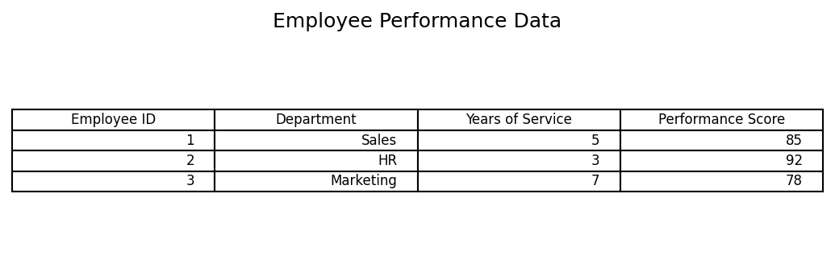
Observation: The table displays employee ID, department, years of service, and performance score for each employee.

PROGRAM 4: Interactive Employee Performance Dashboard
Develop a Tableau dashboard combining the line chart, bar chart, and the table for interactive exploration of employee performance data.
# Tableau dashboard steps
# 1. Connect to the Employee Performance dataset.
# 2. Create a line chart using Years of Service and Performance Score.
# 3. Create a bar chart using Department and COUNT(Employee ID).
# 4. Create a text table containing all employee performance fields.
# 5. Add the three worksheets to a new Dashboard.
# 6. Add Department and Years of Service filters.
# 7. Configure dashboard actions to filter related views.
# R data preparation
employee_data <- data.frame(
Employee_ID = c(1, 2, 3),
Department = c("Sales", "HR", "Marketing"),
Years_of_Service = c(5, 3, 7),
Performance_Score = c(85, 92, 78)
)
print(employee_data)
Output 4: Interactive Employee Performance Dashboard
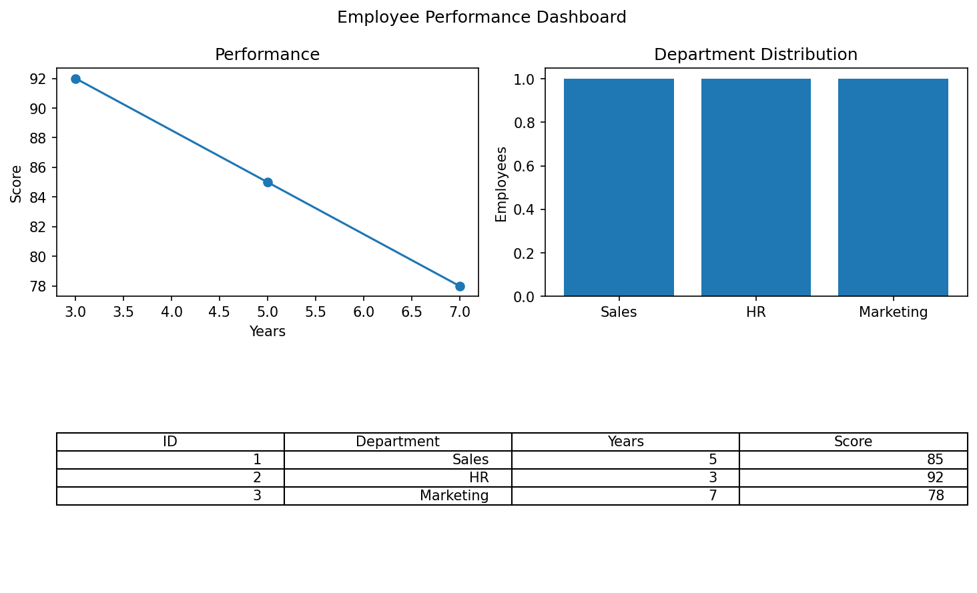
Observation: The dashboard combines employee performance, department distribution, and the employee table. Department and years-of-service filters support interactive exploration.
Procedure
Create vectors for employee ID, department, years of service, and performance score.
Use plot() to compare performance scores by years of service.
Use table() and barplot() to show the number of employees in each department.
Create and print a data frame containing all employee details.
In Tableau, combine the line chart, department bar chart, and table in a dashboard with filters.
Result
Employee performance was visualized using a line chart and department-wise bar chart. The employee data table and an interactive Tableau dashboard layout were also prepared.
Key R Functions Used
Function | Purpose
plot() | Creates a line chart.
order() | Orders observations by years of service.
table() | Calculates department frequencies.
barplot() | Creates a department bar chart.
data.frame() | Creates a structured employee table.

