LAB EXPERIMENT RECORD

Set 9: Online Learning Activity Analysis
Department: AIDS
Course Code / Course Name: DSA0602/ Data Handling and Visualization
Experiment: Data Visualization using R
Aim
To analyze online learning activity using a histogram, boxplot, bubble scatter plot, monthly average quiz-score line chart with moving average smoothing, and an interactive Tableau dashboard.
Dataset: Online_Learning_Activity.csv
Student_ID | Gender | Age | Course | Study_Time (hrs) | Videos_Watched | Quiz_Score | Login_Date
L01 | Male | 20 | R | 3.5 | 12 | 78 | 2025-01-05
L02 | Female | 22 | R | 4.2 | 15 | 85 | 2025-01-05
L03 | Male | 19 | SQL | 2.0 | 8 | 65 | 2025-02-08
L04 | Female | 21 | R | 5.0 | 18 | 92 | 2025-02-08
L05 | Male | 23 | R | 2.5 | 9 | 70 | 2025-03-12
L06 | Female | 20 | SQL | 4.0 | 14 | 88 | 2025-03-12

PROGRAM 1: Histogram and Boxplot of Quiz Scores
Import the dataset in R. Plot a histogram for Quiz_Score. Draw a boxplot of Quiz_Score by Course. Add title and labels. Interpret student performance.
# Create dataset
learning <- data.frame(
Student_ID = c("L01","L02","L03","L04","L05","L06"),
Gender = c("Male","Female","Male","Female","Male","Female"),
Age = c(20,22,19,21,23,20),
Course = c("R","R","SQL","R","R","SQL"),
Study_Time = c(3.5,4.2,2.0,5.0,2.5,4.0),
Videos_Watched = c(12,15,8,18,9,14),
Quiz_Score = c(78,85,65,92,70,88),
Login_Date = c("2025-01-05","2025-01-05","2025-02-08",
"2025-02-08","2025-03-12","2025-03-12")
)
# Histogram
hist(learning$Quiz_Score,
main = "Distribution of Quiz Scores",
xlab = "Quiz Score",
ylab = "Frequency",
col = "skyblue")
# Boxplot by Course
boxplot(Quiz_Score ~ Course,
data = learning,
main = "Quiz Scores by Course",
xlab = "Course",
ylab = "Quiz Score",
col = c("lightgreen", "orange"))
Output 1: Histogram and Boxplot of Quiz Scores
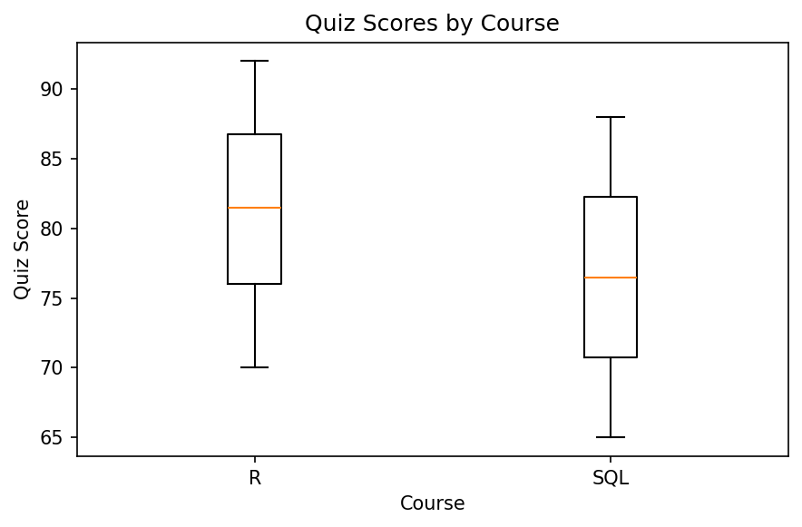
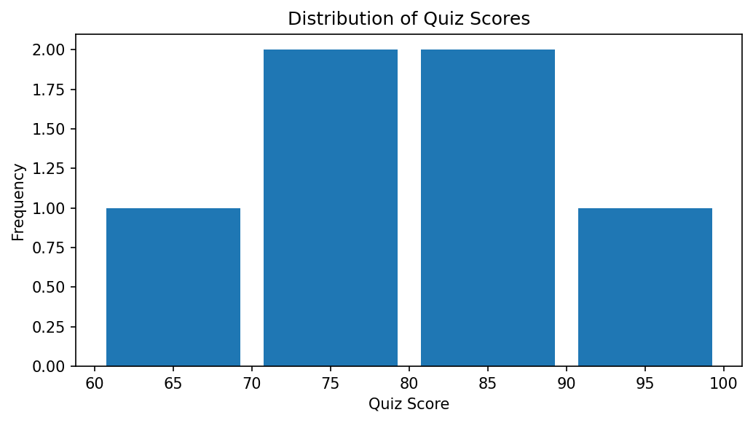
Observation: Quiz scores range from 65 to 92. R course scores are 70, 78, 85, and 92, while SQL scores are 65 and 88. The histogram shows the distribution of all six scores, and the boxplot compares scores between the two courses.

PROGRAM 2: Bubble Scatter Plot of Study Time and Quiz Score
Create a scatter plot using R programming between Study_Time and Quiz_Score. Represent Videos_Watched using bubble size. Apply transparency. Explain the learning pattern.
# Use the learning dataset created in Program 1
# Scale bubble sizes using Videos_Watched
bubble_size <- 1 + learning$Videos_Watched / 8
# Bubble Scatter Plot
plot(learning$Study_Time, learning$Quiz_Score,
pch = 21,
cex = bubble_size,
bg = adjustcolor("steelblue", alpha.f = 0.45),
col = "navy",
xlab = "Study Time (Hours)",
ylab = "Quiz Score",
main = "Study Time vs Quiz Score")
# Add student labels
text(learning$Study_Time, learning$Quiz_Score,
labels = learning$Student_ID,
pos = 3,
cex = 0.7)
Output 2: Bubble Scatter Plot of Study Time and Quiz Score
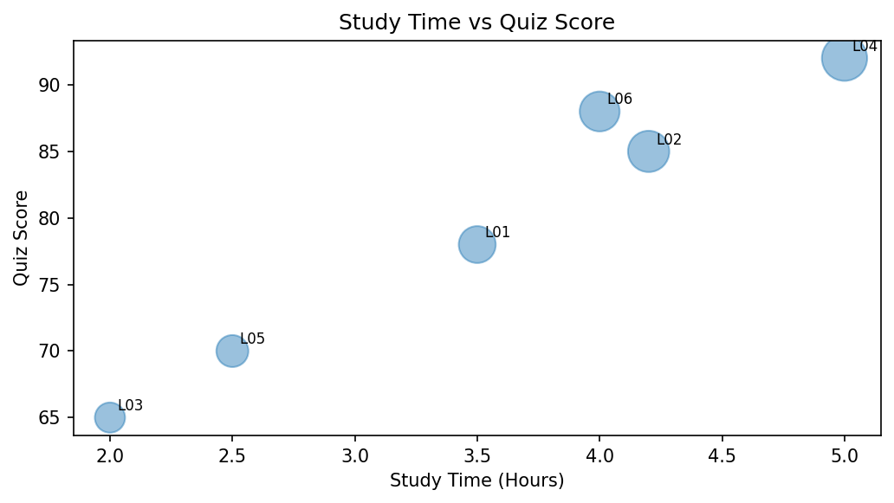
Observation: The plotted data generally suggests that students with more study time tend to obtain higher quiz scores, although the pattern is not perfectly consistent. Larger bubbles represent students who watched more videos. The sample contains only six students, so the pattern should be interpreted cautiously.

PROGRAM 3: Monthly Average Quiz Score with Moving Average
Using R programming, convert Login_Date into Date format. Calculate average quiz score per month. Plot a line chart. Apply moving average smoothing. Identify the trend.
# Convert Login_Date into Date format
learning$Login_Date <- as.Date(learning$Login_Date)
# Extract month
learning$Month <- format(learning$Login_Date, "%Y-%m")
# Calculate monthly average quiz score
monthly_avg <- aggregate(Quiz_Score ~ Month,
data = learning,
FUN = mean)
# Ensure chronological order
monthly_avg <- monthly_avg[order(monthly_avg$Month), ]
# Calculate 2-month trailing moving average
monthly_avg$Moving_Average <- as.numeric(
stats::filter(monthly_avg$Quiz_Score,
filter = c(1/2, 1/2),
sides = 1)
)
# Line chart
plot(seq_len(nrow(monthly_avg)), monthly_avg$Quiz_Score,
type = "o",
xaxt = "n",
xlab = "Month",
ylab = "Average Quiz Score",
main = "Monthly Average Quiz Score",
col = "blue",
ylim = range(c(monthly_avg$Quiz_Score,
monthly_avg$Moving_Average),
na.rm = TRUE))
axis(1, at = seq_len(nrow(monthly_avg)),
labels = monthly_avg$Month)
# Add moving average line
lines(seq_len(nrow(monthly_avg)),
monthly_avg$Moving_Average,
type = "o",
col = "red",
lty = 2)
legend("topright",
legend = c("Monthly Average", "2-Month Moving Average"),
col = c("blue", "red"),
lty = c(1, 2),
pch = 1)
# Display monthly results
print(monthly_avg)
Output 3: Monthly Average Quiz Score with Moving Average
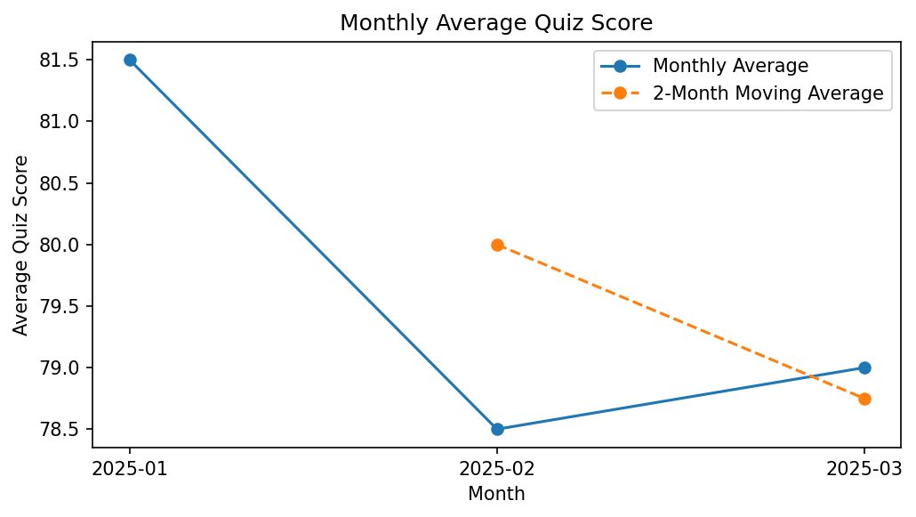
Observation: Monthly average quiz scores are January 81.5, February 78.5, and March 79.0. The scores decrease from January to February and increase slightly in March. The two-month trailing moving average smooths the short-term variation; its first value is unavailable because two months are needed.

PROGRAM 4: Interactive Online Learning Dashboard
Import Online_Learning_Activity.csv into Tableau. Create a bar chart showing average quiz score by Course. Create a scatter plot (Study Time vs Quiz Score). Add filter for Gender and Course. Design a mini interactive dashboard.
# Tableau dashboard steps
# 1. Save the learning data as Online_Learning_Activity.csv.
# 2. Open Tableau and connect to the CSV file.
# 3. Create a bar chart:
# Course -> Columns; Quiz_Score -> Rows; change aggregation to AVG.
# 4. Create a scatter plot:
# Study_Time (hrs) -> Columns; Quiz_Score -> Rows.
# Student_ID -> Detail; Videos_Watched -> Size.
# 5. Add Gender and Course as filters.
# 6. Show the filters and apply them to both worksheets.
# 7. Create a new Dashboard and place both worksheets on it.
# 8. Add a dashboard title and configure filter actions.
# Optional R code to export the dataset for Tableau:
write.csv(learning,
"Online_Learning_Activity.csv",
row.names = FALSE)
Output 4: Interactive Online Learning Dashboard
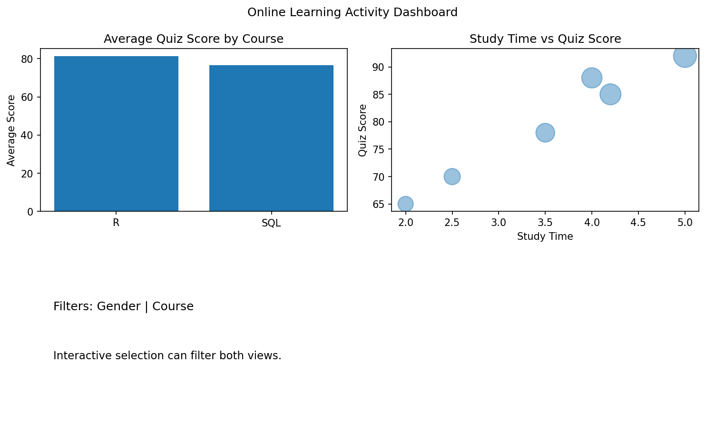
Observation: The Tableau mini dashboard contains average quiz score by course and a study-time versus quiz-score scatter plot. Gender and Course filters allow users to explore the learning activity data.
Procedure
Import or create the Online_Learning_Activity dataset in R.
Use hist() to plot the quiz-score distribution and boxplot() to compare scores by course.
Use plot() with bubble size based on Videos_Watched and transparency to visualize study time versus quiz score.
Convert Login_Date using as.Date(), calculate monthly averages using aggregate(), and apply a moving average using stats::filter().
Import the CSV into Tableau, create the average-score bar chart and scatter plot, add Gender and Course filters, and combine the views in a dashboard.
Result
The online learning activity data was analyzed using a histogram, course-wise boxplot, bubble scatter plot, and monthly average quiz-score line chart with moving average smoothing. A Tableau dashboard design with course and gender filters was also prepared.
Key R Functions Used
Function | Purpose
hist() | Creates a histogram.
boxplot() | Compares quiz-score distributions by course.
plot() | Creates scatter and line charts.
adjustcolor() | Applies transparency to bubble colors.
as.Date() | Converts date strings into Date format.
aggregate() | Calculates monthly average quiz scores.
stats::filter() | Calculates moving average smoothing.
write.csv() | Exports data to a CSV file.

