LAB EXPERIMENT RECORD
Set 2: Customer Feedback Analysis
Field | Details
Department | AIDS
Course Code / Course Name | DSA0602 / Data Handling and Visualization
Experiment | Data Visualization using R
Aim
To analyze customer age and satisfaction data using a histogram, pie chart and stacked bar chart, and to identify prevalent customer sentiments using a word cloud.
Dataset: Customer Satisfaction
Customer ID | Age | Satisfaction Score
1 | 25 | 4
2 | 30 | 5
3 | 35 | 3
4 | 28 | 4
5 | 40 | 5
PROGRAM 1: Histogram of Customer Ages
Create a histogram to represent the distribution of customer ages. Label the axes and title the chart.
# Dataset
age <- c(25, 30, 35, 28, 40)
# Histogram
hist(age,
breaks = seq(20, 45, by = 5),
right = FALSE,
xlab = "Age",
ylab = "Frequency",
main = "Distribution of Customer Ages",
col = "skyblue",
border = "black")
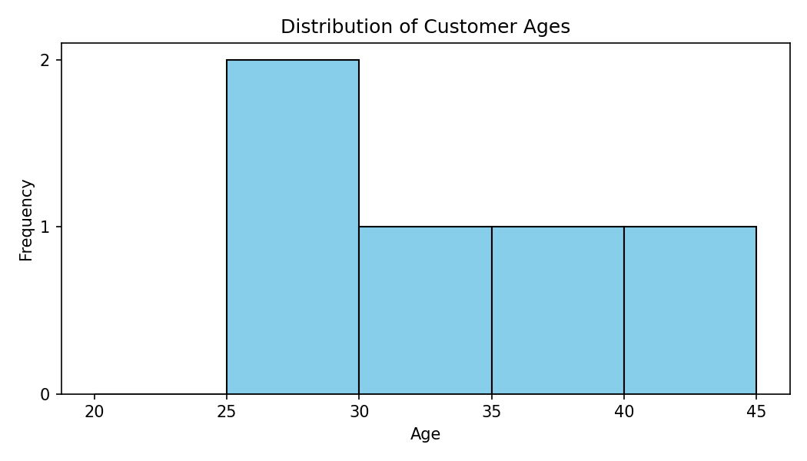
Output 1: Histogram of Customer Ages
Observation: Customer ages range from 25 to 40 years (mean = 31.6). The 25-29 age group is the most common with 2 customers, while the 30-34, 35-39 and 40-44 groups each contain 1 customer.
PROGRAM 2: Pie Chart of Satisfaction Scores
Generate a pie chart to display the overall distribution of customer satisfaction scores. Include labels.
# Dataset
score <- c(4, 5, 3, 4, 5)
# Pie Chart
score_count <- table(score)
pct <- round(score_count / sum(score_count) * 100)
labels <- paste0("Score ", names(score_count), ": ", pct, "%")
pie(score_count,
labels = labels,
col = c("#f4a582", "#92c5de", "#4393c3"),
main = "Customer Satisfaction Score Distribution")
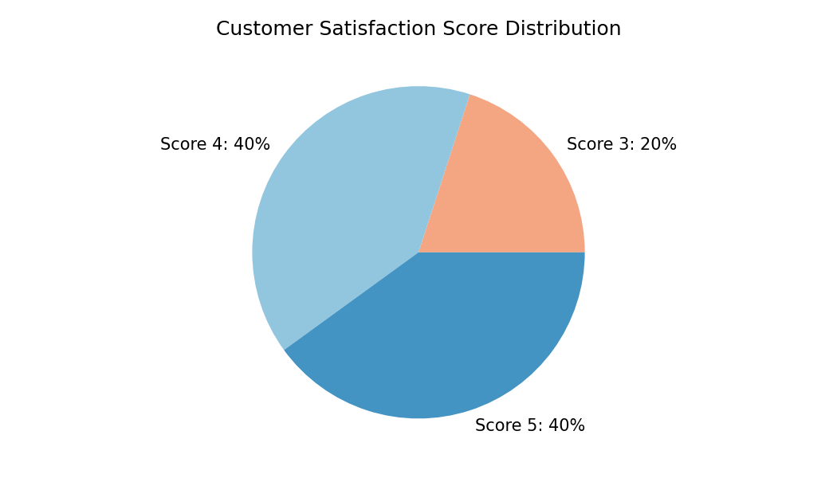
Output 2: Pie Chart of Satisfaction Scores
Observation: Scores 4 and 5 each account for 40% of the customers (2 customers each), and score 3 accounts for 20% (1 customer). No customer gave a score below 3, so overall satisfaction is high.
PROGRAM 3: Stacked Bar Chart of Satisfaction by Age Group
Build a stacked bar chart to visualize the distribution of customer satisfaction scores by age group.
# Dataset
age <- c(25, 30, 35, 28, 40)
score <- c(4, 5, 3, 4, 5)
# Age groups
age_group <- cut(age, breaks = c(20, 30, 40, 50),
labels = c("20-29", "30-39", "40-49"),
right = FALSE)
tab <- table(score, age_group)
# Stacked Bar Chart
barplot(tab,
beside = FALSE,
xlab = "Age Group",
ylab = "Number of Customers",
main = "Satisfaction Scores by Age Group",
col = c("#d6604d", "#92c5de", "#4393c3"),
legend.text = paste("Score", rownames(tab)))
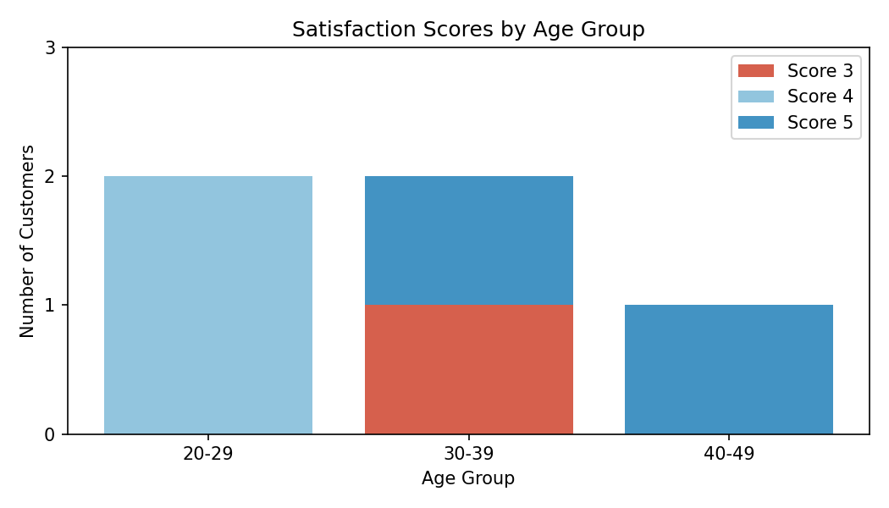
Output 3: Stacked Bar Chart of Satisfaction by Age Group
Observation: The 20-29 group has two customers, both with score 4. The 30-39 group has one customer with score 5 and one with score 3. The 40-49 group has one customer with score 5. Satisfaction therefore does not follow a simple increase or decrease with age in this small sample.
PROGRAM 4: Word Cloud of Customer Feedback
Develop a word cloud from open-ended customer feedback to identify prevalent customer sentiments.
# The supplied Set 2 dataset contains only:
# Customer ID, Age and Satisfaction Score.
# Open-ended feedback text is not provided.
library(wordcloud)
library(tm)
# Add the actual feedback comments before running:
feedback <- c(NA, NA, NA, NA, NA)
corpus <- Corpus(VectorSource(feedback))
corpus <- tm_map(corpus, content_transformer(tolower))
corpus <- tm_map(corpus, removePunctuation)
corpus <- tm_map(corpus, removeWords, stopwords("english"))
tdm <- TermDocumentMatrix(corpus)
freq <- sort(rowSums(as.matrix(tdm)), decreasing = TRUE)
wordcloud(names(freq), freq, min.freq = 1,
colors = brewer.pal(8, "Dark2"))
Output 4: Word Cloud of Customer Feedback
Observation: The supplied Set 2 dataset does not contain open-ended feedback text, so a word cloud cannot be generated from the given data. After the comments are added, larger words in the cloud represent the most frequent terms and indicate the prevalent customer sentiments.
Note: The template code becomes runnable after the customer feedback comments are supplied.
Set 2 Procedure
1. Create the age and satisfaction score vectors from the given customer data.
2. Use hist() to display the distribution of customer ages.
3. Use table() and pie() to show the distribution of satisfaction scores.
4. Group ages with cut() and use barplot() with beside = FALSE to draw the stacked bar chart.
5. Add the feedback comments and use the wordcloud package to generate the word cloud.
Set 2 Result
The histogram, pie chart and stacked bar chart were successfully created from the customer satisfaction data. The word cloud requires open-ended feedback text, which is not included in the supplied dataset.

