LAB EXPERIMENT RECORD
Set 3: Employee Performance Evaluation
Field | Details
Department | AIDS
Course Code / Course Name | DSA0602 / Data Handling and Visualization
Experiment | Data Visualization using R
Aim
To evaluate employee performance using line, bar and scatter charts, analyze the correlation between years of service and performance score, and prepare an interactive Tableau dashboard.
Dataset: Employee Performance
Employee ID | Department | Years of Service | Performance Score
1 | Sales | 5 | 85
2 | HR | 3 | 92
3 | Marketing | 7 | 78
4 | Sales | 4 | 90
5 | HR | 2 | 76
PROGRAM 1: Line Chart of Employee Performance Trend
Create a line chart to visualize the performance trend of employees over time. Include a legend and labels.
# Dataset
emp_id <- c(1, 2, 3, 4, 5)
performance <- c(85, 92, 78, 90, 76)
# Line Chart
plot(emp_id, performance,
type = "o",
xaxt = "n",
xlab = "Employee ID",
ylab = "Performance Score",
main = "Employee Performance Trend",
col = "blue")
axis(1, at = emp_id)
abline(h = mean(performance), col = "red", lty = 2)
legend("bottomleft",
legend = c("Performance Score", "Average (84.2)"),
col = c("blue", "red"),
lty = c(1, 2),
pch = c(1, NA))
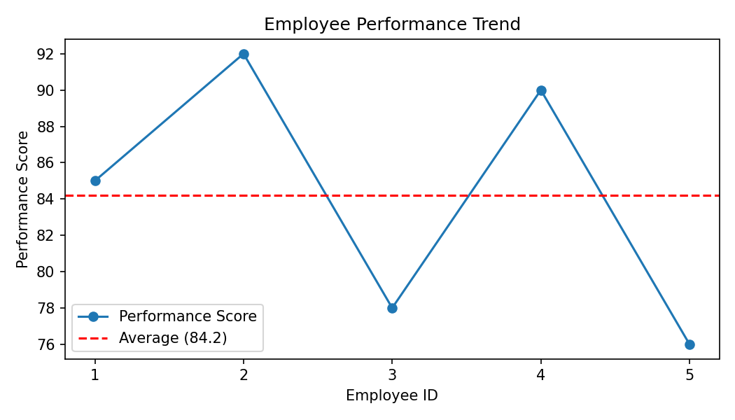
Output 1: Line Chart of Employee Performance Trend
Observation: The dataset has no date field, so employees are plotted in Employee ID order. Employee 2 has the highest score (92) and Employee 5 the lowest (76). The average performance score is 84.2, and Employees 1, 2 and 4 are above it.
PROGRAM 2: Bar Chart of Employees by Department
Generate a bar chart showing the distribution of employees across different departments. Label the chart elements.
# Dataset
department <- c("Sales", "HR", "Marketing", "Sales", "HR")
# Bar Chart
dept_count <- table(department)
barplot(dept_count,
xlab = "Department",
ylab = "Number of Employees",
main = "Employees by Department",
col = c("#2ca02c", "#1f77b4", "#ff7f0e"))
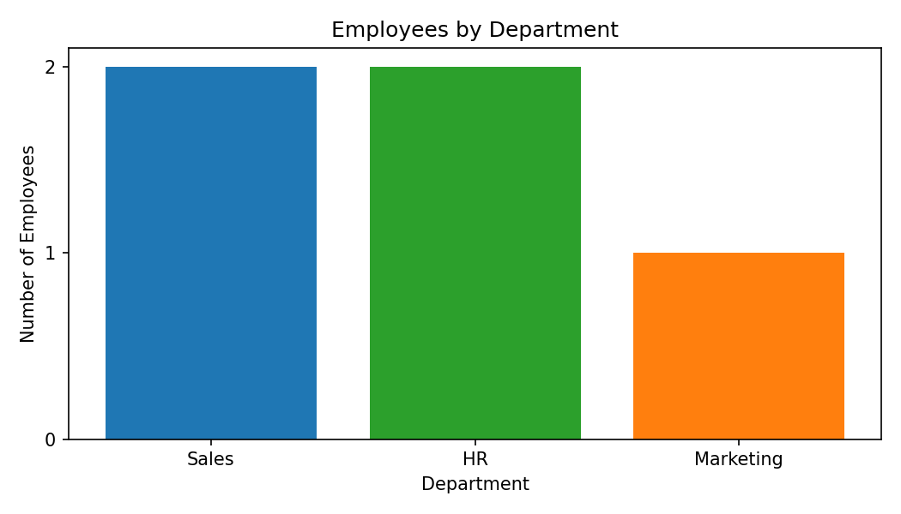
Output 2: Bar Chart of Employees by Department
Observation: Sales and HR each have 2 employees, while Marketing has 1 employee. Employees are therefore spread fairly evenly across the three departments.
PROGRAM 3: Scatter Plot of Years of Service vs Performance
Build a scatter plot to analyze the correlation between years of service and performance scores. Explain any insights.
# Dataset
years <- c(5, 3, 7, 4, 2)
performance <- c(85, 92, 78, 90, 76)
# Scatter Plot
plot(years, performance,
main = "Years of Service vs Performance Score",
xlab = "Years of Service",
ylab = "Performance Score",
pch = 19,
col = "red")
abline(lm(performance ~ years), col = "blue")
# Correlation
cor(years, performance) # -0.169
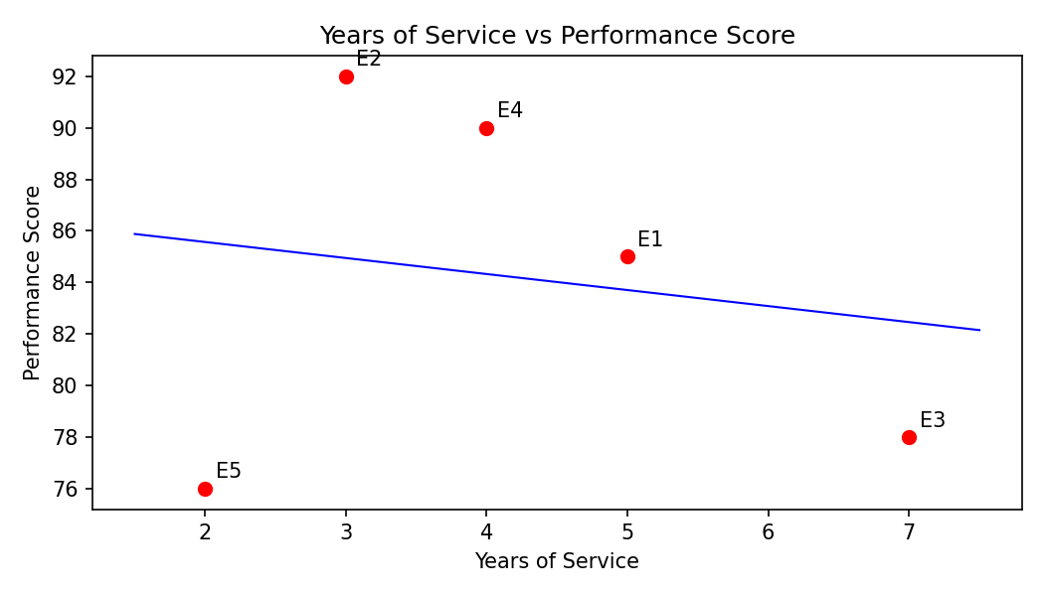
Output 3: Scatter Plot of Years of Service vs Performance
Observation: The correlation coefficient is about -0.17, which indicates a very weak negative relationship. Years of service does not strongly influence performance in this data: the most experienced employee (7 years) scored 78, while an employee with 3 years scored 92. With only five employees, no firm conclusion can be drawn.
PROGRAM 4: Interactive Employee Performance Dashboard
Develop a Tableau dashboard with the line chart and bar chart for interactive exploration.
# Tableau Dashboard - Required Views
# 1. Import the Employee Performance dataset into Tableau.
# 2. Create a line chart: Employee ID (Columns) and
# SUM(Performance Score) (Rows).
# 3. Create a bar chart: Department (Columns) and
# COUNT(Employee ID) (Rows).
# 4. Add both sheets to a dashboard.
# 5. Add a Department filter and enable "Use as Filter" on the
# bar chart for interactive exploration.
# R view for the supplied data:
par(mfrow = c(1, 2))
plot(emp_id, performance, type = "o", xlab = "Employee ID",
ylab = "Performance Score", main = "Performance Trend")
barplot(dept_count, xlab = "Department", ylab = "Employees",
main = "Employees by Department", col = "skyblue")
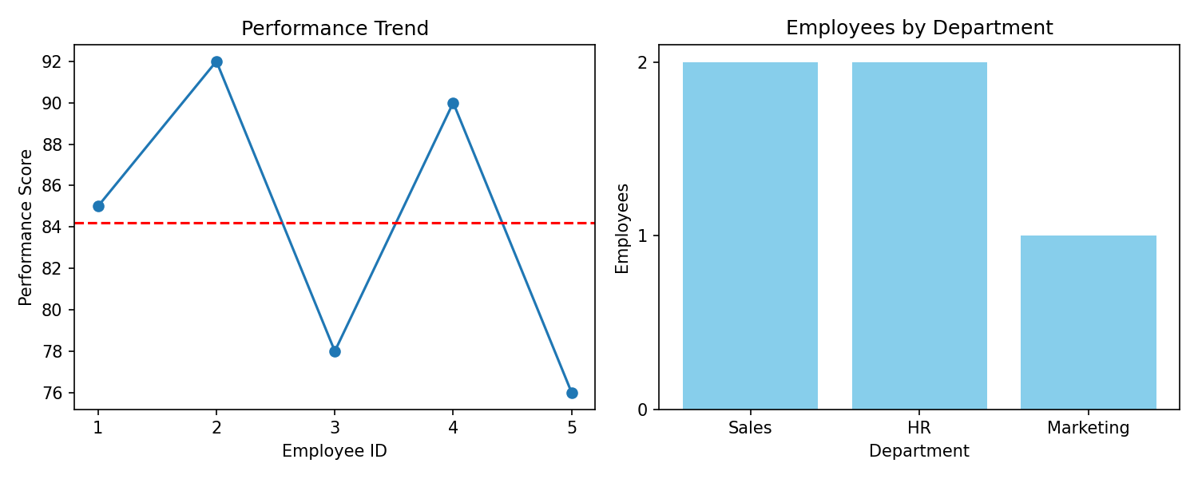
Output 4: Interactive Employee Performance Dashboard
Observation: The dashboard combines the performance trend and the department distribution. Clicking a department bar filters the line chart to that department, allowing quick comparison of Sales, HR and Marketing employees.
Set 3 Procedure
1. Create the employee ID, department, years of service and performance score vectors.
2. Use plot() with type = "o" and legend() to draw the performance line chart.
3. Use table() and barplot() to show the number of employees in each department.
4. Use plot(), abline() and cor() to analyze years of service against performance.
5. Build the Tableau dashboard with the line chart and bar chart and add filters.
Set 3 Result
The employee performance data was successfully visualized using line, bar and scatter charts. The correlation between years of service and performance score is weak (r = -0.17), and the interactive dashboard was designed in Tableau.

