LAB EXPERIMENT RECORD
Set 1: Monthly Sales Data
Field | Details
Department | AIDS
Course Code / Course Name | DSA0602 / Data Handling and Visualization
Experiment | Data Visualization using R
Name | B Mallika
Register Number | 192324234
Date | 29-09-2026
Day | Tuesday
Aim
To visualize monthly sales using line and bar charts, examine the relationship between advertising budget and monthly sales, and prepare an interactive dashboard combining the charts.
Dataset: Monthly Sales
Month | Sales (in $)
January | 15000
February | 18000
March | 22000
April | 20000
May | 23000
PROGRAM 1: Line Chart of Monthly Sales
Create a line chart to visualize the monthly sales. Label the axes and title the chart appropriately.
# Dataset
month <- c("January", "February", "March", "April", "May")
sales <- c(15000, 18000, 22000, 20000, 23000)
# Line Chart
plot(1:5, sales,
type = "o",
xaxt = "n",
xlab = "Month",
ylab = "Sales (in $)",
main = "Monthly Sales Trend",
col = "blue")
axis(1, at = 1:5, labels = month)
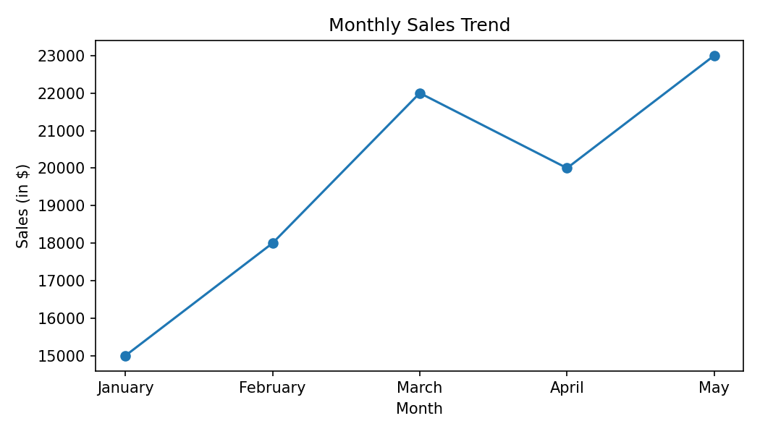
Output 1: Line Chart of Monthly Sales
Observation: Sales increase from $15,000 in January to $22,000 in March, dip slightly to $20,000 in April, and reach the highest value of $23,000 in May. Overall sales grew by $8,000 (about 53%) over the five months.
PROGRAM 2: Bar Chart of Top-Selling Products
Generate a bar chart to display the top-selling products for the year. Label the chart elements.
# The supplied Set 1 dataset contains only Month and Sales.
# Product-wise sales are not provided.
# Template after adding the product data:
product <- c("Product A", "Product B", "Product C")
product_sales <- c(NA, NA, NA) # replace with actual yearly sales
# barplot(sort(product_sales, decreasing = TRUE),
# names.arg = product, xlab = "Product",
# ylab = "Yearly Sales (in $)",
# main = "Top-Selling Products", col = "skyblue")
# R view for the supplied data (sales by month):
month <- c("January", "February", "March", "April", "May")
sales <- c(15000, 18000, 22000, 20000, 23000)
barplot(sales,
names.arg = month,
xlab = "Month",
ylab = "Sales (in $)",
main = "Monthly Sales (Bar View)",
col = "skyblue")
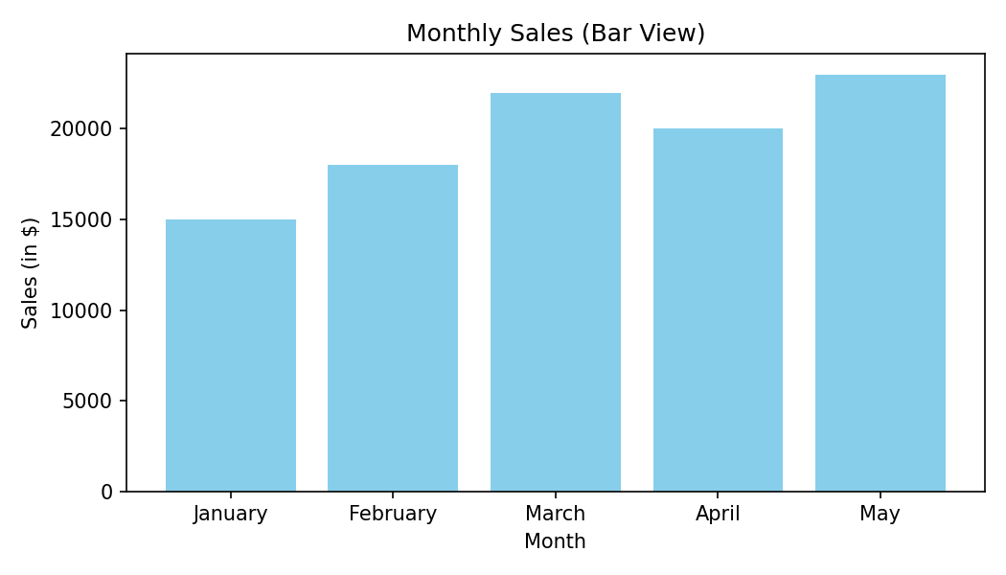
Output 2: Bar Chart of Sales (Supplied Data)
Observation: The supplied dataset has no product field, so the bar chart shows sales for each month. May has the highest sales ($23,000) and January the lowest ($15,000).
Note: A product-wise "top-selling" chart requires a Product column with yearly sales values.
PROGRAM 3: Scatter Plot of Advertising Budget vs Sales
Develop a scatter plot to explore the relationship between advertising budget and monthly sales. Explain the insights drawn from the scatter plot.
# Advertising budget is required for this question.
# The supplied Set 1 dataset does not contain advertising budget.
sales <- c(15000, 18000, 22000, 20000, 23000)
# Add the actual advertising budget before running:
ad_budget <- c(NA, NA, NA, NA, NA)
# Scatter Plot
plot(ad_budget, sales,
main = "Advertising Budget vs Monthly Sales",
xlab = "Advertising Budget ($)",
ylab = "Monthly Sales ($)",
pch = 19,
col = "red")
abline(lm(sales ~ ad_budget), col = "blue")
cor(ad_budget, sales)
Output 3: Scatter Plot of Advertising Budget vs Sales
Observation: The Set 1 source data does not provide advertising budget values, so the relationship cannot be determined from the supplied dataset. Once the budgets are added, a correlation close to +1 would indicate that higher advertising spend is associated with higher monthly sales, while a value near 0 would indicate no clear relationship.
Note: Actual advertising budget values must be added to complete this analysis.
PROGRAM 4: Interactive Sales Dashboard
Build an interactive dashboard combining the line chart and bar chart to allow users to explore sales data interactively.
# Tableau Dashboard - Required Views
# 1. Import the Monthly Sales dataset into Tableau.
# 2. Create a line chart: Month (Columns) and SUM(Sales) (Rows).
# 3. Create a bar chart: Month (Columns) and SUM(Sales) (Rows).
# 4. Place both sheets on one dashboard.
# 5. Enable "Use as Filter" on the bar chart and add a Month filter
# so that users can interactively explore the sales data.
# R view for the supplied data:
par(mfrow = c(1, 2))
plot(1:5, sales, type = "o", xaxt = "n", xlab = "Month",
ylab = "Sales (in $)", main = "Monthly Sales Trend")
axis(1, at = 1:5, labels = month)
barplot(sales, names.arg = month, xlab = "Month",
ylab = "Sales (in $)", main = "Sales by Month", col = "skyblue")
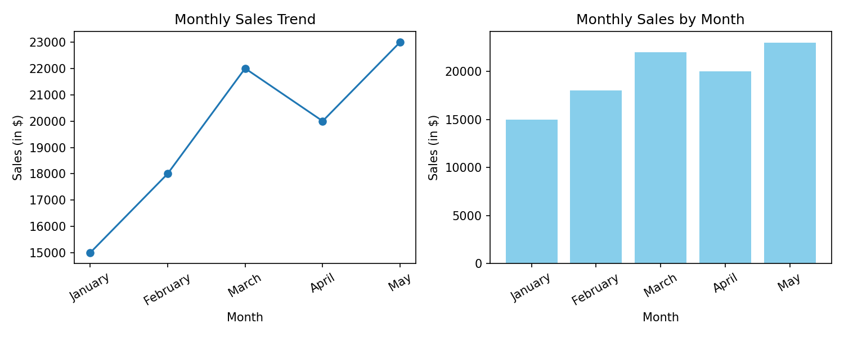
Output 4: Interactive Sales Dashboard
Observation: The dashboard places the sales trend (line chart) beside the month-wise comparison (bar chart). Selecting a month in one view highlights it in the other, making it easy to identify the growth from January to March and the peak in May.
Set 1 Procedure
1. Create the Month and Sales vectors from the given monthly sales data.
2. Use plot() with type = "o" to draw the line chart and label the axes and title.
3. Use barplot() to display the sales values; product-wise data is added when available.
4. Add advertising budget values and use plot() with abline() to study the relationship with sales.
5. Build the Tableau dashboard by placing the line chart and bar chart on a single dashboard with filters/actions.
Set 1 Result
The monthly sales data was successfully represented using a line chart and a bar chart, and the interactive dashboard was designed. The product-wise and advertising-budget analyses require fields that are not included in the supplied dataset.

