LAB EXPERIMENT RECORD
Set 10: Survey Responses Analysis
Field | Details
Department | AIDS
Course Code / Course Name | DSA0602 / Data Handling and Visualization
Experiment | Data Visualization using R
Name | B Mallika
Register Number | 192324234
Date | 06-10-2026
Day | Tuesday
Aim
To visualize survey responses using grouped and stacked bar charts, display the response data in a table, and prepare an interactive Tableau dashboard for exploring the survey results.
Dataset: Survey Responses
Survey ID | Question 1 | Question 2 | Question 3
1 | A | B | C
2 | B | A | D
3 | C | A | B
PROGRAM 1: Grouped Bar Chart of Question 1
Create a grouped bar chart to visualize the distribution of answers for Question 1. Label the chart elements.
# Dataset
survey_id <- c(1, 2, 3)
q1 <- c("A", "B", "C")
q2 <- c("B", "A", "A")
q3 <- c("C", "D", "B")
# Grouped Bar Chart
q1_count <- table(factor(q1, levels = c("A", "B", "C")))
barplot(q1_count,
beside = TRUE,
xlab = "Answer Option",
ylab = "Number of Responses",
main = "Distribution of Answers for Question 1",
col = c("#1f77b4", "#ff7f0e", "#2ca02c"),
legend.text = TRUE)
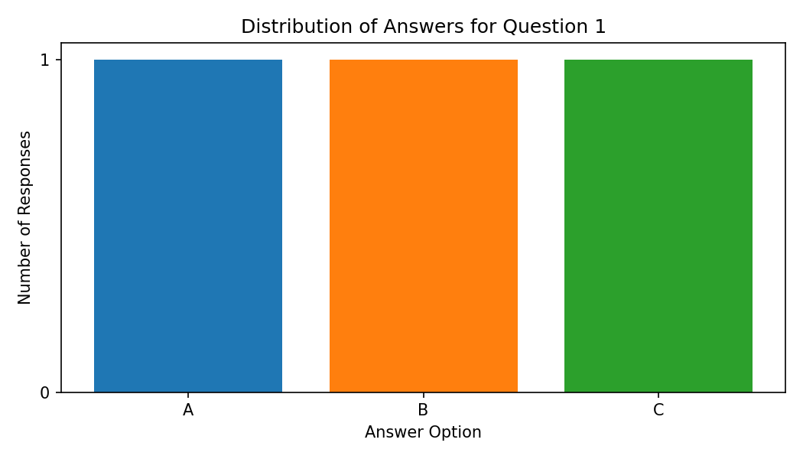
Output 1: Grouped Bar Chart of Question 1
Observation: Each of the answer options A, B and C was chosen by exactly one respondent for Question 1, so the answers are evenly distributed and no option is dominant.
PROGRAM 2: Stacked Bar Chart of All Questions
Generate a stacked bar chart to represent the overall distribution of responses for all three questions.
# Count of each option for every question
options <- c("A", "B", "C", "D")
counts <- rbind(
"Question 1" = table(factor(q1, levels = options)),
"Question 2" = table(factor(q2, levels = options)),
"Question 3" = table(factor(q3, levels = options))
)
# Stacked Bar Chart
barplot(t(counts),
beside = FALSE,
xlab = "Question",
ylab = "Number of Responses",
main = "Overall Distribution of Responses",
col = c("#1f77b4", "#ff7f0e", "#2ca02c", "#d62728"),
legend.text = paste("Option", options))
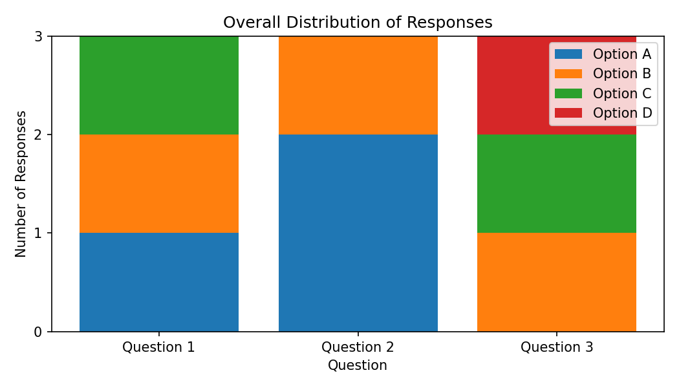
Output 2: Stacked Bar Chart of All Questions
Observation: Option A appears 3 times (once in Question 1 and twice in Question 2) and option B appears 3 times (once in each question). Option C appears 2 times and option D appears once (Question 3 only). Question 2 is dominated by option A.
PROGRAM 3: Survey Response Table
Build a table to show the survey response data for each survey. Label the table elements.
# Survey Response Table
survey_data <- data.frame(
"Survey ID" = survey_id,
"Question 1" = q1,
"Question 2" = q2,
"Question 3" = q3,
check.names = FALSE
)
print(survey_data)
Survey ID | Question 1 | Question 2 | Question 3
1 | A | B | C
2 | B | A | D
3 | C | A | B
Output 3: Survey Response Table
Observation: The table lists the answers given by each of the three surveys for Questions 1 to 3; every survey has one answer per question.
PROGRAM 4: Interactive Survey Dashboard
Develop a Tableau dashboard combining the grouped bar chart, stacked bar chart, and the table for interactive exploration of survey responses.
# Tableau Dashboard - Required Views
# 1. Import the Survey Responses dataset into Tableau and pivot
# Question 1-3 into "Question" and "Answer" fields.
# 2. Create a grouped bar chart: Answer (Columns) and
# COUNT(Survey ID) (Rows), filtered to Question 1.
# 3. Create a stacked bar chart: Question (Columns),
# COUNT(Survey ID) (Rows) and Answer on Color.
# 4. Create a table showing Survey ID against all answers.
# 5. Add all sheets to a dashboard, add a Question filter and
# enable "Use as Filter" on the charts.
# R view for the supplied data:
par(mfrow = c(1, 2))
barplot(q1_count, xlab = "Answer", ylab = "Responses", main = "Question 1")
barplot(t(counts), xlab = "Question", ylab = "Responses",
main = "All Questions", legend.text = options)
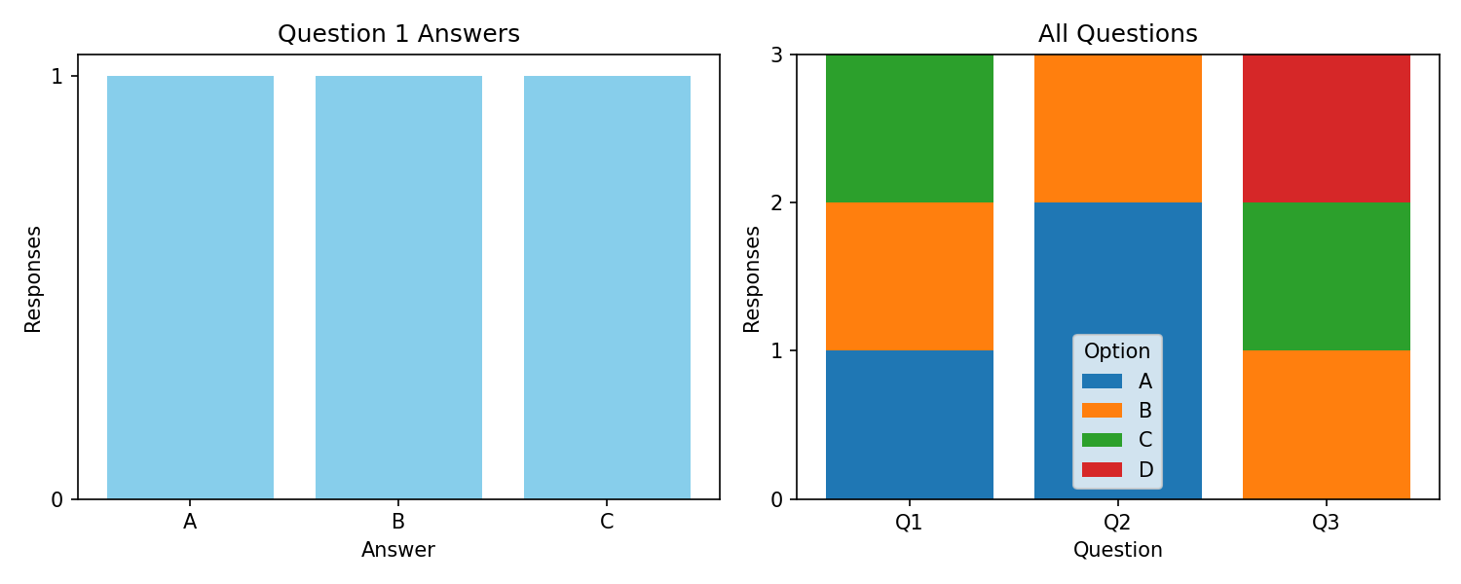
Output 4: Interactive Survey Dashboard
Observation: The dashboard combines the Question 1 answer distribution, the all-question stacked view and the response table. Clicking an option in the stacked bar highlights the matching survey rows in the table.
Set 10 Procedure
1. Create the Survey ID and Question 1 to 3 vectors from the given survey data.
2. Use table() and barplot() to draw the grouped bar chart for Question 1.
3. Build a count matrix for all questions and use barplot() with beside = FALSE for the stacked bar chart.
4. Use data.frame() to display the survey responses as a table.
5. Create the Tableau dashboard by combining the charts and the table and adding filters.
Set 10 Result
The survey responses were successfully visualized using grouped and stacked bar charts and displayed in a table. The interactive dashboard was designed in Tableau for exploring the responses.

