LAB EXPERIMENT RECORD
Set 11: Product Category Analysis
Field | Details
Department | AIDS
Course Code / Course Name | DSA0602 / Data Handling and Visualization
Experiment | Data Visualization using R
Aim
To analyze product category sales using a funnel chart and a pie chart, display the sales data in a table, and prepare an interactive Tableau dashboard.
Dataset: Product Categories
Category | Sales (in $)
Electronics | 50000
Clothing | 35000
Appliances | 40000
PROGRAM 1: Funnel Chart of Product Category Sales
Generate a funnel chart to analyze the sales conversion process for each product category. Label the stages and title the chart.
# Dataset
category <- c("Electronics", "Clothing", "Appliances")
sales <- c(50000, 35000, 40000)
# Sort categories from highest to lowest sales (funnel stages)
ord <- order(sales, decreasing = TRUE)
category <- category[ord]
sales <- sales[ord]
# Funnel Chart (centered horizontal bars)
plot(NULL, xlim = c(0, max(sales)), ylim = c(0.5, 3.5),
axes = FALSE, xlab = "", ylab = "",
main = "Sales Funnel by Product Category")
for (i in 1:3) {
left <- (max(sales) - sales[i]) / 2
rect(left, 4 - i - 0.4, left + sales[i], 4 - i + 0.4,
col = c("#1f77b4", "#ff7f0e", "#2ca02c")[i])
text(max(sales) / 2, 4 - i,
paste0(category[i], ": $", sales[i]), col = "white", font = 2)
}
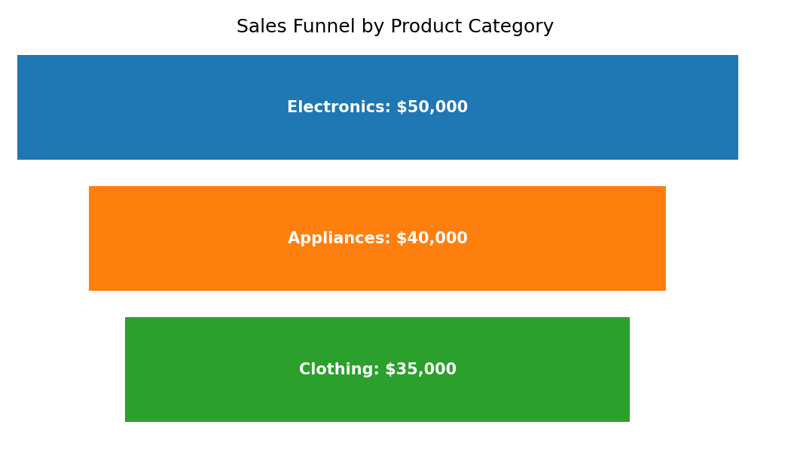
Output 1: Funnel Chart of Product Category Sales
Observation: Electronics is the widest stage with $50,000 (40% of total sales), followed by Appliances with $40,000 (32%) and Clothing with $35,000 (28%). The funnel narrows from Electronics to Clothing, showing the ranking of categories by sales.
Note: The dataset gives only total sales per category. A true conversion funnel (for example visits, carts and orders) requires stage-wise counts, so the categories are ranked as funnel stages.
PROGRAM 2: Product Category Sales Table
Build a table to display the sales data for each product category. Label the table elements.
# Product Category Sales Table
category_data <- data.frame(
Category = c("Electronics", "Clothing", "Appliances"),
"Sales (in $)" = c(50000, 35000, 40000),
check.names = FALSE
)
print(category_data)
sum(category_data$"Sales (in $)") # Total = 125000
Category | Sales (in $)
Electronics | 50000
Clothing | 35000
Appliances | 40000
Output 2: Product Category Sales Table
Observation: The table lists the sales of each category. Total sales across the three categories are $125,000, with Electronics contributing the most and Clothing the least.
PROGRAM 3: Interactive Product Category Dashboard
Develop a Tableau dashboard combining the pie chart, funnel chart, and the table for interactive exploration of product category data.
# Tableau Dashboard - Required Views
# 1. Import the Product Categories dataset into Tableau.
# 2. Pie chart: Category on Color, SUM(Sales) on Angle.
# 3. Funnel chart: bar chart of SUM(Sales) by Category, sorted in
# descending order, with the bars centered (dual axis / negative
# copy of Sales).
# 4. Table: Category and SUM(Sales).
# 5. Place all three sheets on one dashboard, add a Category filter
# and enable "Use as Filter" on the pie chart.
# R view for the supplied data:
par(mfrow = c(1, 2))
pie(sales, labels = paste0(category, " (",
round(sales / sum(sales) * 100, 1), "%)"),
main = "Sales Share")
barplot(sales, names.arg = category, main = "Sales by Category")
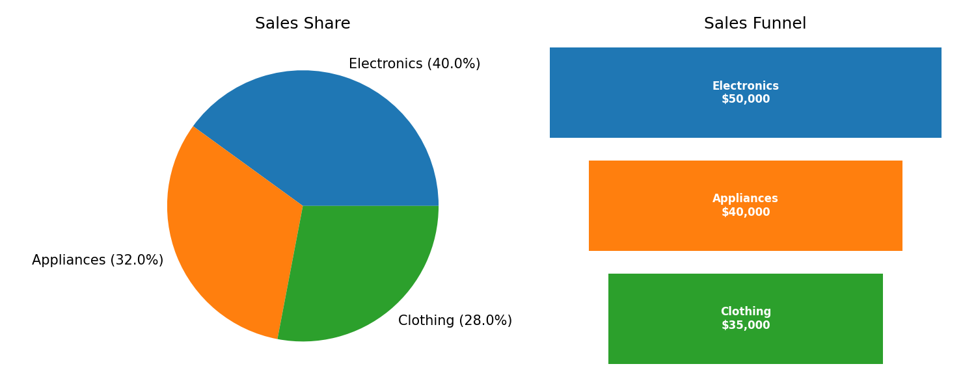
Output 3: Interactive Product Category Dashboard
Observation: The dashboard shows the sales share (pie), the category ranking (funnel) and the sales table together. Selecting a slice such as Electronics filters the funnel and the table to that category.
PROGRAM 4: Pie Chart of Sales by Category
Create a pie chart to represent the distribution of sales across product categories. Include labels.
# Pie Chart
pct <- round(sales / sum(sales) * 100, 1)
labels <- paste0(category, " (", pct, "%)")
pie(sales,
labels = labels,
col = c("#1f77b4", "#ff7f0e", "#2ca02c"),
main = "Sales Distribution by Product Category")
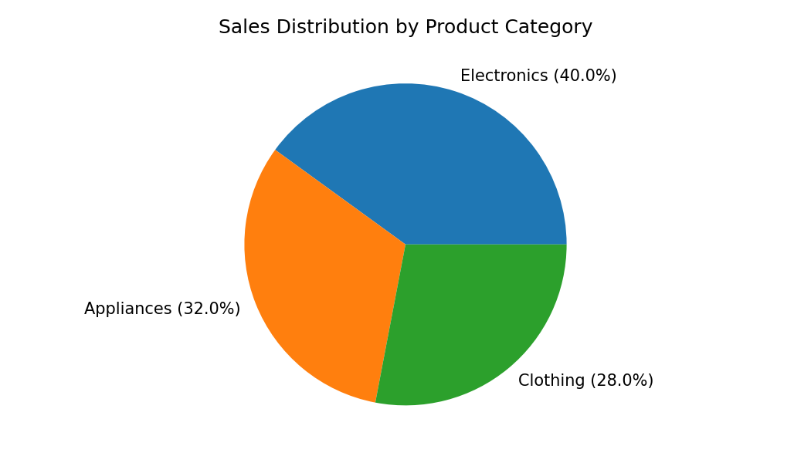
Output 4: Pie Chart of Sales by Category
Observation: Electronics holds the largest share of sales (40%), Appliances 32% and Clothing 28%. No single category dominates, but Electronics leads by $10,000 over Appliances.
Set 11 Procedure
1. Create the category and sales vectors from the given product category data.
2. Sort the sales values and draw the funnel chart using rect() and text() in base R.
3. Display the category sales in a data frame (table).
4. Use pie() with percentage labels to show the sales distribution.
5. Build the Tableau dashboard combining the pie chart, funnel chart and table with filters.
Set 11 Result
The product category sales were successfully represented using a funnel chart, table and pie chart, and the interactive dashboard was designed in Tableau. Electronics contributes the highest share (40%) of the total sales of $125,000.

