LAB EXPERIMENT RECORD
Set 12: Website Traffic Analysis
Field | Details
Department | AIML
Course Code / Course Name | DSA0602 / Data Handling and Visualization
Experiment | Data Visualization using R
Aim
To analyze website traffic using line and bar charts, display the daily traffic data in a table, and prepare an interactive Tableau dashboard.
Dataset: Website Traffic
Date | Page Views | Click-through Rate
2023-01-01 | 1500 | 2.3%
2023-01-02 | 1600 | 2.7%
2023-01-03 | 1400 | 2.0%
PROGRAM 1: Line Chart of Daily Page Views
Create a line chart to visualize the trend in daily page views over time. Label the axes and title the chart.
# Dataset
date <- as.Date(c("2023-01-01", "2023-01-02", "2023-01-03"))
page_views <- c(1500, 1600, 1400)
ctr <- c(2.3, 2.7, 2.0)
# Line Chart
plot(date, page_views,
type = "o",
xlab = "Date",
ylab = "Page Views",
main = "Daily Page Views Trend")
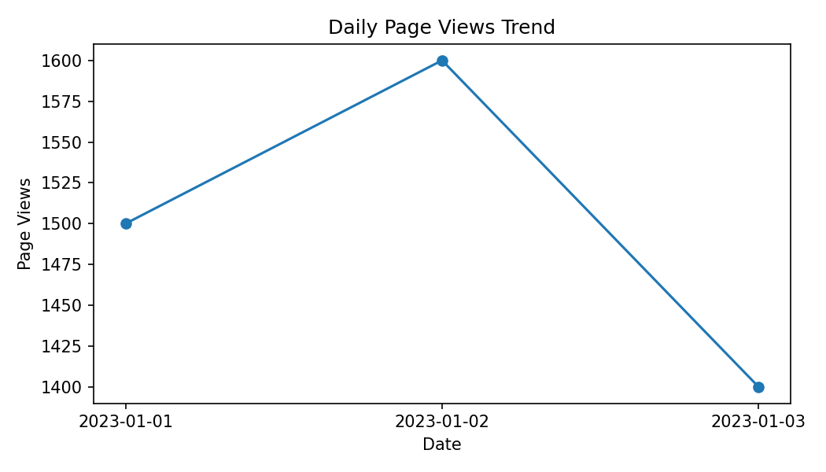
Output 1: Line Chart of Daily Page Views
Observation: Page views rise from 1500 on January 1 to a peak of 1600 on January 2 and then fall to 1400 on January 3, the lowest value of the period.
PROGRAM 2: Bar Chart of Top N Click-through Rates
Generate a bar chart showing the top N days with the highest click-through rates. Label the chart elements.
# Top N days
n <- 2
idx <- order(ctr, decreasing = TRUE)[1:n]
barplot(ctr[idx],
names.arg = format(date[idx], "%Y-%m-%d"),
xlab = "Date",
ylab = "Click-through Rate (%)",
main = "Top 2 Days by Click-through Rate",
col = "skyblue")
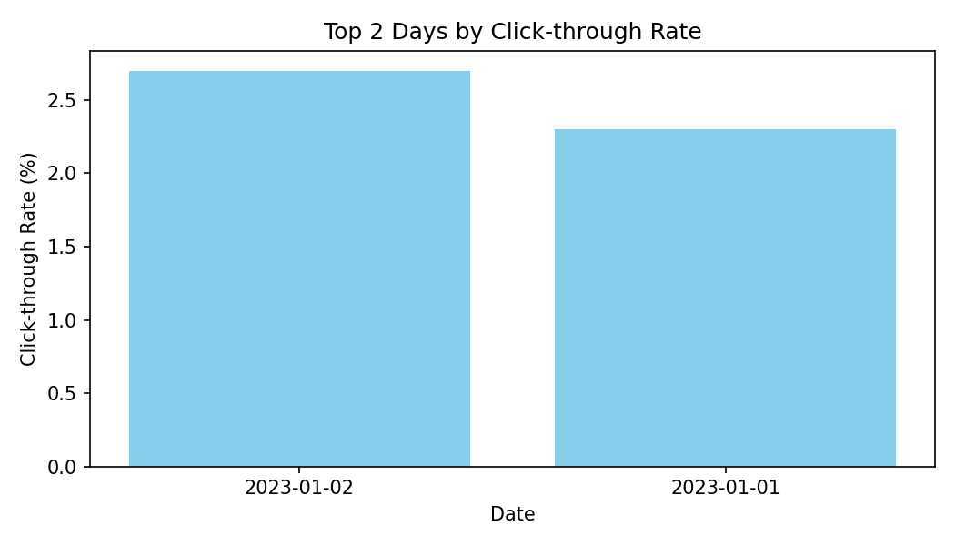
Output 2: Bar Chart of Top N Click-through Rates
Observation: For N = 2, January 2 has the highest click-through rate (2.7%), followed by January 1 (2.3%). January 3 has the lowest rate (2.0%) and is excluded.
PROGRAM 3: Website Traffic Table
Build a table to show the website traffic data for each day. Label the table elements.
# Website Traffic Table
traffic <- data.frame(
Date = date,
"Page Views" = page_views,
"Click-through Rate (%)" = ctr,
check.names = FALSE
)
print(traffic)
Date | Page Views | Click-through Rate
2023-01-01 | 1500 | 2.3%
2023-01-02 | 1600 | 2.7%
2023-01-03 | 1400 | 2.0%
Output 3: Website Traffic Table
Observation: The table shows the page views and click-through rate for each day. January 2 has both the highest page views (1600) and the highest click-through rate (2.7%), while January 3 has the lowest of both (1400 and 2.0%).
PROGRAM 4: Interactive Website Traffic Dashboard
Develop a Tableau dashboard combining the line chart, bar chart, and the table for interactive exploration of website traffic data.
# Tableau Dashboard - Required Views
# 1. Import the Website Traffic dataset into Tableau.
# 2. Line chart: Date (Columns) and SUM(Page Views) (Rows).
# 3. Bar chart: Date (Columns) and AVG(Click-through Rate) (Rows),
# sorted in descending order (Top N filter on Date).
# 4. Table: Date, Page Views and Click-through Rate.
# 5. Add all sheets to one dashboard, add a Date filter and
# enable "Use as Filter" on the line chart.
# R view for the supplied data:
par(mfrow = c(1, 2))
plot(date, page_views, type = "o", xlab = "Date",
ylab = "Page Views", main = "Daily Page Views")
barplot(ctr[idx], names.arg = format(date[idx], "%Y-%m-%d"),
xlab = "Date", ylab = "CTR (%)", main = "Top 2 Days by CTR",
col = "skyblue")
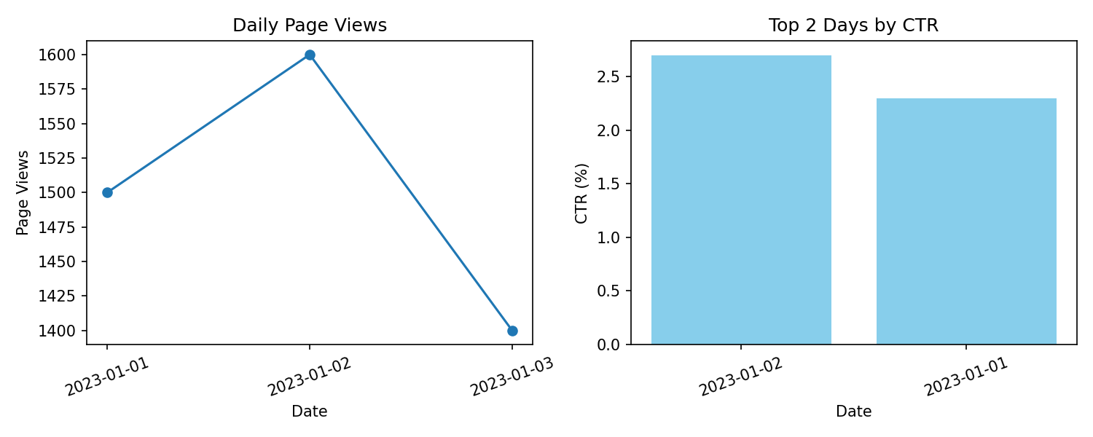
Output 4: Interactive Website Traffic Dashboard
Observation: The dashboard links the page-view trend, the top click-through-rate days and the traffic table. Selecting a date highlights the same day in every view, showing that the best day (January 2) combined high traffic with a high click-through rate.
Set 12 Procedure
1. Create the Date, Page Views and Click-through Rate vectors from the given traffic data.
2. Use plot() with type = "o" to draw the daily page-view line chart.
3. Sort the click-through rates with order() and use barplot() for the top N days.
4. Use data.frame() to display the website traffic table.
5. Build the Tableau dashboard combining the line chart, bar chart and table with filters.
Set 12 Result
The website traffic data was successfully visualized using a line chart, a top-N bar chart and a table, and the interactive dashboard was designed in Tableau. January 2 was the best-performing day with 1600 page views and a 2.7% click-through rate.

