Field | Details
Department | AIDS
Course Code / Course Name | DSA0602 / Data Handling and Visualization
ASSESMENT | CO1-AT1
Name | B Mallika
Register Number | 192324234
Date | 03-10-2026
Day | Saturday

Q1: Coordinate Systems (Cartesian and Polar) [R]

Hour of Day | Store Footfall
6 AM | 10
9 AM | 45
12 PM | 80
3 PM | 60
6 PM | 95
9 PM | 70
12 AM | 20
3 AM | 5

Questions :
- Write an R program to visualize the dataset using a Cartesian coordinate system (bar chart).
- Write another R program (using coord_polar()) to visualize the same data on a 24-hour clock-style Polar coordinate system.
- Compare the effectiveness of both visualizations.
- Explain which coordinate system is more appropriate for cyclical/time-of-day data.
- Justify your answer based on data interpretation.

Answer 1 — Cartesian bar chart
library(ggplot2)

footfall <- data.frame(
Hour = factor(c("6 AM","9 AM","12 PM","3 PM","6 PM","9 PM","12 AM","3 AM"),
levels = c("6 AM","9 AM","12 PM","3 PM","6 PM","9 PM","12 AM","3 AM")), Footfall = c(10, 45, 80, 60, 95, 70, 20, 5)
)

ggplot(footfall, aes(x = Hour, y = Footfall)) + geom_col(fill = "steelblue") +
labs(title = "Store Footfall by Hour",
x = "Hour of Day", y = "Store Footfall") + theme_minimal()

Explanation:
A Cartesian bar chart places the categorical time labels on the x-axis and the numerical footfall values on the y-axis. geom_col() uses the supplied values directly, so the bar height is proportional to the store footfall at each sampled time. The factor levels preserve the intended time order rather than allowing alphabetical ordering.

Output

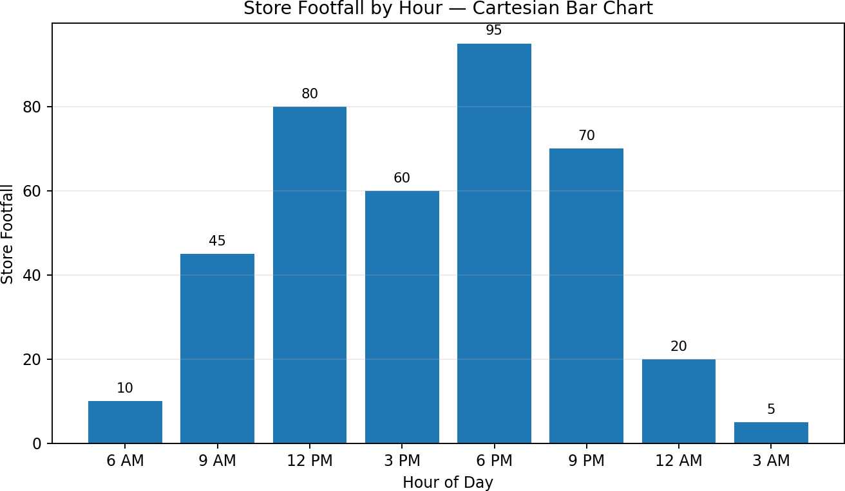

Answer 2 — Polar coordinate system
library(ggplot2)

ggplot(footfall, aes(x = Hour, y = Footfall)) + geom_col(fill = "darkorange", width = 0.9) + coord_polar(theta = "x", start = -pi/2) +
labs(title = "Store Footfall — 24-hour Clock-style Polar View", x = NULL, y = NULL) +
theme_minimal() +
theme(axis.text.y = element_blank(), panel.grid = element_blank())
Explanation: coord_polar(theta = "x") converts the horizontal categorical positions into angular positions around a circle. The same footfall values remain the radial magnitude of the bars. Because the original dataset contains eight sampled times, the circular output represents those eight observations around the clock-style layout; it does not invent missing hourly observations.

Output
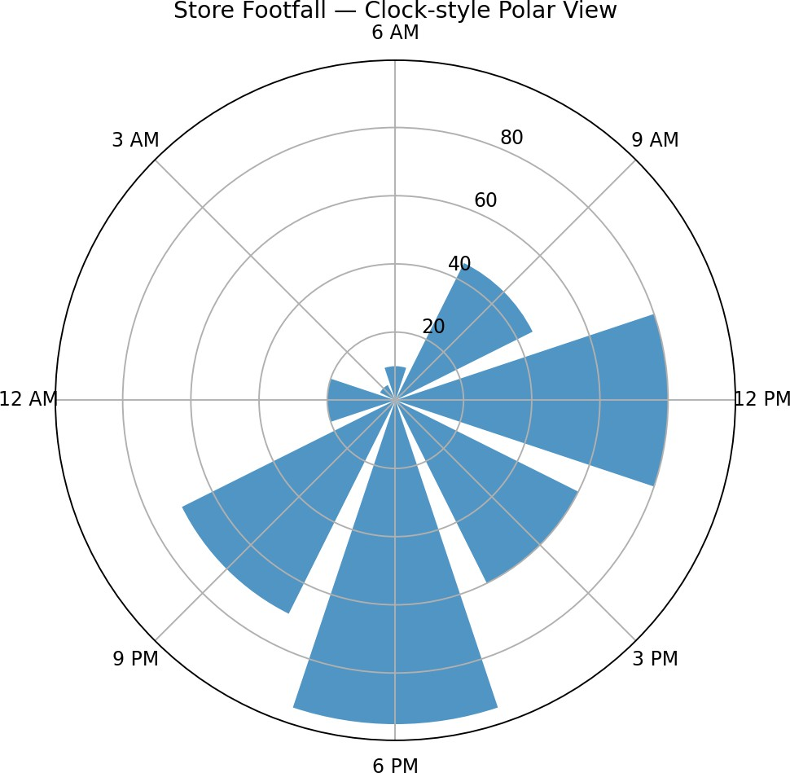

Answer 3 — Comparison
Cartesian: It is easier to compare exact bar heights and rank the observations. For example, 6 PM has the highest footfall (95), followed by 12 PM (80) and 9 PM (70).
Polar: It communicates the cyclical nature of time more naturally and makes the day-night cycle visually intuitive, but precise magnitude comparisons are usually harder because radial lengths are less straightforward than aligned Cartesian bars.

Answer 4 — Appropriate coordinate system
For cyclical/time-of-day data, the polar coordinate system is more appropriate when the main goal is to communicate the repeating daily cycle. A Cartesian system is preferable when accurate numerical comparison is the priority. Thus, polar is the better conceptual representation of cyclic time, while Cartesian is the better analytical representation of exact values.

Answer 5 — Justification from the data
The data rises from 10 at 6 AM to 45 at 9 AM, reaches 80 at 12 PM, falls slightly to 60 at 3 PM, and reaches the maximum of 95 at 6 PM. It then declines to 70 at 9 PM, 20 at 12 AM and 5 at 3 AM. Because the sequence moves through a repeating 24-hour cycle, a circular display is useful for showing where activity peaks within the daily cycle. However, the Cartesian chart should be retained when exact comparisons are required.

Q2: Mapping Data onto Aesthetics [R]

Item | Orders | Rating | Category
I1 | 320 | 4.2 | Electronics
I2 | 540 | 3.8 | Grocery
I3 | 210 | 4.6 | Fashion
I4 | 690 | 4.0 | Grocery
I5 | 150 | 4.8 | Fashion
I6 | 410 | 3.5 | Electronics

Questions (as provided):
- Write an R program (using ggplot2) to create a scatter plot with Orders on the x-axis and Rating on the y-axis.
- Map Category using an appropriate aesthetic (e.g. colour) and Orders using another suitable aesthetic (e.g. size).
- Interpret the relationship between Orders and Rating.
- Identify the type of scale used for each variable (nominal, ordinal, continuous).
- Suggest one alternative visualization that better represents the same data.

Answer 1 & 2 — Scatter plot with aesthetics
library(ggplot2)

items <- data.frame(
Item = c("I1","I2","I3","I4","I5","I6"), Orders = c(320,540,210,690,150,410), Rating = c(4.2,3.8,4.6,4.0,4.8,3.5),
Category = c("Electronics","Grocery","Fashion","Grocery","Fashion","Electronics")
)

ggplot(items, aes(x = Orders, y = Rating,
colour = Category, size = Orders)) + geom_point(alpha = 0.8) +
labs(title = "Orders vs Rating",
x = "Orders", y = "Rating (/5)",
colour = "Category", size = "Orders") + theme_minimal()
Explanation: Orders is mapped to x-position and also to point size, so larger circles represent more orders. Rating is mapped to y-position. Category is mapped to colour, allowing Electronics, Grocery and Fashion to be distinguished visually. These mappings demonstrate how several variables can be encoded simultaneously using position, size and colour.

Output

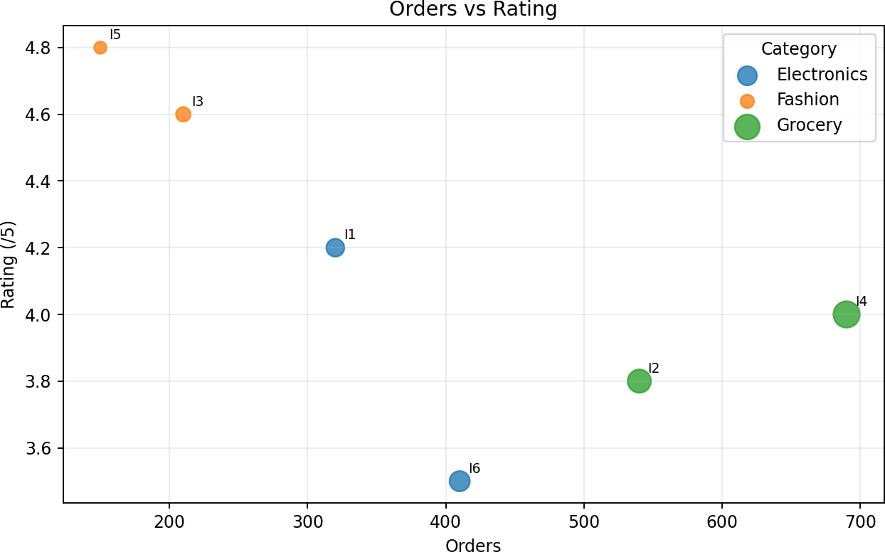

Answer 3 — Interpretation of Orders and Rating
The points show a generally negative relationship: higher order counts tend to be associated with lower ratings in this small dataset. The Pearson correlation between Orders and Rating is approximately -0.70. For example, I5 has only 150 orders but a high rating of 4.8, while I6 has 410 orders and the lowest rating of 3.5. This is an association, not proof that increasing orders causes ratings to fall.

Answer 4 — Scale types
Orders: continuous numerical scale for plotting purposes because it is quantitative and can take numerical values.
Rating: continuous numerical scale in this visualization because values such as 3.5, 4.0 and 4.8 are plotted quantitatively.
Category: nominal scale because Electronics, Grocery and Fashion are labels with no inherent ranking.
Item: nominal identifier; it identifies individual observations rather than representing an ordered measurement.

Answer 5 — Alternative visualization
A dot plot or lollipop chart grouped by Category could be a clearer alternative if the goal is to compare ratings directly. A grouped bar chart can also work, but the scatter plot is better when the relationship between two numerical variables is the central question. For this six-row dataset, a dot plot with Rating on the horizontal axis and Item on the vertical axis would make individual ratings easy to compare.

Q3: Faceting / Small Multiples [R]

Subject | Semester | Avg Score
Maths | Sem1 | 72
Maths | Sem2 | 78
Maths | Sem3 | 81
Physics | Sem1 | 65
Physics | Sem2 | 70
Physics | Sem3 | 75
English | Sem1 | 80
English | Sem2 | 82
English | Sem3 | 85
CS | Sem1 | 74
CS | Sem2 | 83
CS | Sem3 | 90

Questions (as provided):
- Write an R program (using facet_wrap()) to create a faceted plot showing the average-score trend for each Subject separately.
- Choose an appropriate variable to facet by and justify the choice.
- Compare trends across the facets.
- Explain the advantage of faceting over a single combined plot for this dataset.
- Suggest a scenario where faceting would not be suitable.
Answer 1 — Faceted plot using facet_wrap()
library(ggplot2)

scores <- data.frame(
Subject = rep(c("Maths","Physics","English","CS"), each = 3),
Semester = rep(c("Sem1","Sem2","Sem3"), 4), AvgScore = c(72,78,81,65,70,75,80,82,85,74,83,90)
)

scores$Semester <- factor(scores$Semester,
levels = c("Sem1","Sem2","Sem3"))

ggplot(scores, aes(x = Semester, y = AvgScore, group = 1)) + geom_line() +
geom_point(size = 2.5) +
geom_text(aes(label = AvgScore), vjust = -0.7, size = 3) + facet_wrap(~ Subject) +
labs(title = "Average Score Trend by Subject", x = "Semester", y = "Average Score") +
theme_minimal()
Explanation: facet_wrap(~ Subject) creates a separate small panel for each subject. The semester variable is ordered from Sem1 to Sem3, so each panel shows the subject's progression across semesters. The same
y-axis scale is used, which makes cross-subject comparisons meaningful.

Output

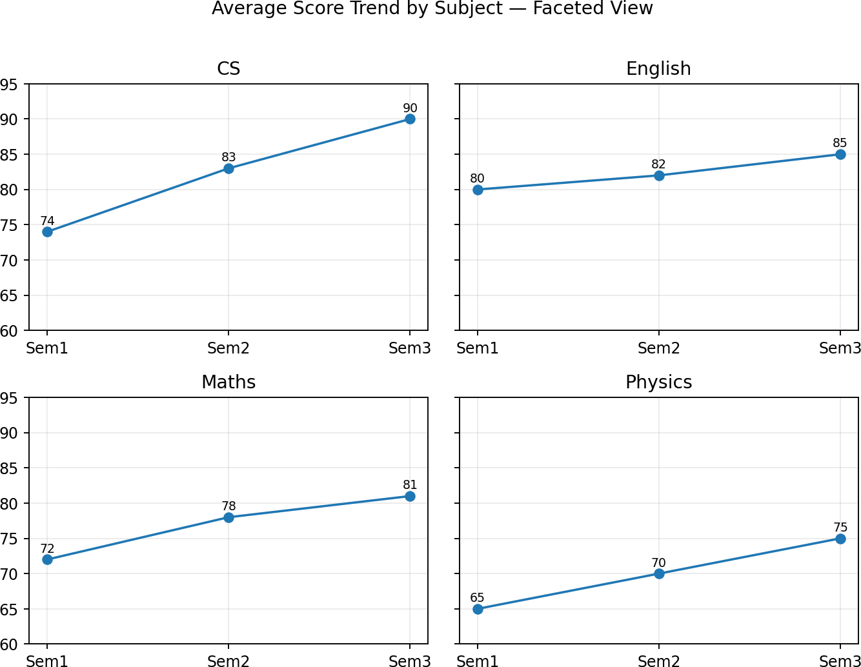

Answer 2 — Variable selected for faceting
Subject is the most appropriate faceting variable because each subject has its own three-semester score trajectory. Faceting by Subject allows the viewer to inspect each trend independently while keeping the same axes and visual structure.

Answer 3 — Comparison of trends
All four subjects improve from Sem1 to Sem3. Maths rises from 72 to 81 (+9), Physics from 65 to 75 (+10), English from 80 to 85 (+5), and CS from 74 to 90 (+16). Therefore, CS has the largest improvement, while English has the smallest improvement. English remains the highest-scoring subject in Sem1 and Sem2, but CS reaches the highest score in Sem3.

Answer 4 — Advantage of faceting
A single combined line chart would contain four lines and could become visually crowded, especially if colours and legends are needed. Faceting separates the subjects into small multiples, reducing overlap and making each subject's progression easy to follow. Because the axes are shared, the viewer can still compare the panels.

Answer 5 — When faceting would not be suitable
Faceting is less suitable when there are many categories and each panel becomes too small to read. It is also less useful when the primary purpose is to compare every observation directly on one common chart and the number of groups is small enough that a single plot remains clear.

Q4: Legends and Annotations [R]

Month | Co. X | Co. Y | Co. Z
Jan | 410 | 380 | 450
Feb | 430 | 395 | 460
Mar | 460 | 410 | 440
Apr | 480 | 430 | 470
May | 520 | 460 | 510
Jun | 500 | 490 | 530

Questions (as provided):
- Write an R program to plot the monthly stock-price trend for all three companies on a single chart with a clear legend.
- Annotate (using annotate()/geom_text()) the point of highest price for each company.
- Explain the role of legends in multi-series visualizations.
- Discuss best practices for placing legends to avoid obscuring data.
- Suggest an alternative to a legend for distinguishing categories (e.g., direct labeling).

Answer 1 — Multi-series line chart with legend
library(ggplot2)

stocks <- data.frame(
Month = factor(c("Jan","Feb","Mar","Apr","May","Jun"),
levels = c("Jan","Feb","Mar","Apr","May","Jun")),
X = c(410,430,460,480,520,500),
Y = c(380,395,410,430,460,490),
Z = c(450,460,440,470,510,530)
)

long <- rbind(
data.frame(Month=stocks$Month, Company="Co. X", Price=stocks$X), data.frame(Month=stocks$Month, Company="Co. Y", Price=stocks$Y), data.frame(Month=stocks$Month, Company="Co. Z", Price=stocks$Z)
)

ggplot(long, aes(x = Month, y = Price, colour = Company, group = Company)) + geom_line(linewidth = 0.9) +
geom_point(size = 2) +
labs(title = "Monthly Stock-Price Trend",
x = "Month", y = "Price (Rs)", colour = "Company") + theme_minimal()
Explanation: The data is converted to long format so that Company can be mapped to colour and each company's observations can be connected with a separate line. The legend then identifies which line corresponds to Co. X, Co. Y and Co. Z.

Output

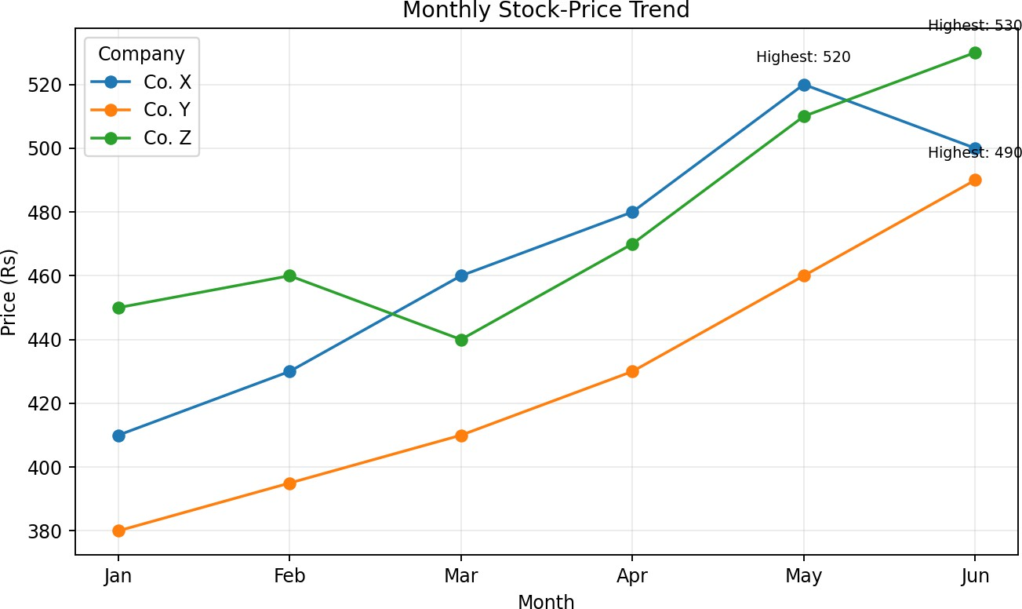

Answer 2 — Annotating highest prices
The highest values are: Co. X = Rs 520 in May, Co. Y = Rs 490 in Jun, and Co. Z = Rs 530 in Jun. A practical R implementation is to use geom_text() with a small data frame containing these three maximum points, or to use annotate() three times. Example:
high <- data.frame(
Company = c("Co. X","Co. Y","Co. Z"),
Month = factor(c("May","Jun","Jun"),
levels = c("Jan","Feb","Mar","Apr","May","Jun")), Price = c(520,490,530)
)

ggplot(long, aes(Month, Price, colour = Company, group = Company)) + geom_line() + geom_point() +
geom_text(data = high, aes(label = paste0("Highest: ", Price)), vjust = -0.8, show.legend = FALSE) +
theme_minimal()

Answer 3 — Role of legends
A legend provides the mapping between a visual encoding and its meaning. In this chart, the line colour alone is not meaningful unless the viewer knows which colour represents each company. The legend makes the
multi-series chart self-explanatory and prevents confusion between Co. X, Co. Y and Co. Z.

Answer 4 — Best practices for legend placement
Place the legend where it does not cover important observations. The top or right side is commonly effective. Keep the legend close to the plot, use clear category names, maintain consistent colours throughout the figure, and avoid excessive legend entries. If the legend becomes visually dominant, move it outside the plotting region or replace it with direct labels.

Answer 5 — Alternative to a legend
Direct labeling is a strong alternative. The company name can be placed beside the final point of each line, allowing the viewer to identify the series without moving their eyes between the chart and a separate legend. This is particularly effective when only a few series are present, as in this dataset.

Q5: Correlation Heatmap [R]

Student | Attendance (%) | Study Hrs/Day | Sleep Hrs/Day | Marks (%)
S1 | 92 | 3.5 | 6.5 | 88
S2 | 75 | 1.5 | 8.0 | 62
S3 | 88 | 2.8 | 7.0 | 80
S4 | 60 | 1.0 | 5.5 | 48
S5 | 95 | 4.0 | 7.5 | 91
S6 | 70 | 2.0 | 6.0 | 58

Questions (as provided):
- Write an R program to compute the correlation matrix of Attendance, Study Hours, Sleep Hours, and Marks, and display it as a heatmap.
- Identify the pair of variables with the strongest correlation.
- Explain what a diverging color scale communicates in a correlation heatmap.
- Discuss one limitation of using correlation to interpret this data.
- Suggest one additional variable that could improve this analysis.

Answer 1 — Correlation matrix and heatmap
library(ggplot2)

students <- data.frame(
Attendance = c(92,75,88,60,95,70), Study_Hours = c(3.5,1.5,2.8,1.0,4.0,2.0),
Sleep_Hours = c(6.5,8.0,7.0,5.5,7.5,6.0), Marks = c(88,62,80,48,91,58)
)

cor_mat <- cor(students)

# Convert matrix to long format for ggplot2 cor_df <- as.data.frame(as.table(cor_mat)) names(cor_df) <- c("Var1","Var2","Correlation")

ggplot(cor_df, aes(Var1, Var2, fill = Correlation)) + geom_tile() +
geom_text(aes(label = round(Correlation, 2))) + scale_fill_gradient2(low = "blue", mid = "white", high = "red",
midpoint = 0, limits = c(-1,1)) +
coord_fixed() +
labs(title = "Correlation Heatmap", x = NULL, y = NULL, fill = "Correlation") +
theme_minimal() +
theme(axis.text.x = element_text(angle = 35, hjust = 1))
Explanation: cor() calculates pairwise Pearson correlation coefficients. The resulting matrix is converted to a long data frame with as.table(), allowing ggplot2 to draw one tile for each variable pair. The diverging gradient is centred at zero: values near +1 indicate strong positive association, values near -1 indicate strong negative association, and values near 0 indicate weak linear association.

Output

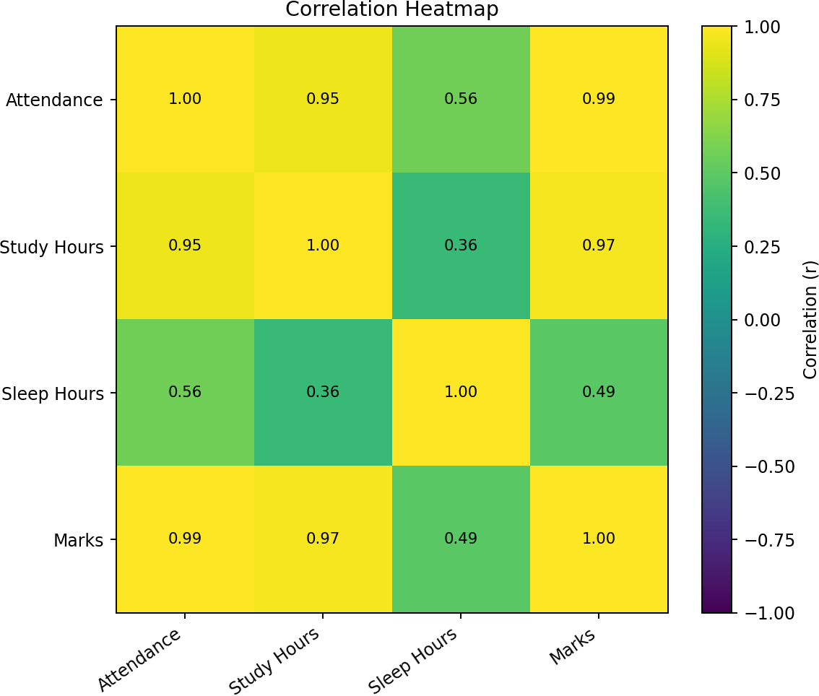

Answer 2 — Strongest correlation
The strongest off-diagonal correlation is between Attendance and Marks, with r  0.994. This is an extremely strong positive linear association in the supplied six-student sample. Study Hours and Marks are also strongly correlated (r  0.969), while Sleep Hours has weaker correlations with the other variables.

Correlation values calculated from the supplied data

Variable | Attendance | Study Hours | Sleep Hours | Marks
Attendance | 1.0 | 0.95 | 0.564 | 0.994
Study Hours | 0.95 | 1.0 | 0.357 | 0.969
Sleep Hours | 0.564 | 0.357 | 1.0 | 0.489
Marks | 0.994 | 0.969 | 0.489 | 1.0

Answer 3 — Diverging colour scale
A diverging colour scale separates negative, zero and positive correlations around a meaningful midpoint of 0. One side represents negative relationships, the midpoint represents little or no linear relationship, and the opposite side represents positive relationships. The strength of the colour indicates how close the correlation is to -1 or +1.

Answer 4 — Limitation of correlation
Correlation measures association, not causation. A high correlation between Attendance and Marks does not prove that increasing attendance alone causes marks to increase. The sample is also very small (only six students), so the observed correlations may not generalize to a larger population. Correlation additionally focuses on linear association and can be affected by outliers.

Answer 5 — Additional variable
A useful additional variable would be Study Method / Study Quality, such as a standardized study-efficiency score or hours of focused study. Other useful variables could include prior academic performance, assignment completion rate, or class participation. Adding such variables could help explain why students with similar attendance or study time may still obtain different marks.

