DSA0601 – Data Handling and Visualization
Slot D | CO1 – AT3 (Visualization Design Exercise, R Only)
Name | Reg. No. | R.No
MALLIKA | 192324234 | 7

QUESTION 1: Color Scales for Multi-Variable Data [R]
City | Temp | Humidity | Rainfall | AQI
Delhi | 44 | 22 | 6 | 365
Mumbai | 35 | 84 | 280 | 110
Chennai | 38 | 78 | 220 | 125
Kolkata | 40 | 72 | 190 | 180
Hyderabad | 39 | 48 | 85 | 160
Bangalore | 31 | 66 | 120 | 72
Pune | 33 | 58 | 95 | 84
Ahmedabad | 43 | 26 | 2 | 290
Jaipur | 45 | 18 | 1 | 320
Lucknow | 39 | 42 | 35 | 240
Bhopal | 38 | 36 | 48 | 175
Patna | 40 | 45 | 72 | 220
Goa | 32 | 89 | 360 | 58
Kochi | 30 | 91 | 410 | 52
Nagpur | 41 | 30 | 12 | 270
Indore | 37 | 34 | 20 | 190
Surat | 36 | 76 | 180 | 145
Visakhapatnam | 34 | 82 | 240 | 98
Coimbatore | 29 | 68 | 130 | 60
Mysuru | 28 | 64 | 145 | 55
An environmental monitoring agency has collected climate data from major Indian cities. Design a visualization that effectively represents Temperature, Air Quality Index (AQI), Rainfall, and Humidity using appropriate colour scales. Select a suitable colour palette and justify its effectiveness for accurate interpretation and accessibility.
ANSWER:

1. Approach
The dataset has 20 cities and four numeric variables that use different units and ranges (°C, %, mm and the AQI index). A heat-map matrix (tile plot) is the most suitable design: each row is a city, each column is a variable, and the colour of every tile encodes the value. Each variable gets its own sequential colour scale and its own legend, so that no variable dominates the others. The cities are sorted by AQI (highest at the top) so that relationships between pollution, heat and rain appear as visible gradients. The exact value is also printed inside each tile, so colour is never the only source of information.

2. Design decisions and justification
Design element | Choice made | Justification
Visual form | Heat-map matrix (cities × variables) | Shows all 20 cities and 4 variables in one compact view and allows quick scanning of patterns across rows.
Type of colour scale | Sequential (light → dark) | All four variables are continuous and ordered, with no meaningful mid-point, so a sequential scale (not diverging or categorical) is correct. Darker = larger value.
Separate scale per variable | Four independent legends | The variables have different units and ranges (Temp 28–45, Humidity 18–91, Rainfall 1–410, AQI 52–365). One shared scale would hide the small ranges and mislead the reader.
Palette choice | ColorBrewer YlOrRd, BuGn, Blues, Purples | Perceptually ordered palettes with steadily changing lightness. Hue also carries meaning: warm = heat, green-teal = humidity, blue = rain, purple = air quality.
Avoid rainbow / jet | Not used | Rainbow scales have uneven lightness, create false boundaries and are unreadable for colour-blind users and in greyscale prints.
Sorting | By AQI, descending | Turns an unordered list into a ranked display; the pollution gradient becomes the visual backbone of the chart.
Direct labelling | Value printed in every tile | Colour is hard to read exactly; numbers give accurate values and make the chart accessible without relying on colour.
Label contrast | White text on dark tiles, black text on light tiles | Keeps every number legible against its background.
Legends | Horizontal colour bars with min and max | Show the exact range of each variable under its own column.

Variable | Palette (low → high) | Reason for selection
Temperature (°C) | YlOrRd: pale yellow → orange → dark red | Warm colours are naturally associated with heat; the lightness steps are easy to rank.
Humidity (%) | BuGn: near-white → dark green-blue | Moisture is associated with water/green hues; the green tone separates it from rainfall.
Rainfall (mm) | Blues: near-white → navy | Blue is the natural colour of water; very low rainfall (1–2 mm) appears almost white.
AQI | Purples: near-white → deep purple | A neutral hue unrelated to temperature or water; the darkest tone signals the most hazardous air.

3. R code
# Q1: Colour scales for multi-variable data (Temperature, Humidity, Rainfall, AQI)
# Packages: install.packages(c("ggplot2", "patchwork")) if not already installed
library(ggplot2)
library(patchwork)

# ---- 1. Data ----
cities <- data.frame(
City = c("Delhi", "Mumbai", "Chennai", "Kolkata", "Hyderabad", "Bangalore", "Pune",
"Ahmedabad", "Jaipur", "Lucknow", "Bhopal", "Patna", "Goa", "Kochi",
"Nagpur", "Indore", "Surat", "Visakhapatnam", "Coimbatore", "Mysuru"),
Temp = c(44, 35, 38, 40, 39, 31, 33, 43, 45, 39, 38, 40, 32, 30, 41, 37, 36, 34, 29, 28),
Humidity = c(22, 84, 78, 72, 48, 66, 58, 26, 18, 42, 36, 45, 89, 91, 30, 34, 76, 82, 68, 64),
Rainfall = c(6, 280, 220, 190, 85, 120, 95, 2, 1, 35, 48, 72, 360, 410,
12, 20, 180, 240, 130, 145),
AQI = c(365, 110, 125, 180, 160, 72, 84, 290, 320, 240, 175, 220, 58, 52,
270, 190, 145, 98, 60, 55)
)

# ---- 2. Order cities by AQI (highest AQI appears at the top) ----
cities$City <- factor(cities$City, levels = cities$City[order(cities$AQI)])

# ---- 3. One heat-map column per variable, each with its own sequential palette ----
make_panel <- function(df, var, title, palette, show_city = FALSE) {
df$value <- df[[var]]
rng <- range(df$value)
# white text on dark cells, black text on light cells (keeps labels readable)
df$txt <- ifelse((df$value - rng[1]) / (rng[2] - rng[1]) > 0.58, "white", "black")

p <- ggplot(df, aes(x = 1, y = City, fill = value)) +
geom_tile(colour = "white", linewidth = 0.6) +
geom_text(aes(label = value, colour = txt), size = 3) +
scale_colour_identity() +
scale_fill_distiller(palette = palette, direction = 1, name = NULL,
limits = rng, breaks = rng) +
labs(title = title, x = NULL, y = NULL) +
theme_minimal(base_size = 10) +
theme(panel.grid = element_blank(),
axis.text.x = element_blank(),
plot.title = element_text(face = "bold", size = 10, hjust = 0.5),
legend.position = "bottom",
legend.key.width = unit(1.4, "cm"),
legend.key.height = unit(0.25, "cm"))
if (!show_city) p <- p + theme(axis.text.y = element_blank())
p
}

p_temp <- make_panel(cities, "Temp", "Temperature (°C)", "YlOrRd", show_city = TRUE)
p_hum <- make_panel(cities, "Humidity", "Relative humidity (%)", "BuGn")
p_rain <- make_panel(cities, "Rainfall", "Rainfall (mm)", "Blues")
p_aqi <- make_panel(cities, "AQI", "Air Quality Index (AQI)", "Purples")

# ---- 4. Combine the four panels side by side ----
final_plot <- (p_temp | p_hum | p_rain | p_aqi) +
plot_annotation(
title = "Climate and air quality of 20 Indian cities (sorted by AQI, highest first)",
theme = theme(plot.title = element_text(face = "bold", hjust = 0.5))
)

print(final_plot)
ggsave("Q1_colour_scales.png", final_plot, width = 9.2, height = 8.4, dpi = 300)

# ---- 5. Correlations that support the interpretation ----
print(round(cor(cities[, c("Temp", "Humidity", "Rainfall", "AQI")]), 2))

4. Output
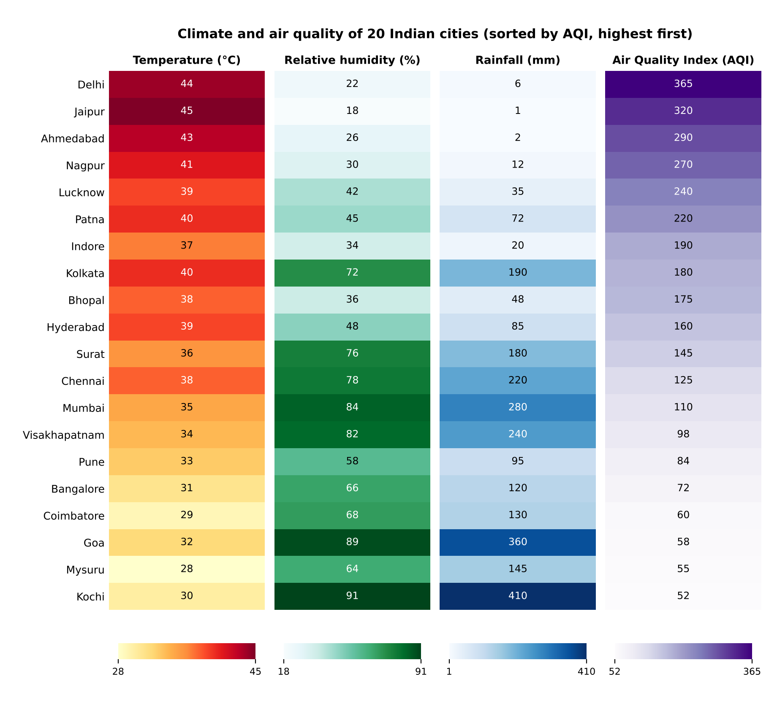
Figure 1: Heat-map matrix of Temperature, Humidity, Rainfall and AQI for 20 Indian cities (each variable has its own sequential colour scale).
Correlation matrix (output of the last line of the R code):
 | Temp | Humidity | Rainfall | AQI
Temp | 1.00 | -0.73 | -0.62 | 0.94
Humidity | -0.73 | 1.00 | 0.93 | -0.85
Rainfall | -0.62 | 0.93 | 1.00 | -0.73
AQI | 0.94 | -0.85 | -0.73 | 1.00

5. Interpretation of the visualization
- Hot, dry inland cities have the worst air. Delhi (44 °C, 6 mm, AQI 365), Jaipur (45 °C, 1 mm, AQI 320), Ahmedabad (43 °C, 2 mm, AQI 290) and Nagpur (41 °C, 12 mm, AQI 270) are the four highest-AQI cities. They show dark red in the Temperature column, almost white in the Rainfall column and dark purple in the AQI column.
- Humid, rainy coastal and southern cities have the cleanest air. Kochi (humidity 91%, rainfall 410 mm, AQI 52), Goa (89%, 360 mm, AQI 58), Mysuru (AQI 55) and Coimbatore (AQI 60) have the lowest AQI values.
- Strong statistical links: AQI is strongly positively correlated with temperature (r = 0.94) and negatively with humidity (r = −0.85) and rainfall (r = −0.73); humidity and rainfall move together (r = 0.93).
- Correlation does not prove causation; rainfall washes pollutants from the air, but local emissions and geography also play a role.

6. Why the colour design is effective and accessible
- Accurate interpretation: sequential palettes with monotonic lightness make “darker = higher” unambiguous; separate scales prevent one variable from distorting another; printed values give exact readings.
- Colour-blind safety: the chosen ColorBrewer sequential palettes vary mainly in lightness, which stays distinguishable for red-green colour-blind readers. No red-versus-green contrast is used to carry meaning.
- Greyscale / print safety: because lightness changes steadily, the chart still ranks correctly when photocopied in black and white.
- Redundant encoding: colour + number + sorted position all communicate the same information.

7. Conclusion
A sorted heat-map matrix with one sequential, perceptually ordered, colour-blind-friendly palette per variable communicates all four climate variables accurately. It exposes the main finding clearly: high temperature with low rainfall and humidity coincides with high AQI.

QUESTION 2: Cartesian vs. Polar Coordinates [R]
Month | Coal | Gas | Solar | Wind | Hydro
Jan | 620 | 310 | 45 | 80 | 140
Feb | 580 | 295 | 60 | 95 | 150
Mar | 590 | 305 | 90 | 120 | 160
Apr | 605 | 320 | 130 | 150 | 170
May | 640 | 340 | 180 | 170 | 180
Jun | 670 | 355 | 230 | 185 | 195
Jul | 690 | 360 | 250 | 195 | 205
Aug | 720 | 370 | 245 | 190 | 210
Sep | 700 | 365 | 210 | 175 | 200
Oct | 680 | 350 | 160 | 150 | 185
Nov | 650 | 335 | 90 | 110 | 165
Dec | 630 | 320 | 50 | 90 | 150
The following dataset contains monthly electricity generation from different energy sources. Develop visualizations using Cartesian Coordinates and Polar Coordinates. Compare both visualizations and determine which coordinate system provides better analytical insight. Explain your design decisions.
ANSWER:

1. Approach
The same data are drawn twice with identical colours, markers and scales so that only the coordinate system changes. In the Cartesian chart, month is the horizontal position and generation is the vertical position. In the polar chart, month is the angle (Jan at the top, clockwise) and generation is the distance from the centre. The data are first converted from wide to long (tidy) format with `pivot_longer()` so that Source can be mapped to colour. In the polar version January is repeated as month 13 so the line closes the annual circle.

2. R code
# Q2: Cartesian vs Polar coordinates - monthly electricity generation
# Packages: install.packages(c("ggplot2", "tidyr")) if not already installed
library(ggplot2)
library(tidyr)

# ---- 1. Data ----
energy <- data.frame(
Month = month.abb,
Coal = c(620, 580, 590, 605, 640, 670, 690, 720, 700, 680, 650, 630),
Gas = c(310, 295, 305, 320, 340, 355, 360, 370, 365, 350, 335, 320),
Solar = c(45, 60, 90, 130, 180, 230, 250, 245, 210, 160, 90, 50),
Wind = c(80, 95, 120, 150, 170, 185, 195, 190, 175, 150, 110, 90),
Hydro = c(140, 150, 160, 170, 180, 195, 205, 210, 200, 185, 165, 150)
)

# Wide -> long (tidy) format: one row per Month x Source
energy_long <- pivot_longer(energy, cols = -Month,
names_to = "Source", values_to = "Generation")
energy_long$Source <- factor(energy_long$Source,
levels = c("Coal", "Gas", "Solar", "Wind", "Hydro"))
energy_long$MonthNo <- match(energy_long$Month, month.abb)

# ---- 2. Colour-blind-safe (Okabe-Ito) colours + shapes (redundant encoding) ----
pal <- c(Coal = "#000000", Gas = "#CC79A7", Solar = "#E69F00",
Wind = "#56B4E9", Hydro = "#0072B2")
shp <- c(Coal = 16, Gas = 15, Solar = 17, Wind = 18, Hydro = 25)

common <- list(
scale_colour_manual(values = pal, name = "Source"),
scale_fill_manual(values = pal, name = "Source"),
scale_shape_manual(values = shp, name = "Source"),
theme_minimal(base_size = 11),
theme(legend.position = "bottom", plot.title = element_text(face = "bold"))
)

# ---- 3(a). Cartesian coordinates: multi-line chart ----
p_cartesian <- ggplot(energy_long,
aes(MonthNo, Generation, colour = Source, fill = Source,
shape = Source, group = Source)) +
geom_line(linewidth = 1) +
geom_point(size = 2.5) +
scale_x_continuous(breaks = 1:12, labels = month.abb) +
scale_y_continuous(limits = c(0, 800), breaks = seq(0, 800, 200)) +
labs(title = "Monthly electricity generation by source (Cartesian coordinates)",
x = "Month", y = "Electricity generation (dataset units)") +
common

# ---- 3(b). Polar coordinates: same data, month = angle, generation = radius ----
jan <- subset(energy_long, MonthNo == 1) # repeat January as month 13
jan$MonthNo <- 13 # so that the line closes the circle
polar_data <- rbind(energy_long, jan)

p_polar <- ggplot(polar_data,
aes(MonthNo, Generation, colour = Source, fill = Source,
shape = Source, group = Source)) +
geom_line(linewidth = 1) +
geom_point(data = energy_long, size = 2.5) +
scale_x_continuous(limits = c(1, 13), breaks = 1:12, labels = month.abb) +
scale_y_continuous(limits = c(0, 800), breaks = seq(200, 800, 200)) +
coord_polar(theta = "x", start = 0) +
labs(title = "Monthly electricity generation by source (polar coordinates)",
x = NULL, y = NULL) +
common

print(p_cartesian)
print(p_polar)
ggsave("Q2_cartesian.png", p_cartesian, width = 7.2, height = 4.4, dpi = 300)
ggsave("Q2_polar.png", p_polar, width = 6.2, height = 5.6, dpi = 300)

# ---- 4. Numerical summary used to compare what each chart reveals ----
stats <- do.call(rbind, lapply(split(energy_long, energy_long$Source), function(d) {
data.frame(Min = min(d$Generation),
Max = max(d$Generation),
Mean = round(mean(d$Generation), 1),
Peak_Month = d$Month[which.max(d$Generation)],
Ratio = round(max(d$Generation) / min(d$Generation), 2))
}))
print(stats)

3. Output
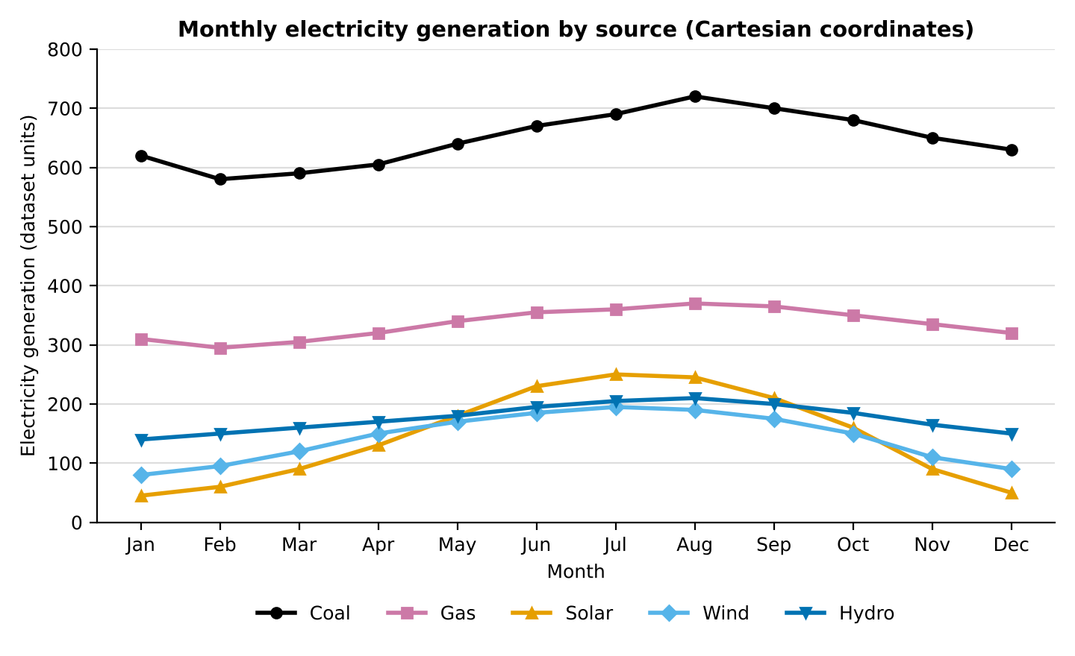
Figure 2: Monthly electricity generation by source in Cartesian coordinates.
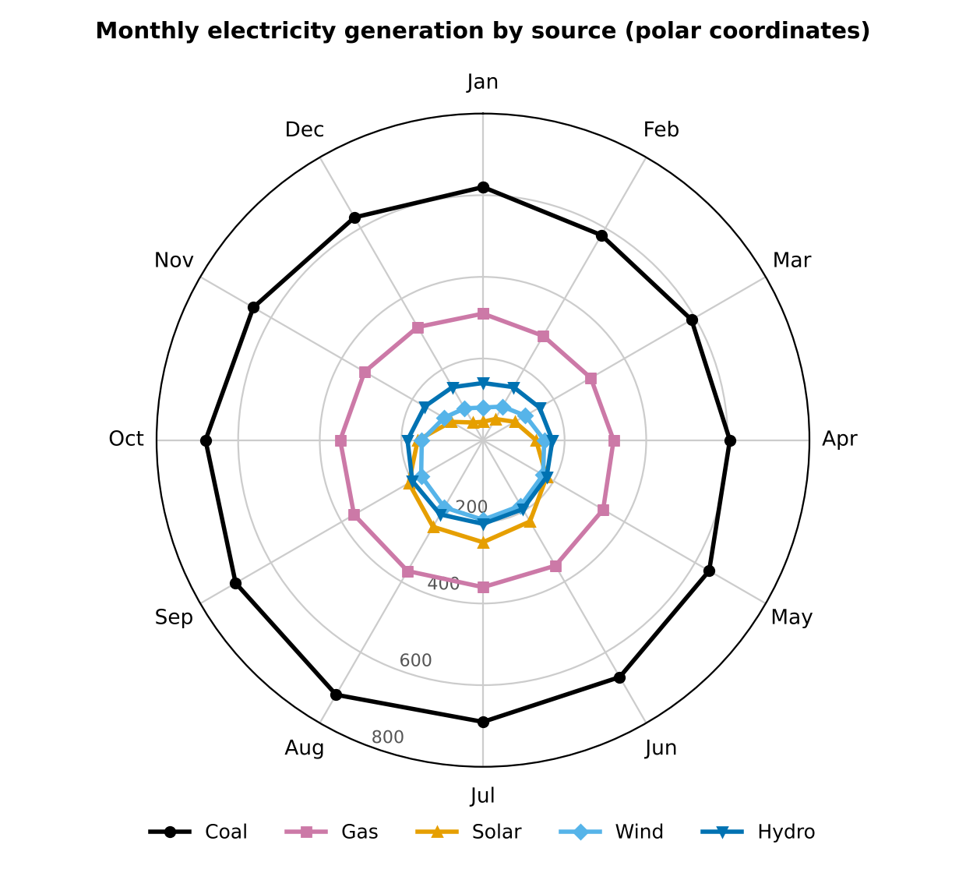
Figure 3: Monthly electricity generation by source in polar coordinates.
Expected console output (summary statistics printed by the last line of the code):
Min Max Mean Peak_Month Ratio
Coal 580 720 647.9 Aug 1.24
Gas 295 370 335.4 Aug 1.25
Solar 45 250 145.0 Jul 5.56
Wind 80 195 142.5 Jul 2.44
Hydro 140 210 175.8 Aug 1.50

4. What the visualizations show
- Coal dominates generation (7,775 of 17,360 total units = 44.8%), followed by Gas (23.2%), Hydro (12.2%), Solar (10.0%) and Wind (9.9%).
- Every source peaks in the middle of the year (July–August) and is lowest in January–February.
- Solar is the most seasonal source: it rises from 45 in January to 250 in July (5.56 times), whereas Coal and Gas vary by only about 1.25 times.
- Crossovers between sources: solar exceeds wind from May to October, equals hydro in May (180) and exceeds hydro from June to September. These crossings are clearly visible in the Cartesian chart.

5. Comparison of the two coordinate systems
Criterion | Cartesian coordinates | Polar coordinates
Reading exact values | Easy: position along a common aligned axis is the most accurately judged visual channel. | Harder: reader must judge distance from the centre along different angles.
Comparing sources in one month | Direct vertical comparison along the same x position. | Values lie on a radial line; comparison is possible but less precise.
Detecting trends and crossovers | Excellent; lines cross clearly (e.g. solar passing hydro). | Weak; crossings are compressed near the centre.
Showing the yearly cycle | Good, but the line starts and stops (Dec is far from Jan). | Very good; Dec connects back to Jan, so the cyclic nature is obvious.
Legibility of small values | Solar, Wind and Hydro are separated vertically. | Low-value lines are crowded close to the centre and overlap.
Perceptual distortion | None; linear, zero-based axis. | Shapes look larger on the outside; the enclosed area exaggerates large values.
Familiarity | Familiar to all readers. | Needs explanation; angular axis labels are harder to follow.
Best use | Analysis, comparison and precise reading. | Showing seasonality / periodic patterns.

6. Decision: which coordinate system gives better analytical insight?
The Cartesian coordinate system provides better analytical insight for this dataset. The main tasks are to compare five sources, read values accurately and notice trends and crossovers, and these are all done best with aligned positions on a common scale. The polar chart is a good supporting view because it shows that the pattern repeats every year, but it compresses the small series near the centre and makes precise comparison difficult.

7. Design decisions explained
- Same colours and markers in both charts (colour-blind-safe Okabe–Ito palette plus different shapes), so differences come only from the coordinate system.
- Y-axis starts at zero (0–800) in both charts, which avoids exaggerating differences.
- Lines with markers are used because the data are ordered in time and the lines show continuity.
- Months ordered Jan–Dec (not alphabetical), with Jan at the top in the polar chart and clockwise direction, the convention of a clock.
- Legend at the bottom and a descriptive title so that each chart can be understood on its own.

8. Conclusion
Both coordinate systems show that Coal is the main source and that all sources peak in mid-year. The Cartesian chart is better for analysis (accurate reading, comparison and crossover detection), while the polar chart is better only for emphasising the annual cycle. Cartesian coordinates are therefore recommended as the primary visualization.

QUESTION 3: Integrated / Capstone Design [R]
Company | Sector | Revenue | ProfitMgn | Employees | MarketCap
C1 | IT | 420 | 8.2 | 1500 | 8500
C2 | Banking | 580 | 15.6 | 3200 | 12000
C3 | Healthcare | 720 | 11.4 | 2100 | 9800
C4 | Retail | 850 | 9.3 | 4200 | 7600
C5 | Energy | 980 | 18.5 | 2800 | 14500
C6 | IT | 1150 | 20.4 | 5100 | 18200
C7 | Banking | 1320 | 17.8 | 6800 | 21500
C8 | Healthcare | 1480 | 14.2 | 3900 | 16800
C9 | Retail | 1650 | 10.5 | 7200 | 13200
C10 | Energy | 1820 | 22.1 | 4500 | 24500
C11 | IT | 2050 | 24.5 | 8100 | 28500
C12 | Banking | 2280 | 19.8 | 9500 | 32500
C13 | Healthcare | 2550 | 16.7 | 6200 | 24800
C14 | Retail | 2840 | 13.4 | 10300 | 19200
C15 | Energy | 3150 | 26.2 | 7200 | 38200
C16 | IT | 3480 | 28.1 | 11800 | 42500
C17 | Banking | 3860 | 21.5 | 13200 | 46800
C18 | Healthcare | 4250 | 18.3 | 8600 | 35600
C19 | Retail | 4680 | 15.2 | 14500 | 29800
C20 | Energy | 5200 | 30.4 | 16000 | 52000
A financial analytics company has collected performance data for twenty publicly listed companies. Develop an integrated visualization that effectively communicates Revenue, Profit Margin, Market Capitalization, Employee Strength, and Industry Sector. Use appropriate aesthetic mappings, coordinate systems, scales, and colour palettes to maximise interpretability while minimising perceptual bias.
ANSWER:

1. Approach
Five variables must be shown together: four quantitative (Revenue, Profit Margin, Market Capitalization, Employees) and one categorical (Sector). The design is a two-panel integrated dashboard. Panel A is a bubble chart that uses the most accurate visual channels (position) for the two most important numeric variables, bubble area for market capitalisation and colour for sector. Panel B shows employee strength as zero-based horizontal bars using the same sector colours, ordered by revenue so that it lines up with Panel A. Together the panels carry all five variables without overloading a single plot.

2. Aesthetic mappings, scales and colours
Variable | Visual channel | Scale / coordinate | Reason
Revenue | x position (Panel A) | Cartesian, log10 axis (500 to 5,000) | Revenue spans a 12× range (420–5,200); a log axis spreads the many small and mid-sized companies and shows proportional differences.
Profit margin (%) | y position (Panel A) | Linear, 5–34% | Position along a common scale is the most accurate channel; a linear scale is right for a percentage.
Market capitalisation | Bubble area (Panel A) | scale_size_area (area proportional to value) | Area, not radius, is mapped to the value, so a company with twice the market cap has twice the area; this avoids size exaggeration.
Employees | Bar length (Panel B) | Linear, starts at zero | Bar length from a zero baseline is accurate for counts; it avoids overloading Panel A.
Industry sector | Colour (both panels) | Colour-blind-safe Okabe–Ito categorical palette | Sector has no order, so distinct hues (not a sequential scale) are used; the same colours link both panels.

3. R code
# Q3: Integrated / capstone design - 20 listed companies
# Packages: install.packages(c("ggplot2", "patchwork", "ggrepel", "scales"))
library(ggplot2)
library(patchwork)
library(ggrepel)
library(scales)

# ---- 1. Data ----
companies <- data.frame(
Company = paste0("C", 1:20),
Sector = c("IT", "Banking", "Healthcare", "Retail", "Energy",
"IT", "Banking", "Healthcare", "Retail", "Energy",
"IT", "Banking", "Healthcare", "Retail", "Energy",
"IT", "Banking", "Healthcare", "Retail", "Energy"),
Revenue = c(420, 580, 720, 850, 980, 1150, 1320, 1480, 1650, 1820,
2050, 2280, 2550, 2840, 3150, 3480, 3860, 4250, 4680, 5200),
ProfitMgn = c(8.2, 15.6, 11.4, 9.3, 18.5, 20.4, 17.8, 14.2, 10.5, 22.1,
24.5, 19.8, 16.7, 13.4, 26.2, 28.1, 21.5, 18.3, 15.2, 30.4),
Employees = c(1500, 3200, 2100, 4200, 2800, 5100, 6800, 3900, 7200, 4500,
8100, 9500, 6200, 10300, 7200, 11800, 13200, 8600, 14500, 16000),
MarketCap = c(8500, 12000, 9800, 7600, 14500, 18200, 21500, 16800, 13200, 24500,
28500, 32500, 24800, 19200, 38200, 42500, 46800, 35600, 29800, 52000)
)
companies$Company <- factor(companies$Company, levels = paste0("C", 1:20))

# ---- 2. Colour-blind-safe categorical palette for the 5 industry sectors ----
sector_pal <- c(IT = "#0072B2", Banking = "#E69F00", Healthcare = "#009E73",
Retail = "#CC79A7", Energy = "#D55E00")
to_label <- c("C1", "C15", "C16", "C17", "C18", "C20") # label only notable companies

# ---- 3. Panel A: bubble chart (Cartesian coordinates, logarithmic x-axis) ----
# x = Revenue (log) y = Profit margin area = Market cap colour = Sector
pA <- ggplot(companies, aes(x = Revenue, y = ProfitMgn, size = MarketCap, fill = Sector)) +
geom_point(shape = 21, colour = "white", alpha = 0.85) +
geom_text_repel(data = subset(companies, Company %in% to_label),
aes(x = Revenue, y = ProfitMgn, label = Company),
inherit.aes = FALSE, size = 3, fontface = "bold") +
scale_x_log10(breaks = c(500, 1000, 2000, 5000), labels = comma) +
scale_y_continuous(limits = c(5, 34)) +
scale_size_area(max_size = 15, breaks = c(10000, 30000, 50000),
labels = comma, name = "Market capitalisation") +
scale_fill_manual(values = sector_pal, name = "Industry sector") +
guides(fill = guide_legend(order = 1, override.aes = list(size = 4)),
size = guide_legend(order = 2, override.aes = list(fill = "grey60"))) +
labs(title = "A. Revenue vs profit margin (bubble area = market capitalisation)",
x = "Revenue (log scale)", y = "Profit margin (%)") +
theme_minimal(base_size = 10) +
theme(legend.position = "bottom", legend.box = "vertical",
plot.title = element_text(face = "bold", size = 10))

# ---- 4. Panel B: employee strength as zero-based horizontal bars ----
pB <- ggplot(companies,
aes(x = Employees, y = factor(Company, levels = rev(levels(Company))),
fill = Sector)) +
geom_col(width = 0.7, show.legend = FALSE) +
scale_fill_manual(values = sector_pal) +
scale_x_continuous(labels = comma, expand = expansion(mult = c(0, 0.05))) +
labs(title = "B. Employees (ordered by revenue)", x = "Number of employees", y = NULL) +
theme_minimal(base_size = 10) +
theme(plot.title = element_text(face = "bold", size = 10))

# ---- 5. Integrate both panels into one dashboard ----
final_plot <- (pA + pB + plot_layout(widths = c(1.55, 1))) +
plot_annotation(
title = paste0("Performance of 20 listed companies: revenue, profit margin, ",
"market cap, employees and sector"),
theme = theme(plot.title = element_text(face = "bold", size = 11, hjust = 0.5))
)

print(final_plot)
ggsave("Q3_integrated_dashboard.png", final_plot, width = 10.4, height = 5.8, dpi = 300)

# ---- 6. Sector averages that support the interpretation ----
sector_summary <- aggregate(cbind(Revenue, ProfitMgn, Employees, MarketCap) ~ Sector,
data = companies, FUN = mean)
print(sector_summary)
print(round(cor(companies[, c("Revenue", "ProfitMgn", "Employees", "MarketCap")]), 2))

4. Output
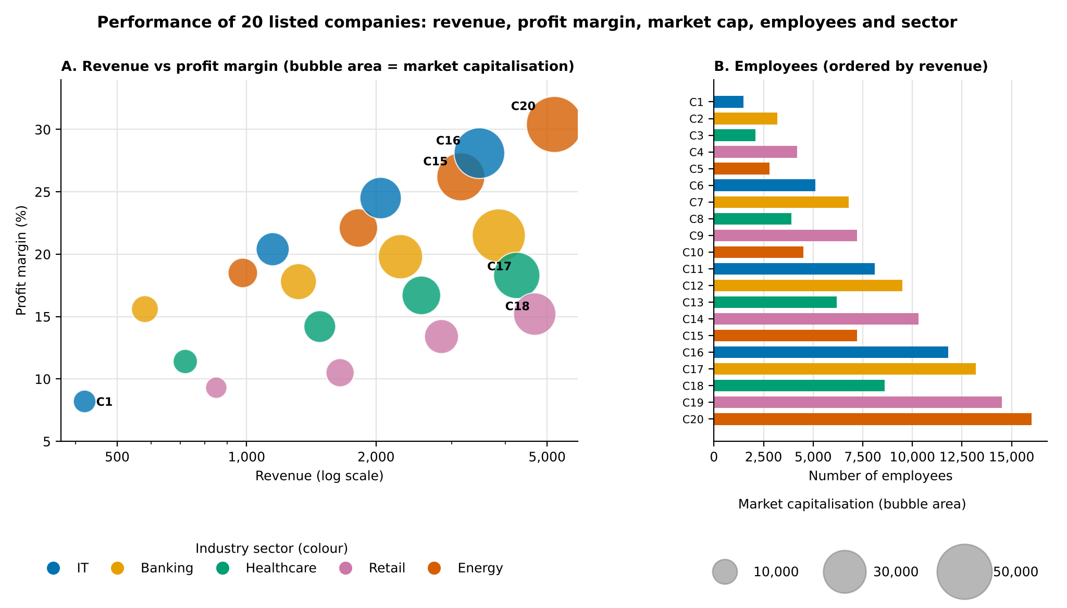
Sector averages (computed from the dataset; printed by `sector_summary`):
Sector | Revenue | ProfitMgn (%) | Employees | MarketCap
Banking | 2,010 | 18.7 | 8,175 | 28,200
Energy | 2,787.5 | 24.3 | 7,625 | 32,300
Healthcare | 2,250 | 15.2 | 5,200 | 21,750
IT | 1,775 | 20.3 | 6,625 | 24,425
Retail | 2,505 | 12.1 | 9,050 | 17,450

Correlation matrix (second print statement in the code):
 | Revenue | ProfitMgn | Employees | MarketCap
Revenue | 1.00 | 0.58 | 0.91 | 0.88
ProfitMgn | 0.58 | 1.00 | 0.56 | 0.84
Employees | 0.91 | 0.56 | 1.00 | 0.83
MarketCap | 0.88 | 0.84 | 0.83 | 1.00

5. Insights from the visualization
- Bigger companies are more profitable and more highly valued: bubbles move up and to the right and become larger; Revenue is strongly correlated with Market Cap (r = 0.88) and Employees (r = 0.91), and Profit Margin is linked to Market Cap (r = 0.84).
- C20 (Energy) has the highest revenue (5,200), the highest margin (30.4%) and the largest market cap (52,000). C16 (IT) also shows a high margin (28.1%) with 42,500 market cap.
- Sector differences: Energy has the highest average margin (24.3%) and IT is next (20.3%); Retail has the lowest margin (12.1%) but the largest average workforce (9,050 employees), a labour-intensive pattern. C1 (IT) has the smallest revenue (420), the fewest employees (1,500) and the lowest margin (8.2%).
- Revenue alone does not decide valuation: C18 (Healthcare) has higher revenue (4,250) than C15 (Energy, 3,150) but a lower market cap (35,600 vs 38,200), because its profit margin is lower (18.3% vs 26.2%). Panel A shows this by position and bubble size together.

6. How perceptual bias is minimised
- Area, not radius, encodes market cap, and a size legend with three reference values (10,000, 30,000, 50,000) lets the reader decode bubble sizes.
- Position carries the two most important variables, because humans judge position most accurately.
- Bars start at zero in Panel B, so bar length is proportional to the number of employees.
- Log axis is labelled clearly (“Revenue (log scale)”) with readable tick values, so it is not mistaken for a linear axis.
- Colour is used only for the categorical variable; a colour-blind-safe palette with 5 distinct hues avoids misleading ordering; transparency reduces overplotting and only notable companies are labelled to avoid clutter.
- No 3D effects, no dual y-axes and no pie charts, which are known to distort perception.

7. Conclusion
The integrated two-panel design communicates Revenue, Profit Margin, Market Capitalization, Employee Strength and Industry Sector together. It uses Cartesian coordinates with a log revenue axis, area-proportional bubbles, zero-based bars and a colour-blind-safe categorical palette, so the chart is readable and has low perceptual bias.

QUESTION 4: Nonlinear Axis for Skewed Data [R]
Team | LinesOfCode | Bugs | Devs | Complexity
T1 | 12000 | 35 | 5 | 2.1
T2 | 18000 | 52 | 7 | 2.4
T3 | 25000 | 60 | 9 | 2.7
T4 | 35000 | 72 | 10 | 3
T5 | 48000 | 88 | 12 | 3.2
T6 | 62000 | 110 | 14 | 3.5
T7 | 81000 | 125 | 16 | 3.8
T8 | 96000 | 142 | 18 | 4.1
T9 | 120000 | 165 | 20 | 4.5
T10 | 150000 | 188 | 22 | 4.8
T11 | 185000 | 205 | 25 | 5.1
T12 | 240000 | 240 | 28 | 5.4
T13 | 310000 | 280 | 30 | 5.8
T14 | 390000 | 320 | 34 | 6.2
T15 | 480000 | 365 | 38 | 6.6
T16 | 620000 | 420 | 42 | 7.1
T17 | 810000 | 490 | 46 | 7.6
T18 | 1050000 | 560 | 50 | 8
T19 | 1350000 | 640 | 55 | 8.5
T20 | 1800000 | 720 | 60 | 9
A software company has recorded project statistics for twenty software development teams. Design a visualization that requires the use of a nonlinear axis transformation to represent highly skewed data. Justify the selected transformation and explain how it improves interpretation over a linear scale.
ANSWER:

1. Why the data need a nonlinear axis
The variable LinesOfCode is highly right-skewed: it ranges from 12,000 (T1) to 1,800,000 (T20), a 150-fold range. The mean (394,100) is more than twice the median (167,500), and the skewness coefficient is 1.58. On a linear axis, the 8 teams below 100,000 lines are squeezed into the first 5.6% of the axis width, so their points overlap and their pattern cannot be seen, while a few very large teams stretch the axis.

2. Selected transformation: base-10 logarithm
The log10 transformation is applied to Lines of Code (the skewed variable) and to Bugs (which also grows over a wide range, 35 to 720), giving a log–log plot. The reasons are:
- All values are positive and non-zero, so the logarithm is defined; no special handling (such as log(1+x) or a symmetric log) is needed.
- The data grow multiplicatively: each step from one team to the next increases the size by roughly 20–50%. A log axis gives equal distances to equal ratios, so these steps appear evenly spaced.
- It removes the skew: the skewness of Lines of Code drops from 1.58 to −0.10 after log10, so the distribution becomes nearly symmetric.
- It linearises a power-law relationship, which makes the underlying pattern easy to see and to fit with a straight line.
Transformation | Suitable? | Reason
Linear (none) | No | Compresses small teams into a tiny region and overplots them.
Square root | Partly | Reduces skew only mildly; a 150× range is still strongly compressed.
Logarithm (base 10) | Yes (chosen) | Handles a 150× range, easy to read (ticks at 10k, 100k, 1M), makes ratios and power laws visible.
Symmetric log / log(1+x) | Not needed | Useful only for zeros or negative values, which do not occur here.

3. R code
# Q4: Nonlinear (logarithmic) axis for highly skewed data
# Packages: install.packages(c("ggplot2", "patchwork", "scales"))
library(ggplot2)
library(patchwork)
library(scales)

# ---- 1. Data ----
teams <- data.frame(
Team = paste0("T", 1:20),
LinesOfCode = c(12000, 18000, 25000, 35000, 48000, 62000, 81000, 96000, 120000, 150000,
185000, 240000, 310000, 390000, 480000, 620000, 810000, 1050000,
1350000, 1800000),
Bugs = c(35, 52, 60, 72, 88, 110, 125, 142, 165, 188, 205, 240, 280, 320, 365,
420, 490, 560, 640, 720),
Devs = c(5, 7, 9, 10, 12, 14, 16, 18, 20, 22, 25, 28, 30, 34, 38, 42, 46, 50, 55, 60),
Complexity = c(2.1, 2.4, 2.7, 3, 3.2, 3.5, 3.8, 4.1, 4.5, 4.8, 5.1, 5.4, 5.8, 6.2,
6.6, 7.1, 7.6, 8, 8.5, 9)
)

# ---- 2. How skewed is the data? ----
cat("Max/Min LOC ratio :", max(teams$LinesOfCode) / min(teams$LinesOfCode), "\n")
cat("Mean LOC :", mean(teams$LinesOfCode), "\n")
cat("Median LOC :", median(teams$LinesOfCode), "\n")

# ---- 3. Common aesthetics: x = LOC, y = Bugs, size = Devs, colour = Complexity ----
base_plot <- ggplot(teams, aes(x = LinesOfCode, y = Bugs, size = Devs, colour = Complexity)) +
geom_point(alpha = 0.9) +
scale_colour_viridis_c(name = "Complexity") +
scale_size_continuous(range = c(2, 7), name = "Developers") +
theme_minimal(base_size = 10) +
theme(plot.title = element_text(face = "bold", size = 10))

short_labels <- label_number(scale_cut = cut_short_scale())

# ---- 4(a). Linear axes (baseline for comparison) ----
p_linear <- base_plot +
scale_x_continuous(labels = short_labels) +
labs(title = "A. Linear x-axis", x = "Lines of code", y = "Bugs")

# ---- 4(b). Logarithmic (base-10) axes ----
p_log <- base_plot +
geom_smooth(data = teams, aes(x = LinesOfCode, y = Bugs), inherit.aes = FALSE,
method = "lm", formula = y ~ x, se = FALSE,
colour = "grey30", linetype = "dashed", linewidth = 0.6) +
scale_x_log10(breaks = c(1e4, 3e4, 1e5, 3e5, 1e6, 2e6), labels = short_labels) +
scale_y_log10(breaks = c(30, 50, 100, 200, 400, 700)) +
labs(title = "B. Logarithmic (base-10) axes", x = "Lines of code (log scale)",
y = "Bugs (log scale)")

final_plot <- (p_linear + p_log) + plot_layout(guides = "collect") +
plot_annotation(
title = "Software teams: project size vs bugs (point size = number of developers)",
theme = theme(plot.title = element_text(face = "bold", size = 11, hjust = 0.5))
)

print(final_plot)
ggsave("Q4_log_axis.png", final_plot, width = 10, height = 4.6, dpi = 300)

# ---- 5. Quantify the improvement from the transformation ----
fit_lin <- lm(Bugs ~ LinesOfCode, data = teams)
fit_log <- lm(log10(Bugs) ~ log10(LinesOfCode), data = teams)
cat("R-squared (linear) :", round(summary(fit_lin)$r.squared, 3), "\n")
cat("R-squared (log-log) :", round(summary(fit_log)$r.squared, 3), "\n")
cat("Power-law exponent :", round(coef(fit_log)[2], 2), "\n")

4. Output
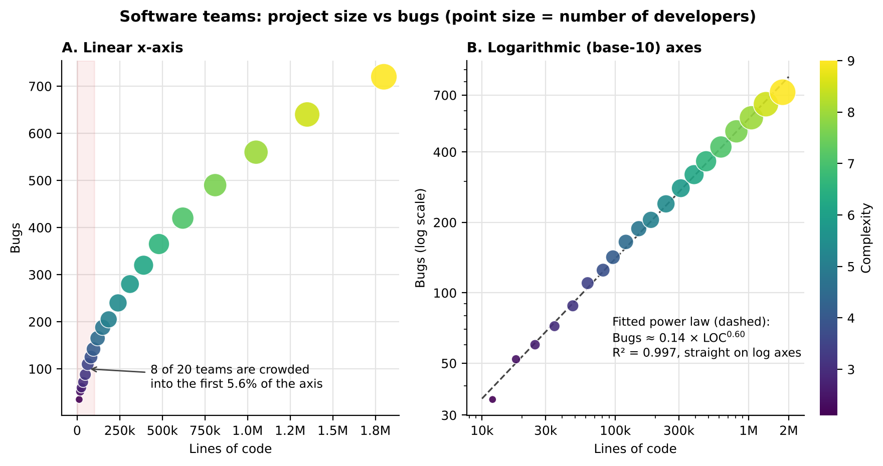
Figure 5: Bugs versus Lines of Code on a linear axis (A) and on logarithmic axes (B); colour = complexity, point size = developers.
Expected console output (from the `cat()` statements):
Max/Min LOC ratio : 150
Mean LOC : 394100
Median LOC : 167500
R-squared (linear) : 0.938
R-squared (log-log) : 0.997
Power-law exponent : 0.6

5. How the logarithmic axis improves interpretation
Aspect | Linear scale (Panel A) | Logarithmic scale (Panel B)
Spread of points | 8 of 20 teams are crowded in the first 5.6% of the axis and overlap. | Teams are evenly spread from 10k to 2M lines; every team is distinguishable.
Shape of relationship | A curve that bends and flattens; hard to describe. | A straight line: bugs follow a power law, Bugs ≈ 0.14 × LOC^0.60.
Model fit (R²) | 0.938 for a straight-line fit. | 0.997 for a straight-line fit on log axes.
Meaning of distance | Equal distances = equal absolute differences; dominated by large teams. | Equal distances = equal ratios (×2 or ×10); growth rates are comparable at all sizes.
Small teams | Their pattern is invisible. | Clearly visible and consistent with large teams.

- Quantitative insight: the fitted exponent is about 0.60, so bugs grow more slowly than code size: doubling the lines of code increases bugs by only about 1.5 times (2^0.6 ≈ 1.5). Bug density therefore falls with size, from 35 bugs per 12,000 lines (2.9 per 1,000 lines) in T1 to 720 bugs per 1,800,000 lines (0.4 per 1,000 lines) in T20.
- Complexity (colour) increases steadily from T1 to T20 and is aligned with project size, and developers (point size) also grow with size; both are easy to read once the points are spread out.

6. Precautions when using a logarithmic axis
- The axis is labelled “log scale” and uses real values (10k, 30k, 100k, 300k, 1M, 2M) as tick labels, not log values, so the reader does not mistake it for a linear axis.
- Points (not bars) are used, because bars must start at zero and zero does not exist on a log axis.
- The linear panel is shown next to it so the reader can verify that the transformation reveals structure and does not create it.

7. Conclusion
Because Lines of Code is highly skewed (150× range, skewness 1.58), a linear axis hides most teams. The base-10 logarithmic axis spreads the data evenly, reduces skewness to nearly zero and reveals a clean power-law relationship with bugs (R² = 0.997, exponent about 0.6). It therefore gives a much more accurate and interpretable picture than a linear scale.

