LAB EXPERIMENT

SET 17: EMPLOYEE PERFORMANCE ANALYSIS

Department | AIDS
Course Code / Course Name | DSA0602 / Data Handling and Visualization
Experiment | Data Visualization using R and Tableau
Name | B Mallika
Register Number | 192324234
Date | 10 October 2026
Day | Saturday

Aim
To analyze employee performance data using a line chart, a bar chart and a performance table in R, and to build an interactive dashboard using Tableau. Dataset: Employee Performance

Employee ID | Department | Years of Service | Performance Score
1 | Sales | 5 | 85
2 | HR | 3 | 92
3 | Marketing | 7 | 78

PROGRAM 1: Line Chart of Performance Trend
Create a line chart to visualize the performance trend of employees over time. Label the axes and title the chart.
# Dataset
employees <- data.frame( Employee_ID = 1:3,
Department = c("Sales", "HR", "Marketing"), Years_of_Service = c(5, 3, 7),
Performance_Score = c(85, 92, 78)
)

# Arrange by years of service so the line shows the trend over time emp_sorted <- employees[order(employees$Years_of_Service), ]

# Line Chart
plot(emp_sorted$Years_of_Service, emp_sorted$Performance_Score, type = "b", pch = 19, lwd = 2, col = "steelblue",
xlab = "Years of Service", ylab = "Performance Score",
main = "Employee Performance Trend by Years of Service", xaxt = "n", ylim = c(70, 100))
axis(1, at = emp_sorted$Years_of_Service) text(emp_sorted$Years_of_Service, emp_sorted$Performance_Score,
labels = emp_sorted$Department, pos = 3)

OUTPUT:
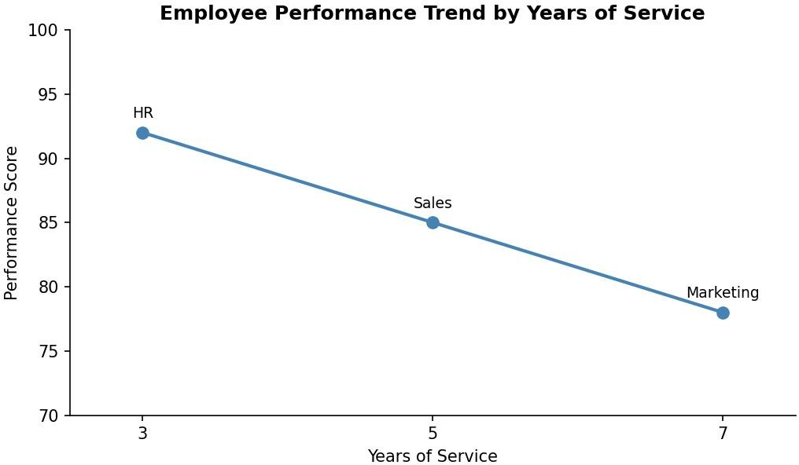
Output 1: Employee Performance Trend (Line Chart)

Observation:
Performance falls steadily as years of service increase: HR (3 years) scores 92, Sales (5 years) scores 85 and Marketing (7 years) scores 78. The score drops by 7 points for every 2 additional years of service, so the line slopes downward in a straight line.

PROGRAM 2: Bar Chart of Employees by Department
Generate a bar chart showing the distribution of employees across different departments. Label the chart elements.
# Count of employees in each department dept_count <- table(employees$Department)

# Bar Chart barplot(dept_count,
col = c("steelblue", "darkorange", "forestgreen"), xlab = "Department",
ylab = "Number of Employees",
main = "Distribution of Employees by Department", ylim = c(0, 2), yaxp = c(0, 2, 2))

OUTPUT:
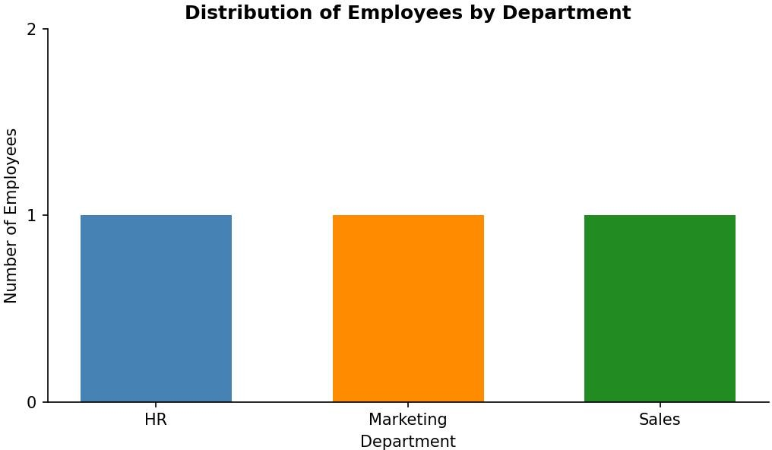
Output 2: Distribution of Employees by Department (Bar Chart)

Observation:
Each of the three departments (HR, Marketing and Sales) has exactly one employee, so all bars have the same height of 1 and the employees are spread evenly across the departments.

PROGRAM 3: Table of Employee Performance Data
Build a table to display the performance data for each employee. Label the table elements.
# Dataset
employees <- data.frame( Employee_ID = 1:3,
Department = c("Sales", "HR", "Marketing"), Years_of_Service = c(5, 3, 7),
Performance_Score = c(85, 92, 78)
)

# Add a rank column (1 = highest performance score) employees$Rank <- rank(-employees$Performance_Score)

# Display the table print(employees)

# Average performance score mean(employees$Performance_Score)

OUTPUT:

Employee_ID | Department | Years_of_Service | Performance_Score | Rank
1 1 | Sales | 5 | 85 | 2
2 2 | HR | 3 | 92 | 1
3 3 | Marketing | 7 | 78 | 3
[1] 85
Output 3a: Employee Performance Table (R Console)

Employee ID | Department | Years of Service | Performance Score | Rank
1 | Sales | 5 | 85 | 2
2 | HR | 3 | 92 | 1
3 | Marketing | 7 | 78 | 3
Output 3b: Employee Performance Table with Rank

Observation:
The table gives the exact performance score of each employee. HR has the highest score (92) and rank 1, Sales is second (85) and Marketing is last (78). The average performance score is 85, which equals the Sales score.

PROGRAM 4: Interactive Employee Performance Dashboard in Tableau
Develop a Tableau dashboard combining the line chart, bar chart and the table for interactive exploration of employee performance data.

Steps in Tableau
- Save the data as an Excel or CSV file and connect to it in Tableau (Connect > Microsoft Excel / Text file). Check that Years of Service and Performance Score are numeric measures and Department is a dimension.
- Sheet 1 (Line Chart): Drag Years of Service (as a continuous or discrete dimension) to Columns and Performance Score to Rows (SUM). Set the Marks type to Line, add Department to Label, and rename the sheet "Performance Trend".
- Sheet 2 (Bar Chart): Drag Department to Columns and Employee ID to Rows, then change it to Count (Distinct). Drag Department to Color and add the count to Label. Rename the sheet "Employees by Department".
- Sheet 3 (Table): Drag Employee ID and Department to Rows, and use Measure Names on Columns with Measure Values on Text (Years of Service and Performance Score). Rename the sheet "Performance Table".
- Create a new Dashboard (Dashboard > New Dashboard), set the size to Automatic, and drag the three sheets onto the dashboard area.
- Add interactivity: select each chart and click Use as Filter, so clicking a department or point in one view filters the others. Add a Department filter (Show Filter > Apply to Worksheets > All Using This Data Source).
- Add the title "Employee Performance Dashboard" and test the filters in Presentation Mode.

OUTPUT:
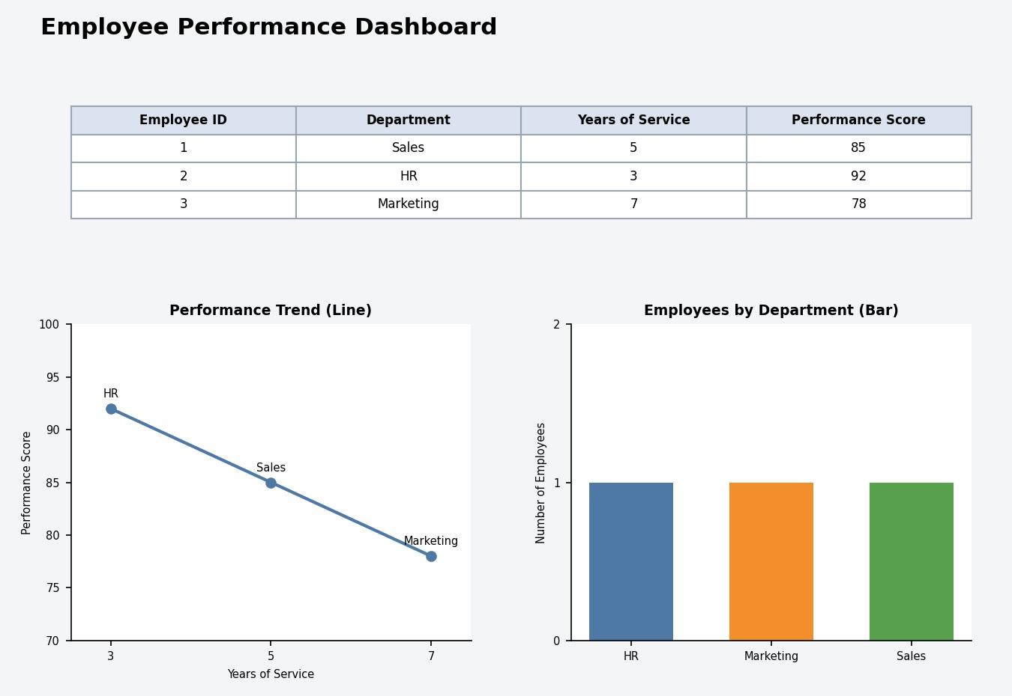
Output 4: Interactive Employee Performance Dashboard (Tableau)

Observation:
The dashboard shows the performance trend, the department distribution and the employee performance table together.

Procedure
- Create the employee data frame in R with Employee ID, Department, Years of Service and Performance Score.
- Sort the data by years of service and use plot() with type = "b" to draw the line chart of the performance trend.
- Use table() to count employees per department and barplot() to draw the bar chart.
- Add a Rank column, display the data frame with print() and calculate the average score with mean().
- Load the employee file into Tableau and build the line chart, bar chart and table worksheets.
- Combine the worksheets in a Tableau dashboard and add filters and actions for interactivity.

RESULT:
The employee performance data was successfully analyzed using a line chart, a bar chart and a performance table in R. An interactive Tableau dashboard was also created, combining all three views so that users can explore the performance data by department and years of service.

Key Functions and Tools Used

Function / Tool | Purpose
data.frame() / order() | Creates the employee table and sorts it by years of service.
plot(type = "b") | Creates the line chart of the performance trend.
table() / barplot() | Counts employees per department and draws the bar chart.
rank() / print() / mean() | Ranks employees, displays the table and calculates the average score.
Tableau Worksheets | Build the line chart, bar chart and table views.
Tableau Dashboard | Combines worksheets with filters and actions.

