NAME | B. MALLIKA
REGISTER NUMBER | 192324234
DEPARTMENT | ARTIFICIAL INTELLIGENCE AND DATA SCIENCE
COURSE CODE | DSA0602
COURSE NAME | DATA HANDLING AND VISUALIZATION
EXPERIMENT | ACTIVITY
DATE | 01-10-2026
DAY | THURSDAY

SET NO 7
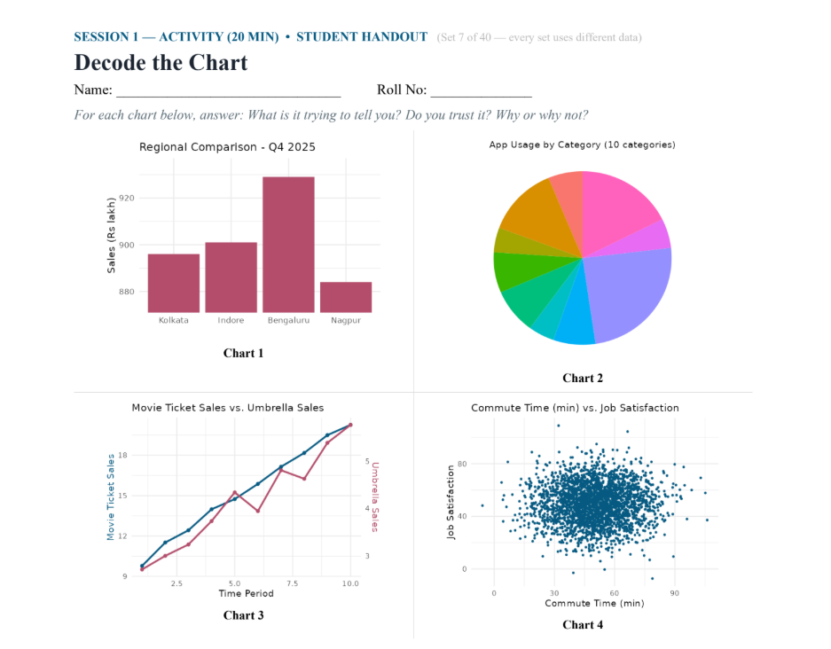
ANALYSING THE ABOVE GRAPHS:
Chart 1 – Regional Comparison
- This is a bar chart showing sales in four regions.
- The regions shown are Kolkata, Indore, Bengaluru, and Nagpur.
- Bengaluru has the highest sales among all four regions.
- Nagpur has the lowest sales.
- Indore has slightly higher sales than Kolkata.
- The difference between the regions is relatively small.
- The chart helps us compare sales performance across regions.
- Trust: The chart is useful, but the Y-axis starts around 880 instead of 0, which can make the differences look bigger.

Chart 2 – App Usage by Category
- This is a pie chart showing app usage across 10 categories.
- Each section represents one category's share of total app usage.
- The largest sections represent the categories with the highest usage.
- The smaller sections represent categories with lower usage.
- App usage is not equally divided among all categories.
- The chart gives a quick idea of how total usage is distributed.
- Trust: It is useful for seeing the overall distribution, but exact values are difficult to identify because percentages are not labelled.

Chart 3 – Movie Ticket Sales vs. Umbrella Sales
- This is a line chart comparing two types of sales over 10 time periods.
- Movie ticket sales show a general upward trend.
- Umbrella sales also increase overall but have some ups and downs.
- Movie ticket sales increase more consistently than umbrella sales.
- Both sales reach their highest point at the end of the period.
- The graph helps us understand how the two sales changed over time.
- Trust: The chart is useful, but the two variables use different Y-axes, so their line heights should not be directly compared.

Chart 4 – Commute Time vs. Job Satisfaction
- This is a scatter plot showing the relationship between commute time and job satisfaction.
- The X-axis represents commute time in minutes.
- The Y-axis represents job satisfaction.
- Most data points are concentrated around 30–70 minutes of commute time.
- Most job satisfaction values are around the middle range.
- The points are widely scattered across the graph.
- There is no obvious strong relationship visible between commute time and job satisfaction.
- A statistical correlation test would be needed to determine the exact relationship.
- Trust: The scatter plot is appropriate for showing the relationship, but the graph alone cannot prove whether one variable affects the other.

