DSA0602 • DATA HANDLING AND VISUALIZATION
LAB EXPERIMENT
SET 24: PRODUCT INVENTORY MANAGEMENT

Experiment Details
Field | Details
Department | AIDS
Course Code / Course Name | DSA0602 / Data Handling and Visualization
Experiment | Data Visualization using R and Tableau
Name | B Mallika
Register Number | 192324234
Date | 15 October 2026
Day | Thursday

Aim
To visualize product inventory quantities using R bar charts and outline an interactive Tableau dashboard.

Dataset: Product Inventory
Product ID | Product Name | Quantity Available
1 | Product A | 250
2 | Product B | 175
3 | Product C | 300
4 | Product D | 200
5 | Product E | 220

PROGRAM 1: Bar Chart of Product Inventory
In R, create a bar chart to visualize the quantity of each product. Label axes and title the chart.
R Code:
inventory <- data.frame(Product_ID=1:5, Product=c("Product A","Product B","Product C","Product D","Product E"), Quantity=c(250,175,300,200,220))
barplot(inventory$Quantity, names.arg=inventory$Product, col="steelblue", xlab="Product", ylab="Quantity Available", main="Product Inventory by Quantity", ylim=c(0,350), las=2)
OUTPUT:
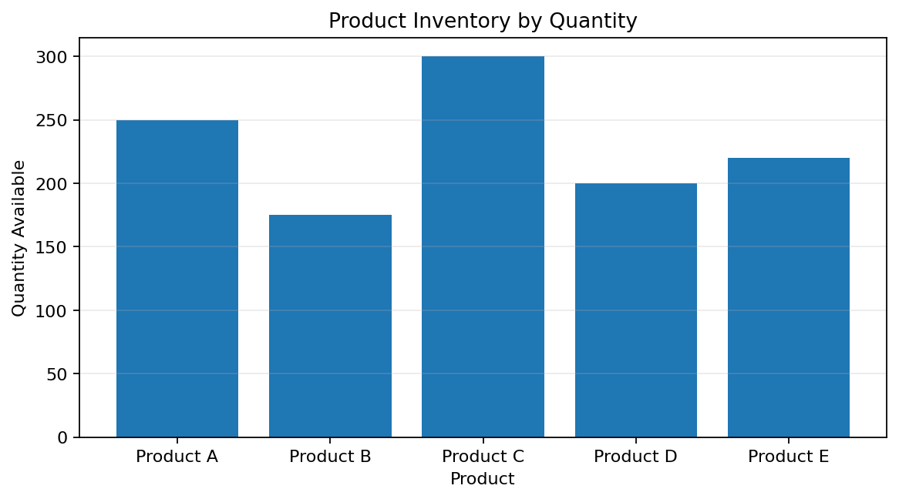
Output 1: Bar Chart of Product Inventory
Observation: Product C has the highest inventory (300 units), while Product B has the lowest (175 units).

PROGRAM 2: Product Quantity Comparison
Create a second chart comparing the quantity of each product. A category-stacked chart needs a category field.
R Code:
barplot(inventory$Quantity, names.arg=inventory$Product, col=c("steelblue","darkorange","seagreen","mediumpurple","slategray"), xlab="Product", ylab="Quantity Available", main="Inventory Quantity by Product", ylim=c(0,350), las=2)
legend("topright", legend=inventory$Product, fill=c("steelblue","darkorange","seagreen","mediumpurple","slategray"), cex=.7)
Data note: The dataset has no Product_Category field.
OUTPUT:
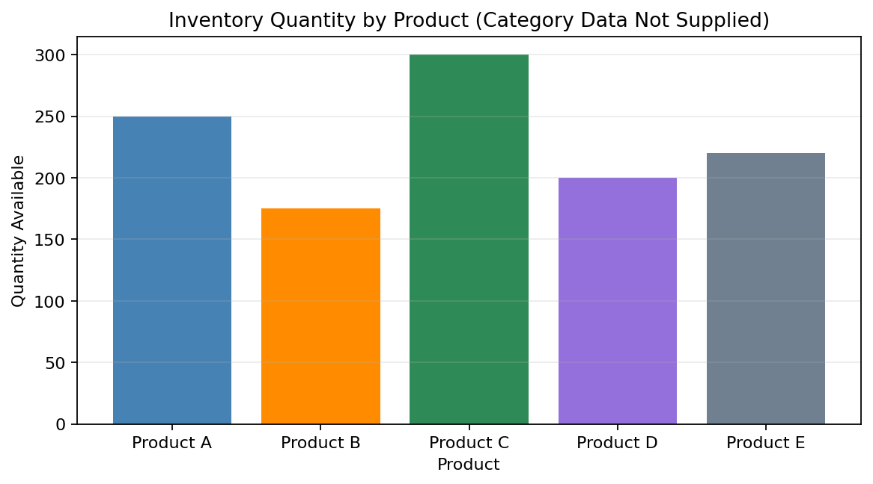
Output 2: Product Quantity Comparison
Observation: The chart compares available quantities across products. A true stacked-by-category chart cannot be generated from the supplied fields.

PROGRAM 4: Available Quantity by Product ID
Create a scatter plot to explore inventory values; the supplied data do not include product prices.
R Code:
plot(inventory$Product_ID, inventory$Quantity, pch=19, col="darkorange", xlab="Product ID", ylab="Quantity Available", main="Available Quantity by Product ID")
text(inventory$Product_ID, inventory$Quantity, labels=inventory$Product, pos=3, cex=.7)
Data note: The dataset has no Product_Price field; the output plots provided quantities by product ID.
OUTPUT:
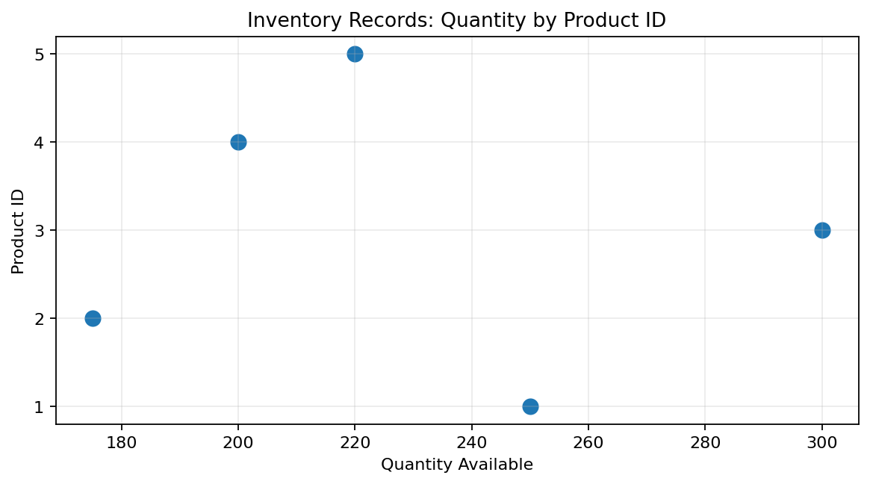
Output 4: Available Quantity by Product ID
Observation: Price-versus-quantity relationship cannot be concluded without product prices.

PROGRAM 3: Tableau Dashboard
In Tableau, build a dashboard combining product inventory charts.
- Save Product_ID, Product, and Quantity as CSV and connect Tableau to the file.
- Create a bar chart with Product on Columns and Quantity on Rows; show labels and title it Product Inventory.
- Create a second product comparison view. Add Product_Category only if the source data are extended.
- Create a dashboard, place both sheets, and add a Quantity filter.
- Enable Use as Filter and test selecting products.
The supplied PDF does not include product categories or prices, so category-stacked and price-versus-quantity analyses need additional data.

Procedure
- Create an R data frame from the supplied product inventory table.
- Use barplot() to compare available quantities.
- Record that product category and price fields are absent.
- Import the CSV into Tableau and combine worksheets in a dashboard.

RESULT
Product quantities were visualized using R. Product C has the most stock (300) and Product B the least (175). Category-based stacking and price-versus-quantity analysis require additional fields.

Key Functions and Tools Used
Function / Tool | Purpose
data.frame() | Stores product inventory data.
barplot() | Compares product quantities.
plot() | Displays quantities against product ID when price is unavailable.
Tableau Dashboard | Combines worksheets and filters.

