**Name: Mallika Azmy Siddika**

**Aim : This experiment conveys learning about how write a file using fs module and to implement the process of copying data from file to another file using stream.**

# Task to be done:

Step 1: Open File that stored output of Experiment 1

----- Notepad empdetails.txt

Step 2: Create a New File name copy.txt (keep it empty)

----- Notepad copy1.txt

Step 3: Create a New JS File name trans.js .This file will contain the code to transfer data from empdetails.txt to copy1.txt

Step 4: Write the code to the Copy Data in trans.js and run it.



# Code for experiment/practical:

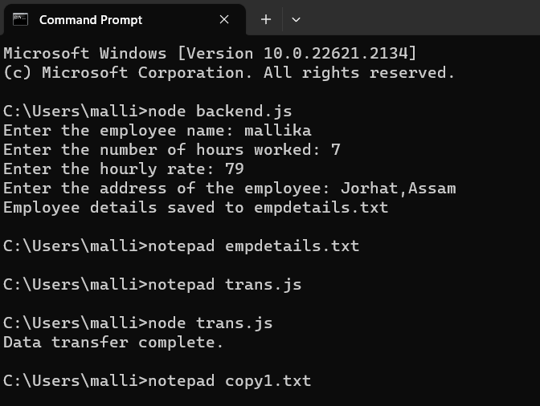

**experiment 1 data (This data is to be Transferred to new File )**

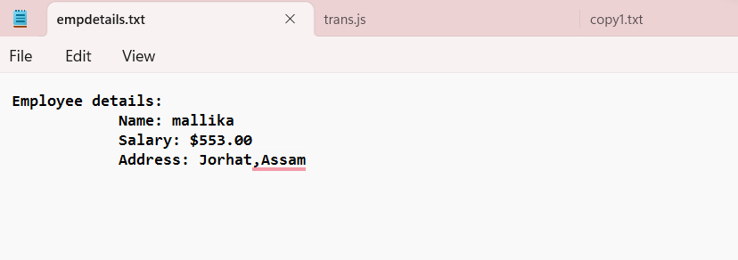



# Js file for transferring data:

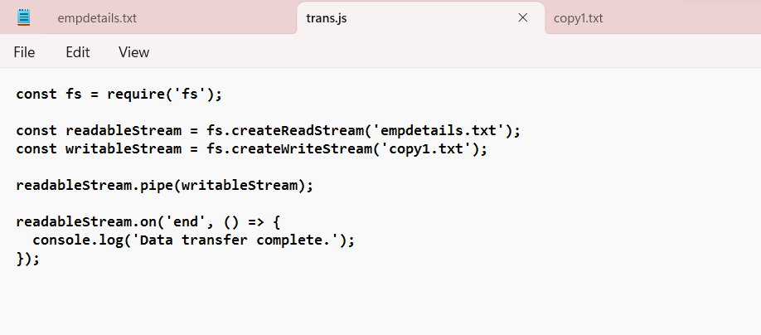

**Data Transferred -**



# Learning outcomes (What I have learnt):

**Understanding File Streams**: Understood the concept of file streams and their significance in efficiently handling large data transfers.

**Using the fs Module**: Demonstrated the ability to use the fs module's **writeFile()** functions to interact with files for writing operations.

**Using the Stream methods** : Demonstrated the ability of reading data from a file using a **createReadStream()** and write it to another file using **createWriteStream()** functions and the pipe method to connect the two streams.