**Source code:**

First open the test plan give name to the test plan to lesson end project

Next add some HTTP Headers

Next step add thread group to test plan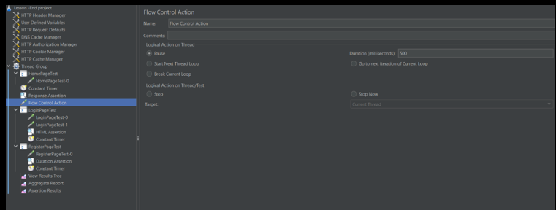

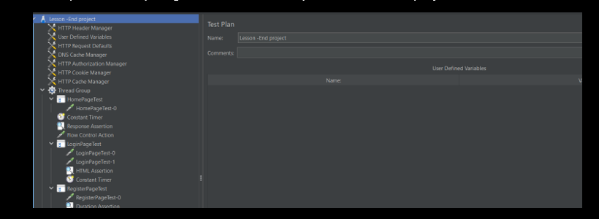

In Thread group add some logic controller and give name as home page test

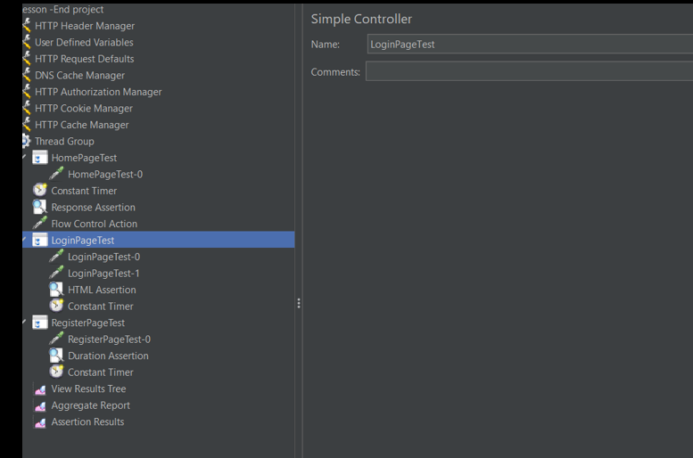

Next step add Http request go to thread group>add >samplers>http request give name as homepage test -0

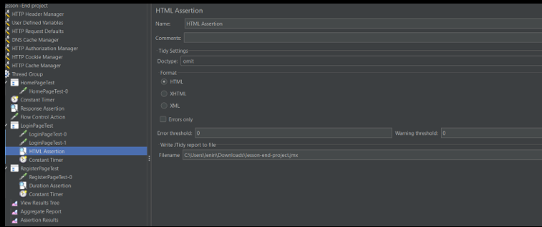

Next add html request to give name as login page test-1:

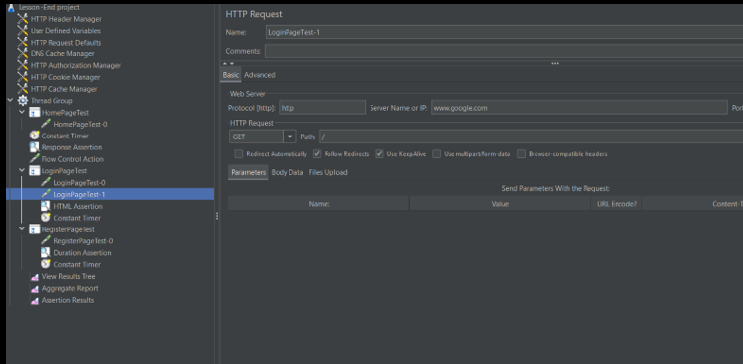

Next add HTML assertion go to samplers>assertions>html assertion

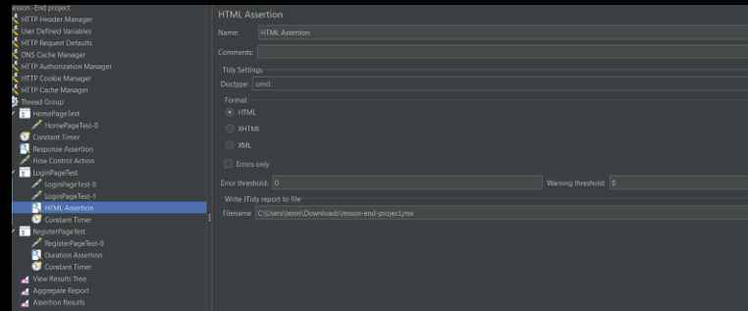

Next add timers go to samplers section>timers>constant timers

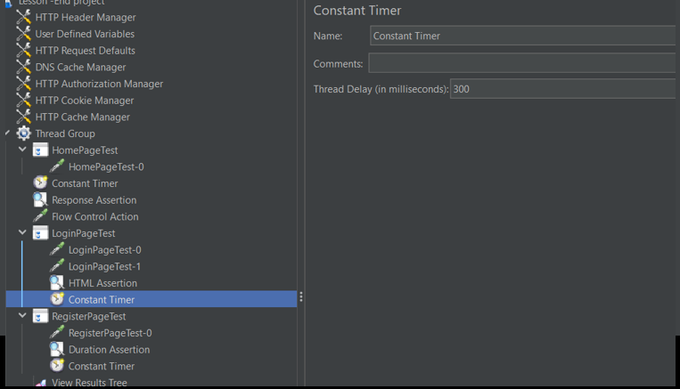

Next step add go to thread group> add > logical controller>throughput controller>give name as RegisterPage test

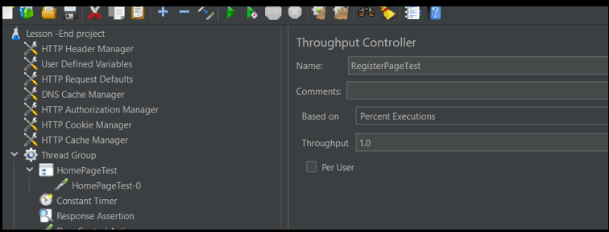

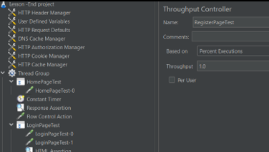

Next add http request name as RegisterdPage test-0

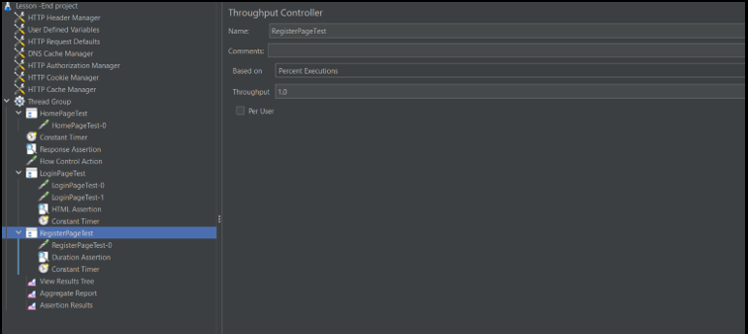

Next add Assertion assertion name duration assertion

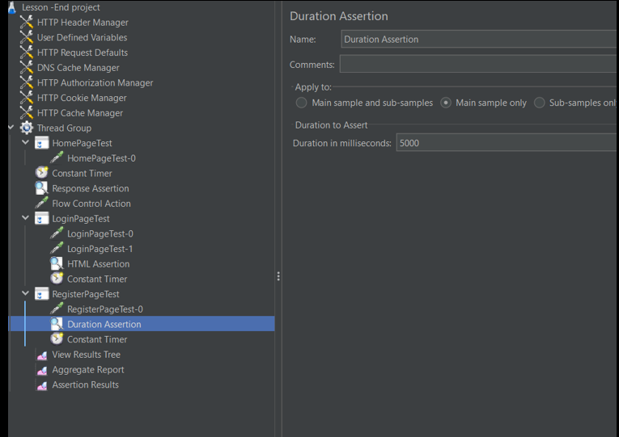

Next add timer select constant timer

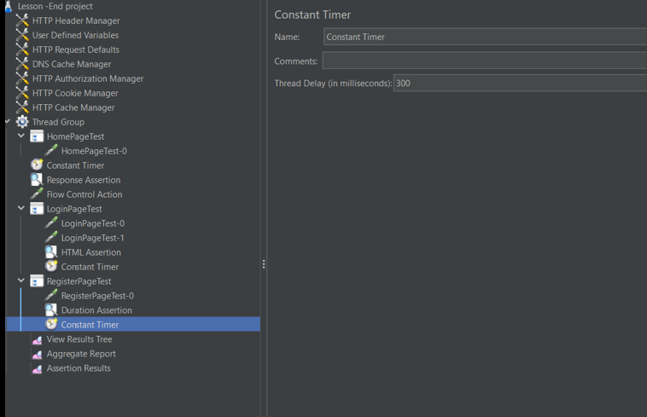

Next go to test plan >add > listeners>select view results tree

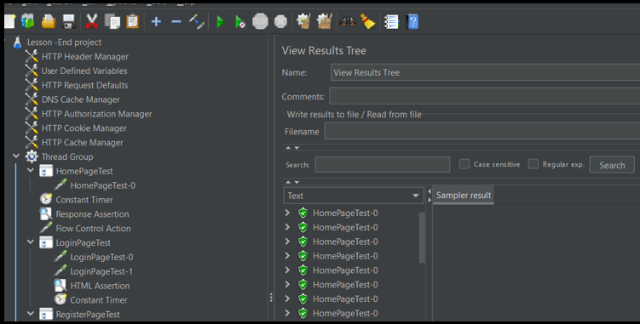

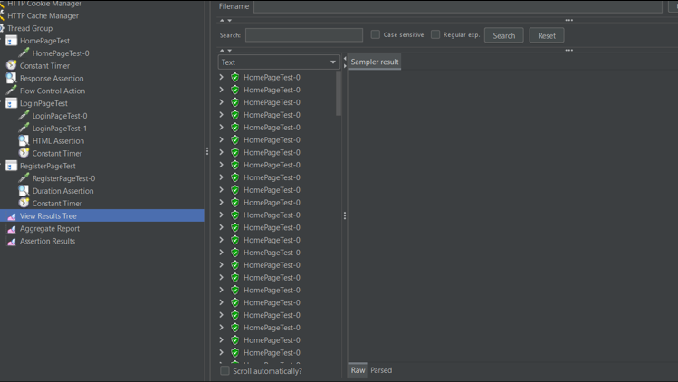

Next add aggregation report:

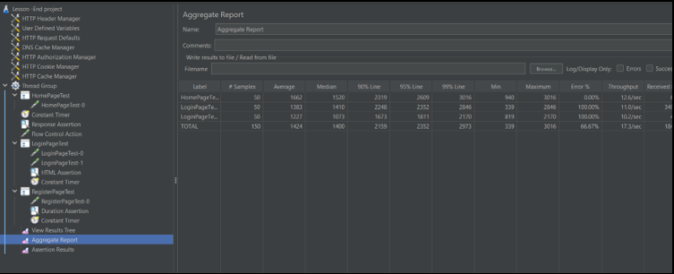

Next add test plan >thread group> listeners>assertion results

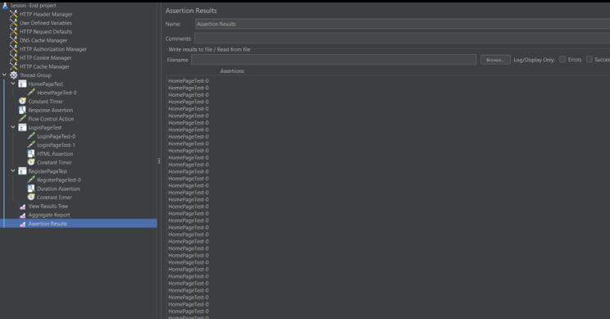

**ASSISTED PRACTICE (HTTP AUTHENTICATION MANAGER, COOKIES AND CSV DATA SET CONFIG)**

HTTP Authentication Manager :

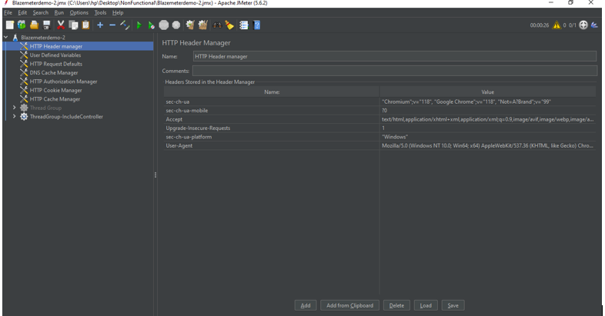

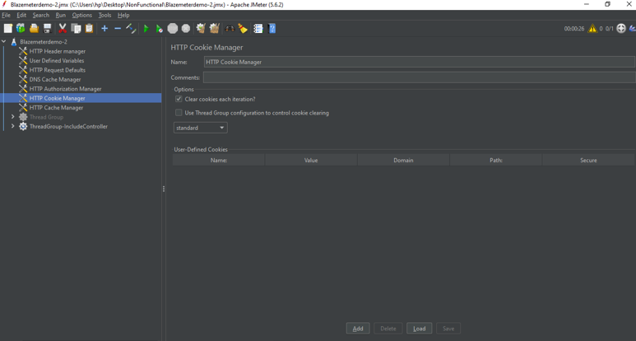



**ASSISTED PRACTICE (PRE AND POST PROCESSORS IN JMETER)**

Post Processors:

Step1: Open Jmeter -> Add Thread Group

Step2: Right click on Thread Group -> Add -> Sampler -> HTTP request

Step3: In HTTP request, Give “https” as Protocol, Give “blazedemo.com” as Server, Give “/” as Path

Step4: Right click on HTTP request -> Add -> Post Processors -> Regular Expression Extractor

Step5: In Regular Expression Extractor, Give “city” as Name of created variable, Give “<option value="(.*?)">(.*?)</option” as Regular Expression, Give “$1$” as Template, Give “-1” as Match Number, Give “City not Found” as Default value

Step6: Right click on Thread Group -> Add -> Logic Controller -> For Each Controller

Step7: In For Each Controller, Give “city” as Input variable prefix, Give “1” as Start index for loop, Give “${city_matchNr}” as End index for loop -> Give “eachCity” as Output variable name

Step8: Right click on For Each Controller -> Add -> Sampler -> Dummy Sampler -> Give the name of Dummy Sampler as “The city name is -${eachCity}” (To install the Dummy Sampler -> Go to options of Jmeter -> Click On Plugin manager -> Available plugins -> Search for Dummy Sampler and install it(select the checkbox) -> Once it has been installed, Click on “Apply changes and restart jmeter” at the bottom of this window -> Jmeter will restart )

Step9: Right click on Thread Group -> Add -> Listener -> View results tree (to see the output)

Step10: Right click on Thread Group -> Add -> Sampler -> Debug Sampler

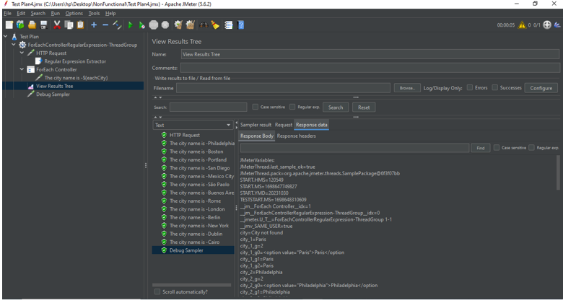

Pre Processors:

Step1: Open Jmeter -> Add Thread Group

Step2: Right click on Thread Group -> Add -> Logic controllers -> If Controller

Step3: In If Controller, Give the details as shown below:

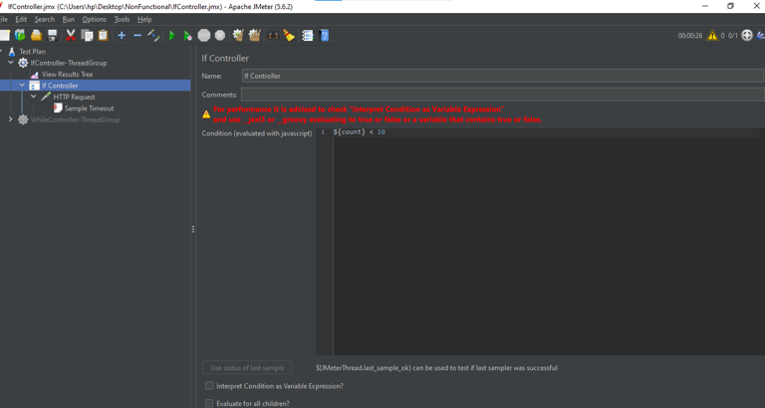

Step4: Right click on If Controller -> Add -> Sampler -> HTTP Request

Step5: In HTTP Request , Give the details as shown below:

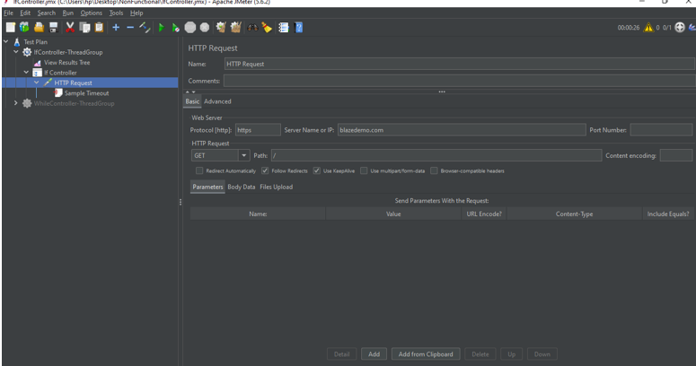

Step6: Right click on HTTP Request -> Add -> Pre Processors -> Sample Timeout

Step7: In Sample Timeout, Give the Sample Timeout of “2000 milliseconds”

Step8: Right click on Thread Group -> Add -> Listener -> View Results Tree (to see the output)

Step9: Save it and execute

