Project Synopsis

Entitled

“SKIN DISEASE DETECTION USING MACHINE LEARNING”


Submitted in partially fulfillment of the requirements for the award of the Degree of Bachelor of Computer Application of Rani Chennamma University, Belagavi
KLE SOCIETY’S

COLLEGE OF BACHELOR OF COMPUTER APPLICATION GOKAK

RANI CHANNAMMA UNIVERSITY BELAGAVI 2025-26
Submitted by
Sahana Awaradi (U15EW23S0112)
Priya Patil (U15EW23S0141)
Nisha Shiraganvakar (U15EW23S0151)

Under The Guidance of
Prof.Suprita Walvekar

Introduction

Skin diseases are a significant health concern worldwide, affecting millions of people. Early detection is crucial for effective treatment and prevention of complications. Machine learning technology can aid in diagnosing skin diseases using images, enabling timely interventions. By leveraging these advancements, we can improve skin health outcomes and quality of life.
Machine learning has emerged as an effective solution in the healthcare domain. Machine learning techniques can analyze medical images and identify disease patterns with high accuracy. In skin disease detection, these models are trained using large datasets of skin images to recognize visual features such as color, texture, and shape. This reduces human error and speeds up the diagnostic process.
The Skin Disease Detection System using Machine Learning aims to assist doctors and general users by providing an automated and reliable diagnosis. By uploading a skin image, the system predicts the type of skin disease at an early stage. This approach helps in starting treatment on time, improves healthcare accessibility, and supports medical professionals in making better clinical decisions.

• Skin disease diagnosis requires expert dermatologists
Accurate identification of skin diseases needs experienced dermatologists. Normal users or general doctors may find it difficult to identify diseases correctly from skin images.
• Manual diagnosis is time-consuming and costly
Traditional diagnosis involves physical visits, tests, and expert consultation, which takes time. It also increases medical costs for patients.
• Limited access to specialists in rural areas
People in rural or remote areas often do not have easy access to dermatologists. This leads to delayed diagnosis and untreated skin conditions.
• Existing systems lack early and accurate prediction
Most existing systems detect diseases only at later stages. They do not provide early and highly accurate prediction, which is important for timely treatment.
OBJECTIVES
The main objectives of this project are:
- To detect skin diseases using machine learning
Machine learning techniques are used to analyze skin images and identify possible diseases. This helps in automatic and efficient disease detection.
- To classify diseases accurately using CNN
Convolutional Neural Networks (CNN) are used to extract image features and classify skin diseases into different categories. This improves accuracy compared to traditional methods.
- To assist doctors and users with early diagnosis
The system helps doctors and common users by providing early disease detection. Early diagnosis allows timely treatment and prevents complications.
- To reduce diagnosis time and human error
Automated analysis reduces the time required for diagnosis. It also minimizes human errors caused by manual observation and fatigue
- • Detection of common skin diseases from images
The system analyzes skin images to identify common skin diseases. Image-based detection makes the process fast and user-friendly.
- • Applicable for hospitals and personal use
This system can be used by hospitals for clinical support and by individuals for basic self-checking. It increases accessibility to skin disease diagnosis.
- • Supports early-stage diagnosis
The model helps in detecting diseases at an early stage before symptoms become severe. Early detection improves treatment success and recovery.
- • Can be extended with more disease categories
The system can be upgraded by adding new skin disease classes. This makes it flexible and scalable for future improvements.

Data Flow Diagram

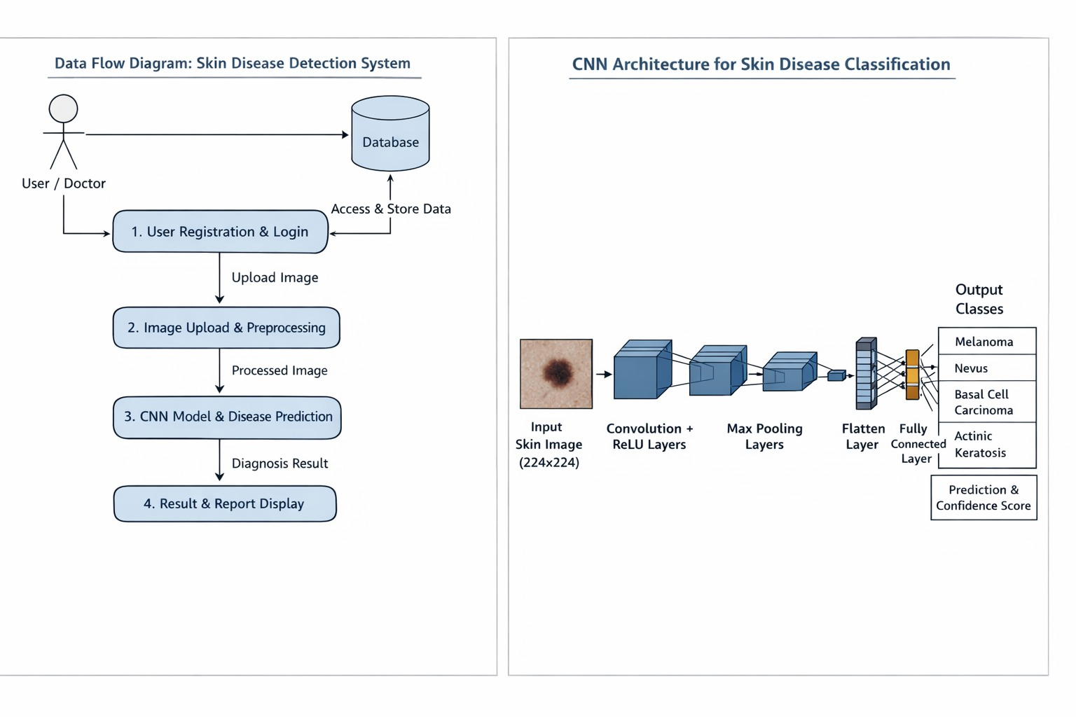
- Image uploaded by user
The user uploads a skin image through the system interface. This image is used as the input for disease analysis.
- Image preprocessing and enhancement
The uploaded image is resized and enhanced to remove noise and improve quality. This helps the model analyze the image more accurately.
- Feature extraction using CNN
CNN automatically extracts important features such as color, texture, and patterns from the skin image. These features are used for disease identification.
- Disease classification and confidence output
The system classifies the image into a specific skin disease category. It also provides a confidence score showing prediction accuracy.
- Result displayed to user
The final disease prediction and confidence level are displayed to the user. This helps users and doctors understand the diagnosis easily.

Languages
- HTML,CSS,JavaScript – Front-End-Development
- Python – Machine Learning & Image Processing

System Requirement Specification

Hardware Requirements:
-Processor
-RAM
-Storage

Software Requirements:
-Operating System
-Window 10/11
-Linux(Ubuntu 20.04 or above)
Result Analysis
• Accurate prediction of skin diseases
The system uses machine learning and CNN to predict skin diseases with high accuracy. This helps in reliable and consistent diagnosis.
• Early detection and prevention
Early identification of skin diseases allows timely treatment. This helps prevent the disease from becoming severe or spreading further.
• User-friendly diagnosis support system
The system is easy to use and does not require technical knowledge. Users can upload images and get results quickly.
• Improved healthcare assistance
The system supports doctors by reducing manual workload. It also improves access to healthcare services, especially in remote areas.

Conclusion
The Skin Disease Detection System shows how artificial intelligence can be used to detect skin diseases effectively. By analyzing images, the system provides quick and reliable results.
This project helps reduce the dependency on specialists and can support better healthcare services, particularly in rural areas.

Reference: https://doi.org/10.3390/pr11041003
https://www.curresweb.com/index.php/CSI1/article/view/630
https://www.w3schools.com/ai/ai_machine_learning.asp

