REPORT
SQL for Project_Movie_database
- Can you get all data about movies?
SELECT *
FROM movies;


- How do you get all data about directors?
SELECT *
FROM directors;
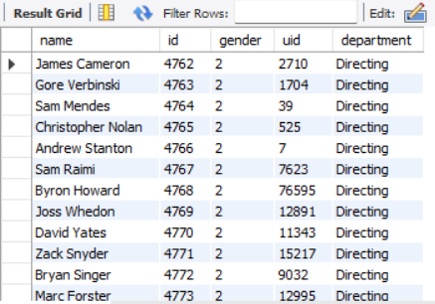

- Check how many movies are present in IMDB.
SELECT COUNT(*) AS Total_movies
FROM movies;


- Find these 3 directors: James Cameron ; Luc Besson ; John Woo
SELECT *
FROM directors
WHERE Name IN ('James Cameron', 'Luc Besson', 'John Woo');


- Find all directors with name starting with S.
SELECT *
FROM directors
WHERE Name LIKE 'S%';
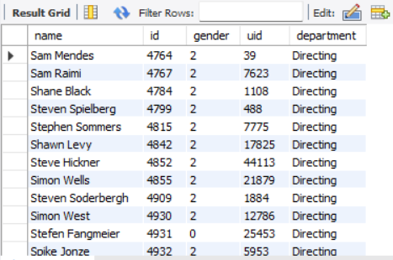

- Count female directors.
SELECT COUNT(*) AS Female_directors_count
FROM directors
WHERE gender = 1;


- Find the name of the 10th first women directors?
SELECT *
FROM directors
WHERE gender = 1
order by id
LIMIT 1 OFFSET 9;


- What are the 3 most popular movies?
SELECT ID, original_title, title, popularity, release_date
FROM movies
ORDER BY popularity DESC
LIMIT 3;


- What are the 3 most bankable movies?
SELECT ID, original_title, title, revenue, release_date
FROM movies
ORDER BY revenue DESC
LIMIT 3;


- What is the most awarded average vote since the January 1st, 2000?
SELECT id, original_title, title, vote_average, vote_count, release_date
FROM movies
WHERE release_date >= '2000-01-01'
AND vote_average = (
SELECT MAX(vote_average)
FROM movies
WHERE release_date >= '2000-01-01'
);


- Which movie(s) were directed by Brenda Chapman?
SELECT m.id, m.original_title, m.title, m.release_date, d.name AS director
FROM movies m
JOIN directors d ON m.director_id = d.id
WHERE d.name = 'Brenda Chapman';

There are no movies in the dataset that were directed by Brenda Chapman.
- Which director made the most movies?
SELECT d.id, d.name, COUNT(m.id) AS movie_count
FROM directors d
LEFT JOIN movies m ON d.id = m.director_id
GROUP BY d.id, d.name
ORDER BY movie_count DESC
LIMIT 1;

- Which director is the most bankable?
SELECT d.id, d.name, SUM(m.revenue) AS total_revenue
FROM directors d
LEFT JOIN movies m ON d.id = m.director_id
GROUP BY d.id, d.name
ORDER BY total_revenue DESC
LIMIT 1;
