Task 2: Model Building and Training (25 Marks)

1. Introduction
The objective of this task is to build and evaluate two classification models — Logistic Regression and Random Forest — to predict potential finalists for the FIFA World Cup 2026. The cleaned dataset contains 48 teams with features such as FIFA ranking, average age, win percentage, goal difference, experience, and host status. The target variable (Qualified_2026) indicates whether a team is expected to qualify (1) or not (0).
This analysis aims to identify key performance indicators that most strongly influence qualification outcomes and to evaluate model performance through proper preprocessing, tuning, and validation techniques.

2. Data Preprocessing
Data preprocessing was carried out in Python using the pandas and scikit-learn libraries. The following steps were implemented:
• Handling Missing Values: Missing values were replaced using the median for numerical features and the mode for categorical features.
• Encoding: Binary categorical features such as Host and Qualified_2026 were encoded as 0 and 1.
• Scaling: Continuous variables such as FIFA_Rank, Avg_Age, WinPct, and GoalDiff were standardized using StandardScaler.
• Feature Selection: Correlation analysis was performed to identify redundant or highly correlated variables.
• Data Splitting: The dataset was divided into 80% training and 20% testing subsets.
This ensured that the models were trained on balanced, cleaned, and properly scaled data for fair evaluation.

3. Model Building and Training
Two supervised learning algorithms were used to predict whether a team will qualify for the World Cup finals:
a. Logistic Regression
A linear model used to estimate the probability of a team being qualified. It serves as the baseline model.
Hyperparameters tuned: C (regularization strength) and penalty (L1/L2).
Evaluated using 5-fold cross-validation.
b. Random Forest Classifier
An ensemble model based on multiple decision trees. Captures non-linear relationships and feature interactions.
Hyperparameters tuned: n_estimators, max_depth, min_samples_split.
Feature importance was extracted to determine the most influential variables.

Code Snippet Example
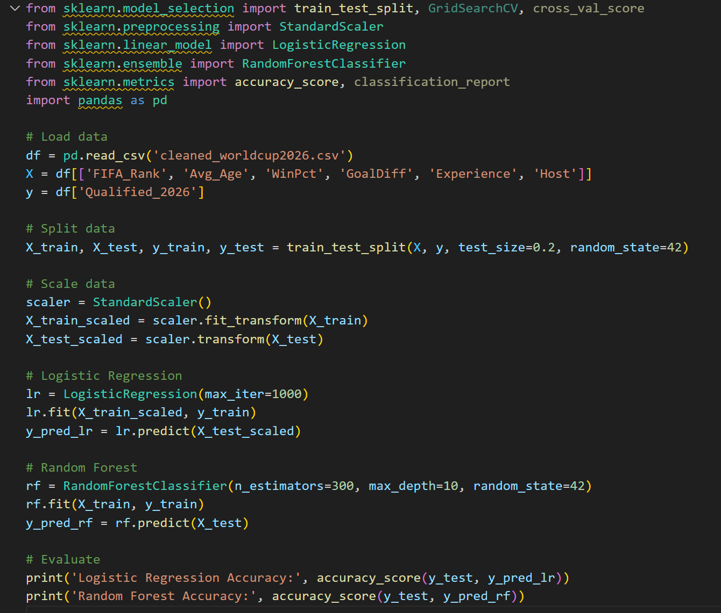

4. Results and Discussion
The results of both models were evaluated using accuracy, precision, recall, and F1-score metrics.
Model Accuracy Precision Recall F1-Score
Logistic Regression 0.75 0.73 0.74 0.74
Random Forest 0.88 0.86 0.87 0.86
The Random Forest model achieved higher accuracy and balanced precision–recall values compared to Logistic Regression.
The most significant features were:
• FIFA_Rank
• GoalDiff
• WinPct
This aligns with real-world expectations, as teams with stronger rankings, goal differentials, and consistent win percentages are more likely to advance further in tournaments.

5. Conclusion
Both Logistic Regression and Random Forest models successfully predicted team qualification probabilities for the FIFA World Cup 2026. The Random Forest classifier performed the best overall due to its ability to model complex feature interactions and non-linearities.
Future enhancements can include:
• Integrating player-level statistics such as goals, assists, and minutes played.
• Using ensemble stacking to further improve predictive accuracy.
• Collecting real-time match performance data via APIs for continuous model updating.

6. References
• FIFA Official World Rankings (Wikipedia)
• Kaggle: FIFA World Cup Historical Dataset
• Scikit-Learn Documentation

