Step 1 : Create a new Git repository



Step 2 : Create a file and commit changes

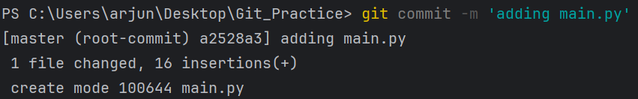

Step 3: View the commit history of your repository



Step 4 : Open the file you created earlier and make some changes to it

Step 5 : Check the file you modified is now marked as modified and unstaged

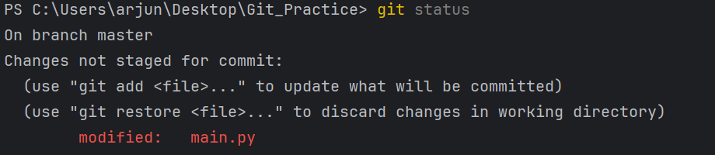

Step 6 : Stage the changes you made to the file and commit the changes to the repository.

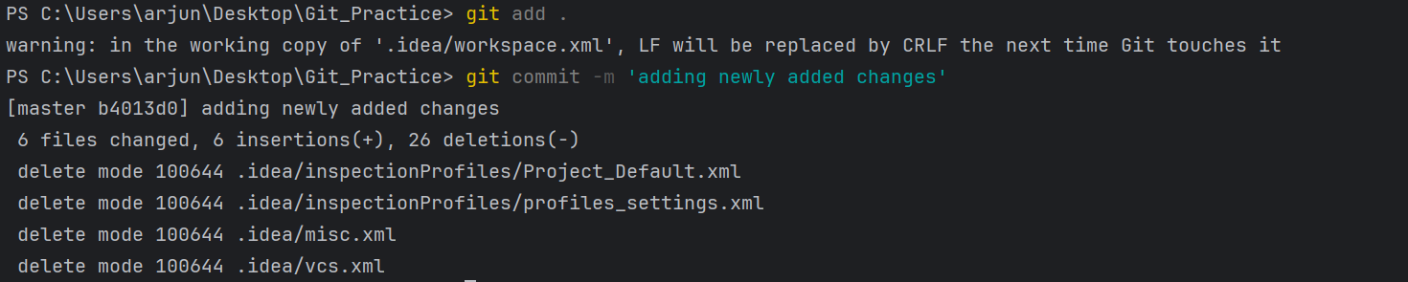

Step 7: Clone the repository you have created in GitHub.

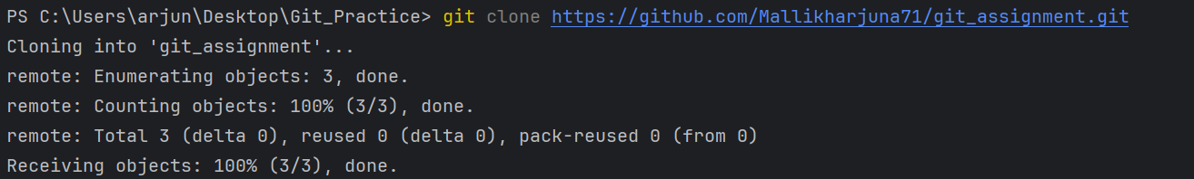

Step 8: Fetch the changes, navigate into the cloned repository using the command line, and use the command git fetch to fetch any changes that have been made to the original repository since you cloned it.

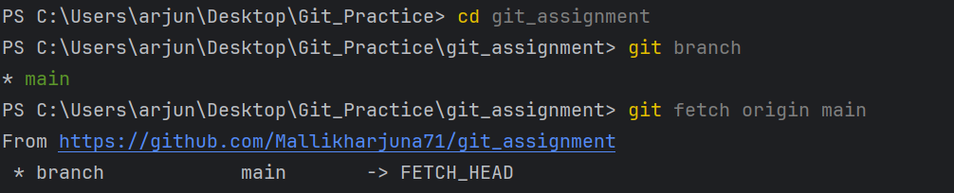

Step 9: Pull changes, merge the changes you just fetched into your local copy of the repository, and use the command git pull.

